**Practical : 1**

**Aim :** WAP to illustrate the concept of Pure Virtual Function using at least three classes.

**Program :**

#include <iostream>

using namespace std;

class A

{

public:

virtual void method1() = 0;

virtual void method2() = 0;

void method()

{

cout << "my name is khushbu";

}

};

class B : public A

{

public:

void method1()

{

cout << endl << "i completed 12th science in ankur vidhyabhavana";

}

};

class C : public B

{

public:

void method2()

{

cout << endl << "i'm currently study in tmt bca clg";

}

};

int main()

{

C c;

c.method();

c.method1();

c.method2();

return 0;

}

**Output :**

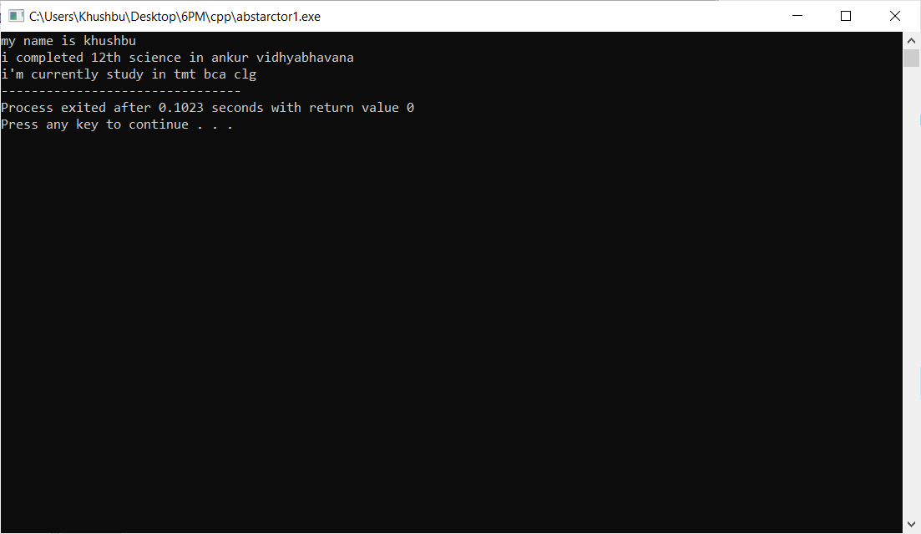

**Practical : 2**

**Aim :** WAP to enforce yourself to provide implementation of the method getAllDetails() of Employees class.

**Program :**

#include<iostream>

using namespace std;

class A

{

public :

int id;

char name[100];

char department[100];

int salary;

virtual void getDetails() = 0;

};

class Emp : public A

{

public:

void setdata()

{

cout << endl << "Enter Employee's ID : ";

cin >> id;

cout << "Enter Employee's Name : ";

cin >> name;

cout << "Enter Employee's Department : ";

cin >> department;

cout << "Enter Employee's Salary : ";

cin >> salary;

}

void getDetails()

{

cout <<endl << "Employee's ID : " << id << endl

<< "Employee's Name : " << name << endl

<<" Employee's Department : " << department << endl

<< "Employee's Salary : " << salary << endl;

}

};

int main()

{

Emp e[100];

int i, n;

cout << "Enter how many Employee details you want to enter : ";

cin >> n;

for(i = 0 ; i < n ; i++)

{

e[i].setdata();

}

for(i = 0 ; i < n ; i++)

{

e[i].getDetails();

}

return 0;

}

**Output :**

