INDIAN INSTITUTE OF INFORMATION TECHNOLOGY

**Assignment 2**

Subject: Image and Video Processing

Faculty: Dr. Badri N Subudhi

**Submitted By: Khushbu V Parmar (202262005)**

**OBJECTIVE: Median Filtering.**

The median filter is the filtering technique used for noise removal from images and signals. The median filter is very crucial in the image processing field as it is well known for the preservation of edges during noise removal. The prior duty of the filter is to scan every input data interceding the overall entries with the median function known as the “window” method. The window tends to be a little bit complex over the higher-dimensional signals. The number of medians is set according to the number of windows, falling under odd and even categories.

The median filter is one type of nonlinear filter. It is very effective at removing impulse noise, the “salt and pepper” noise, in the image. The principle of the median filter is to replace the grey level of each pixel with the median of the grey levels in neighbourhoods of the pixels, instead of using the average operation. For median filtering, we specify the kernel size, list the pixel values, covered by the kernel, and determine the median level. If the kernel covers an even number of pixels, the average of two median values is used. Before beginning median filtering, zeros must be padded around the row edge and the column edge. Hence, edge distortion is introduced at the image boundary.

**Python Code:** Attached zip file (median_filtering.ipynb)

**Images used**: Assignment images/ Assignment1/images

<https://sites.google.com/view/badrisubudhi/home/assignment-images?authuser=0>

**Output Images:**

* 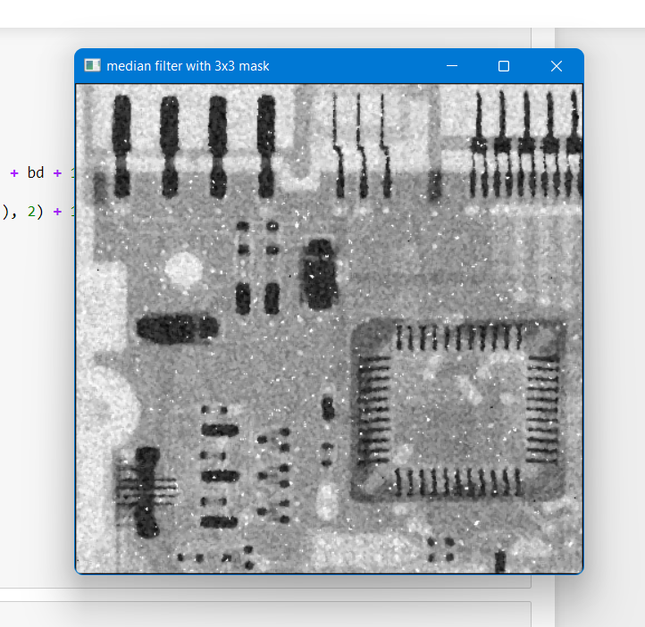Output using 3x3 Mask
* 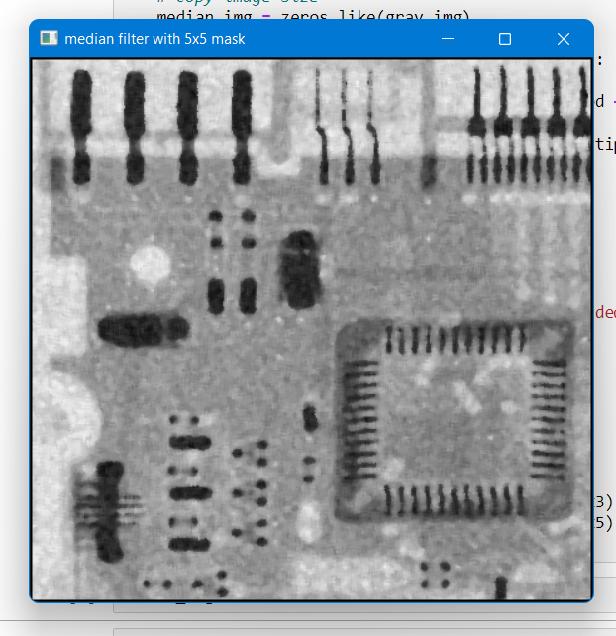Output using 5x5 Mask
* 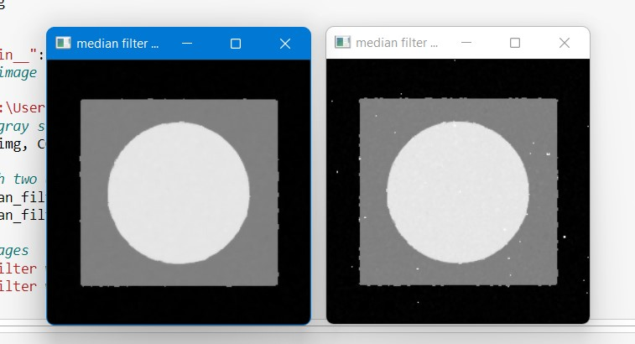Image 2
* 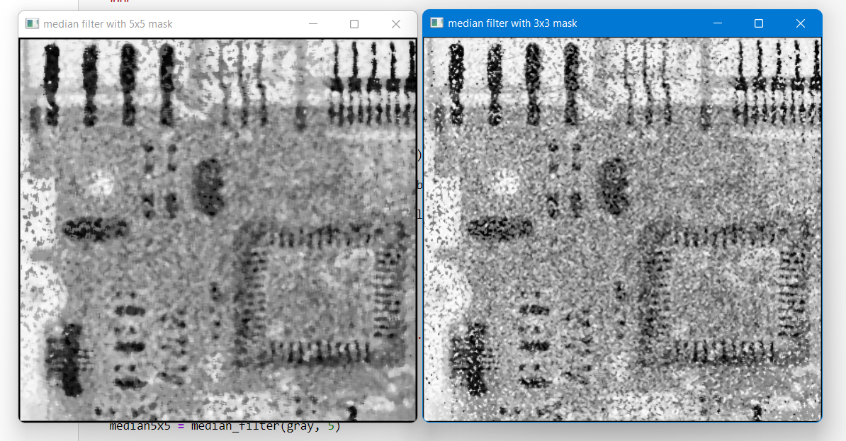Image 3