Installation of MongoDB
Step 1: Go to MongoDB Download Center to download MongoDB Community Server.
- Go to https://www.mongodb.com/
- Under the Products tab
|-Community Edition
|-Download Community
|-Download Mongo dB Community server (8.x.x)
| -Select Version, Platform, Package(msi- Microsoft Software Installer) and Download it

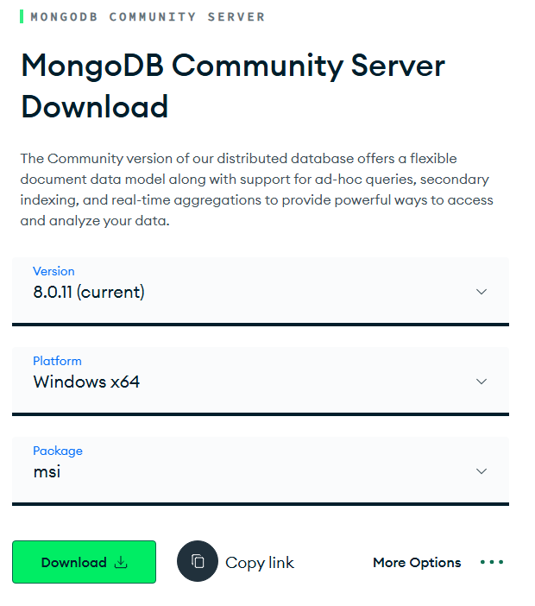
Here, You can select any version, Windows, and package according to your requirement. For Windows, we need to choose:

Step 2: When the download is complete open the msi file and click the next button in the startup screen:
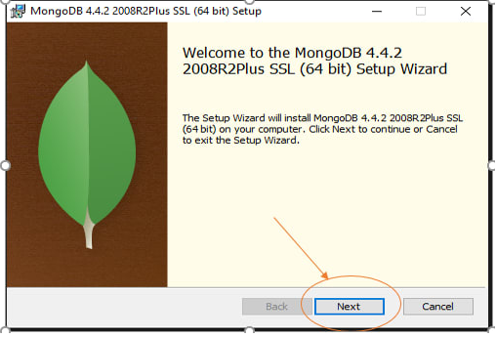
Step 3: Now accept the End-User License Agreement and click the next button:

Step 4: Now select the complete option to install all the program features. Here, if you can want to install only selected program features and want to select the location of the installation, then use the Custom option:
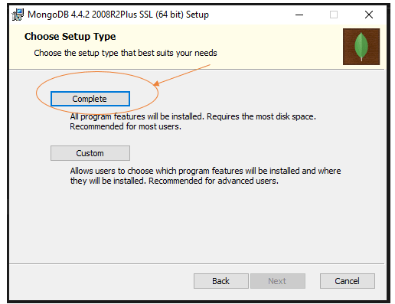
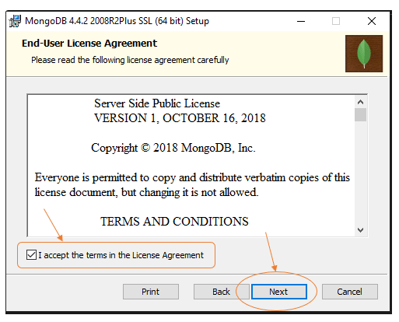

Step 5: Select “Run service as Network Service user” and copy the path of the data directory. Click Next:
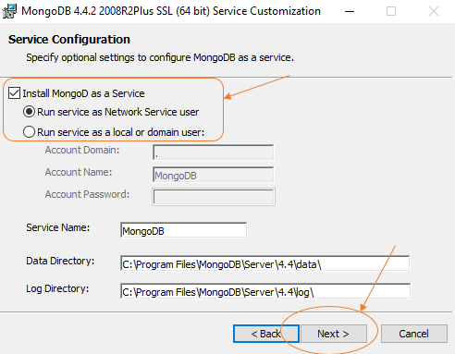

Additional Step: Install MongoDB Compass:

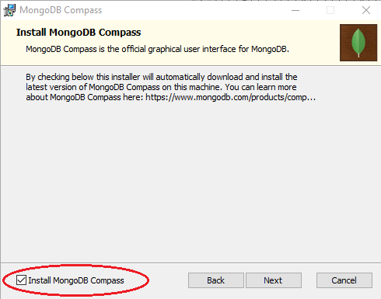

Step 6: Click the Install button to start the installation process:
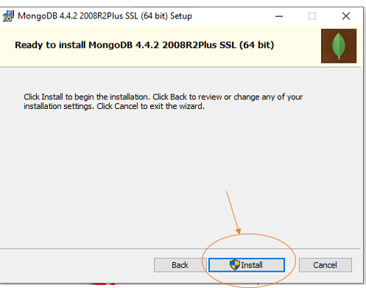

Step 7: After clicking on the install button installation of MongoDB begins:
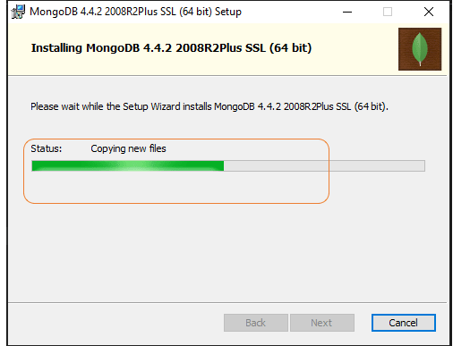

Step 9: Now click the Finish button to complete the installation process:
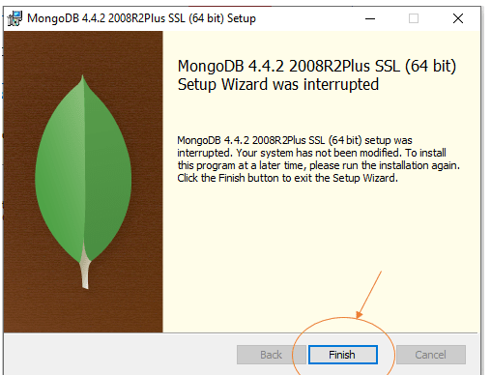

Download Mongo Shell
The mongo shell is an interactive JavaScript interface to MongoDB. You can use the mongo shell to query and update data as well as perform administrative operations.

The mongosh command starts the MongoDB Shell, a command-line interface for interacting with your MongoDB server. It allows you to:
- Perform administrative tasks
- Create and manage databases and collections
- Insert, query, and update documents
- Run MongoDB commands and scripts
(*Always use latest version)
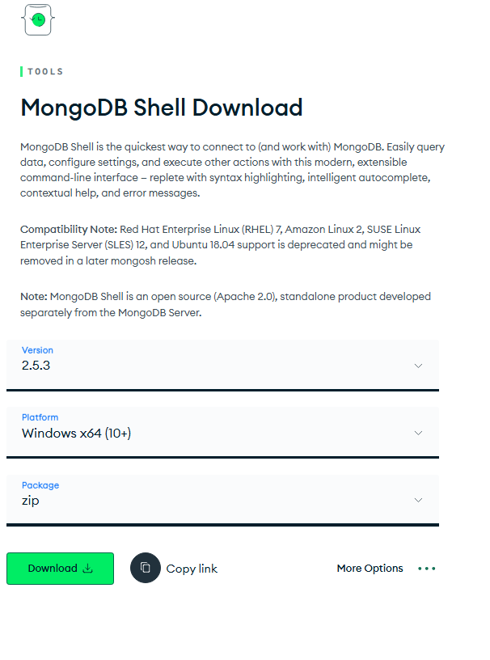
Step 1
|- Go to https://www.mongodb.com/try/download/shell
|- Download (.Zip file)
|- Extract files and from bin folder Copy exe and dll files to
“C:\ProgramFiles\MongoDB\Server\8.0\bin”

Step 2*(If required): Set path property in environment variable (Under User variables temporary if you don’t have administrative rights)

|- open environment variable
|-Select “System Variable” > Path
|-Click on “Edit”
|-Add “C:\Program Files\MongoDB\Server\8.0\bin”

Step 3:Verify MongoDB Installation

Check MongoDB Server Version

To confirm MongoDB is installed and accessible via command line:
Open Command Prompt, type: mongod –version

This will display the version of the MongoDB server (mongod) installed.

Step 4:Start the MongoDB Shell
In Command Prompt, type: mongosh

This connects to the default MongoDB instance running on: localhost:27017

It will shown as below screenshot.
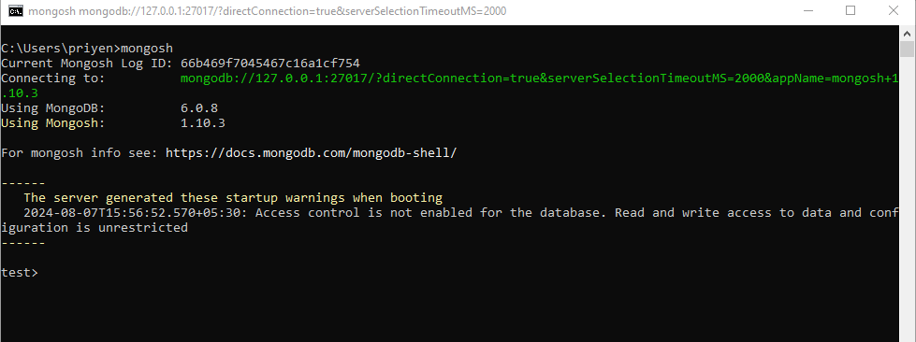
Connect to a Specific MongoDB Instance:
mongosh "mongodb://hostname:port"

mongosh "mongodb://192.168.1.100:27018"

Install MongoDB Compass(Individuals): (no complex setup) (GUI)

MongoDB Compass is a graphical user interface (GUI) tool provided by MongoDB for interacting with MongoDB databases. It is designed to provide a user-friendly way to visualize, manipulate, and manage your data without needing to use the command line.

To download
- Go to https://www.mongodb.com/try/download/shell
- And download MongoDB Compass Download (GUI) (1.49.8 stable)

