Write html/css script using bootstrap to perform following tasks. Use grid system and
responsive effect must be observed.
a. Set four columns in a row shown in image1 which contains image, title and description in each column.
b. Columns must be observed vertically as shown in image2 from small screen size. (<576).
c. Design should be same as shown below using bootstrap classes only.

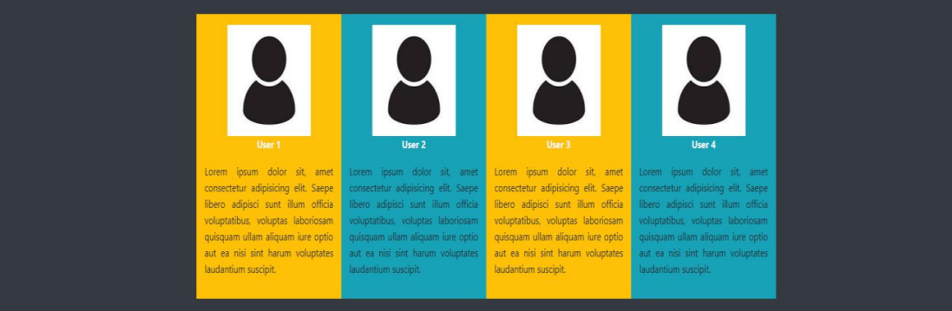
Img1

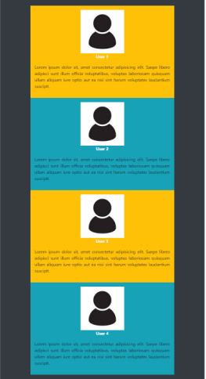
Img2

