AbleSpace — Caseload & Take Data Walkthrough
Part 2 Submission — UX & Functionality Review
Prepared by Khushbu Jamliya for the AbleSpace Full Stack Developer Assessment
This document walks through the Caseload screen and the Take Data (session capture) flow in AbleSpace, explains how the workflow functions, and calls out UX and functionality improvements. Screenshots were taken directly from the live product using a demo account.

1. Workflow Walkthrough
The Caseload screen is a clinician's home base for the students they work with. It lists every assigned student in a table, along with a few pieces of at-a-glance information: IEP Due date, Eval Due date, who else is collaborating on that student's case, and how many minutes of service time are logged. Each row also has a "Take Data" button, which is the entry point into an actual data-collection session for that student.
Clicking "Take Data" opens the session capture screen for that student. At the top, it shows the session's date and time window, and two status pills — "Accommodations" and "Services Not Tracked" — that summarize relevant compliance context for the session. Below that, the student's IEP goals are listed down the left side (Social Studies, Writing, Math, Reading, Toileting, Behavior, and so on), each with a short preview of its target criteria.
Selecting a goal from that list loads it into the main capture panel on the right. The full goal description appears at the top (e.g. "Demo Student1 will take 5 bites, from a handheld snack, such as a cheese stick in 4 out of 5 opportunities"), followed by a "Trial" navigator and the actual data-entry control — a large tappable area used to log the outcome of each trial as the clinician works through the goal with the student in real time. An "Undo" option sits above it in case of a mis-tap.
Below the capture area is a Notes/Lesson Plan panel, where the clinician can attach session notes, either typed fresh or loaded from a previous session ("Load Last Note"). The screen also offers Graph, Stats, and Info tabs (next to Capture) for viewing this goal's data trends without leaving the session, and a "+Phase" control, presumably for advancing the goal to a new instructional phase once criteria are met.
In short, the workflow is: pick a student from the Caseload → open a live session via Take Data → work through their IEP goals one at a time, logging trial-by-trial data as it happens → optionally attach notes → the session's data then feeds into that student's ongoing progress tracking (visible via Graph/Stats).

2. UX & Functionality Observations

2.1 Caseload Screen
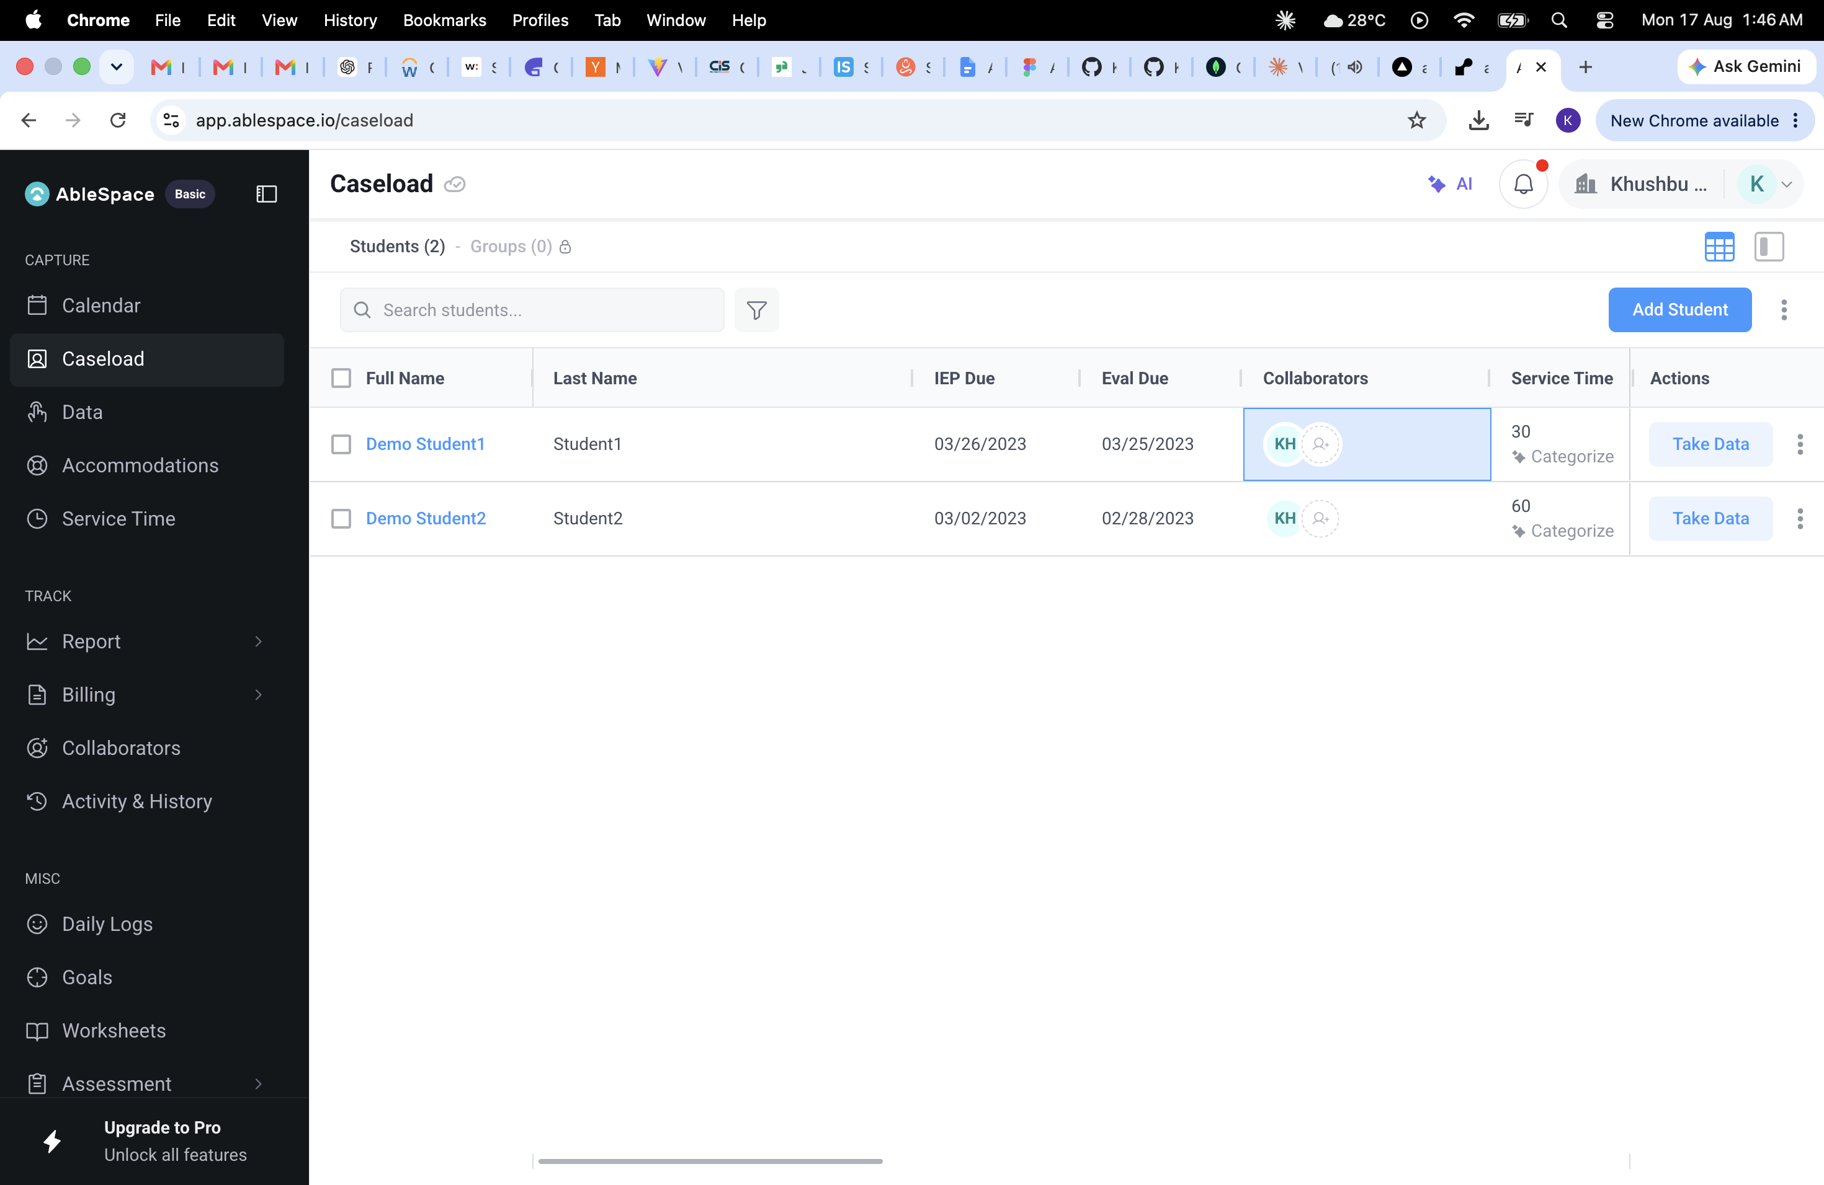
The Caseload screen showing a clinician's assigned students, key dates, and quick actions.
2.1.1. Collaborators column uses more width than its content needs
Observation: The Collaborators column shows only a small avatar and an 'add' icon per row, but occupies a wide fixed column, pushing Service Time and Actions further right and contributing to the horizontal scroll visible at the bottom of the table.
Suggestion: Narrow the Collaborators column to fit its content (avatar + add icon), or convert it to a compact overflow indicator (e.g. '+2 more') when there are multiple collaborators. This would free up space and likely remove the need to scroll horizontally on standard screen widths.
2.1.2. "Categorize" label under Service Time is unclear
Observation: Each row shows a number (e.g. '30', '60') under Service Time, with a small 'Categorize' link stacked beneath it. It isn't obvious from the visual alone what 'Categorize' does — whether it's a filter, a way to log time against IEP goal categories, or something else — without clicking it.
Suggestion: Add a short tooltip on hover, or rename it to something more explicit (e.g. 'Log by category') so its function is clear without requiring a click to discover it.
2.1.3. No sort affordance on date-sensitive columns
Observation: IEP Due and Eval Due are both dates that directly affect compliance deadlines, but the column headers give no visible indication that they're sortable (no arrow/caret icon), so a clinician can't easily surface which students have the most urgent deadlines.
Suggestion: Add sort indicators to IEP Due and Eval Due (and ideally a default sort by soonest-due), so at-risk deadlines surface at the top of the list without the user needing to hunt for a sort control.
2.1.4. Table requires horizontal scrolling on a standard viewport
Observation: A horizontal scrollbar is visible at the bottom of the table even on a full desktop browser width, meaning some columns are only reachable by scrolling sideways — easy to miss, especially for the rightmost Actions column.
Suggestion: Reduce the width of low-content columns (see 2.1.1) and consider letting less-critical columns (e.g. Collaborators) collapse into an expandable row detail on narrower screens, keeping the primary action (Take Data) always visible without scrolling.

2.2 Take Data — Session Capture Screen
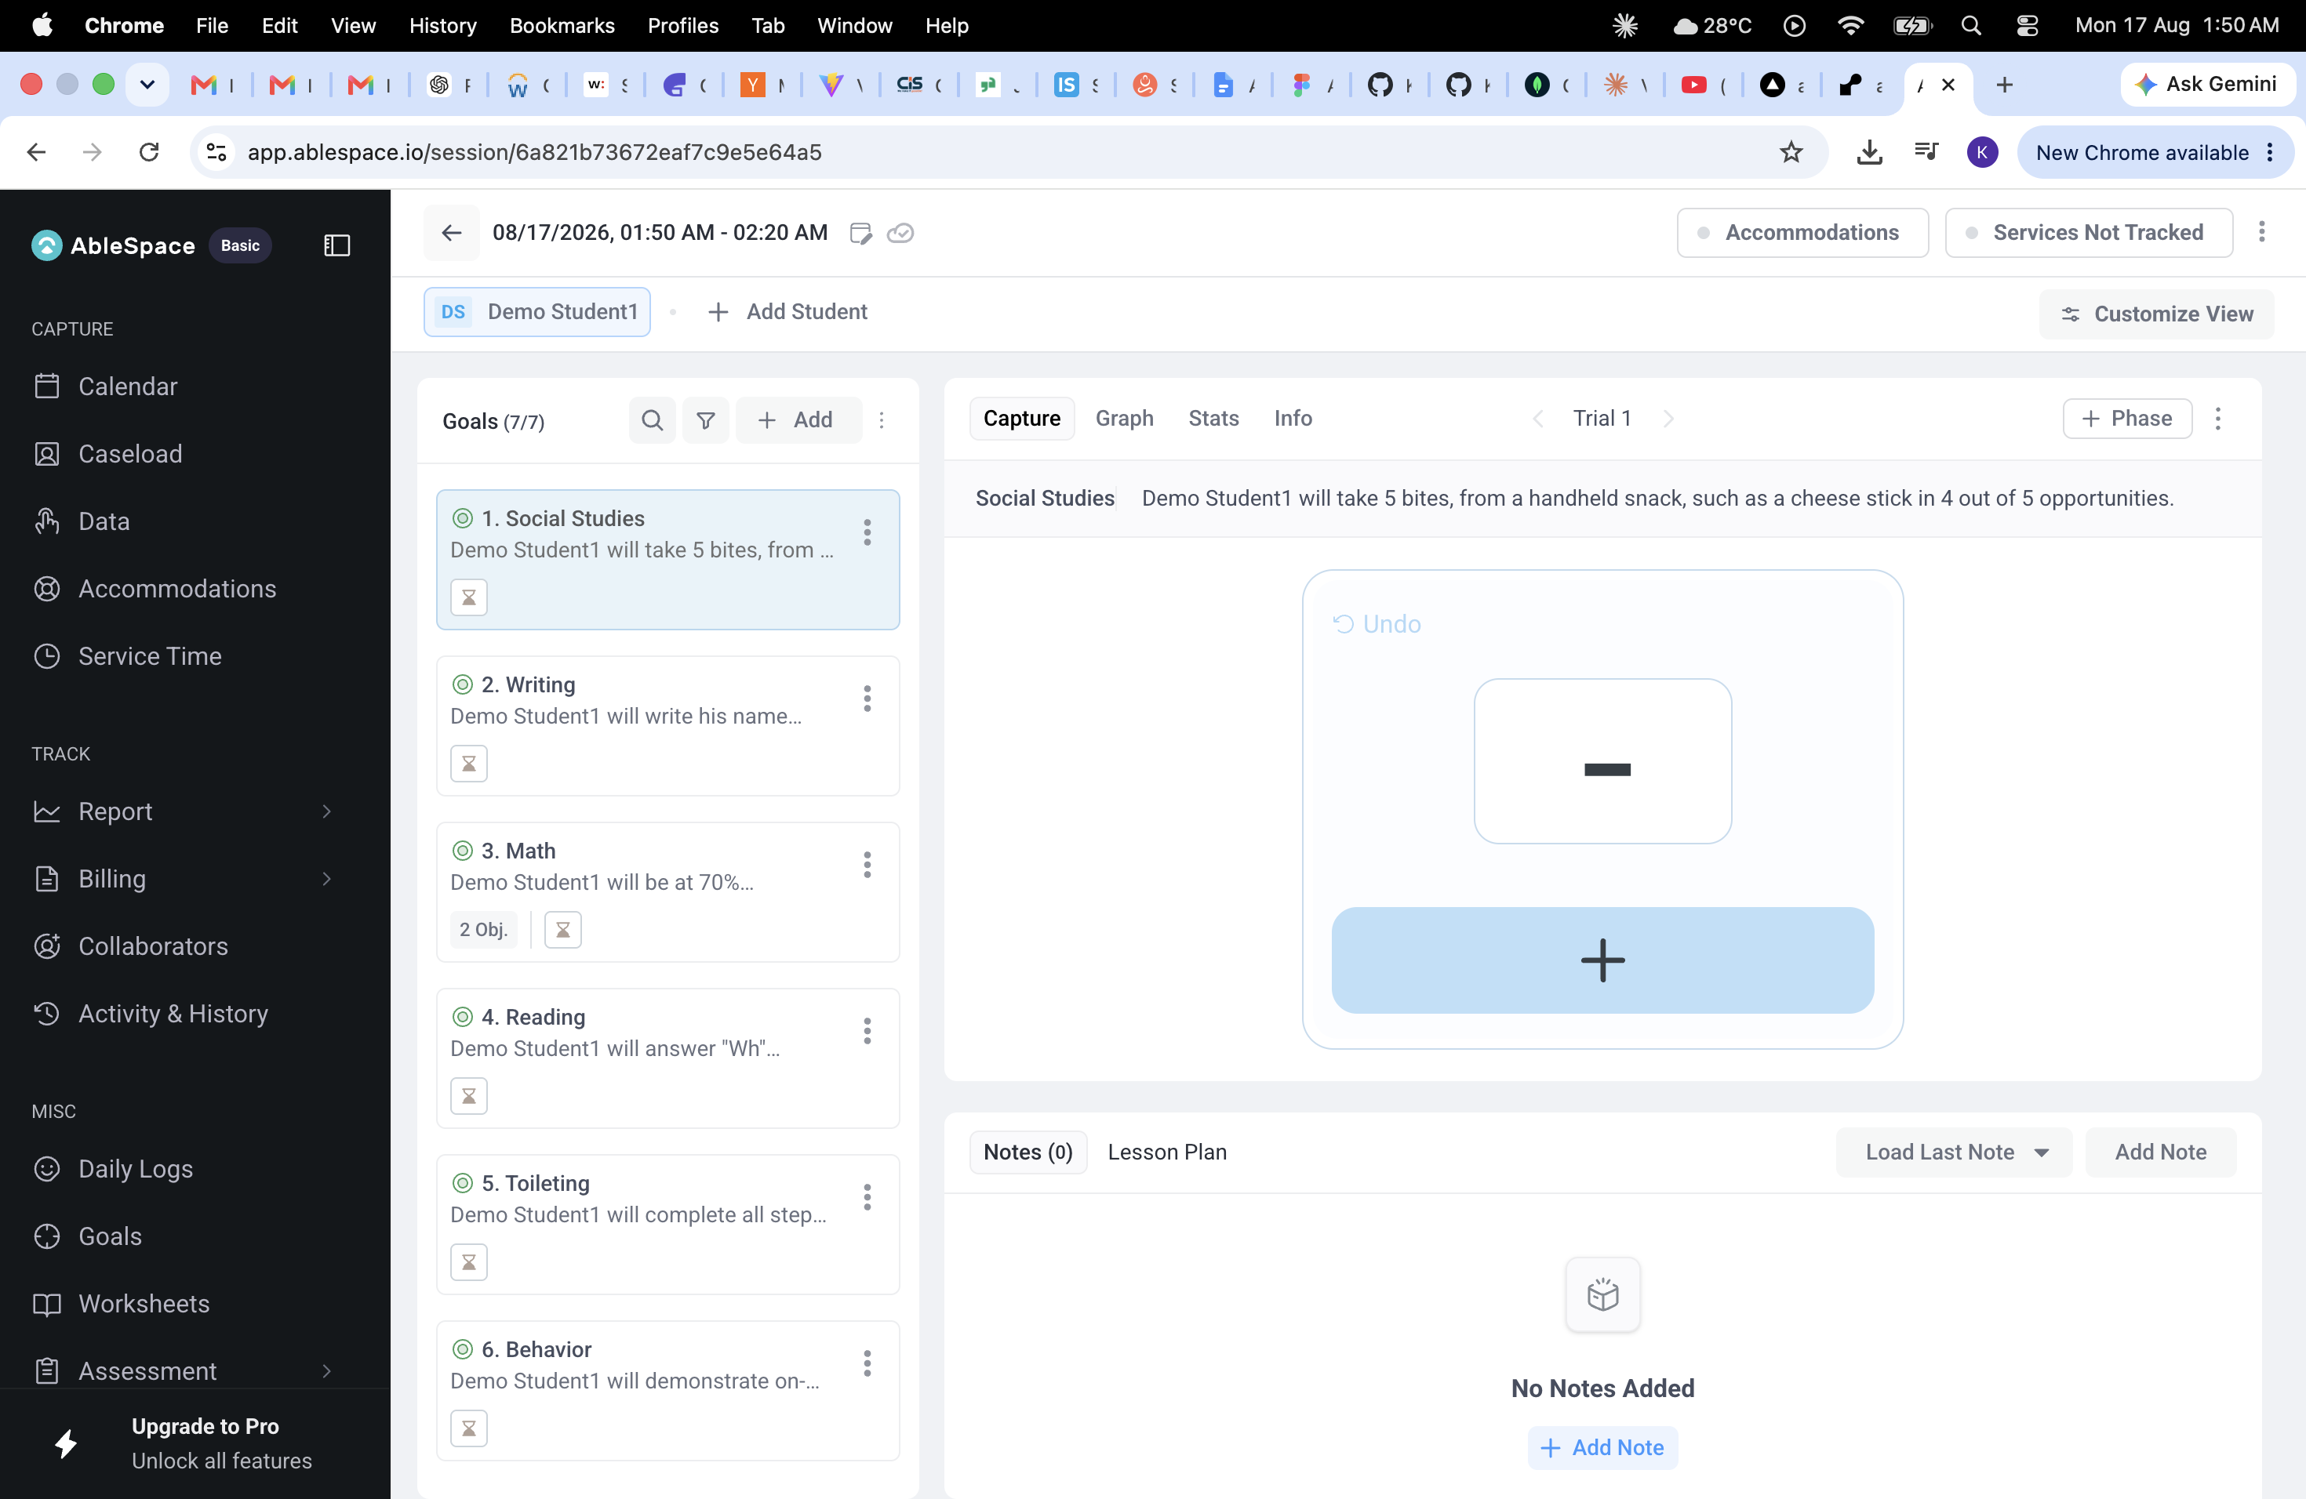
The session capture screen reached via "Take Data", showing the goals list, trial capture area, and notes panel.
2.2.1. The primary capture control's meaning isn't self-evident
Observation: The main interaction area — where a clinician logs a trial result — shows an 'Undo' link, a small square with a dash icon, and a large '+' button below it, but nothing labels what tapping the '+' records (a correct response? a trial count increment? a specific data type?). In a live session, a clinician needs to act quickly and correctly without pausing to interpret icons.
Suggestion: Add a clear, short label to the capture button (e.g. '+ Log Correct Response' or '+ Log Trial') so its function is unambiguous at a glance, especially for new users or substitute clinicians who haven't memorized the icon system.
2.2.2. Goal descriptions are truncated in the working list
Observation: Each goal card in the left sidebar (e.g. "Demo Student1 will take 5 bites, from …") is cut off with an ellipsis. During a live session, a clinician needs to reference the exact target criteria — number of trials, prompt level, accuracy threshold — quickly and repeatedly.
Suggestion: Allow the full goal text to expand inline (e.g. on hover or a single click that doesn't navigate away), or make the sidebar panel resizable, so the clinician isn't forced to lose their place in the capture flow just to re-read the goal wording.
2.2.3. No visible trial count or session progress
Observation: The Trial navigator shows "Trial 1" with left/right arrows, but there's no indication of how many trials are planned for this session or goal (e.g. "Trial 1 of 5"), making it hard for a clinician to know whether they're on track to complete the session's data requirements.
Suggestion: Show a trial counter with a known or running total (e.g. "Trial 1 of 5" if a target is set, or "Trial 1" with a running tally otherwise), so progress through the session is visible without needing to mentally track it.
2.2.4. "Services Not Tracked" reads as a passive toggle rather than a compliance flag
Observation: The pill labeled "Services Not Tracked" near the top of the screen is styled the same as the neutral "Accommodations" pill next to it, but it likely represents an important compliance gap (untracked service minutes can affect IEP compliance). Its current styling doesn't visually distinguish it as something that needs attention.
Suggestion: Style compliance-relevant states like "Services Not Tracked" with a distinct visual treatment (e.g. a warning color or icon) so they stand out from purely informational toggles like "Accommodations," reducing the chance a clinician overlooks it during a busy session.
2.2.5. Notes panel occupies significant space while empty
Observation: The Notes/Lesson Plan panel at the bottom of the screen takes up roughly a third of the visible capture area even when there are no notes yet ("No Notes Added"), competing for attention with the primary data-capture interaction above it.
Suggestion: Collapse the Notes panel to a compact bar by default when empty, expandable on demand, so the capture area — the main reason the screen is opened — gets more visual priority during active data collection.

3. Summary
The core workflows on both screens are functional and the information architecture is generally logical (student list → session detail → goal-by-goal capture). The improvements above are mostly about clarity and information density: making the primary action on the capture screen unambiguous, surfacing compliance-relevant states more prominently, and reducing friction in referencing full goal criteria during a live session — all changes aimed at reducing cognitive load for a clinician working through a caseload under time pressure.

