WEEK 6 TASK
Model Evaluation, Reporting &
Business Impact Communication
Customer Trend Prediction in the Beauty & Wellness Industry

Student Name: Patel Khushi
Project Dataset: salon_appointments_dummy.csv
Project Focus: Daily service-demand estimation
Task: Week 6 — Model Evaluation and Business Reporting

1. Executive Summary
This report evaluates three regression approaches for estimating daily salon service demand: a Mean baseline, Ridge Regression, and a shallow Decision Tree Regressor. The project uses salon_appointments_dummy.csv, a small synthetic dataset containing 100 appointment records from approximately one month. Appointment records were aggregated into service-by-date booking counts, and the data was split chronologically so that earlier dates were used for training and later dates for testing.
Ridge Regression achieved the lowest Mean Absolute Error (MAE) at 0.532, but its RMSE (0.575) was slightly worse than the baseline (0.573). The baseline had the best R-squared value (-0.046), while the Decision Tree had the weakest overall result (MAE 0.541, RMSE 0.612, R² -0.194). All R² values were negative, so none of the tested approaches demonstrated reliable predictive value over the held-out period. The appropriate business decision is not to deploy a model yet. Instead, collect more representative historical data, validate across multiple time windows, and reassess after the forecasting process is improved.

Key takeaway
A responsible evaluation does not simply select the model with the best single score. It checks whether the model consistently improves on a simple benchmark and whether the evidence is strong enough to support a business decision.

2. Project Background and Business Objective
Beauty and wellness businesses need to plan staff, appointment slots, supplies, and promotional activity around expected demand. When demand is underestimated, customers may face limited availability; when it is overestimated, staff time and resources may be underused.
The project objective is to investigate whether historical appointment patterns can help estimate the number of bookings for each service on a given date. The output is intended to support planning, not to make automatic decisions about individual customers.
Item | Definition
Business question | Can appointment history and calendar information estimate daily demand by service?
Prediction target | booking_count: number of appointments for a service on a date
Model type | Regression, because the target is a numeric count
Intended users | Salon managers, booking coordinators, and marketing planners
Current status | Exploratory evaluation only; not ready for operational deployment

3. Dataset and Preparation
The project dataset is named salon_appointments_dummy.csv. It contains 100 synthetic appointment records covering approximately one month. Synthetic data is useful for practicing a workflow, but it may not represent real customer behavior, seasonality, cancellations, or operational constraints.
For modeling, the records were grouped by appointment date and service name to calculate booking_count. A complete date-by-service grid was considered so that dates with no bookings for a service could be represented as zero rather than disappearing from the table. Calendar features included service name and weekday. A chronological split used earlier dates for training and later dates for testing.
Preparation step | Why it matters
Parse appointment dates consistently | Avoids invalid date values and supports time ordering.
Check missing values and duplicates | Reduces avoidable data-quality errors.
Aggregate by date and service | Creates a clear numeric demand target.
Include zero-booking date/service combinations | Prevents demand from being represented only when bookings exist.
Use a chronological split | Better reflects predicting future dates from past information.
Keep preprocessing inside a model pipeline | Reduces the risk of information leakage.

Important limitation: the dataset does not contain a verified appointment-status label suitable for cancellation prediction. Therefore, this report evaluates service-demand regression and does not claim to evaluate cancellation classification.

4. Evaluation Framework
The evaluation framework compares a simple reference model against two candidate regressors. The baseline is essential: a more complicated model should only be preferred when it provides a meaningful and repeatable improvement on data that was not used for training.
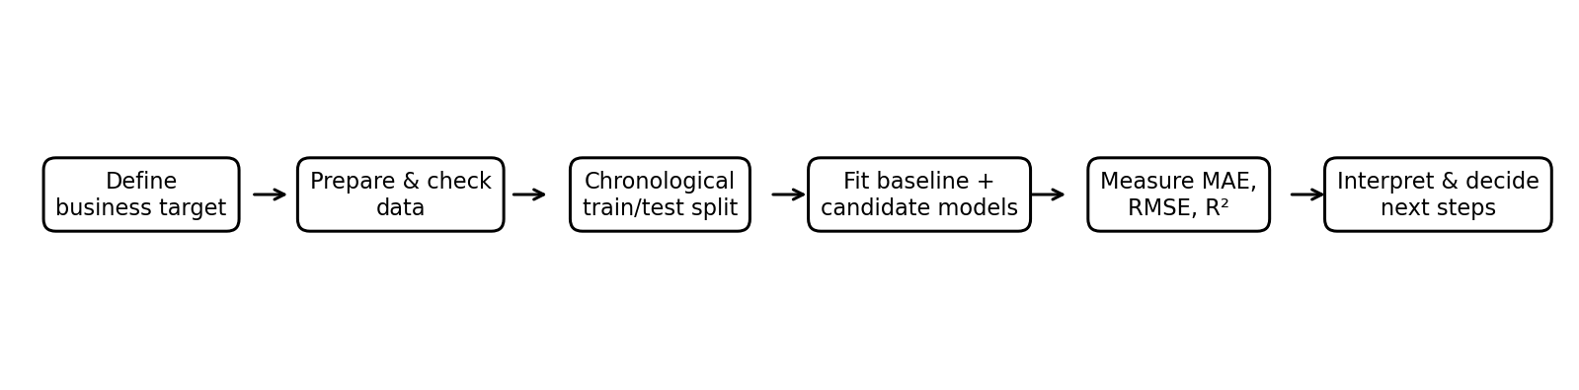
Figure 1. Recommended workflow for evaluating the service-demand models.
Stage | Evaluation activity | Decision purpose
1. Define | Specify booking_count as the target and service/date as the forecasting unit. | Ensures the problem is measurable.
2. Prepare | Check dates, missing values, duplicate records, and target construction. | Improves data reliability.
3. Split | Train on earlier dates and test on later dates. | Mimics future prediction.
4. Fit | Train the mean baseline, Ridge Regression, and shallow Decision Tree. | Provides a simple benchmark and candidate models.
5. Measure | Calculate MAE, RMSE, and R² on the same test set. | Compares error magnitude and explanatory performance.
6. Interpret | Check the metrics together and account for small sample size. | Avoids selecting a model based on one score alone.
7. Improve | Collect more data and evaluate on multiple rolling time windows. | Builds stronger evidence before deployment.

5. Performance Metrics and Rationale
Metric | What it means | How to interpret it here
MAE | Average absolute difference between actual and predicted booking counts. | Lower is better; easy to explain in units of bookings.
RMSE | Square root of average squared prediction error; larger errors receive more weight. | Lower is better; useful when large misses are especially costly.
R² | Compares model error with the variation in the actual target relative to a mean-based reference. | Closer to 1 is generally better. A negative score means the model performs worse than predicting the test-set mean under this metric.

Accuracy, precision, recall, F1-score, and ROC-AUC are mainly used for classification problems. Because this task predicts a numeric booking count, MAE, RMSE, and R² are more appropriate. If a future project defines a valid binary outcome such as cancellation versus completion, classification metrics could be added for that separate task.

6. Model Performance Results
The table below uses the executed Week 5 results. The values are reported to three decimal places. All models were evaluated on the same chronological holdout.
Model | MAE ↓ | RMSE ↓ | R² ↑ | Interpretation
Mean baseline | 0.537 | 0.573 | -0.046 | Best RMSE and R² among the tested models; useful benchmark.
Ridge regression | 0.532 | 0.575 | -0.052 | Lowest MAE, but RMSE and R² are slightly worse than baseline.
Decision tree (depth=3) | 0.541 | 0.612 | -0.194 | Weakest performance on all three metrics except no metric advantage.

6.1 Mean Absolute Error
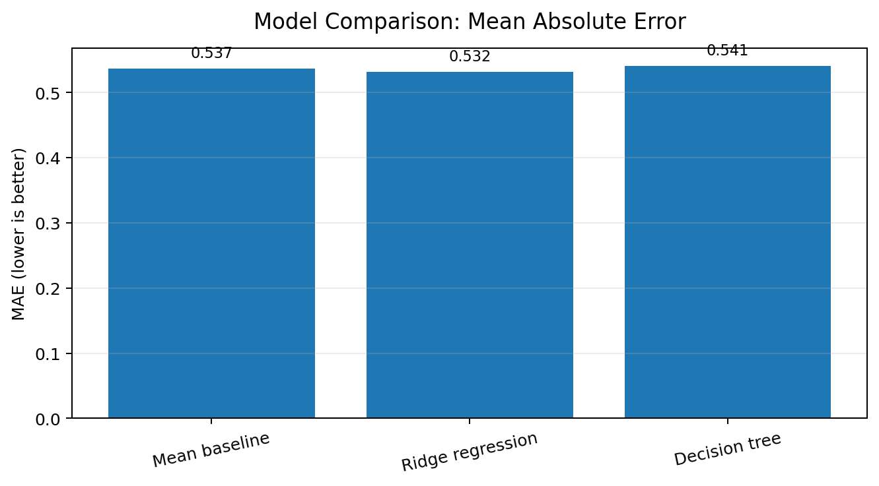
Figure 2. MAE comparison. Ridge Regression has the smallest MAE, but the difference from the baseline is only 0.005.

6.2 Root Mean Squared Error
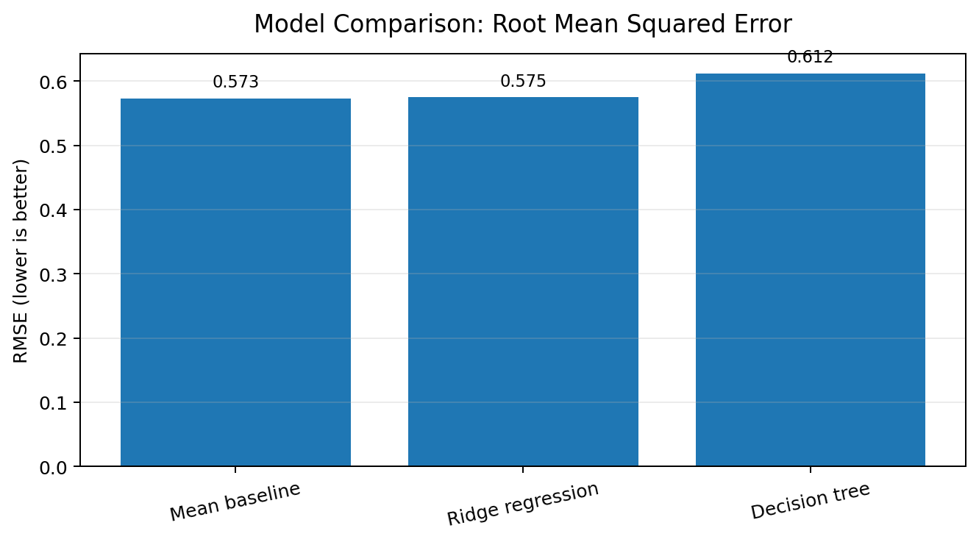
Figure 3. RMSE comparison. The mean baseline has the lowest RMSE, while the Decision Tree has the largest.

6.3 R-squared
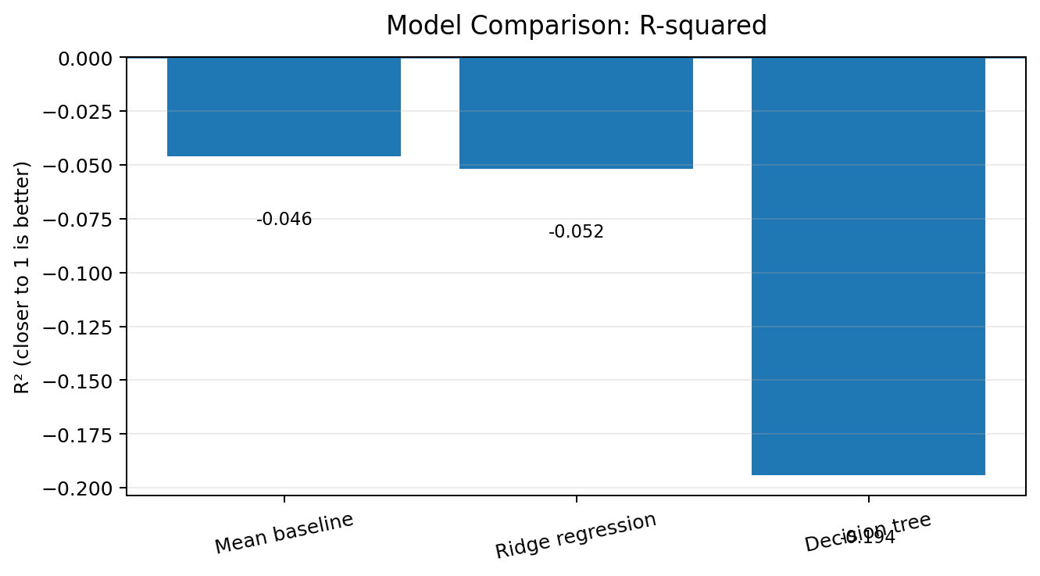
Figure 4. R² comparison. Negative values indicate that none of the models explains the held-out variation better than the mean-based reference.

7. Results Interpretation
Ridge Regression is the best model only if the decision is based on MAE alone: its score of 0.532 is 0.005 lower than the baseline's 0.537. However, its RMSE is 0.575 compared with 0.573 for the baseline, and its R² is -0.052 compared with -0.046. These differences do not provide convincing evidence that Ridge Regression is a useful improvement.
The Decision Tree is not recommended based on this test. It has the highest MAE (0.541), the highest RMSE (0.612), and the most negative R² (-0.194). This may reflect the limited amount of data, unstable patterns, or a model that is too complex for the available sample.
The baseline's negative R² also matters. It does not mean that the model is 'negative percent accurate'; R² is not an accuracy percentage. It means the predictions did not outperform the mean-reference approach in terms of squared-error performance on this test set.

8. Validation Plan and Model Testing Strategy
Validation stage | Plan | Acceptance check
Data validation | Verify date formats, missing values, duplicates, service names, and complete date/service combinations. | No unexplained data-quality issues; target is reproducible.
Chronological holdout | Reserve the latest period as a final test set and do not tune models against it. | Test period reflects future prediction.
Rolling-origin validation | Train on an initial time window, test on the next window, then move forward and repeat. | Performance is reasonably consistent across windows.
Baseline comparison | Compare candidate models against a simple mean or service-specific naive forecast. | Candidate should improve error consistently, not just once.
Error analysis | Review MAE/RMSE by service and date; inspect unusually large misses. | Errors are understood and acceptable for the planning use case.
Business pilot | Run forecasts alongside normal planning without automating decisions. | Managers can interpret forecasts and document benefits or failures.
Ongoing monitoring | Compare forecasted and actual demand weekly; retrain only after review. | No sustained deterioration or major data drift.

Recommended next experiment: collect several months of real appointment data and use rolling-origin validation. Include holidays and seasonal periods where possible. A single short holdout is not enough to establish dependable forecasting performance.

9. Business Impact for Beauty and Wellness
Business area | Potential use of a reliable forecast | Current evidence status
Staff scheduling | Estimate demand by service and prepare staffing plans. | Potential use only; current model is not reliable enough.
Appointment capacity | Identify days or services that may need more available slots. | Potential use only; validate with more data.
Inventory planning | Plan supplies associated with expected service volume. | Needs service-to-supply mapping and real usage data.
Marketing campaigns | Schedule promotions around low-demand periods and assess results with controlled tests. | Forecast alone does not prove a promotion will cause more bookings.
Customer experience | Reduce avoidable capacity mismatches and support timely booking availability. | Should be tested in a supervised pilot.
Business reporting | Compare actual versus predicted demand and track error over time. | Can begin as a monitoring exercise once the pipeline is reproducible.

A forecast should be treated as a planning signal rather than a guarantee. Managers should consider staff availability, service duration, revenue, costs, holidays, and operational constraints before changing schedules or promotions.

10. Actionable Recommendations
- Do not deploy the current model for operational decisions. None of the tested models showed convincing performance over the baseline.
- Collect more representative data. Aim for several months or more of real appointment records, including busy and quiet periods.
- Improve the target table. Create a complete date-by-service series and include zero-booking days.
- Add relevant features only when available at prediction time. Potential features include service category, weekday, public holidays, appointment lead time, duration, and previous booking counts.
- Evaluate multiple time windows. Use rolling-origin validation and preserve a final untouched test period.
- Report uncertainty and error by service. A single average score can hide poor performance for particular services.
- Pilot before scaling. Show forecasts beside actual demand and gather manager feedback before changing staffing or marketing.
- Protect customer information. Use only necessary fields, restrict access to identifiers, and avoid exposing personal details in reports.

11. Limitations and Risks
Limitation | Effect on conclusions | Mitigation
Synthetic dataset | Patterns may not match actual salon customers. | Validate on real, appropriately governed data.
Only 100 appointments / about one month | Small sample and short history make scores unstable. | Collect longer history across different seasons.
Negative R² values | Models have not shown reliable improvement over a mean reference. | Improve features and target construction, then re-evaluate.
One chronological holdout | Results may depend heavily on the chosen test dates. | Use rolling-origin validation.
Limited predictors | Service and weekday may not capture demand drivers. | Add legitimate, available-at-prediction-time features.
No verified status label for cancellation | Cancellation prediction cannot be evaluated from this target. | Obtain a reliable appointment outcome field for a separate classification task.
Forecasts do not establish causation | A pattern does not prove that a promotion or schedule change caused an outcome. | Use controlled experiments to evaluate interventions.

Responsible-use principle: use predictions to support human planning, not to deny service or treat customers differently without a clear, fair, and reviewed reason.

12. Final Conclusion
This evaluation compared a Mean baseline, Ridge Regression, and a shallow Decision Tree Regressor for daily salon service-demand estimation. Ridge Regression produced the lowest MAE (0.532), but the mean baseline produced the best RMSE (0.573) and R² (-0.046). The Decision Tree performed worst overall. All three R² scores were negative, so the current experiment does not establish that a candidate model can forecast demand reliably.
The most defensible business recommendation is to postpone deployment, collect more representative historical data, improve the service-by-date target, and validate with multiple chronological windows. Once a model consistently outperforms a baseline, it can be tested in a supervised pilot to support staff scheduling, appointment capacity, inventory planning, and marketing decisions. This approach connects technical evaluation to practical business impact without overstating what the evidence shows.

13. References and Tools
- Project dataset: salon_appointments_dummy.csv (synthetic educational dataset used in the Week 5 project).
- Week 5 artifact: Week_5_Predictive_Modeling.ipynb and Week_5_Model_Comparison_Results.csv.
- Python libraries used in the project: pandas, NumPy, Matplotlib, and scikit-learn.
- Metric definitions: scikit-learn documentation for mean_absolute_error, mean_squared_error, and r2_score.

14. Submission Checklist
☐ Replace the student-name blank on the cover page.
☐ Check that the report title and dataset filename match your repository.
☐ Keep the Week 5 notebook, results CSV, and this Week 6 report consistent.
☐ If your evaluator requires screenshots from your own notebook, capture the executed model comparison and charts.
☐ Upload the DOCX to the existing project repository unless your instructions specifically require a new repository.
☐ Review the report once before submitting.

