WEEK 2 TASK – FINAL DATA SOURCING & INITIAL ANALYSIS PLAN

Customer Trend Prediction in the Beauty & Wellness Industry
Data Identification, Sourcing Strategy & Initial Analysis Planning

1. Project Overview
The project aims to understand customer behaviour and service demand in the beauty and wellness sector. The proposed analysis will identify popular services, price patterns, appointment timing, repeat-customer behaviour and factors that may help predict future demand. Week 2 converts the Week 1 business problem into a documented data sourcing, quality assessment, exploratory analysis and modelling plan.

2. Week 1 Problem Alignment and Hypotheses
ID | Hypothesis | Variables | Planned analysis
H1 | Service demand differs by service type. | service_name, appointment count | Frequency analysis; chi-square/ANOVA where appropriate.
H2 | Demand varies across days and appointment times. | appointment_date, day_of_week, appointment_time | Grouped counts; heatmap; regression/model features.
H3 | Service price is associated with booking demand. | price, service_name, bookings | Grouped comparison and regression/correlation.
H4 | Repeat-customer behaviour is measurable from appointment history. | customer_id, appointment_date | Visit frequency, repeat rate, customer segmentation.
H5 | Historical appointment features can help identify high-demand periods. | date, time, service, price | Classification/regression/forecasting after sufficient history is obtained.

These hypotheses will be tested using appointment data. Because the current dataset covers only one month, H2 and H5 are preliminary rather than full seasonal conclusions.

3. Selected Dataset – Actual Profile
The selected public dataset is the GitHub file “salon_appointments_dummy.csv” from the Salon & Spa Business Analytics repository. The filename identifies it as dummy/synthetic data, so it is used for initial analysis and methodology development rather than being presented as a representative real-world sample.
Metric | Actual value
Records | 100 appointment records
Original variables | 7
Unique customers | 46
Unique staff members | 4
Unique service types | 7
Date coverage | 01 August 2025 to 31 August 2025
Average price | 35.70
Median price | 40.00
Minimum price | 15.00
Maximum price | 60.00
Total recorded service value | 3570.00
Missing values | 0 across all original columns
Duplicate rows | 0
Duplicate appointment IDs | 0

Original fields: appointment_id, service_name, price, appointment_date, appointment_time, customer_id and staff_member_id.

4. Actual Service-Level Findings
Service | Bookings | Average price | Recorded value
Facial | 16 | 40.00 | 640.00
Manicure | 16 | 20.00 | 320.00
Hair Coloring | 15 | 60.00 | 900.00
Pedicure | 15 | 22.00 | 330.00
Haircut | 13 | 15.00 | 195.00
Massage | 13 | 45.00 | 585.00
Spa Massage | 12 | 50.00 | 600.00

The most frequently booked services are Manicure and Facial, with 16 and 16 bookings respectively. The least frequent service is Spa Massage with 12 bookings.

5. Customer and Appointment Pattern Findings
- The dataset contains 46 unique customers across 100 appointments.
- 29 customers have more than one appointment, while 17 customers appear only once.
- The most common appointment hour is approximately 12:00, with 13 appointments.
- Tuesday has the highest number of appointments, with 20 records.
- 07 August 2025 has the highest number of appointments on a single date, with 7 records.
- The date range covers one calendar month, so the dataset cannot reliably establish annual seasonality.

6. Data Sources and Sourcing Strategy
Source | Type | Use | Strength | Limitation
Salon & Spa Business Analytics – salon_appointments_dummy.csv | Public GitHub synthetic dataset | Main initial appointment EDA and methodology | Directly matches salon appointment variables; accessible | Synthetic, only 100 records and one month
UCSD Amazon Beauty Reviews | Public research dataset | Beauty-product preference/review context and optional sentiment analysis | Large, documented research dataset | Product reviews are not salon bookings
Google Trends India | Public trend tool | External search-interest trends for beauty/wellness terms | Current trend signal; geographic filtering | Search interest is not actual bookings
Foursquare Places API | Public API | Salon/wellness location and POI context if needed | Useful geographic context | API access/quotas and terms apply
India Open Government Data | Government open-data portal | Wellness/health facility context | Government-published source where applicable | Not a direct salon booking source

Source links:
- Salon & Spa Business Analytics repository: https://github.com/fahimtenzel/Salon-Spa-Big_data
- Salon appointments CSV: https://github.com/fahimtenzel/Salon-Spa-Big_data/blob/main/salon_appointments_dummy.csv
- UCSD Amazon Review Data: https://cseweb.ucsd.edu/~jmcauley/datasets/amazon_v2/index.html
- Google Trends India: https://trends.google.co.in/home?geo=IN
- Foursquare Places API: https://docs.foursquare.com/fsq-developers-places/reference/places-api-overview
- India Open Government Data example: https://sandbox.data.gov.in/catalog/health-centres-geolocation-and-facility-details

7. Source Evaluation
Dimension | Current dataset assessment | Future requirement
Accessibility | High – public GitHub CSV | Prefer public/licensed data or authorized operational data
Frequency | Static snapshot | Add newer data if available
Reliability | Good for reproducible synthetic methodology; not real-world prevalence | Use documented real operational/research sources for final claims
Completeness | 0 missing values in current file | Re-check every new source
Time coverage | 1 month | Prefer 12+ months for seasonality
Sample size | 100 appointments | Acquire larger dataset for robust predictive modelling
Representativeness | Limited | Avoid generalizing to the whole beauty/wellness industry

8. Initial EDA Plan
Question | Statistic/technique | Visualization
Which services are most popular? | Count and percentage by service | Bar chart
How are prices distributed? | Mean, median, SD, quartiles, min/max | Histogram + box plot
When are appointments concentrated? | Count by hour/day | Heatmap
Does demand vary by weekday? | Group counts and proportions | Bar chart
Which dates are busiest? | Daily appointment counts | Line chart
How often do customers return? | Visits/customer; repeat rate | Histogram/bar chart
Does price relate to demand? | Grouped comparison/correlation; interpret carefully | Scatter plot/grouped bar
Which staff members have more appointments? | Appointment count by staff | Bar chart
Are there data-quality problems? | Missing/duplicate/validity checks | Quality summary table

9. Statistical Methods
- Descriptive statistics: count, mean, median, standard deviation, minimum, maximum and quartiles.
- Chi-square test: assess association between categorical variables when expected cell counts are adequate.
- ANOVA: compare mean numeric outcomes across more than two groups when assumptions are reasonable.
- Kruskal-Wallis: non-parametric alternative when ANOVA assumptions are not suitable.
- Correlation: measure association between numeric variables; correlation will not be interpreted as causation.
- Confidence intervals and effect sizes will be reported where appropriate, not only p-values.
- A significance level of α = 0.05 will be used for formal hypothesis tests.

10. Machine-Learning Plan
Task | Target | Candidate models | Evaluation
Demand regression | Number of bookings per service/day | Linear Regression, Decision Tree Regressor, Random Forest Regressor | MAE, RMSE, R²
High-demand classification | High-demand vs normal-demand period | Logistic Regression, Decision Tree, Random Forest | Accuracy, Precision, Recall, F1, ROC-AUC
Customer segmentation | No fixed target | K-Means | Silhouette score + segment profiles
Review sentiment (optional) | Positive/neutral/negative | TF-IDF + Logistic Regression; baseline sentiment method | F1/accuracy if labelled
Forecasting (only with sufficient history) | Future booking count | Seasonal-naive/moving average; ARIMA if adequate time series | MAE, RMSE

The current 100-record, one-month synthetic dataset is suitable for demonstrating preprocessing and EDA, but not for claiming reliable seasonal forecasting. A larger, longer dataset is required before final predictive modelling.

11. Preprocessing Plan
- Load raw data without modifying the original file.
- Check column names, data types and unique values.
- Convert appointment_date to a date type and appointment_time to a time type.
- Create derived variables such as day_of_week, hour and service_category.
- Check and report missing values.
- Check exact duplicate rows and duplicate appointment IDs.
- Check invalid prices and inconsistent service labels.
- Inspect outliers before deciding whether removal is justified.
- Encode categorical variables for machine-learning models.
- Use a time-aware train/test split for demand forecasting to prevent future information entering training.
- Remove or anonymize direct personal identifiers if any future operational dataset contains them.
- Document every transformation in the preprocessing pipeline.

12. Actual Data Quality Assessment
Check | Result | Assessment
Missing values | 0 | Excellent for this file
Duplicate rows | 0 | No exact duplicates found
Duplicate appointment IDs | 0 | IDs are unique
Price validity | 15–60 range in current data | No negative prices observed
Date validity | 01–31 August 2025 | Consistent one-month period
Categorical consistency | 7 service labels | Suitable for initial grouping
Sample size | 100 appointments | Too small for strong generalization
Time coverage | 1 month | Insufficient for annual seasonality

13. Limitations and Bias
- The selected CSV is explicitly a dummy/synthetic dataset; it should not be treated as a random sample of real salon customers.
- Only 100 appointments are available, which limits statistical power and model stability.
- All appointments fall within August 2025, so seasonal conclusions cannot be generalized.
- The dataset does not contain demographic, cancellation/no-show, customer satisfaction or marketing-channel variables.
- The recorded price should be interpreted as the value in the source file; currency is not independently verified.
- Additional real or authorized data will be required before making operational claims about actual salons.

14. How the Data Tests the Week 1 Hypotheses
Hypothesis | Evidence from current data | Conclusion status
H1: service demand differs | Service counts range from 12 to 16 bookings | Preliminary descriptive evidence; formal testing should consider assumptions/sample size.
H2: demand varies by day/time | Weekday/hour counts can be compared | Preliminary only because coverage is one month.
H3: price is associated with demand | Service-level price and booking counts are available | Can be explored descriptively; causality cannot be inferred.
H4: repeat behaviour exists | Customer IDs allow visit-frequency calculation | Supported as an observable behaviour; further data needed for prediction.
H5: history predicts future demand | Date/time/service features exist | Model demonstration possible, but robust forecasting needs longer history.

15. Expected Visualizations
- Bar chart of booking count by service.
- Bar chart of total recorded value by service.
- Histogram of service prices.
- Box plot of price by service.
- Line chart of daily appointment volume.
- Bar chart of appointments by weekday.
- Heatmap of weekday versus appointment hour.
- Bar chart of appointments by staff member.
- Histogram of appointments per customer.
- Optional standardized comparison between booking volume and external Google Trends series after additional data collection.

16. Data Collection Roadmap
- Retain the current 100-record dataset as the reproducible initial-analysis dataset.
- Search for and evaluate a larger appointment-level dataset with at least 6–12 months of history.
- Record source URL, dataset owner, access date, license/terms and version.
- Create a data dictionary before modelling.
- Combine only datasets whose variables and units are compatible.
- Perform quality checks before merging.
- Use public review/trend data only as complementary evidence, not as direct appointment counts.
- Re-run EDA after acquiring larger data and compare results with the initial 100-record findings.

17. 30–35 Hour Work Plan
Activity | Hours
Problem/hypothesis alignment | 2
Source discovery and verification | 5
Dataset acquisition and provenance | 5
Data dictionary and quality assessment | 4
EDA and visualization planning | 4
Statistical testing plan | 3
ML method and evaluation planning | 4
Preprocessing plan | 3
Report preparation and final checklist | 4
Total | 34

18. Requirement Checklist
☑ DOC file outlines a data sourcing strategy.
☑ Multiple public data sources and links are provided.
☑ A concrete dataset is identified with actual statistics.
☑ EDA includes descriptive statistics and visualization techniques.
☑ Data quality and relevance are assessed.
☑ Accessibility, frequency and reliability are discussed.
☑ Key variables are identified.
☑ Week 1 hypotheses are mapped to data and tests.
☑ Data cleaning/preprocessing is detailed.
☑ Machine-learning methods and metrics are specified.
☑ Limitations and risks are documented.
☑ The report is logically structured.
☑ Planned next steps for obtaining larger data are documented.

19. References
- Fahim Tenzel, Salon & Spa Business Analytics – public GitHub repository: https://github.com/fahimtenzel/Salon-Spa-Big_data
- Salon appointments CSV: https://github.com/fahimtenzel/Salon-Spa-Big_data/blob/main/salon_appointments_dummy.csv
- McAuley Lab, UCSD, Amazon Review Data: https://cseweb.ucsd.edu/~jmcauley/datasets/amazon_v2/index.html
- Google Trends India: https://trends.google.co.in/home?geo=IN
- Foursquare Places API documentation: https://docs.foursquare.com/fsq-developers-places/reference/places-api-overview
- India Open Government Data Platform: https://sandbox.data.gov.in/
Submission note: The actual dataset findings in this report are based on the uploaded CSV. Planned future sample sizes are labelled as targets and are not presented as observed results. The dummy dataset limitation is explicitly disclosed.

20. Actual Data Visualizations
The following charts were generated directly from the uploaded salon_appointments_dummy.csv file. They provide visual evidence for the preliminary exploratory analysis. Because the dataset is synthetic and covers only August 2025, these figures are descriptive and should not be generalized to the wider industry.
Figure 1. Appointment Count by Service
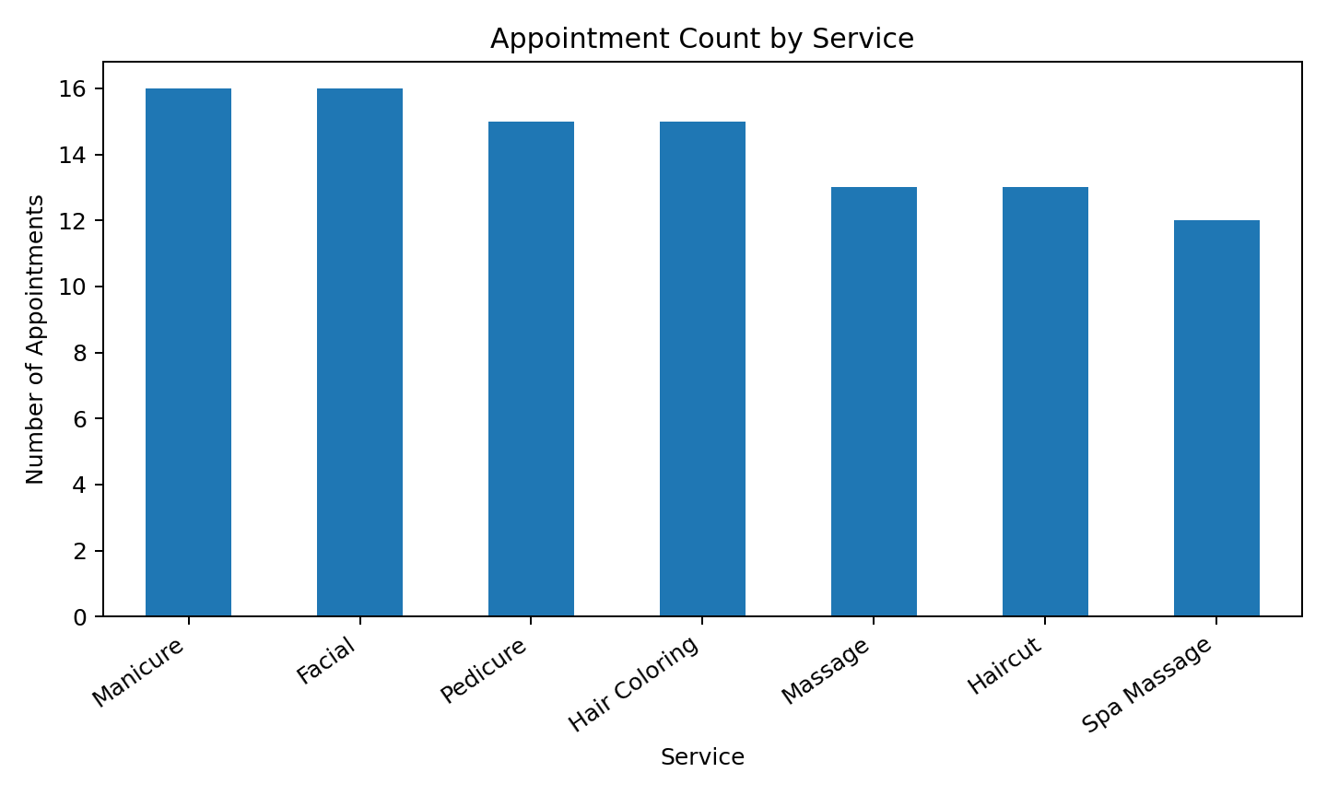
This chart compares demand across the seven service types.
Figure 2. Distribution of Service Prices
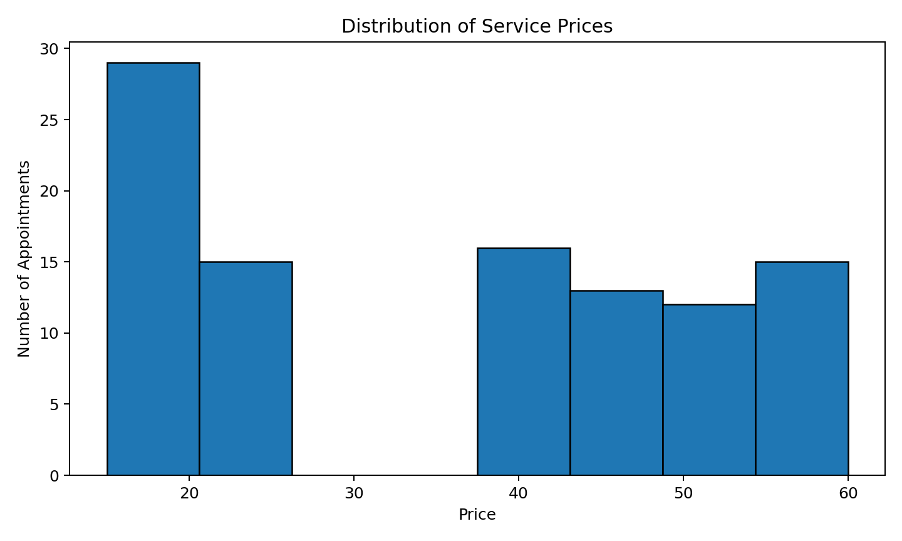
This histogram shows how the recorded service prices are distributed.
Figure 3. Daily Appointment Volume
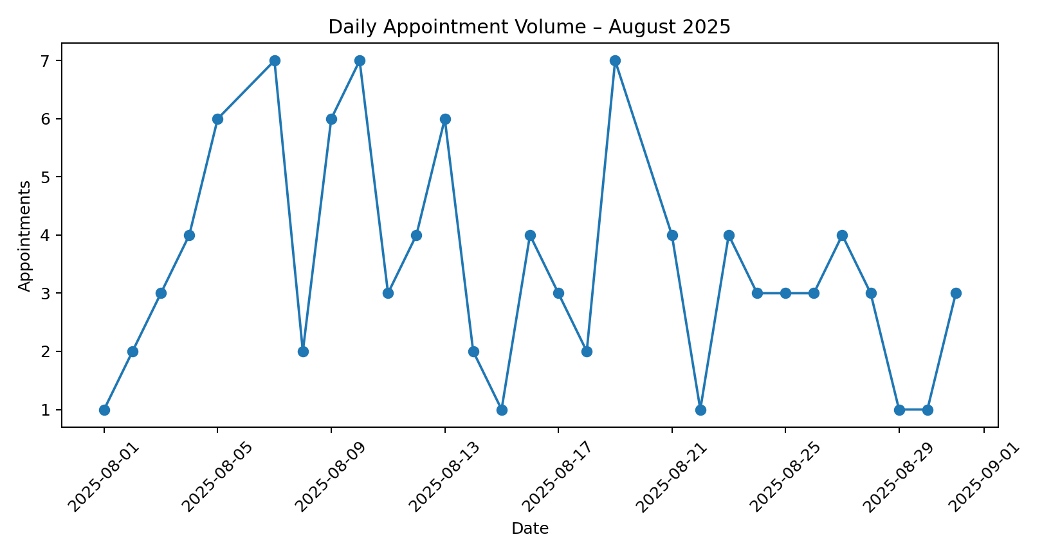
This line chart shows appointment volume across August 2025.
Figure 4. Appointments by Day of Week
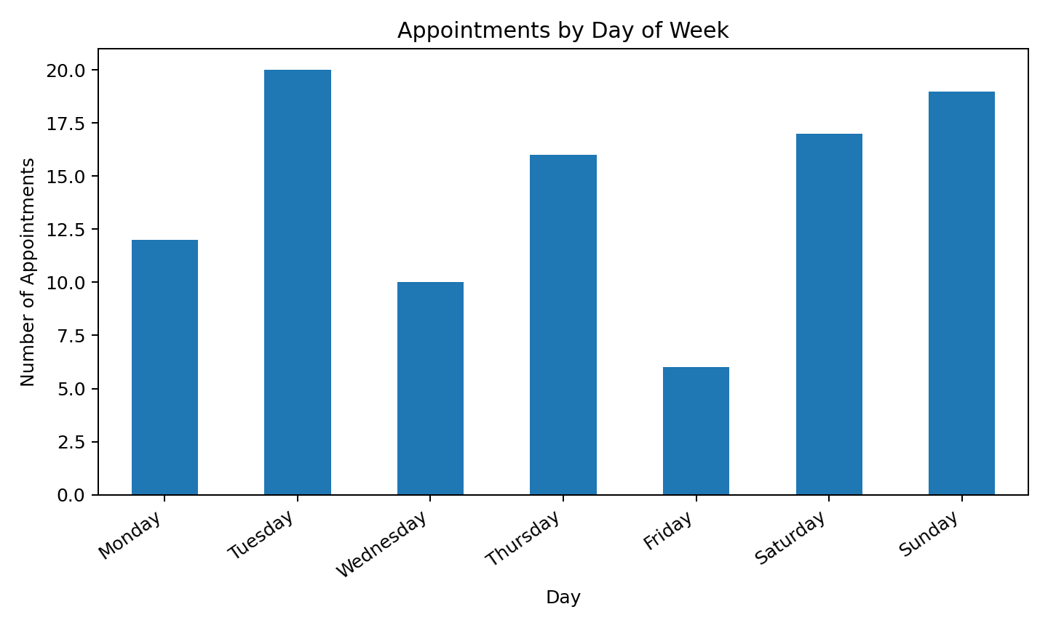
This chart compares appointment volume across weekdays.
Figure 5. Appointments by Appointment Hour
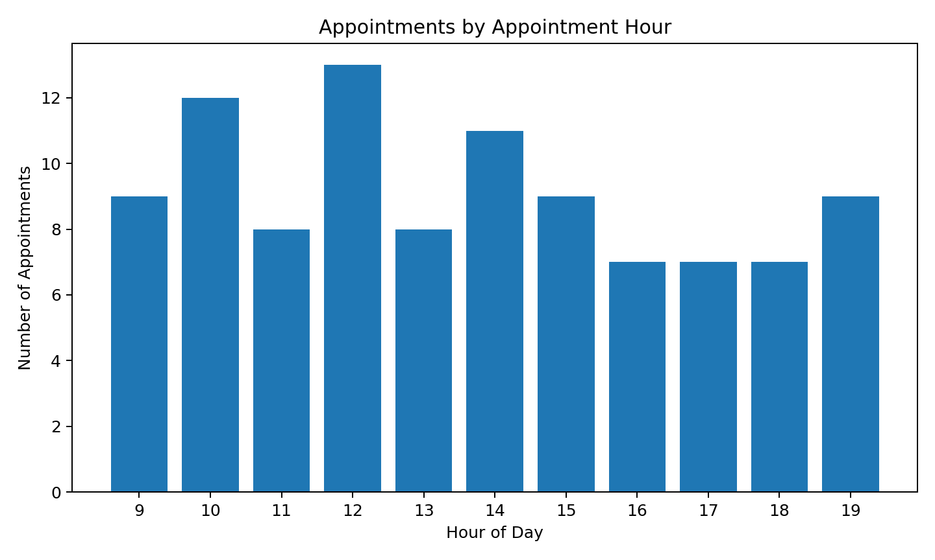
This chart identifies the hours with greater appointment concentration.
Figure 6. Customer Visit Frequency
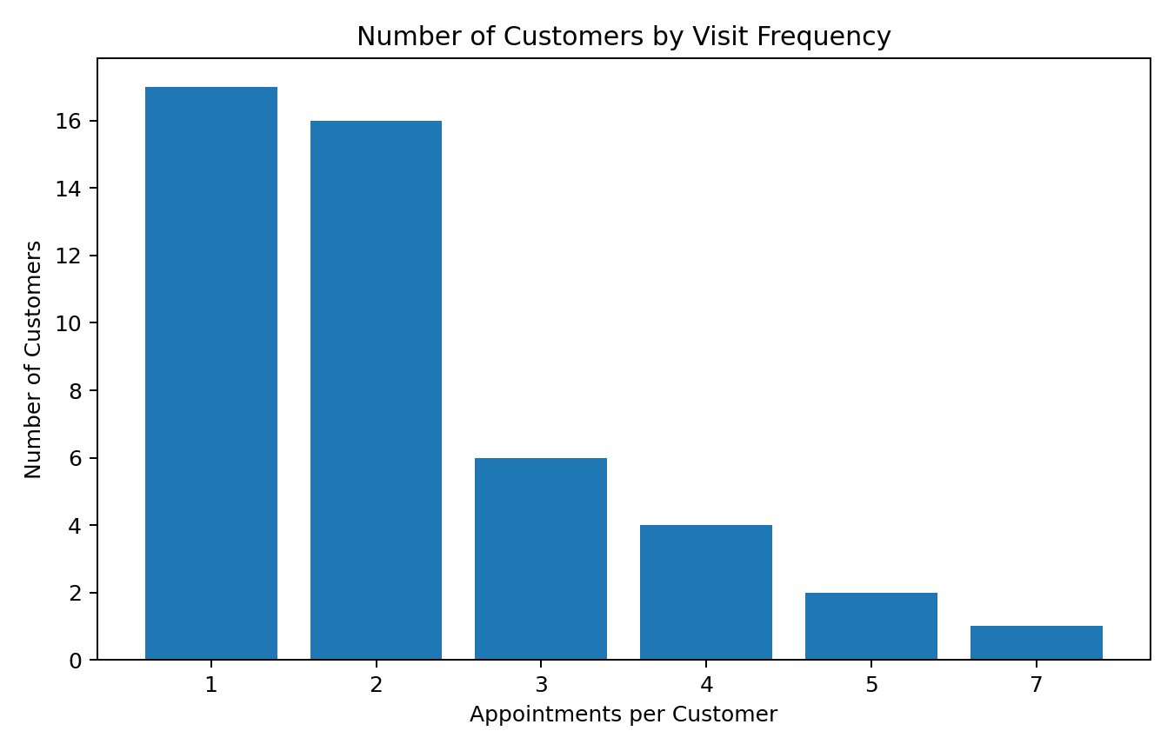
This chart shows how many customers have one, two, three, or more appointments.
Figure 7. Appointments by Staff Member
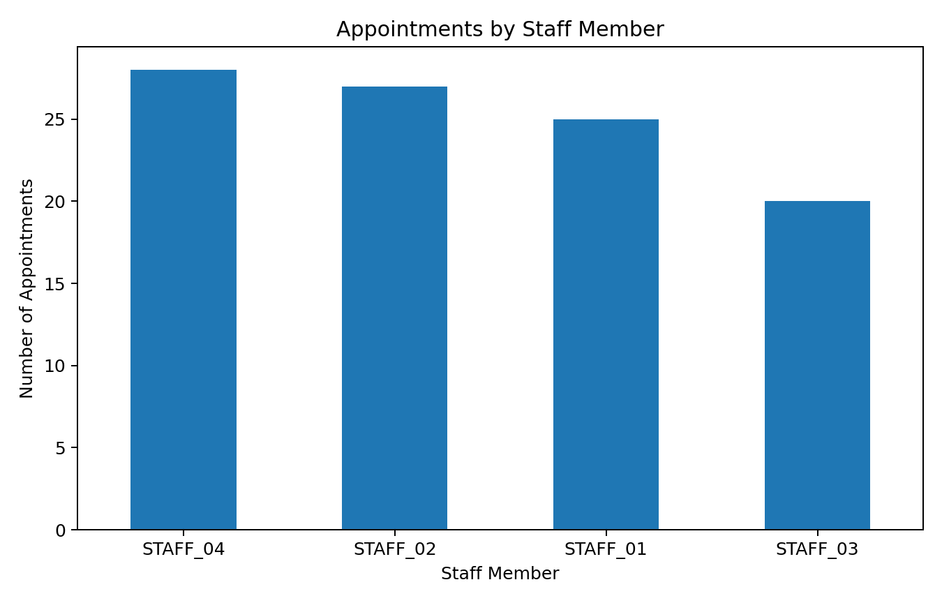
This chart compares the number of recorded appointments assigned to each staff member.

21. Visual Findings
Service-level analysis shows Manicure and Facial as the two highest-volume services, with 16 and 16 appointments. The price distribution spans 15 to 60, with a mean of 35.70. The weekday chart shows Tuesday as the busiest day with 20 appointments. The most common appointment hour is 12:00. These observations are useful for demonstrating the EDA approach, but they are not population-level conclusions.

