TASK 3
LOGISTICS DATA ANALYSIS USING PYTHON
Exploratory Data Analysis, Visualization, and Operational Insights
Hypothetical logistics dataset | Python, Pandas, NumPy, Matplotlib

1. Executive Summary
This project analyzes a hypothetical dataset of 500 shipments and 8 variables. Python was used to generate the dataset, inspect data quality, calculate descriptive statistics, compare transport modes, calculate correlations, and create six visualizations. The sample contains 372 on-time shipments (74.4%) and 128 delayed shipments (25.6%). Mean delivery time is 59.97 hours and mean transportation cost is 9,918.38 cost units. Because the dataset is simulated and most variables are generated independently, findings are educational and should not be generalized to a real company.

2. Objectives
- Define a hypothetical logistics dataset with delivery, shipment, transportation, and status variables.
- Inspect data quality, data types, missing values, and duplicate records.
- Calculate central tendency, dispersion, distributions, and correlations.
- Compare delivery performance and average cost across transportation modes.
- Create relevant visualizations and explain the choice of each chart.
- Present evidence-based findings and recommendations while stating limitations.

3. Dataset Description
The dataset contains 500 rows and 8 columns. It was generated using NumPy with a fixed random seed of 42, so the same code reproduces the same records. Each row represents one hypothetical shipment.
Variable | Type | Description
Shipment_ID | Integer | Sequential identifier for each shipment.
Distance_km | Integer | Shipment distance in kilometres.
Shipment_Weight_kg | Integer | Shipment weight in kilograms.
Shipment_Volume | Integer | Simulated volume measure; physical unit is not specified.
Transport_Mode | Category | Road, Rail, Air, or Sea.
Delivery_Time_hours | Integer | Delivery duration in hours.
Transportation_Cost | Integer | Simulated cost in unspecified cost units.
Delivery_Status | Category | On Time or Delayed.

4. Methodology
- Data simulation: NumPy generated 500 hypothetical records using a fixed random seed.
- Data inspection: Pandas checked dimensions, column types, missing values, duplicate rows, and summary statistics.
- Statistical analysis: Mean, median, mode, standard deviation, minimum, maximum, range, grouped averages, and Pearson correlations were calculated.
- Visualization: Matplotlib generated a histogram, status bar chart, cost comparison bar chart, scatter plot, correlation heatmap, and box plot.
- Interpretation: The charts were interpreted descriptively. Correlation was not treated as proof of causation.

5. Data Quality Assessment
The dataset has 500 records and 8 columns. There are 0 missing values and 0 fully duplicated rows. No imputation or duplicate removal was necessary for this generated dataset. These checks establish structural completeness, not real-world validity.

6. Exploratory Data Analysis

6.1 Descriptive statistics
Variable | Mean | Median | Std. dev. | Minimum | Maximum
Distance km | 504.44 | 501.50 | 285.82 | 11 | 999
Shipment Weight kg | 250.50 | 246.00 | 139.74 | 5 | 498
Shipment Volume | 48.77 | 50.00 | 28.89 | 1 | 99
Delivery Time hours | 59.97 | 61.00 | 33.69 | 2 | 119
Transportation Cost | 9918.38 | 9706.00 | 5508.10 | 511 | 19981
Mean delivery time is 59.97 hours and median delivery time is 61.00 hours. The delivery-time range is 117 hours. Mean transportation cost is 9,918.38 cost units and its standard deviation is 5,508.10, indicating considerable variation in the generated costs.

6.2 Delivery performance
On-time rate = 372/500 × 100 = 74.4%. Delayed rate = 128/500 × 100 = 25.6%. In this simulated sample, approximately one in four shipments is marked delayed. Since status was randomly assigned, this is not a measured real-world service level.

6.3 Performance by transportation mode
Mode | Shipments | Avg. distance (km) | Avg. delivery (hours) | Avg. cost
Air | 129 | 506.19 | 58.43 | 9687.05
Rail | 130 | 521.45 | 59.22 | 10086.55
Road | 133 | 490.79 | 61.32 | 9778.26
Sea | 108 | 498.70 | 61.07 | 10164.82
Air has the lowest average delivery time and average cost in this generated sample, while Sea has the highest average cost and Road has the highest average delivery time. These are descriptive comparisons only. Because costs and times were not generated from realistic transport rules, they should not be used to choose a real mode.

6.4 Correlation analysis
Variable | Distance km | Shipment Weight kg | Shipment Volume | Delivery Time hours | Transportation Cost
Distance km | 1.00 | -0.03 | -0.00 | 0.07 | -0.02
Shipment Weight kg | -0.03 | 1.00 | -0.00 | -0.01 | -0.04
Shipment Volume | -0.00 | -0.00 | 1.00 | 0.05 | -0.07
Delivery Time hours | 0.07 | -0.01 | 0.05 | 1.00 | 0.10
Transportation Cost | -0.02 | -0.04 | -0.07 | 0.10 | 1.00
The Pearson correlation between distance and delivery time is 0.07; between delivery time and transportation cost it is 0.10. These are very weak linear relationships, which is expected because most fields were generated independently. Real-world relationships may depend on route, traffic, fuel prices, load, service level, weather, and handling time.

7. Visualizations: Rationale and Interpretation

Figure 1. Distribution of delivery times
A histogram groups a numerical variable into intervals and helps reveal spread, concentration, and possible skew. Delivery times span a broad range in this simulation, so the chart shows substantial variation rather than a single fixed duration.
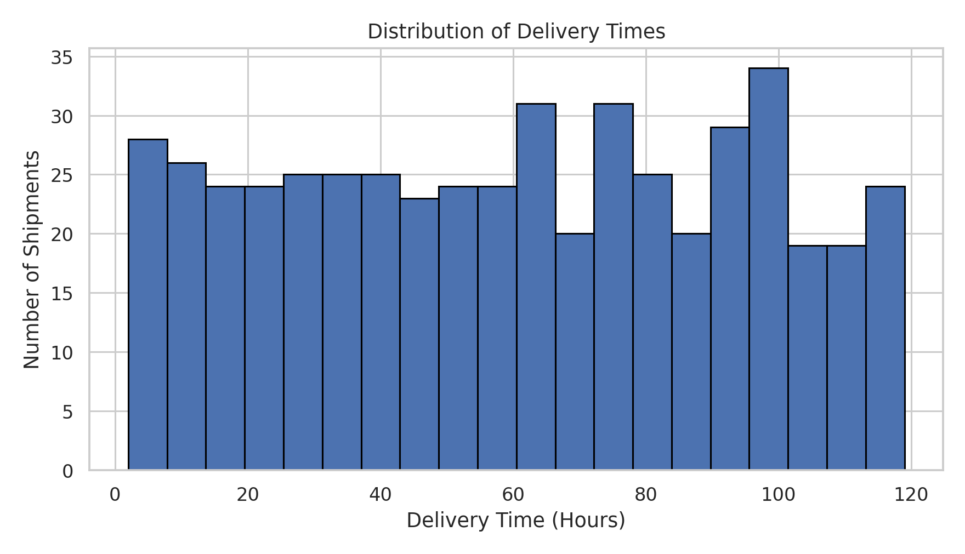

Figure 2. On-time versus delayed shipments
A bar chart is suitable for comparing category counts. It shows 372 on-time shipments (74.4%) and 128 delayed shipments (25.6%), making the status balance easy to understand.
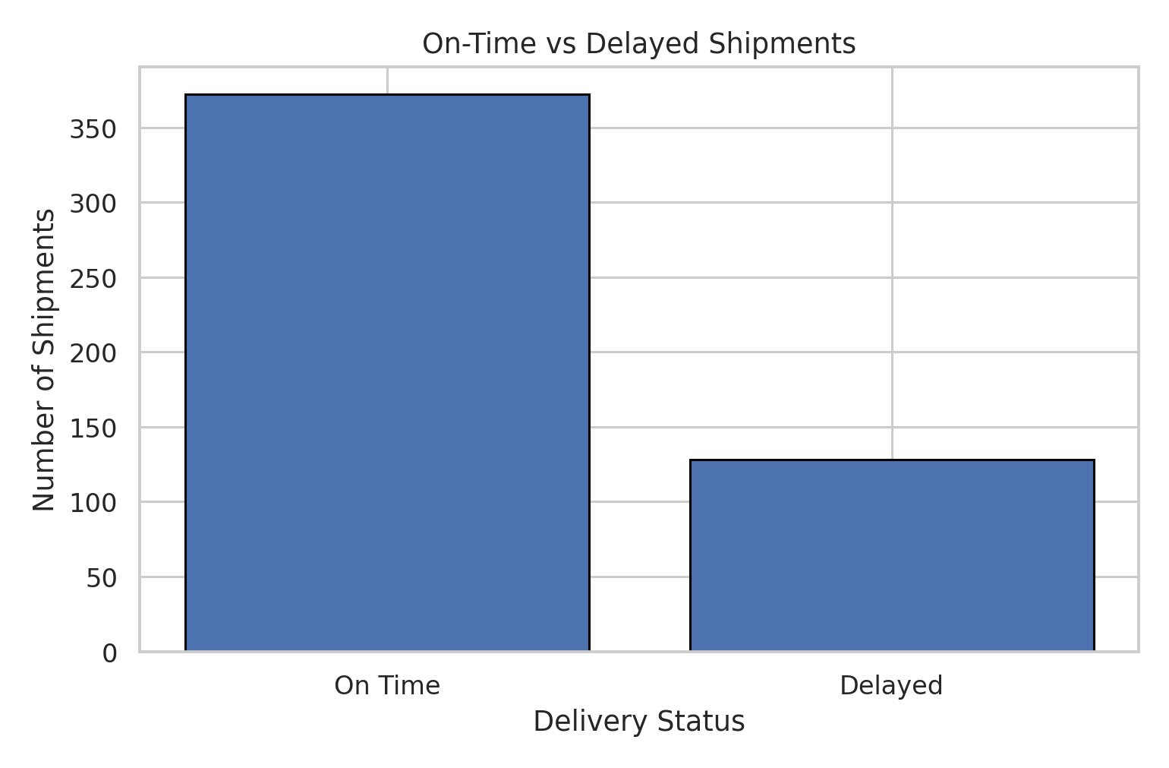

Figure 3. Average transportation cost by mode
A bar chart compares a numerical average across transport categories. Sea has the highest average cost and Air the lowest in this sample. Because costs were randomly generated, this does not prove which mode is genuinely cheapest.
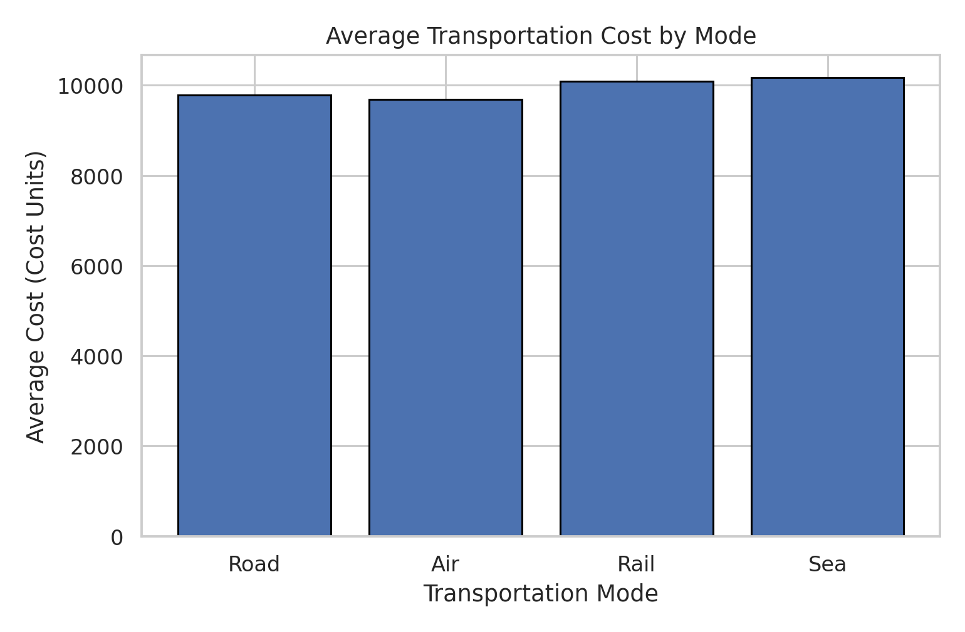

Figure 4. Distance versus delivery time
A scatter plot shows individual observations and is appropriate for exploring relationships between two numeric variables. Points are widely dispersed, consistent with a very weak distance-time correlation of 0.07. This chart cannot identify causes of delay.
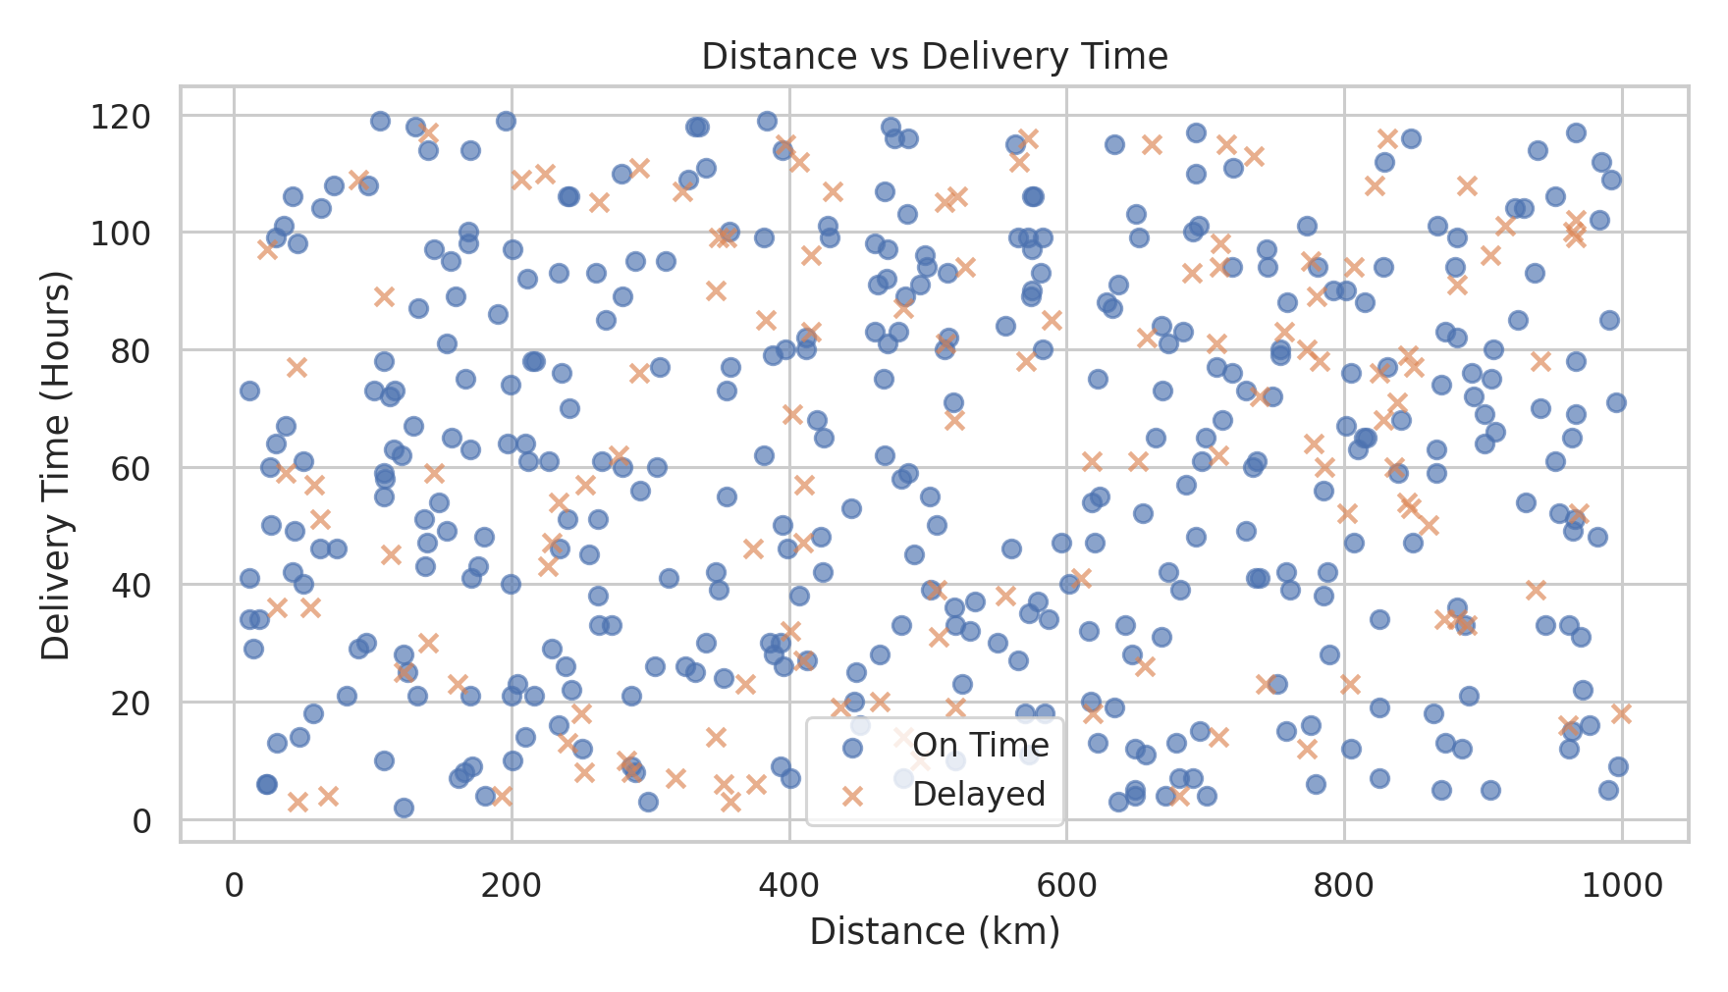

Figure 5. Correlation heatmap
A heatmap displays Pearson correlations in a compact matrix. Off-diagonal values close to zero indicate weak linear relationships in this simulated dataset. Diagonal values equal 1 because each variable correlates perfectly with itself.
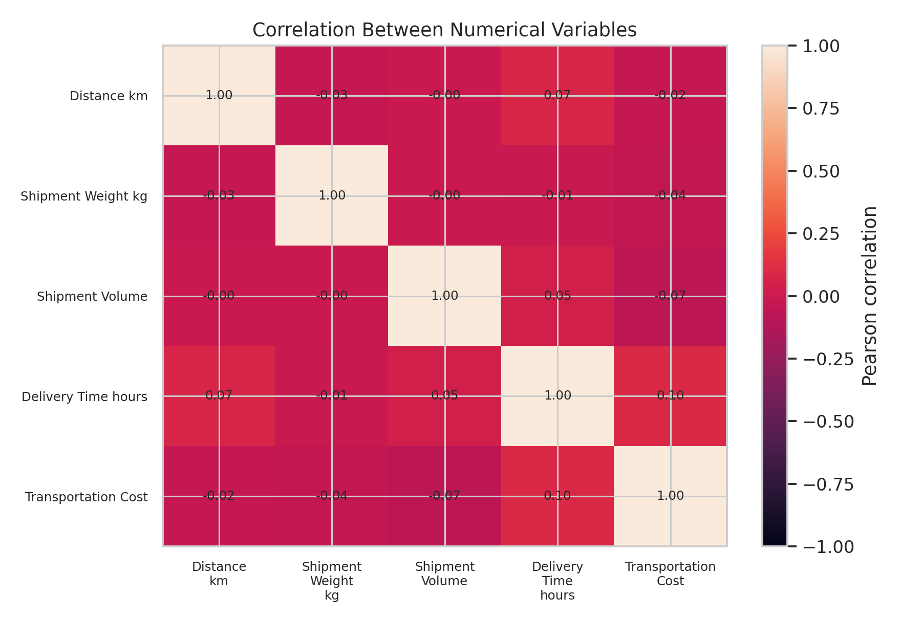

Figure 6. Delivery time by transportation mode
A box plot compares medians, quartiles, and spread across categories. The distributions overlap substantially, so the chart does not show a strong separation between transport modes in this simulation.
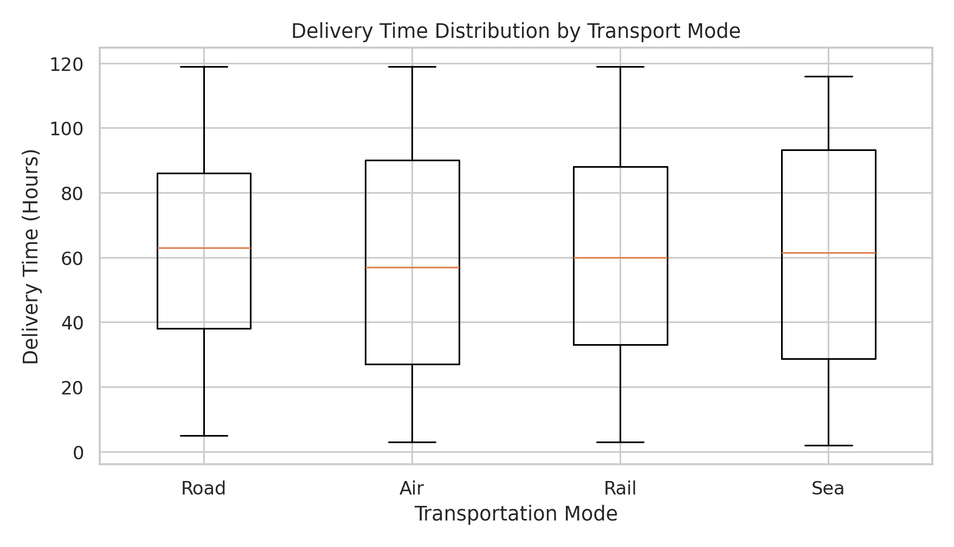

8. Python Implementation: Code Excerpts
The complete runnable implementation is supplied in logistics_analysis.py. The following excerpts illustrate the key techniques.

8.1 Dataset creation
np.random.seed(42)
df = pd.DataFrame({
"Shipment_ID": range(1, 501),
"Distance_km": np.random.randint(10, 1000, 500),
"Delivery_Time_hours": np.random.randint(2, 120, 500),
"Transportation_Cost": np.random.randint(500, 20000, 500)
})
A fixed seed makes the random data reproducible. The full script adds shipment weight, volume, transport mode, and delivery status.

8.2 Descriptive statistics and data quality
print(df.info())
print(df.isnull().sum())
print("Duplicates:", df.duplicated().sum())
print(df.describe())
print(df[numeric].median())
print(df[numeric].corr())
Pandas methods summarize the data, check completeness, identify exact duplicate rows, calculate medians, and produce Pearson correlations.

8.3 Example visualization
fig, ax = plt.subplots()
ax.hist(df["Delivery_Time_hours"], bins=20, edgecolor="black")
ax.set_title("Distribution of Delivery Times")
ax.set_xlabel("Delivery Time (Hours)")
ax.set_ylabel("Number of Shipments")
fig.savefig("visualizations/01_delivery_time_distribution.png", dpi=220)
The histogram was selected because it shows the frequency distribution of a numeric variable. The complete script includes code for all six charts.

9. Key Findings
- The dataset contains 500 shipments and has no missing values or fully duplicated rows.
- The simulated on-time rate is 74.4% and the delayed rate is 25.6%.
- Mean delivery time is 59.97 hours; mean cost is 9,918.38 cost units.
- Air has the lowest average delivery time and cost in this sample; Sea has the highest average cost.
- Distance and delivery time have a very weak linear correlation (0.07).
- Most numeric fields were generated independently, so the relationships are useful for practice but not real-world evidence.

10. Recommendations
- Record planned and actual delivery times, route, carrier, traffic, weather, warehouse processing time, and reasons for delays.
- Track on-time delivery by route, carrier, mode, region, and time period rather than relying on one overall rate.
- Compare total logistics cost, including fuel, handling, storage, insurance, shipment size, and service level, before selecting a mode.
- Validate units and value ranges, enforce unique shipment IDs, and flag impossible durations or negative costs.
- Use representative anonymized operational data before making business decisions.
- For future analysis, use data with realistic relationships and test whether conclusions remain consistent.

11. Limitations
This is hypothetical data for an educational task. Most variables were generated independently, so realistic cause-and-effect relationships are not represented. Transportation cost units are unspecified, shipment volume has no defined physical unit, and delivery status was randomly assigned rather than calculated from promised delivery time. The findings are not real-company benchmarks. Recommendations are proposed next steps, not proven interventions.

12. Conclusion
This project demonstrates a reproducible Python workflow for logistics data exploration. The 500-shipment simulated dataset has an on-time rate of 74.4% and a mean delivery time of 59.97 hours. Six visualizations summarize delivery-time spread, status counts, average costs, numeric relationships, and differences by mode. A strong analysis combines numerical evidence, suitable visualizations, explanations, and limitations. Real operational conclusions require representative data.

Appendix A. How to Run the Project
Install Python 3.9 or later. Open a terminal in the project folder and run: pip install pandas numpy matplotlib. Then run: python logistics_analysis.py. The script writes the CSV file to data/ and all six charts to visualizations/.

References
Pandas documentation — https://pandas.pydata.org/docs/
NumPy documentation — https://numpy.org/doc/
Matplotlib documentation — https://matplotlib.org/stable/

