WEEK 4 TASK REPORT
Predictive Modeling and Optimization in Logistics Systems
  - Prepared using a simulated logistics dataset of 500 shipments.

1. Executive Summary
This project investigates whether shipment distance, weight, volume, transport mode, and transportation cost can predict delivery time in hours. The dataset contains 500 shipment records and 8 columns. Two regression models—Linear Regression and Random Forest Regression—were trained and evaluated using an 80/20 train-test split and five-fold cross-validation. The model with the lower test MAE was Linear Regression. However, both models have weak test-set predictive performance (R² values close to or below zero), which means the available features do not explain delivery-time variation well in this simulated dataset. The most important finding is therefore a data limitation: stronger operational predictors and more representative data are needed before using the model for live dispatch decisions.

2. Problem Definition and Objective
Logistics teams need reliable estimates of delivery time to communicate expected arrival times, identify shipments that may need attention, and plan staff and transport capacity. The objective is to build and compare regression models that forecast Delivery_Time_hours, evaluate their errors on unseen records, and propose optimization actions that can be tested with additional operational data.

3. Dataset Description
The CSV contains 500 simulated shipment records and eight columns. There are no missing values and no duplicate rows in the inspected file. Shipment_ID is an identifier and is excluded from the predictors. Delivery_Status is also excluded because it may be assigned after the delivery outcome and would risk target leakage.
Column | Type | Use
Shipment_ID | Integer | Identifier; excluded from model
Distance_km | Integer | Predictor
Shipment_Weight_kg | Integer | Predictor
Shipment_Volume | Integer | Predictor
Transport_Mode | Category | Predictor; one-hot encoded
Delivery_Time_hours | Integer | Target variable
Transportation_Cost | Integer | Predictor, if known at prediction time
Delivery_Status | Category | Descriptive analysis only; excluded to avoid leakage
Transport mode counts: Road: 133, Rail: 130, Air: 129, Sea: 108. Delivery status counts: On Time: 372, Delayed: 128. The simulated data labels 25.6% of shipments as delayed. This percentage describes this dataset only and should not be treated as an estimate of real-world performance.

4. Data Preparation
- Loaded the CSV with pandas and checked shape, data types, missing values, and duplicate rows.
- Used an 80% training set and a 20% hold-out test set with random_state=42 for reproducibility.
- Imputed numeric missing values with the median and categorical missing values with the most frequent category; this keeps the pipeline robust even if future data contains gaps.
- Standardized numeric predictors for the Linear Regression pipeline.
- One-hot encoded Transport_Mode so the models can use categorical values.
- Excluded Shipment_ID because it is not a meaningful operational feature and excluded Delivery_Status to prevent target leakage.

5. Model Selection and Rationale

5.1 Linear Regression
Linear Regression is a baseline model that estimates a linear relationship between the selected input features and delivery time. It is relatively easy to explain and provides a useful reference point.

5.2 Random Forest Regression
Random Forest combines predictions from many decision trees and can represent nonlinear relationships and interactions. The implementation uses 300 trees, a minimum leaf size of 3, and a fixed random seed for reproducibility.

6. Evaluation Method
The models were evaluated on a held-out test set that was not used to fit the models. Five-fold cross-validation was also used to estimate how the models may perform across different train/validation splits. Metrics are:
- MAE (Mean Absolute Error): average absolute prediction error in hours; lower is better.
- RMSE (Root Mean Squared Error): gives greater weight to large errors; lower is better.
- R²: compares the model with a baseline that predicts the target mean; values near zero or below zero indicate little or no useful explanatory power on the test set.

7. Results
Model | Test MAE (h) | Test RMSE (h) | Test R² | 5-fold CV MAE (h)
Linear Regression | 29.70 | 34.41 | -0.004 | 29.21
Random Forest | 29.90 | 35.80 | -0.086 | 29.40
On this split, Linear Regression had the lowest test MAE (29.70 hours). The test R² values are near or below zero, so neither model demonstrates strong predictive value. The model with the lowest MAE is the better of these two candidates on this split, but it should not be considered ready for production.
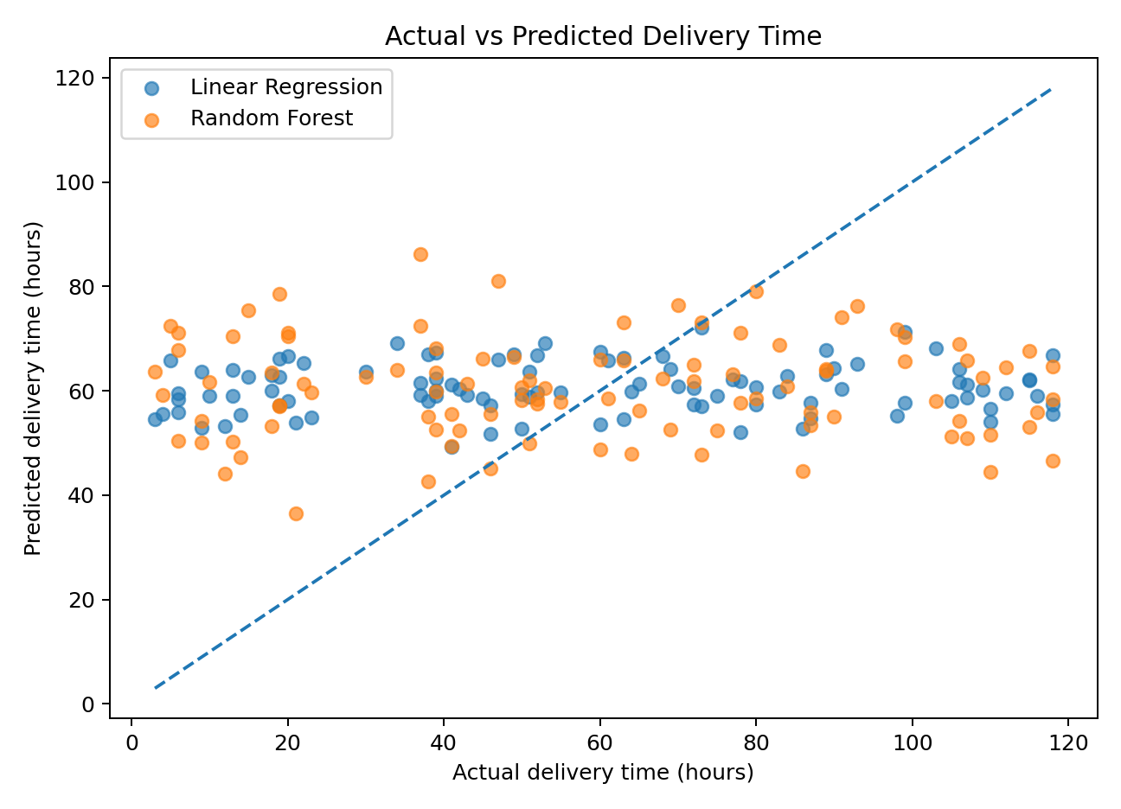
Figure 1. Actual versus predicted delivery time. Points close to the diagonal represent more accurate predictions.
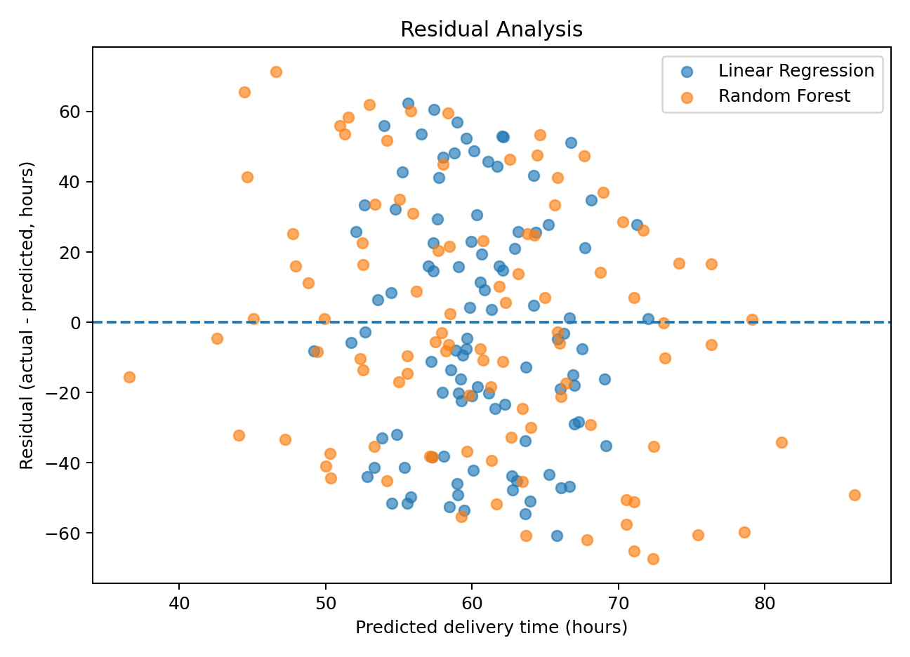
Figure 2. Residual analysis. Residuals should be randomly distributed around zero; patterns can indicate model limitations.
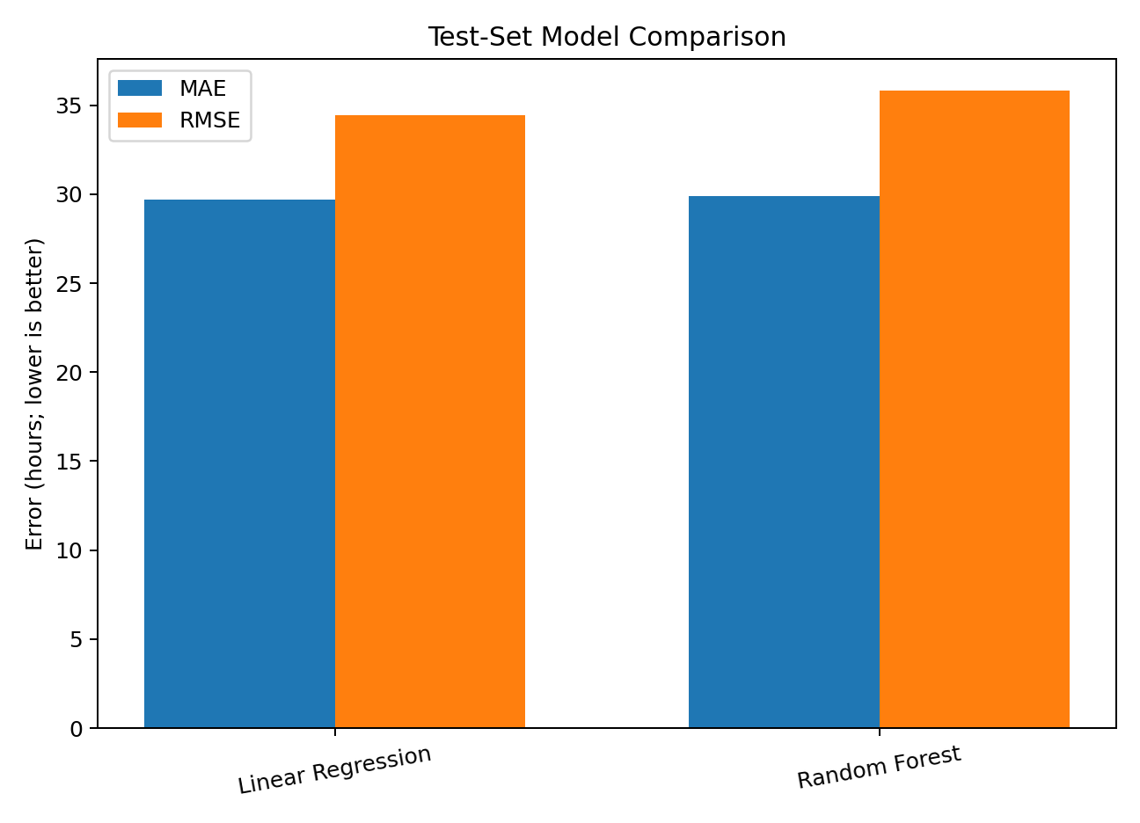
Figure 3. Test-set MAE and RMSE comparison; lower values are preferred.
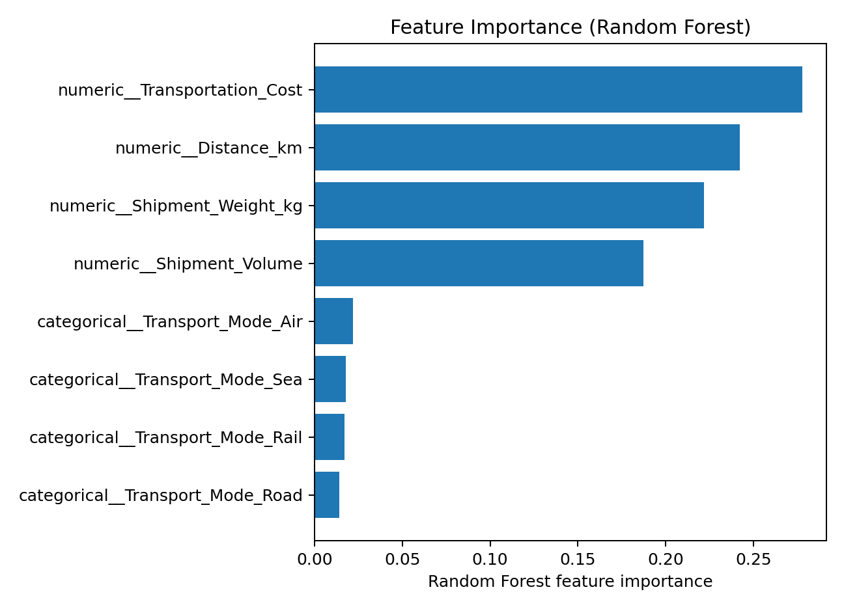
Figure 4. Random Forest feature importance. This indicates model reliance, not causation.

8. Interpretation and Limitations
The weak test R² results indicate that the chosen features do not explain delivery-time differences sufficiently in this dataset. This may reflect the simulated nature of the data, limited sample size, missing operational variables, or weak relationships between the available predictors and the target. The results should not be overstated. Feature importance and correlations describe patterns in the data and do not establish causal relationships.
Potential additional predictors include origin and destination, route distance measured by road network, traffic conditions, weather, dispatch time, day of week, warehouse processing duration, carrier, number of stops, service level, and historical route performance. These features should be collected where appropriate, checked for quality, and made available at the time a prediction is required.

9. Optimization Strategies
- Risk-based shipment monitoring: Once a model has been validated on real historical data, flag shipments with predicted delivery time above the service threshold for human review. Do not automate penalties or customer promises based on this weak model.
- Route planning: Combine travel-time predictions with route distance, traffic, vehicle capacity, and delivery windows. Compare feasible routes by expected time and cost, and pilot changes on a small set of routes.
- Resource allocation: Use reliable demand and arrival forecasts to schedule drivers, vehicles, and warehouse staff during peak periods. Validate staffing recommendations against observed workloads.
- Cost optimization: Compare cost per shipment and cost per kilometre by transport mode while controlling for distance, shipment weight, volume, and service level. Avoid selecting the cheapest mode if it violates delivery commitments.
- Data collection and monitoring: Record planned and actual dispatch/arrival timestamps, route, carrier, traffic/weather conditions, failed delivery attempts, and exceptions. Monitor MAE/RMSE by route and mode and retrain only when validated performance improves.

10. Suggested Future Work
- Collect a larger, real operational dataset and document how the simulated data was generated.
- Check for outliers, target distribution, and data quality issues before training.
- Tune Random Forest hyperparameters using GridSearchCV on the training data only, then evaluate once on the untouched test set.
- If records are time-ordered, use a time-based split instead of random splitting to better represent forecasting future shipments.
- Compare against a simple mean/median baseline and consider a prediction interval or quantile model for uncertainty-aware planning.
- Measure operational outcomes in a pilot, such as on-time delivery rate, cost per shipment, and late-shipment rate, before claiming savings.

11. Conclusion
This task demonstrates an end-to-end predictive modeling workflow: problem definition, dataset inspection, preprocessing, model training, cross-validation, test evaluation, visualization, and optimization recommendations. Linear Regression and Random Forest were compared using MAE, RMSE, and R². The observed performance is weak, which is an important result rather than a reason to hide the metrics. The next priority is to improve the data and validate models against real delivery operations. Only after reliable predictive performance is demonstrated should the forecasts be used to support route, staffing, or cost decisions.

Appendix A. Reproducibility
The accompanying Python script is named week4_predictive_modeling.py. Install pandas, numpy, matplotlib, and scikit-learn, place the script and logistics_dataset.csv in the same folder, and run: python week4_predictive_modeling.py. The script saves evaluation metrics and plots in a week4_outputs folder.

