Database Design Document
AI Resume Analyser
Group 30
Jigyasa - IN26013889
Khushi Singh Chauhan - IN26013274
Divyansh Kumar Srivastav - IN26012578
Unnat Upadhyay - IN26013219
Manan Jadam - IN26013585
Himanshu Kumar - IN26013210
Yash Aman - IN26013014

1. Introduction
This document defines the database design for the AI Resume Analyser, based on the functional and non-functional requirements captured in the Requirement Analysis document. It specifies the entities, attributes, data types, constraints, and relationships needed to support resume upload and parsing, ATS scoring, job-description matching, recommendation generation, interview question generation, and analysis history.
The design supports the core user stories: uploading a resume, viewing ATS score and feedback, comparing a resume against a target job role, generating interview questions, and viewing or downloading past analysis reports.

2. Database Overview
Type: Relational Database (RDBMS), e.g. PostgreSQL or MySQL.
Rationale: The data is highly structured with clear one-to-many relationships between a user, their resumes, job descriptions, and analysis results, which makes a relational model a natural fit and simplifies enforcing referential integrity, uniqueness (e.g., user email), and transactional consistency across related tables (an analysis report and its scores, keywords, recommendations, and interview questions should be created together).
Design Principles:
- Normalized to Third Normal Form (3NF) to avoid data redundancy.
- Every child table stores a foreign key back to its parent so that a full analysis report can be reconstructed with joins.
- Text extracted from resumes and generated content (feedback, recommendations, interview questions) is stored so it can be redisplayed or re-downloaded without repeating AI calls.
- Sensitive fields (e.g., password_hash) are never stored in plain text, per the security requirement.
- Uploaded resume files themselves can be held in transient/object storage rather than the database, per the privacy requirement of no unnecessary permanent file storage; the database stores only extracted_text and a temporary storage reference.

3. Entity List
Entity | Purpose
Users | Stores registered user accounts and authentication details.
Resumes | Stores uploaded resumes and their extracted text content.
JobDescriptions | Stores target job roles/descriptions submitted by the user.
AnalysisReports | Stores the top-level result of one resume analysis run.
CategoryScores | Stores per-category scores and feedback for an analysis (e.g., formatting, content quality).
SkillsKeywords | Stores detected, matched, and missing skills/keywords for an analysis.
Recommendations | Stores actionable, prioritized improvement suggestions for an analysis.
InterviewQuestions | Stores generated Technical, Project, and HR interview questions for an analysis.
ErrorLogs | Stores parsing/service failures for troubleshooting and error-handling requirements.

4. Table Schemas

4.1 Users
Stores registered user accounts, including job seekers/students and system administrators.
Field | Data Type | Constraint | Description
user_id | INT / UUID | PK, Auto-generated | Unique identifier for the user.
full_name | VARCHAR(100) | NOT NULL | User's full name.
email | VARCHAR(150) | NOT NULL, UNIQUE | User's login email address.
password_hash | VARCHAR(255) | NOT NULL | Securely hashed password (never stored in plain text).
role | ENUM | NOT NULL, DEFAULT 'job_seeker' | 'job_seeker' or 'admin'.
created_at | TIMESTAMP | NOT NULL, DEFAULT NOW() | Account creation timestamp.
updated_at | TIMESTAMP | NULLABLE | Last profile update timestamp.
Primary Key: user_id
Foreign Key(s): None

4.2 Resumes
Stores metadata and extracted text for each resume a user uploads.
Field | Data Type | Constraint | Description
resume_id | INT / UUID | PK, Auto-generated | Unique identifier for the resume.
user_id | INT / UUID | FK -> Users.user_id, NOT NULL | Owner of the resume.
file_name | VARCHAR(255) | NOT NULL | Original uploaded file name.
file_type | ENUM | NOT NULL | 'PDF' or 'DOCX'.
storage_reference | VARCHAR(255) | NULLABLE | Temporary object-storage reference (not a permanent copy).
extracted_text | TEXT | NULLABLE | Text content extracted from the resume for analysis.
status | ENUM | NOT NULL, DEFAULT 'uploaded' | 'uploaded', 'parsed', or 'failed'.
uploaded_at | TIMESTAMP | NOT NULL, DEFAULT NOW() | Upload timestamp.
Primary Key: resume_id
Foreign Key(s): user_id -> Users.user_id

4.3 JobDescriptions
Stores a target job role or job description a user submits for role-specific matching.
Field | Data Type | Constraint | Description
jd_id | INT / UUID | PK, Auto-generated | Unique identifier for the job description entry.
user_id | INT / UUID | FK -> Users.user_id, NOT NULL | User who submitted the job description.
job_title | VARCHAR(150) | NULLABLE | Target job title/role.
description_text | TEXT | NOT NULL | Full job description text (must be non-empty).
created_at | TIMESTAMP | NOT NULL, DEFAULT NOW() | Submission timestamp.
Primary Key: jd_id
Foreign Key(s): user_id -> Users.user_id

4.4 AnalysisReports
Stores the top-level record for a single resume analysis run, linking a resume, an optional job description, and the resulting scores.
Field | Data Type | Constraint | Description
analysis_id | INT / UUID | PK, Auto-generated | Unique identifier for the analysis report.
user_id | INT / UUID | FK -> Users.user_id, NOT NULL | User who ran the analysis.
resume_id | INT / UUID | FK -> Resumes.resume_id, NOT NULL | Resume being analyzed.
jd_id | INT / UUID | FK -> JobDescriptions.jd_id, NULLABLE | Job description used for role matching, if any.
ats_score | DECIMAL(5,2) | NULLABLE | Overall ATS compatibility score.
overall_score | DECIMAL(5,2) | NULLABLE | Overall resume quality score.
status | ENUM | NOT NULL, DEFAULT 'processing' | 'processing', 'completed', or 'failed'.
created_at | TIMESTAMP | NOT NULL, DEFAULT NOW() | Analysis run timestamp.
Primary Key: analysis_id
Foreign Key(s): user_id -> Users.user_id; resume_id -> Resumes.resume_id; jd_id -> JobDescriptions.jd_id

4.5 CategoryScores
Stores per-category scores and supporting feedback for an analysis (e.g., formatting, sections, content quality, skills relevance).
Field | Data Type | Constraint | Description
category_score_id | INT / UUID | PK, Auto-generated | Unique identifier for the category score row.
analysis_id | INT / UUID | FK -> AnalysisReports.analysis_id, NOT NULL | Parent analysis report.
category_name | VARCHAR(100) | NOT NULL | e.g. 'Formatting', 'Content Quality', 'Skills Relevance'.
score | DECIMAL(5,2) | NOT NULL | Score for this category.
feedback_text | TEXT | NULLABLE | Brief reason/explanation supporting the score.
Primary Key: category_score_id
Foreign Key(s): analysis_id -> AnalysisReports.analysis_id

4.6 SkillsKeywords
Stores skills/keywords detected in the resume, and, when a job description is present, which are matched or missing.
Field | Data Type | Constraint | Description
skill_id | INT / UUID | PK, Auto-generated | Unique identifier for the skill/keyword row.
analysis_id | INT / UUID | FK -> AnalysisReports.analysis_id, NOT NULL | Parent analysis report.
skill_name | VARCHAR(100) | NOT NULL | Name of the skill or keyword.
keyword_type | ENUM | NOT NULL | 'detected', 'matched', or 'missing'.
Primary Key: skill_id
Foreign Key(s): analysis_id -> AnalysisReports.analysis_id

4.7 Recommendations
Stores actionable, prioritized recommendations for improving the resume.
Field | Data Type | Constraint | Description
recommendation_id | INT / UUID | PK, Auto-generated | Unique identifier for the recommendation.
analysis_id | INT / UUID | FK -> AnalysisReports.analysis_id, NOT NULL | Parent analysis report.
recommendation_text | TEXT | NOT NULL | The improvement suggestion text.
priority | ENUM | NOT NULL, DEFAULT 'medium' | 'high', 'medium', or 'low'.
Primary Key: recommendation_id
Foreign Key(s): analysis_id -> AnalysisReports.analysis_id

4.8 InterviewQuestions
Stores generated Technical, Project, and HR interview questions based on the resume.
Field | Data Type | Constraint | Description
question_id | INT / UUID | PK, Auto-generated | Unique identifier for the interview question.
analysis_id | INT / UUID | FK -> AnalysisReports.analysis_id, NOT NULL | Parent analysis report.
question_type | ENUM | NOT NULL | 'Technical', 'Project', or 'HR'.
question_text | TEXT | NOT NULL | The generated interview question.
Primary Key: question_id
Foreign Key(s): analysis_id -> AnalysisReports.analysis_id

4.9 ErrorLogs
Stores parsing failures and service errors so the system can distinguish invalid file, unreadable content, missing input, and service failure, and avoid fabricating results after a failure.
Field | Data Type | Constraint | Description
error_id | INT / UUID | PK, Auto-generated | Unique identifier for the error log entry.
user_id | INT / UUID | FK -> Users.user_id, NULLABLE | User affected, if known.
resume_id | INT / UUID | FK -> Resumes.resume_id, NULLABLE | Related resume, if applicable.
error_type | VARCHAR(100) | NOT NULL | e.g. 'InvalidFile', 'ParsingFailed', 'ServiceFailure'.
error_message | TEXT | NOT NULL | Details of the error for troubleshooting.
occurred_at | TIMESTAMP | NOT NULL, DEFAULT NOW() | When the error occurred.
Primary Key: error_id
Foreign Key(s): user_id -> Users.user_id; resume_id -> Resumes.resume_id

5. Relationships
- Users (1) — (M) Resumes: a user may upload multiple resumes.
- Users (1) — (M) JobDescriptions: a user may submit multiple target job descriptions.
- Users (1) — (M) AnalysisReports: a user may run multiple analyses over time.
- Resumes (1) — (M) AnalysisReports: a single resume can be analyzed more than once (e.g., against different job descriptions).
- JobDescriptions (1) — (M) AnalysisReports: a job description may be reused across multiple analyses; this link is optional, since general resume feedback does not require a job description.
- AnalysisReports (1) — (M) CategoryScores: one analysis produces several category-level scores.
- AnalysisReports (1) — (M) SkillsKeywords: one analysis produces multiple detected/matched/missing skill rows.
- AnalysisReports (1) — (M) Recommendations: one analysis produces multiple prioritized recommendations.
- AnalysisReports (1) — (M) InterviewQuestions: one analysis produces multiple Technical/Project/HR questions.
- Users (1) — (M) ErrorLogs: a user's failed attempts are logged for support and non-fabrication guarantees.

6. Entity-Relationship Diagram
The diagram below shows all entities, their key attributes, and the cardinality of each relationship.
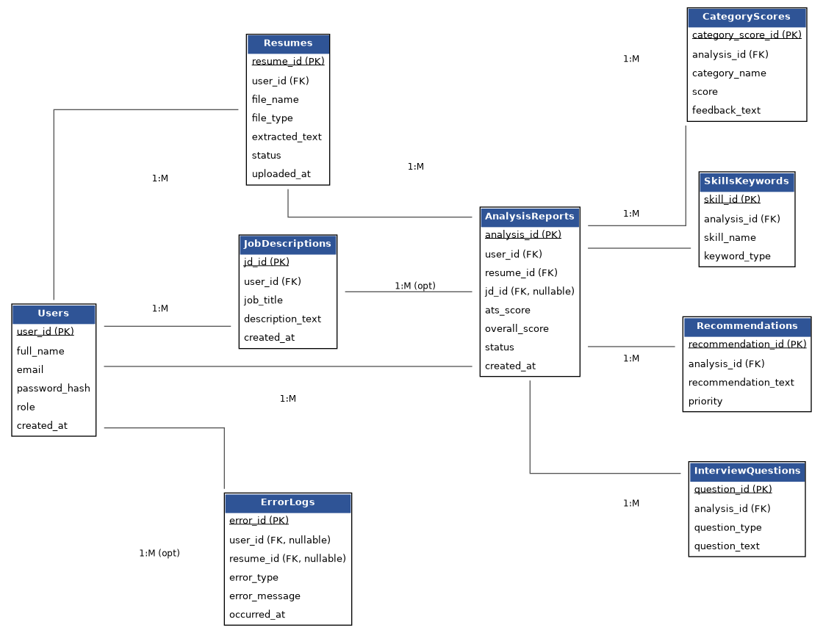

7. Requirements-to-Database Mapping
This table traces each functional requirement from the Requirement Analysis document to the table(s) responsible for supporting it.
Functional Requirement | Related Table(s)
Register and log in securely | Users
Upload a PDF/DOCX resume for analysis | Resumes
Provide a target job role or job description | JobDescriptions
Generate an ATS compatibility score / overall score | AnalysisReports
Evaluate formatting, sections, content quality, skills, relevance | AnalysisReports, CategoryScores
Identify missing skills and keywords vs. a job role | SkillsKeywords
Generate actionable, prioritized recommendations | Recommendations
Generate Technical, Project, and HR interview questions | InterviewQuestions
View previous resume analysis reports / history | AnalysisReports (queried by user_id)
Download analysis reports as PDF | AnalysisReports + related child tables (assembled at export time)
Delete previously saved analysis reports | AnalysisReports (cascading delete to child tables)
Distinguish invalid file, unreadable content, missing input, service failure | ErrorLogs

8. Normalization Summary
- 1NF: All attributes hold atomic values (e.g., skills/keywords are individual rows in SkillsKeywords rather than a comma-separated field).
- 2NF: Every non-key attribute depends on the whole primary key; junction/detail tables (CategoryScores, SkillsKeywords, Recommendations, InterviewQuestions) each have their own surrogate primary key, avoiding partial dependencies.
- 3NF: No transitive dependencies — e.g., job description details live only in JobDescriptions and are referenced by AnalysisReports via jd_id, rather than being copied into every analysis row.

9. Notes on Non-Functional Requirements
- Security: password_hash stores a salted hash, never a plain-text password; access to another user's rows is prevented by always filtering on the authenticated user_id.
- Privacy: the Resumes table stores extracted_text needed for analysis and re-display, while the original file itself is kept only in temporary object storage (storage_reference) rather than permanently in the database.
- Performance: analysis_id is indexed as a foreign key across all child tables (CategoryScores, SkillsKeywords, Recommendations, InterviewQuestions) to keep report retrieval fast.
- Scalability: the one-to-many design lets each user accumulate unlimited resumes and analysis history without schema changes.
- Maintainability: ENUM-like status/category fields are isolated to single columns, making it straightforward to extend categories or add new question types.

