Abstract — Modern world finding appropriate route in the daytime in a busy city with the traffic limitation is a major problem. With the busy life of modern people, more consumers prefer to shop online. This the transportation of packages has increased and in result to that logistics planning constraints have also increased. Due to the significant growth of the e-commerce industry, logistics planning is one of the most popular issues.
ROUTE OPTIMIZATION AND LOGISTIC PLANNING(HYBRID)

Khushi Gupta Mayuri Jaiswal Sakshi Verma
In this paper we have approached two algorithms Hybrid Genetic Algorithm (GA) with Light Gradient Boosting Machine integrated with Local Search. This Route Optimization and Logistics Planning (Hybrid) model results in cost reduction, finding the smallest route for different locations with efficiency. This combined approach leverages the GA's search capabilities and the Light GBM strong predictive performance. The integration of these algorithms has significantly advanced this field. This helps in real-time scheduling routes for multiple stops.
The result validates that it is capable of optimizing the routes by using the above hybrid model approach.
Keywords — Dijkstra Algorithm, Optimized Genetic Algorithm, Light Gradient Boosting Machine, Particle Swarm Optimization, Route Optimization, Logistic Planning.
I. INTRODUCTION
Nowadays, road traffic is a major problem in the world. People will not reach their destination location on time due to extreme traffic congestion on the crossroads, metropolitan zones, and nearby marketplaces. Some factors like weather fluctuation, road breakdown, and conduction of political rallies cause delays in pick-up and drop-off. Reaching several stops for delivery and pickup becomes challenging for the supplier to arrive on time. Therefore, it is very vital to get the optimized path to reach the destination on time.
This Route Optimization and Logistic Planning System is designed to attain the best routes for the delivery and pickup of several stops in one go. Route optimization is the method of discovering the streamline route for reducing the time of making it to the destination. To implement the above method an accurate and effective planning comes into play and that is achieved by logistic planning. Logistic
planning helps to attain the optimized routes for the delivery process to cover all the break points.
These systems are highly used for optimizing the paths for suppliers, delivery agents, and distributors using logistic planning. In this system, a hybrid model approach is applied. The LGBM model used for predicting the routes for the user and then streamlined it with Optimized Genetic Algorithm for discovering cost effective routes.
II. RELATED WORK
The paper [1] was written by Eric Hsueh-Chan Lu and Ya-Wen Yang presented the Iterative Logistics Solution Planner (ILSP) approach with its two main phases initial logistics solution generation and iterative logistics solution for package partitioning, route planning and quality enhancement. Experimental results demonstrate that this approach results in improved logistics planning problem of delivery and pickup.
The paper [2] was written by Yao Chen presented the non-dominated sorting genetic algorithm II (NSGA2) approach that connects the urban and rural regions to form a logistics distribution network. This aims to reduce the total distribution cost. Experimental results demonstrated validate the productivity of the approach and its capability in urban-rural integrated logistics.
The paper [3] was written by Alexander T. Richter, Sebastian Stiller presented the robust optimization technique for strategically routing the customer. Implemented using realistic cost function, robust method for uncertainty mechanism and large networks with standard mixed-integer linear program. The results presents that robust approach substantially reduced the cost.
The paper [4] was written by Xin Zhang, Yan Chen and Taoying Li presented the optimization technique using Dijkstra Algorithm in place of solution to shortest path problem. After clarifying the process, the results show maximization of profit and reduction in cost.
The paper [5] was written by Qianfei Liu presented a technique using Artificial Intelligence and Internet of Things technologies for optimizing the logistics distribution routes to increase the efficiency and decrease the cost. This technique demonstrated the feasibility in practical execution and futuristic research suggestions.
The paper [6] was written by Surya Prakash, Utkal Mehta and Bibhya Sharma recommends AI-driven method for predicting multimodal network routes. Implemented this method with the inclusion of Monte Carlo simulations followed by the LSTM network to handle the unavailable routes. The result demonstrated validation of model's performance in correctly predicting routes to tackle dynamic unavailability and disruption problem.
The paper [7] was written by Vu Hong Son Pham, Van Nam Nguyen and Nghiep Trinh Nguyen Dang presented the combination of whale efficiency algorithm (WOA) with the grey wolf optimizer (GWO) to accomplish hybrid whale optimization algorithm (hGWOA) model for enhancement of routing capacity. The results shows that hGWOA method surpasses other algorithms for cases including scale and complexity for distance optimization.
The paper [8] by Hasan Daneshvar, Sadegh Niroomand, Omid Boyer and Abdollah Hadi-Vencheh looks at delivery problems caused by heavy daytime traffic. The authors build a system that groups customer locations and create routes using advanced search methods. The routes can change in real time when road or weather conditions shift. Using data from Aarhus, Denmark, the study shows that this method reduces overall costs compared to older approaches.
The paper [9] written by Hai Zhao, Ashutosh Sharma, works to make delivery routes work better and faster. They have integrated a basic math model with a smart search to plan the paths. They have tested two improved versions of method, each using a simple hill-climbing algorithm to make search stronger. The results show both improved versions works better. It helps cut down travel distance a lot.
The paper [10] written by Quan Gan, tries to make planning routes easier and more effective. The author built a model that deals with time limit to find optimal path for vehicles. They improve two older search ideas and test on sample data that this new method works better than many older ones. They also check different settings to see which ones give the best results.
The paper [11] written by Wu-Chih Hu, Hsin-Te Wu, Hsin-Hung Cho, Fan-Hsun Tseng, this paper makes a system that helps delivery cars find a faster way to travel. It looks at map data, predicts road busy times, and then picks the quickest direction to go. The system can plan for many stops and lets workers see where each car is. Tests show it saves time and works well. It can also be used in real delivery work.
The paper [12] written by Thananut Phiboonbanakit, Teerayut Horanont, Van-Nam Huynh, Thepchai Supnithi introduced a system that helps delivery firms pick more efficient routes. It uses a learning method that improves its choices step by step until a good route is found. Tests with real companies show it boosts profits and works better than earlier approaches.
The paper [13] written by Liu Xin, Peng Xu, Gu Manyi, this paper aims to understand the logistic distribution methods of the Genetic Algorithm (GA). Meeting the requirements and dividing the delivery area, making a functional plan by including various factors. The comparison shows that the traditional algorithm takes longer to find the correct way than the algorithm developed this time.
III. METHODOLOGY
A. Data Preprocessing
The dataset "Dynamic Supply Chain Logistics" obtained from Kaggle which contains 15000 rows and 26 columns. It aims to remove the inconsistency from original data by converting the timestamp to data time, handling the missing values, encoding categorical variables and normalization.
B. Algorithms Used
Light Gradient Boosting Machine is fast and efficient algorithm used for machine learning task like feature extraction based on the importance score like lead_time_days, driver_behavior_score etc.

Dijkstra Algorithm is used to calculate the exact shortest path in a graph while Optimized Genetic Algorithm is based on local search principles to search optimized routes. Dijkstra is cost effective and less efficient algorithm while Optimized Genetic is lower cost and more efficient and flexible algorithm to find the desired route for multiple stops.

Particle Swarm Algorithm (PSO) algorithm is a metaheuristic algorithm which is based on the social interaction. Particle Swarm Optimization algorithm is used to discover the most optimized and fuel-efficient routesby repeatedly moving a “swarm: of stop moving through out the possible routes to find the optimal route. PSO algorithm is examine as more desirable algorithm than the traditional or predetermined algorithms. This algorithm is popular for its faster rate of convergence to an optimal solution collate to numerous heuristic algorithms in high-dimensional spaces.

Optimized Genetic Algorithm are the searching and optimization algorithm used for logistic route planning. It imitate natural selection of the routes to solve the knotty problems and multi-destination routing problems efficiently by bringing down the cost, time and the distance to reach the destination. It repeatedly upgrade the routes by cross-selection, crossover and mutation to discover the optimal route by narrowing the computational time considerably. It has the capability to stramline the route planning time from hours to minutes.

C. Mathematical Formulations

Route Efficiency = $\frac{DriverBehaviorScore }{TrafficCongestionLevel+1}$
Environmental Stress = Weather Severity + $\frac{Temperature}{10}$
Combined Risk = Route Risk + Disruption Likelihood + Delay Probability
R² Score = 1 - $\frac{{∑\left(acual value-predicted value\right)}^{2}}{{∑\left(acual value-mean of actual values\right)}^{2}}$
Mean Absolute Error (MAE) = $\frac{1}{n} \sum_{i=1}^{n}{|actual value-predicted value|}$

D. System Workflow
Fig. 1. Illustrates the complete workflow of the Hybrid Route Optimization System, from data collection through to visualization and results.

The workflow begins with Data Collection (Logistics/IoT/Traffic Data), followed by Data Preprocessing (Cleaning, Encoding, Missing Values), Feature Engineering (Efficiency, Risk, Environmental Stress), and Exploratory Data Analysis (Correlation, Visualization). Subsequently, a Machine Learning Model is trained and evaluated, followed by Route Graph Creation using NetworkX, The Cost Function Calculation incorporates Distance, Traffic, Weather, and Fuel parameters. Finally, Optimization using Dijkstra + Hybrid Optimizer is performed, with Performance Evaluation using R²and MAE metrics.

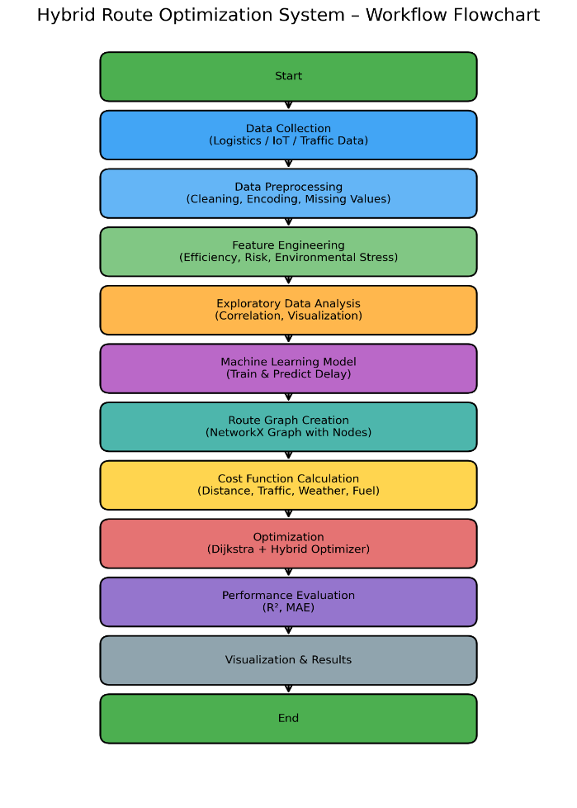

IV. RESULTS AND DISCUSSION
The below table shows the route cost, efficiency and execution time of the traditional algorithms and optimized algorithms for the route optimization and route planning to reduce the cost of delay by the hybrid model approach.

Algorithms | Cost | Efficiency | Execution Time
Dijkstra Algorithm | 103016.83 | 0.000010 | 0.088486
Optimized Genetic Algorithm | 15508.95 | 0.000010 | 14.836783
Particle Swarm Optimization | 15952.90 | 0.000063 | 2.731772
Hybrid GA + Local Search | 12566.88 | 0.000080 | 2.536175

As shown in Table I, the Hybrid GA + Local Search achieves the lowest route cost of 12,566,88, significantly outperforming the Dijkstra Algorithm (103,016.83), OPTIMIZED Genetic Algorithm (15,508.90), and Particle Swarm Optimization (15,952.90). When Dijkstra and OGA share the same low efficiency value, the Hybrid approach achieves the best balance between cost and execution time.

- Risk Classification Performance
The machine learning model trained for risk classification demonstrated exceptional performance. Fig 2. Shows the detailed classification report, while Fig. 3 presents the confusion matrix.

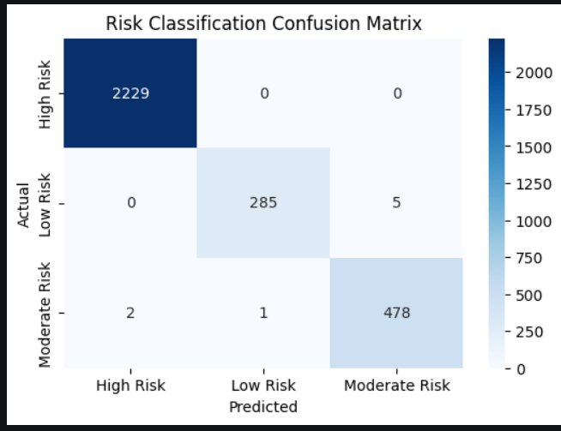

The classification model achieves an overall accuracy of 0.9973 with a weighted F1-score of 0.9973 on the test of 3,000 samples. For the High Risk class (2,229 samples), both precision and recall reach 1.00, indicating perfect classification. The Low Risk class (290 samples) achieves a precision of 1.00 and recall of0.98, with only 5 samples misclassified as Moderate Risk. The Moderate Risk class (481 samples) achieves a precision of 0.99 and recall of 0.99, with 2 samples misclassified as High Risk and 1 as Low risk. These results confirm the robustness of the Light-GBM- based classification approach for risk prediction in logistics route planning.

- Route Cost Comparison
Fig. 4 presents the average route cost comparison across the four optimization algorithms evaluated in this study.
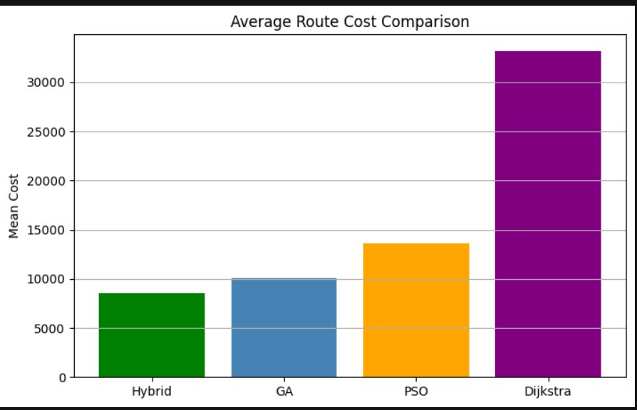

The bar chart clearly demonstrates the superiority of the Hybrid GA + Local Search approach, achieving a mean cost of approximately 8,500- significantly lower than the Genetic Algorithm (~10,000), Particle Swarm Optimization (~13,500), and the traditional Dijkstra Algorithm (~33,000). The hybrid approach provides approximately a 74% cost reduction compared to Dijkstra, validating the effectiveness of combining GA’s global search with local search refinement.

V. CONCLUSION

This paper presented a comprehensive evaluation of route optimization and logistic planning strategies using a Hybrid Model combining Genetic Algorithm (GA) with Local Search, benchmarked against Dijkstra’s Algorithm, Optimized Genetic Algorithm(OGA), and Particle Swarn Algorithm(PSO). The experimental results, validated on the Dynamic Supply Chain Logistics dataset from Kaggle containing 14,999 samples and 26 features, demonstrate the clear superiority of the Hybrid approach.

From the comparative analysis, the traditional Dijkstra Algorithm recorded the highest route cost of 103,016.83 with minimal efficiency (0.000010) and an execution time of 0.088486 seconds, confirming its inadequacy for large-scale, multi-stop logistics scenarios. The Optimized Genetic Algorithm reduced the cost substantially to 15,508.95, while Particle Swarn Optimization achieved a cost of 15.952.90 with improved efficiency. The proposed Hybrid GA + Local Seach model achieved the best overall performance, with the lowest cost of 12,566.88, highest efficiency of 0.000080, and a competitive execution time of 2.536175 seconds.

The integrated LightGBM-based risk classification component further strengthened the system’s predictive capabilities, achieving an accuracy of 99.73% and a weighted F1-score of 0.9973 across three risk classes- High Risk, Low Risk, and Moderate Risk. The near perfect classification performance validates the model’s ability to accurately assess delivery risk in dynamic supply chain environments.

The average route cost comparison (Fig. 4) further confirms these findings, with the Hybrid method achieving approximately 74% cost reduction over the traditional Dijkstra baseline. This substantial improvement underlines the practical significance of integrating metaheuristic optimization with machine learning-based prediction for real-world logistics applications.

In summary, the Hybrid Model approach offers a scalable, accurate, and cost-efficient solution for modern logistics route optimization. It successfully addresses challenges of traffic congestion, multiple delivery stops, and dynamic environmental consitions that traditional deterministic algorthms fail to handle effecitively. The proposed syste, logistics platforms, last-mile delivery services, and intelligent transportation systems.

V1. FUTURE WORK

Future work is focusing on integrating real-time traffic weather etc. The advanced algorithms such as Genetic Algorithm, Optimized Genetic Algorithm and Particle Swarn Optimization. Logistics Operations can lower transportational costs while maintaining time deliveries. Cost efficiency can reduce fuel consumption, travel distance, and delivery delays. Future extensions of this work may include incorporating reinforcement learning for dynamic re-route, expanding the dataset to include real-time IoT and GPS streams, and extending the system to handle multi-objective optimization considering both cost and carbon emissions simultaneously.

REFERENCES
[1] E. Hsueh-Chan Lu and Y.-W. Yang, "A hybrid route planning approach for logistics with pickup and delivery with Iterative Logistics Solution Planner technique," 2018.
[2] Y. Chen, "Vehicle scheduling and route optimization for urban-rural integrated Logistics distribution using non-dominated sorting genetic algorithm II," 2024.
[3] A. T. Richter and S. Stiller, "Robust Strategic Route Planning in Logistics used realistic cost function with the mixed-integer linear program," 2016.
[4] X. Zhang, Y. Chen, and T. Li, "Optimization of logistics route using Dijkstra Algorithm," in Proc. IEEE 6th Int. Conf. Software Engineering and Service Science (ICSESS), 2015.
[5] Q. Liu, "Logistics Distribution Route Optimization with Artificial Intelligence and Internet of Things," 2024.
[6] S. Prakash, U. Mehta, and B. Sharma, "AI-driven Multimodal route planning using Monte Carlo simulations and LSTM network," IEEE Access, 2024.
[7] V. H. S. Pham, V. N. Nguyen, and N. T. N. Dang, "Hybrid whale optimization algorithm for enhanced routing of limited capacity," 2024.
[8] H. Daneshvar, S. Niroomand, O. Boyer, and A. Hadi-Vencheh, "Hybrid intelligent transportation system for optimization of goods distribution network routing," 2023.
[9] H. Zhao and A. Sharma, "Logistics Distribution Route Optimization Based on Improved Particle Swarm Optimization," An International Journal of Computing and Informatics, 2023.
[10] Q. Gan, "A logistics distribution route optimization model based on hybrid intelligent algorithm and its application," Analysis of Operations Research, July 2022.
[11] W.-C. Hu, H.-T. Wu, H.-H. Cho, and F.-H. Tseng, "Optimal Route Planning System for Logistics Vehicles Based on Artificial Intelligence," Journal of Internet Technology, vol. 21, no. 3, pp. 757-764, May 2020.
[12] T. Phiboonbanakit, T. Horanont, V.-N. Huynh, and T. Supnithi, "A Hybrid Reinforcement Learning-Based Model for the Vehicle Routing Problem in Transportation Logistics," 30 November 2021, IEEE.
[13] L. Xin, P. Xu, and G. Manyi, "Logistics Distribution Route Optimization Based on Genetic Algorithm," Computational Intelligence and Neuroscience, July 2022.

