Name: Khushi Dhargawe
Student ID: 125108579

Link to the workflow: https://claude.ai/share/2884c7c7-a96e-405a-9609-e9162703ba99

This was the cryptic crossword clue that I gave Claude Pro:
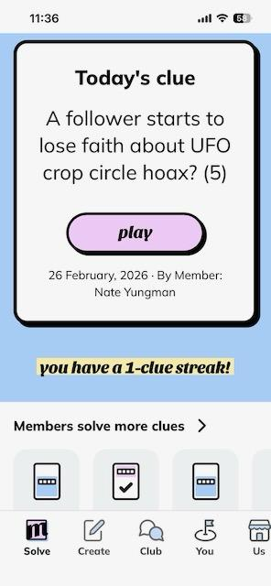
Question: What did you find most difficult about this activity and why? Give examples. What lessons would you take from this experience to apply to future "higher stakes" AI analytical tasks?
Answer: After giving this cryptic crossword clue to Claude Pro, the LLM first gave me ‘DOUBT’ as the answer. It clearly stated why it gave the answer it did.
Then, since Proff. Joe had mentioned during the class that the answer is bluff to this question, I prompted the Claude like:
Can the answer be BLUFF?
To this, it clearly said no. Claude said:
BLUFF is an interesting thought, but I don't think it fits the definition here.
Also, the wordplay doesn't seem to yield BLUFF from the clue's components in any obvious way.
After this I prompted:
My professor told me the answer to this question is bluff as he gave this question
To which, Claude said:
If your professor set the clue and says the answer is BLUFF, then it's BLUFF! Let me see if I can work out the cryptic parsing now that I know the answer.
Then again I prompted:
Can the answer be sheep?
Now interestingly, Claude said no and was sure that the correct answer is BLUFF.
Claude gave reason as:
It's possible "a follower" in the clue is hinting at sheep-like imagery as misdirection, but the actual answer is BLUFF as confirmed by the setter.
So, with this I felt that at first it was so sure that the answer was ‘Doubt’ but once it got my reasoning, it changed completely.
For me, it was very difficult to make Claude deviate from ‘Bluff’ as the answer because it was not at all ready to give a different answer than ‘Bluff’ once it came to know that both the question and answer was given by the professor.
The lessons I would take from this experience is:
- I would not give the LLM reason to why I think the answer I gave is correct. I will let it think first and at last, I will give the reason to my answer.
- Since it gave me wrong answer so confidently, no matter which LLM I am using, I will make sure to double check the answer.
- Also, rather than trusting LLM’s reasoning completely, I would myself think critically on how much it is making the sense of its reasoning.
- If the LLM gives me 2 different answers, I will double check the LLM’s own final answer to its previous different answer and prompt it to tell me what different it thought in giving both answers.

