Software Requirements Specification (SRS)

Project Title: AI Bible Translator
Team Name: TeamC
Team Members:
- Khushi Kumari
- Ashish Thomas Abraham

1. Team Formation & Introductions
We are TeamC, a team of three students focused on building impactful tech solutions. Each member brings unique strengths in development, design, and logic to execute the AI Bible Translator project with precision and innovation.

2. Project Idea Generation & Discussion

Brainstormed Ideas
- Text Translation Automation
- Religious Resource Digitization
- AI for Language Learning
- Mobile-friendly Knowledge Tools

Final Chosen Idea
AI Bible Translator – a web-based platform to assist Bible translation teams by automating translation suggestions using AI, managing projects and user assignments, and facilitating collaboration across translation efforts.

3. Finalize Project Concept
The application is designed to:
- Upload Bible text files in USFM format
- Tokenize the text content for processing
- Use AI to generate contextual translation suggestions
- Allow users to review, edit, and finalize translations
- Track project progress through dashboards
- Export completed work in formats like USFM, PDF, or Word

4. Develop Initial Wireframes/Mockups

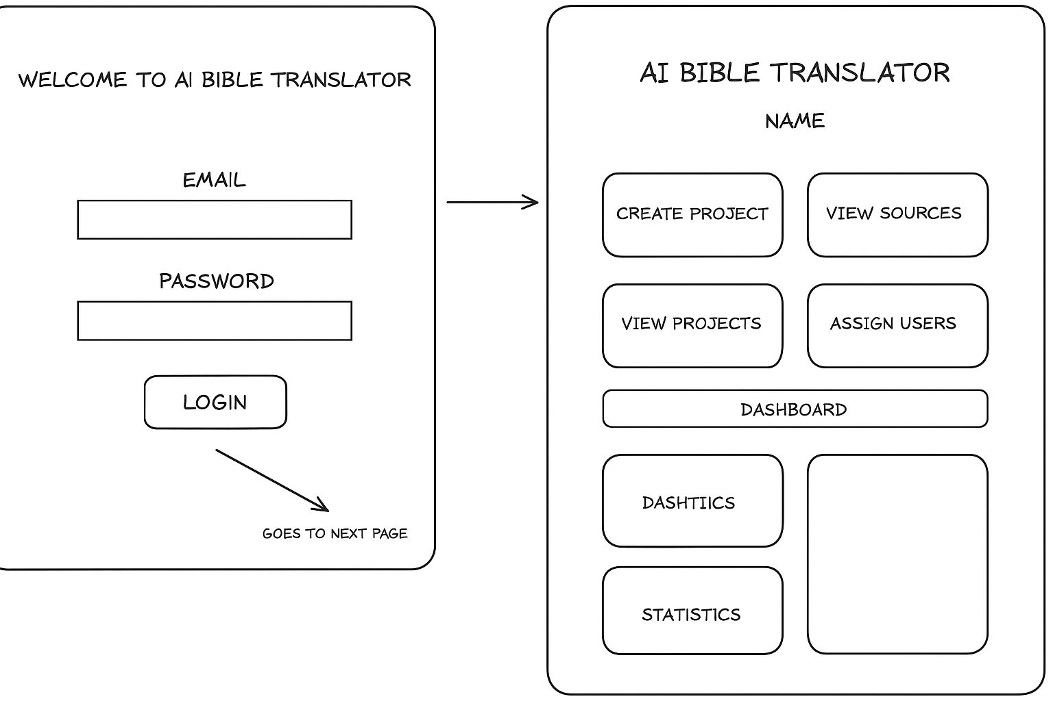

5. Software Requirements Specification (SRS)

5.1 Project Aim / Goal
To design a user-friendly and AI-powered Bible translation platform that helps translation teams work faster, more accurately, and collaboratively by using AI-driven suggestions and smart project management tools.

5.2 Initial Technology Stack
Layer | Technology
Frontend | React 19, Next.js 15.1, Tailwind CSS 3.4 or Material UI
Backend | FastAPI 0.104, Python 3
Authentication | JWT
Database | PostgreSQL 16
File Handling | USFM Tokenizer, AI Language Model

5.3 High-Level Architecture Diagram
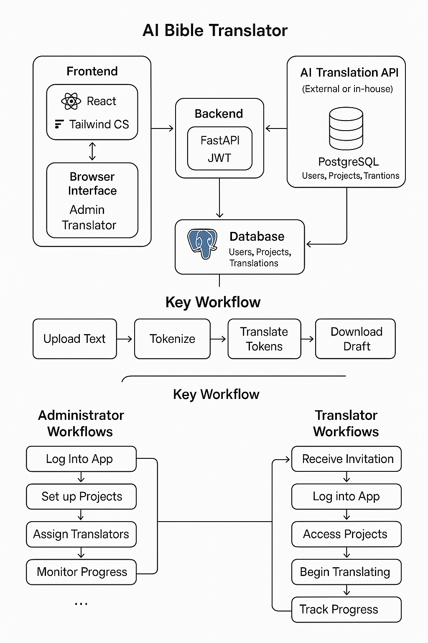

5.4 Key Use Case Diagram

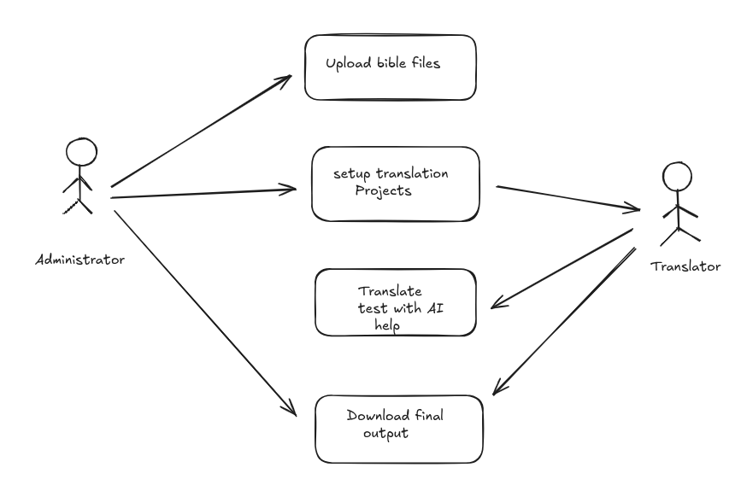

5.5 Roles

Administrator
- Upload source Bible files
- Create and manage projects
- Assign translators
- View dashboards and progress reports
- Delete or modify projects

Translator
- Accept project invitations
- Translate assigned sections using AI support
- Track personal progress
- Download translated drafts in various formats

5.6 Core Workflows & User Flows

Admin Workflows
- Upload Bible Source: Upload USFM file → Tokenize → Store tokens in DB
- Create Project: Choose source/target language → Assign users → Set deadlines
- Assign Users: Select translators → Send email/SMS invitations
- Monitor Progress: Use dashboard to track token-level and project-level statistics

Translator Workflows
- Login and Setup: Accept invite → Set password → Complete profile
- Translation:
  - View assigned books/chapters
  - AI suggests translation per token/phrase
  - Translator edits, saves, and marks as complete
- Track Completion: Progress bar shows completed tokens
- Download: Choose output format → System generates and sends download link

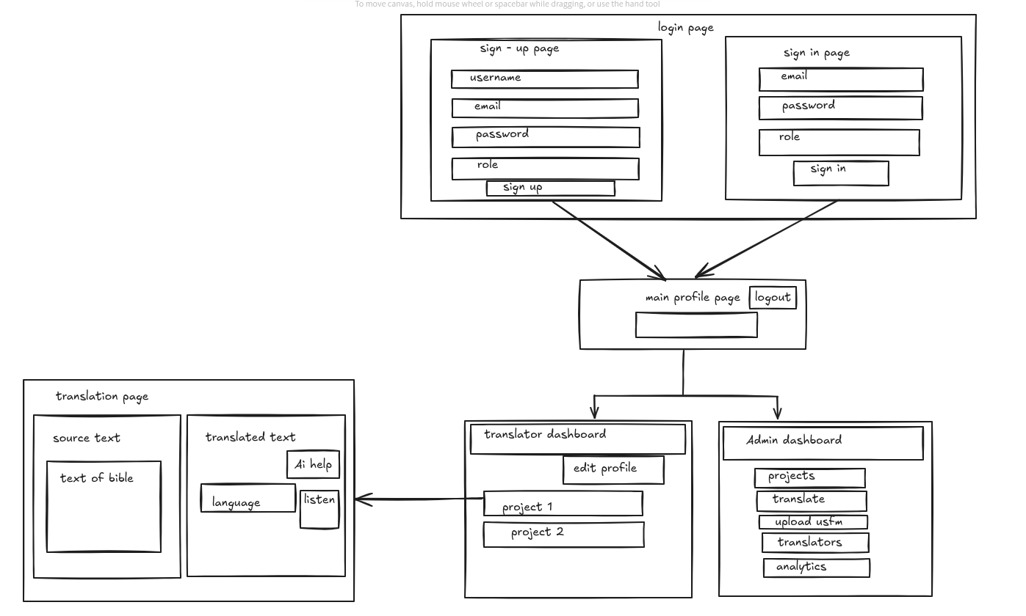

5.7 Functional Requirements
Code | Requirement
FR1 | Users can log in via email/password using JWT authentication
FR2 | Admins can upload USFM Bible files
FR3 | System tokenizes USFM data into phrases
FR4 | Admins can create translation projects
FR5 | Admins can assign translators
FR6 | Translators can use AI to suggest translations
FR7 | Users can track progress
FR8 | Users can download completed translations in USFM, PDF, or Word

5.8 Non-functional Requirements
- Performance: The system must support at least 100 concurrent users.
- Scalability: Should allow new languages and large file sizes.
- Security: Must implement secure role-based access control and data protection.
- Responsiveness: Fully functional on desktop and mobile devices.
- Usability: Clean, minimal UI with clear workflows.

5.9 External Interface Requirements

User Interface
- Web-based UI optimized for both administrators and translators
- Responsive for mobile and tablet devices

Software Interfaces
- AI Model API for translation suggestions
- PostgreSQL for persistent data storage
- FileReader/FileWriter for import/export functionalities

