Bird Observation

National Conservation Foundation (NCF) Report1

## What are the birds listed?

1. Accipiter badius
2. Milvus migrans
3. Psittacula krameri
4. Bubulcus ibis
5. Corvus splendens

## What is the distribution of the bird species?

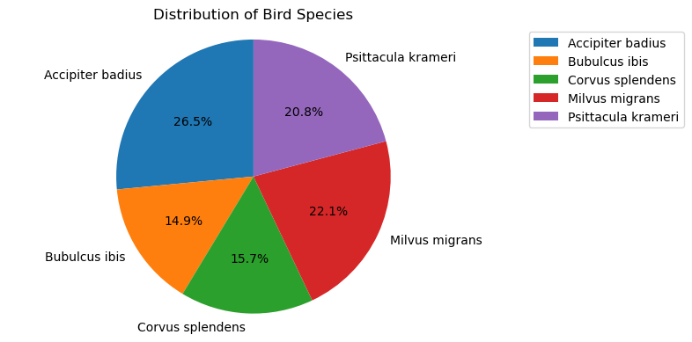

## What is the count of the birds?

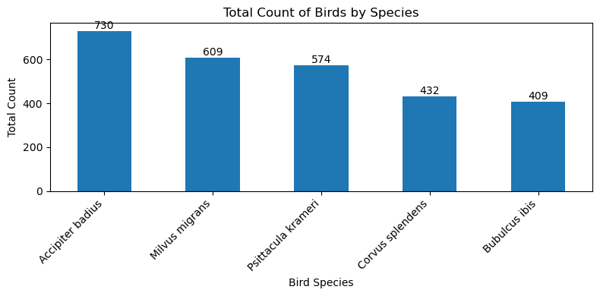

## How frequently is each bird identified in the region?

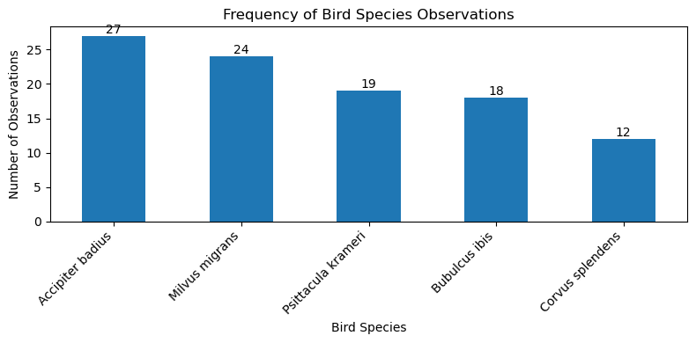

## How are the birds scattered (geographical distribution) in the region?

