Report

Contents

Introduction 3

Methodology 3

Data Source 3

Data Processing 3

Tools and Techniques 3

Data Collection 4

Results and discussions 8

Cumulative New Challenge Qualifiers Over Time 8

Participant Trends: Monthly 8

Participant Trends: Yearly 9

Participant Trends: Seasonal (Summer v/s Winter) 10

Participation consistency 11

Yearly average category-wise unique participation 11

Yearly average seasonal unique participation 12

People in challenges 12

Conclusion 13

List of Figures

Figure 1: The eBird monthly challenge website by BCI 4

Figure 2: Challenge webpage 5

Figure 3: Challenge-result webpage 6

Figure 4: Cumulative graph of new challenge qualifiers every challenge. 7

Figure 5: Line graph of participant trends every month 7

Figure 6: Line graph of participant trends every year with percentage change compared to previous year 8

Figure 7: Summer v/s Winter - Participation frequency by year with percentage change compared to previous year 9

Figure 8: Double graph for comparison between consistent and inconsistent submissions 10

Figure 9: Bar graph of yearly average unique participants in each category 10

Figure 10: Bar graph of top 20 qualifiers w.r.t. all the challenges 11

List Tables

Table 1: Base table from the main challenges website. 4

Table 2: Combined table of corresponding challenges and results 4

# Introduction

The Nature Conservation Foundation (NCF), advances science-based and community-driven conservation across India. In collaboration with Bird Count India (BCI), it promotes citizen science through eBird, a global platform for documenting and sharing bird observations.

BCI conducts regular eBird challenges that set structured goals for birdwatchers, motivating participation while improving the quality and volume of bird monitoring data for research and conservation.

As part of this internship with NCF, the focus was to analyze participant engagement in eBird challenges, with the objective of understanding patterns of participation, factors influencing engagement, and overall contribution to long-term bird monitoring. This analysis provides insights into how citizen science initiatives can be strengthened to maximize participation, inclusivity, and scientific value.

# Methodology

This internship was conducted under the Data Analysis and Visualization domain, with the primary objective of examining participant engagement in the eBirding Challenge. The work spanned two months (June - August) and focused on analyzing and visualizing participation patterns across challenges, with engagement studied through weekly and monthly trend analysis and results presented using visual dashboards and analytical summaries for clarity and interpretability.

## Data Source

The data was obtained from **NCF’s birding challenge pages** ([<https://birdcount.in/tag/ebird-monthly-challenge/>](https://birdcount.in/tag/ebird-monthly-challenge/)), which host records of challenge announcements and participant results.

## Data Processing

* **Web Scraping:** Data was extracted using **Python (BeautifulSoup)** to automate retrieval of challenge details and results.
* **Data Cleaning & Structuring:** Extracted data was cleaned, standardized, and organized into required columns and categories with the assistance of **Ollama3 (local LLM)**.
* **Challenge Categorization:** Each challenge was classified into categories:
  + **List-based** (e.g., number of checklists submitted)
  + **Habitat-based** (e.g., wetlands, grasslands)
  + **Location-based** (e.g., rooftop, 100m radius, hotspots)
  + **Species-based** (e.g., cuckoos, brood parasites)
  + **Media-based** (e.g., photos, audio, video uploads)

## Tools and Techniques

The analysis was carried out using:

* **Python (Pandas, Matplotlib, Seaborn, BeautifulSoup)** for data extraction, cleaning, and visualization.
* **Excel** for supplementary analysis and tabular summaries.
* **Ollama3 (local LLM)** for text-based data segregation and category mapping.

# Data Collection

The initial phase of data collection involved web scraping the target website to extract all published articles. The results of this process were consolidated into Table 1, which listed the article URLs along with their respective publication dates.

Table : Base table from the main challenges website.

|  |  |  |  |  |
| --- | --- | --- | --- | --- |
| **Image URL** | **Title** | **Article URL** | **Content** | **Date** |
| <https://birdcount.in/wp-content/uploads/2025/05/Violet-Cuckoo-by-Anand-Ramesh-870x580.jpeg> | June 2025 eBirding Challenge | <https://birdcount.in/jun25-challenge/> | Get Ready for Cuckoo Season! Upload 25 checklists, with at least five of them containing a brood-parasitic cuckoo. | May 31, 2025 |
| <https://birdcount.in/wp-content/uploads/2025/05/Rufous-winged-Fulvetta-by-Manjula-Desai-870x580.jpeg> | April 2025 eBirders of the Month | <https://birdcount.in/apr2025-ebirders/> | Congratulations to the 39 eBirders who met the April 2025 eBird challenge. Special congratulations to Neeraja V for winning this challenge! | May 29, 2025 |
| <https://birdcount.in/wp-content/uploads/2025/04/Golden-headed-Cisticola-_ML622468972-870x633.jpeg> | May 2025 eBirding Challenge | <https://birdcount.in/may25-challenge/> | Complete the challenge by uploading at least 20 eligible checklists from the same location! | Apr 30, 2025 |
| <https://birdcount.in/wp-content/uploads/2025/04/Brown-headed-Gull-y-Nimitha-R-870x673.jpeg> | March 2025 eBirders of the Month | <https://birdcount.in/mar2025-ebirders/> | Congratulations to the 255 eBirders who met the March 2025 eBird challenge. Special congratulations to Sudheesh Thattekkadu for winning this challenge! | Apr 21, 2025 |

Each article URL redirected to one of two types of webpages:

Challenge Webpages – Containing the description of the birding challenge. (as in Figure 2)

Challenge Result Webpages – Containing the outcomes of the challenge, including the list of qualified birders. (as in Figure 3)

Following this, every article from Table 1 was systematically scraped to capture information from both challenge and challenge-result webpages. These paired datasets were then integrated to form a unified record of each challenge, including both the original description and the subsequent participant outcomes. (as in Table 2)

Table : Combined table of corresponding challenges and results

|  |  |  |  |  |  |  |  |  |  |  |
| --- | --- | --- | --- | --- | --- | --- | --- | --- | --- | --- |
| **Month** | **Year** | **Article URL** | **List based** | **Location based** | **Species based** | **Habitat based** | **Media based** | **Time based** | **Content** | **names_of_birders** |
| April | 2014 | <https://birdcount.in/apr14-challenge/> | 1 | 0 | 0 | 0 | 0 | 1 | Welcome to the first instalment of our monthly series of eBirding Challenges! More information on these challenges, and why | ["Aidan & Savio Fonseca", "Anish Aravind", "Arya Vinod", "Bela Arora", "Dhananjai Mohan", "Ganeshwar S V" |
| May | 2014 | <https://birdcount.in/may14-challenge/> | 1 | 0 | 0 | 0 | 0 | 1 | While we wait until 5th May to allow enough time for eBirders to enter their April lists, it's time to announce the May eBirding | ["Aidan & Savio Fonseca", "Anish Aravind", "Arya Vinod", "Bela Arora", "Ganeshwar SV |
| June | 2014 | <https://birdcount.in/june14-challenge/> | 1 | 1 | 0 | 0 | 0 | 1 | The eBirding Challenge for June is this: Choose at least four distinct locations, and from each, upload at least five complete bird lists | ["abhijith a.p.c", "Abhijith surendran", "abhirami-niranjana C", "Able Lawrence", "adit soans", "Aidan & |
| July | 2014 | <https://birdcount.in/jul14-challenge/> | 1 | 0 | 0 | 0 | 0 | 1 | The Challenge for June was quite steep: upload at least five lists from each of at least four distinct locations. Were you able to | ["Abhijith Surendran", "Able Lawrence", "Anish Aravind", "Anshuman Sarkar", "Arun  Lal", "Arya |

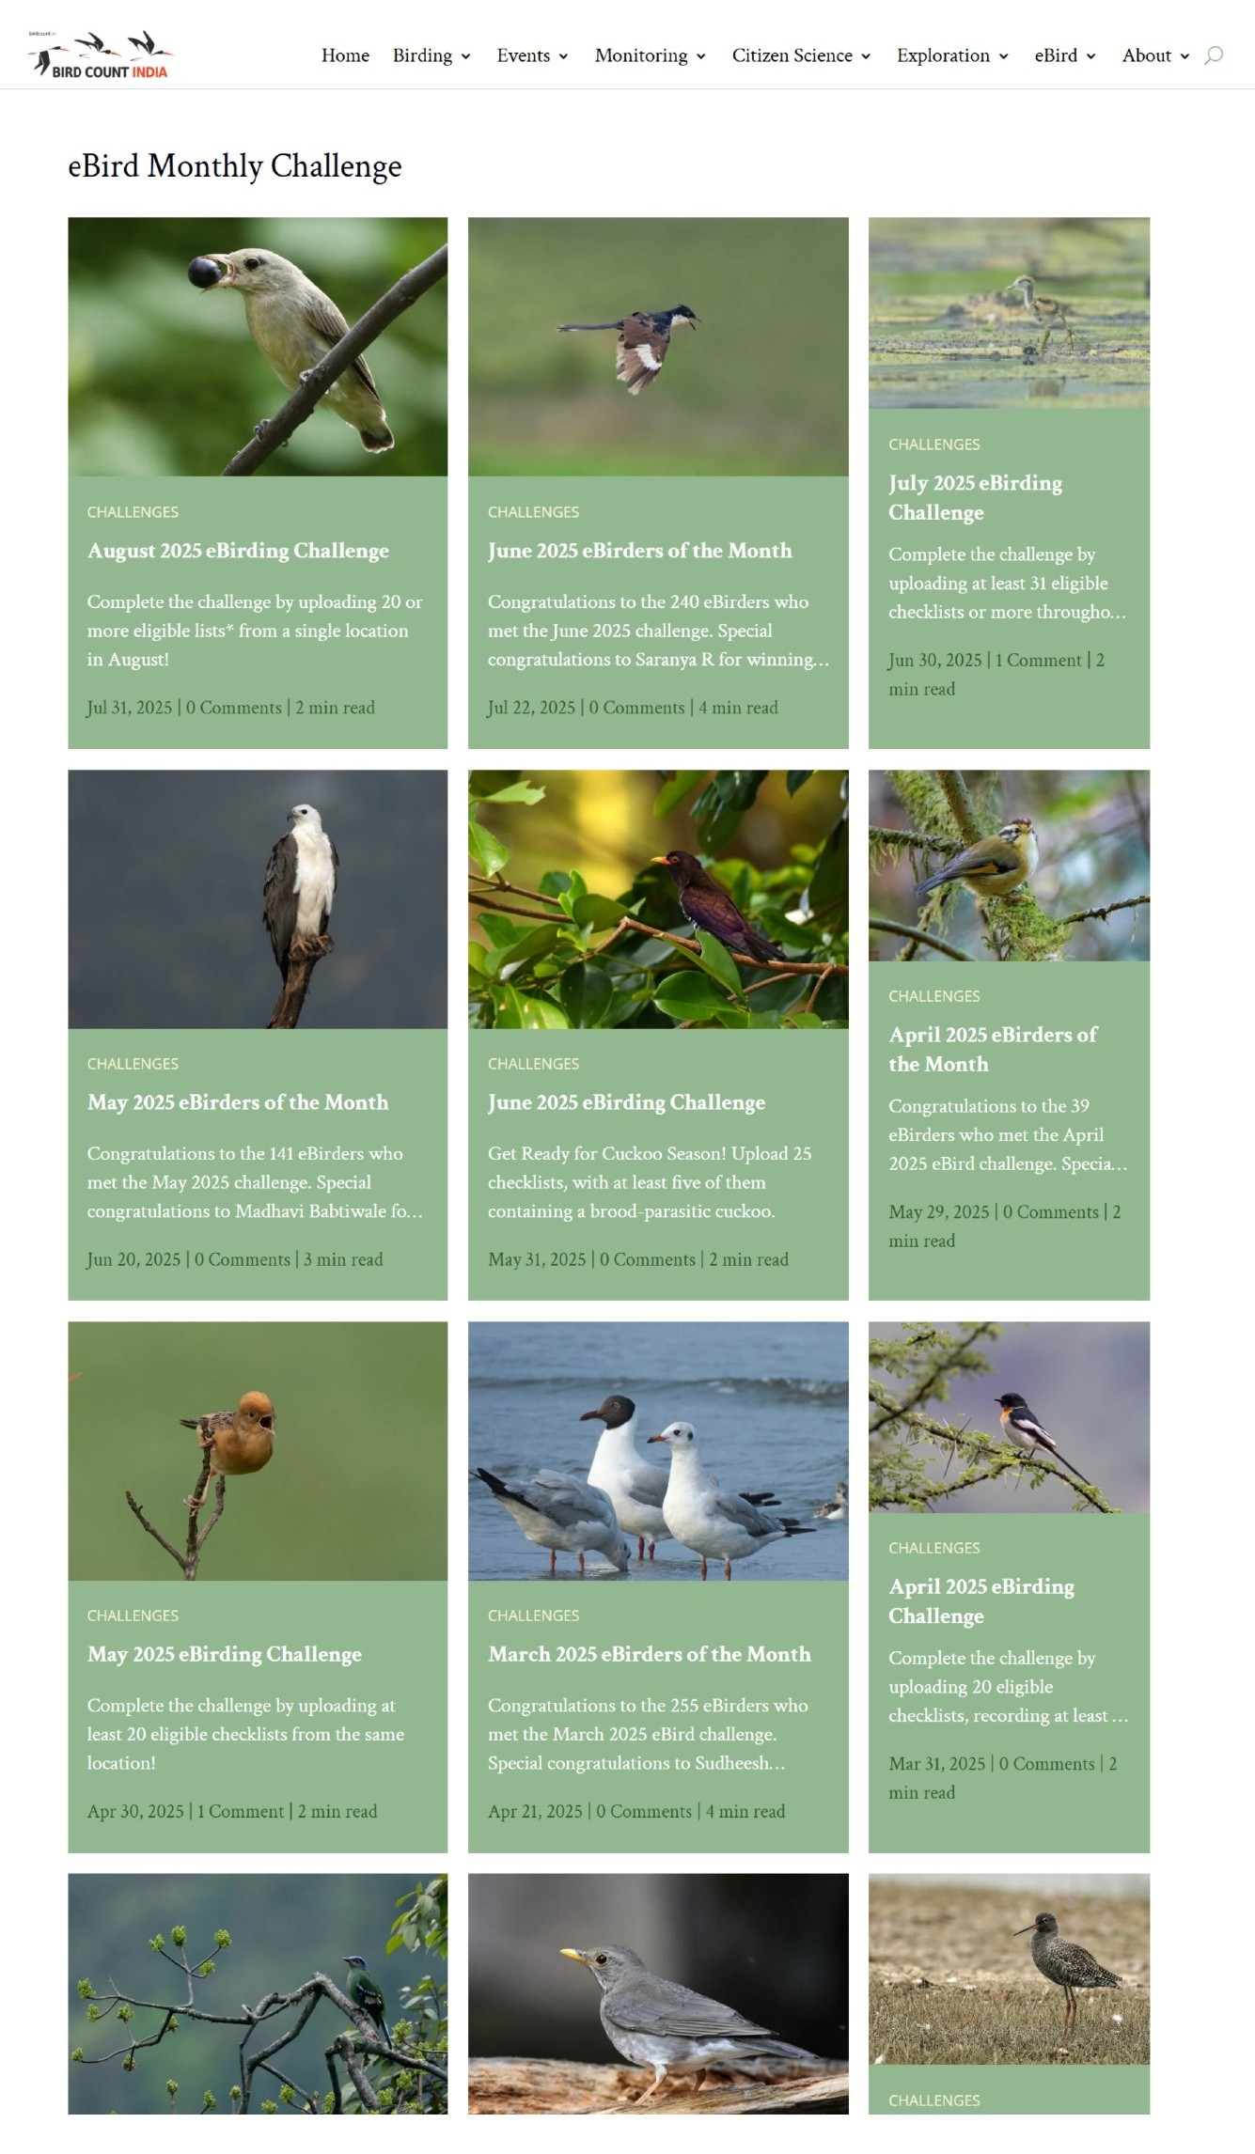

Figure : The eBird monthly challenge website by BCI

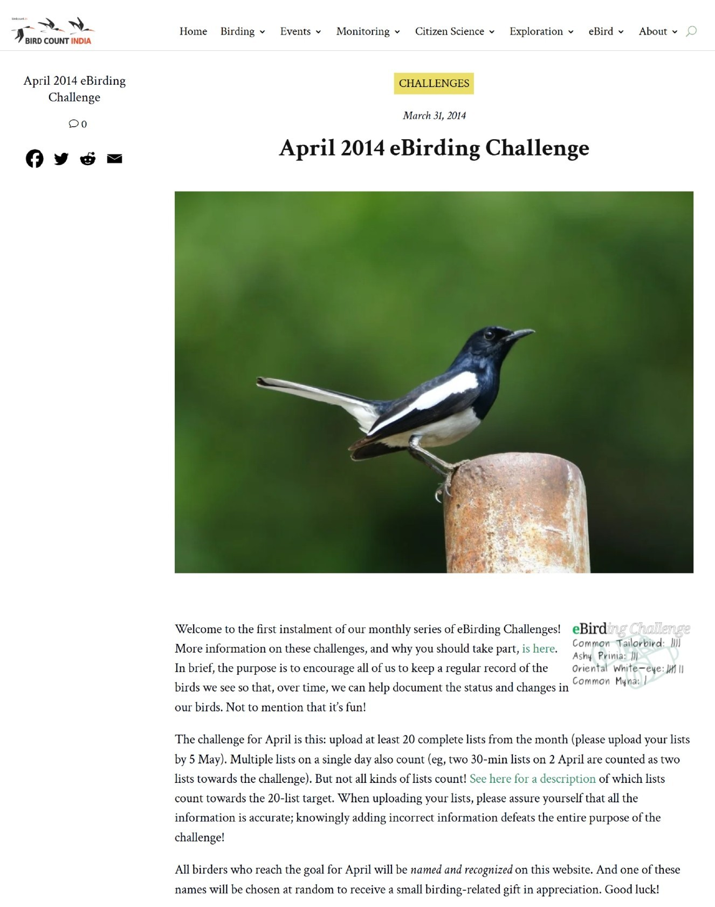

Figure : Challenge webpage

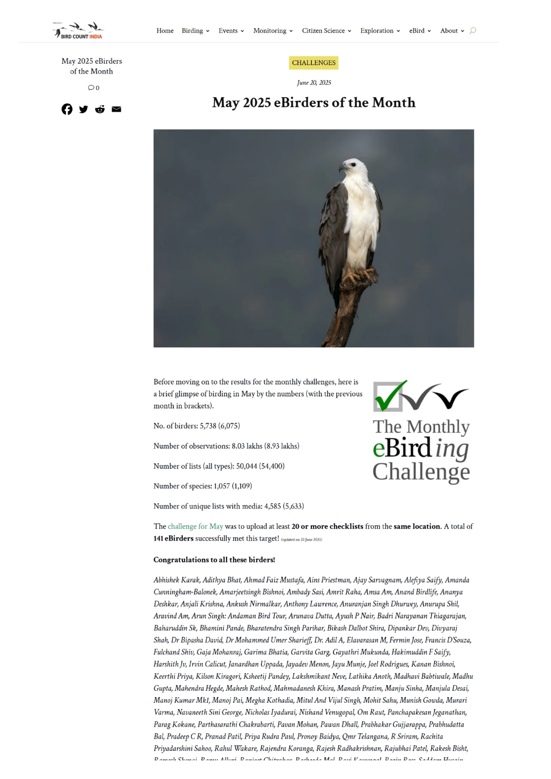

Figure : Challenge-result webpage

# Results and discussions

## Cumulative New Challenge Qualifiers Over Time

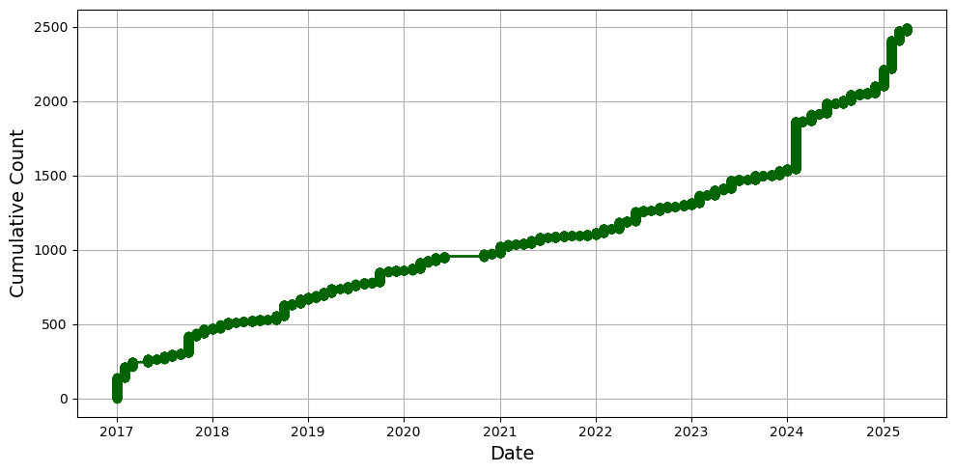

Figure : Cumulative graph of new challenge qualifiers every challenge.

The cumulative count shows a steady upward trend from 2017 to 2025, indicating consistent growth in participation over time. Clear points of sharp increase, such as in 2018, 2024, and early 2025, suggest periods of higher engagement, likely linked to campaigns, challenges, or outreach events. Between these peaks, the growth remains gradual but stable, showing sustained baseline participation. Overall, the data presents a strong long-term rise in engagement with distinct surges connected to targeted efforts.

## Participant Trends: Monthly

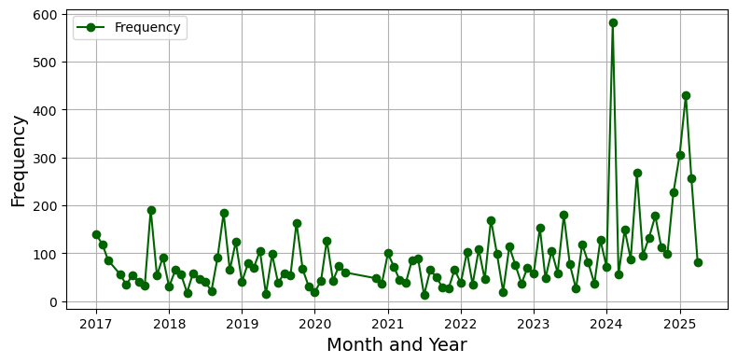

Figure : Line graph of participant trends every month

The line chart shows the monthly frequency of eBirding Challenge participations from 2017 to 2025. Frequencies are calculated as the total number of challenge completions per month, summed across all participants. The trend shows fluctuations over the years, with modest participation between 2017 and 2022, usually ranging from 20 to 150 entries per month. From 2023 onwards, a gradual increase is observed, leading to a sharp peak in early 2024, when participation reached nearly 600 entries in a single month, the highest in the dataset. The following months in 2024 and 2025 also show higher engagement, with many months crossing 200 entries. These findings indicate a steady rise in participation over time, especially in recent years, reflecting both growth in the eBirding community and the effectiveness of engagement strategies after 2023.

## Participant Trends: Yearly

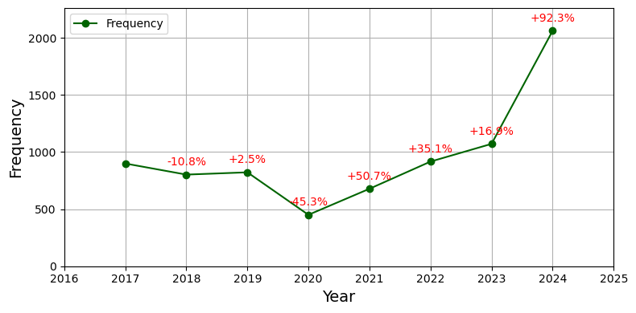

Figure : Line graph of participant trends every year with percentage change compared to previous year

The yearly participation trend shows fluctuations in engagement between 2017 and 2025. After a decline from about 900 in 2017 to a low of about 450 in 2020, participation steadily recovered, with strong growth from 2021 onward. The peak occurred in 2024, exceeding 2000, which is more than four times the 2020 level. In 2025, participation is lower than 2024 (about 1050 as of June), but it already surpasses most pre-2023 values, suggesting that year-end totals may match or exceed earlier highs. These patterns indicate that engagement responds strongly to targeted initiatives, with 2024 standing out as a year of exceptional growth.

## Participant Trends: Seasonal (Summer v/s Winter)

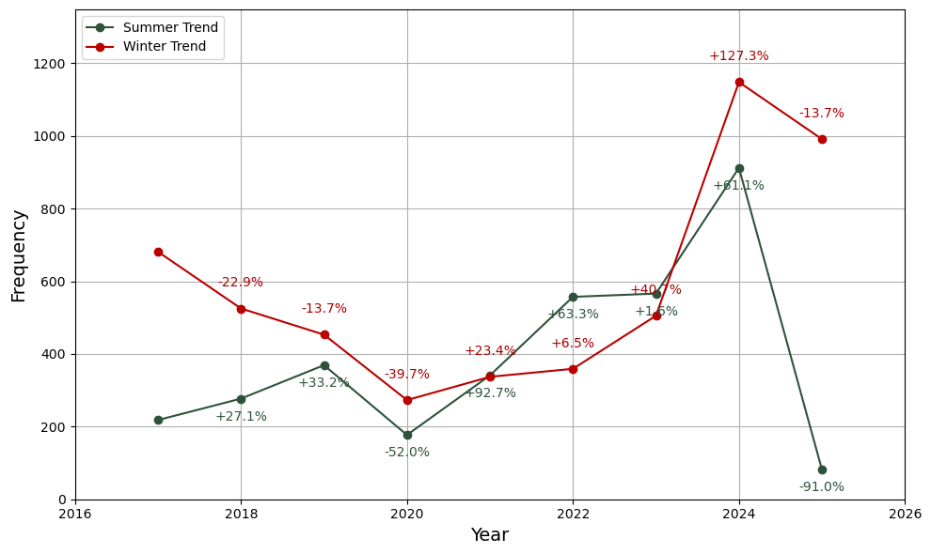

Figure : Summer v/s Winter - Participation frequency by year with percentage change compared to previous year

The line chart compares annual participation trends in eBirding Challenges across summer (April–September) and winter (October–March) seasons from 2017 to 2025. Frequencies are calculated as the total number of participations per season, and percentage changes are computed year-on-year to show relative growth or decline. The results highlight contrasting seasonal patterns: winter participation declined between 2017 and 2020 (−22.9% in 2018 and −39.7% in 2020) before recovering steadily, with strong growth in 2023 (+40.1%) and a peak in 2024 (+127.3%), marking the highest winter participation in the study period. Summer participation, though lower in absolute numbers, showed larger relative shifts, with strong growth in 2021 (+92.7%) and 2024 (+81.1%), followed by a steep decline in 2025 (−91.0%). Overall, winter displays a more consistent and dominant trend, while summer shows irregular spikes followed by sharp declines, reflecting seasonal variation in birdwatching opportunities and engagement.

## Participation consistency

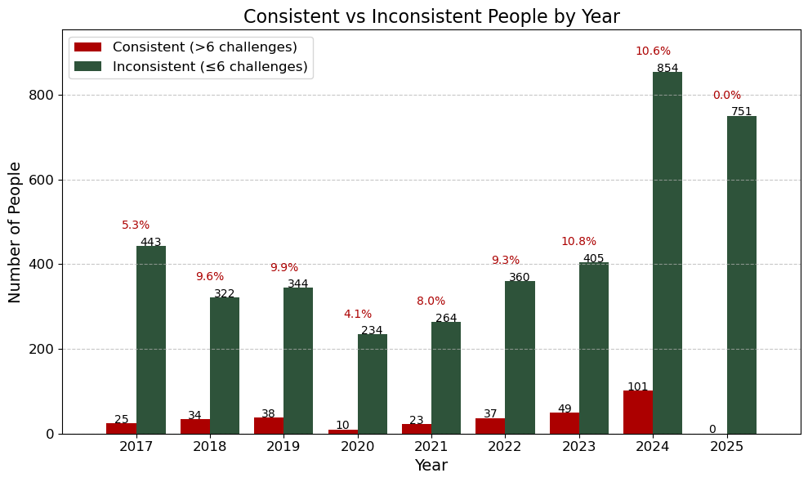

Figure : Double graph for comparison between consistent and inconsistent submissions

Note: The red number above each set indicates the percentage of total people in that year who were consistent.

For e.g., 5.3% of total people i.e. 468 people were consistent i.e. 25 people

The analysis of participant consistency across years shows that although the total number of challenge participants has steadily grown, the proportion of consistent contributors (>6 challenges per year) has remained low. Consistency ranged between 4% and 11% of participants, peaking in 2024 with 101 consistent birders (10.6%). Most participants completed fewer than 6 challenges annually, indicating strong initial engagement but limited long-term retention. The dip in 2020 corresponds with reduced overall participation, likely due to external disruptions.

## Yearly average category-wise unique participation

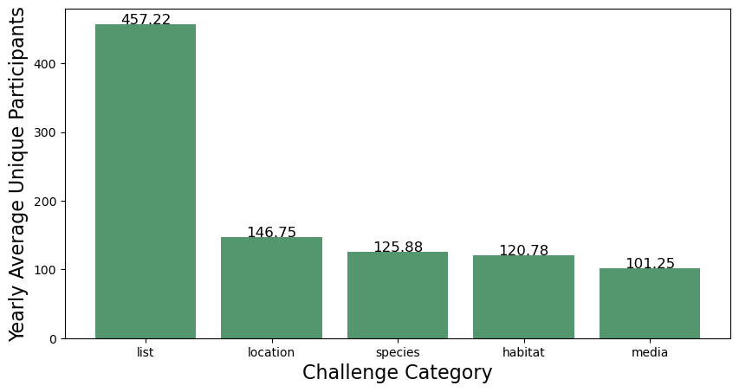

Figure : Bar graph of yearly average unique participants in each category

The bar chart shows the yearly average number of unique participants across different categories of eBirding Challenges. The analysis groups challenge data by category and calculates the average count of distinct participants per year. Results show that list-based challenges had the highest engagement, averaging 586.75 participants annually, followed by location-based challenges with 530.75 participants. In contrast, species-based (170.80), habitat-based (141.90), media-based (136.33), and time-based (119.09) challenges attracted lower participation. This disparity highlights a clear preference for simpler list- and location-oriented formats, which likely offer greater accessibility, while more specialized challenges such as species- or media-focused formats show lower but still meaningful involvement.

## Yearly average seasonal unique participation

Summer: 210

Winter: 379

The analysis calculates the average number of unique participants in eBirding Challenges across summer and winter seasons, using data from 2017 onwards. Seasons are defined as April–September for summer and October–March for winter. Participation levels are measured by counting distinct individuals in each season, followed by averaging values across years. Results show a clear seasonal difference: an average of 210 unique participants in summer compared to 379 in winter. This indicates that winter months consistently attract a larger and more diverse participant base, possibly due to favorable birding conditions, migratory bird influx, or increased observation opportunities. The approach of combining temporal filtering, unique participant counts, and seasonal averaging provides robust insights into seasonal engagement dynamics.

## People in challenges

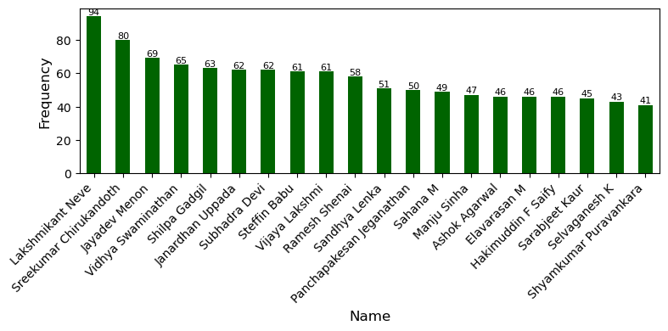

Figure : Bar graph of top 20 qualifiers w.r.t. all the challenges

The analysis identifies the top 20 participants in terms of engagement frequency in eBirding Challenges. Frequencies are calculated as the number of challenges completed by each participant during the study period. Lakshmikant Neve recorded the highest engagement with 100 challenges, followed by Sreekumar Chirukandoth (82) and Jayadev Menon (79). Participation then declines gradually across the ranked list, with Ashok Agarwal and Elavarasan M completing 46 challenges each at the lower end. The results highlight a core group of highly active birders contributing consistently, while engagement levels taper among others. This helps in identifying key contributors and understanding patterns of sustained participation within the citizen science community.

# Conclusion

This internship provided insights into patterns of engagement in the eBirding Challenges conducted by NCF and Bird Count India. The analysis shows steady growth in participation since 2017, with notable surges in 2018, 2023, and 2024, likely driven by targeted outreach and effective challenge formats. Seasonal trends reveal that winter consistently attracts more participants than summer, reflecting ecological opportunities and participant preferences.

The data also reflects the impact of the COVID-19 pandemic: participation dipped in 2020 during lockdowns but began recovering in 2021, with strong growth after restrictions were lifted. Despite rising overall numbers, consistency remains low, with only a small fraction of birders contributing regularly across multiple challenges each year. Category-wise analysis shows that list-based and location-based challenges attract the highest engagement, suggesting that simple and accessible formats resonate most with participants. In contrast, specialized categories such as habitat-, species-, media-, and time-based challenges draw fewer but still meaningful contributions, indicating niches for focused engagement.

Overall, the findings emphasize the need to balance accessibility with diversity in challenge design. Maintaining simple formats can encourage broad participation, while targeted themes can enhance scientific value. Strengthening long-term engagement, through recognition of consistent participants, fostering community interaction, and designing seasonally adaptive challenges, can further increase the impact of citizen science on bird monitoring and conservation in India.

end