Trainee name : Khushi Mordani
Employee id : 150111
Linux Internals – Multithreading Assignment

1.Write a multithreading program, where threads runs same shared golbal variable of
the process between them.

Source code:
//Khushi Mordani
/*1.Write a multithreading program, where threads runs same shared global variable of the process between them.*/
#include<stdio.h>
#include<stdlib.h>
#include<pthread.h>

int sharedvar=49;

void *thread_mul(void *arg)
{
int n;
printf("Enter a number to multiply:");
scanf("%d",&n);
sharedvar = sharedvar * n ;
printf("After multiplication,shared variable is %d\n",sharedvar);
}

void *thread_sub(void *arg)
{
int i;
printf("Enter a number to subtract:");
scanf("%d",&i);
sharedvar = sharedvar - i;
printf("\nAfter subtracting,shared variable is %d\n",sharedvar);
}

int main()
{
pthread_t thread1,thread2;
pthread_create(&thread1,NULL,thread_mul,NULL);
pthread_create(&thread2,NULL,thread_sub,NULL);
pthread_join(thread1,NULL);
pthread_join(thread2,NULL);
printf("Shared variable final value= %d\n",sharedvar);
return 0;
}

Output:

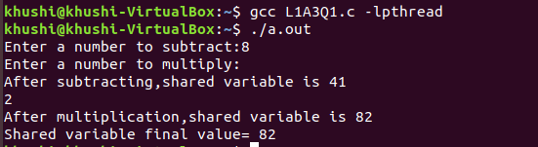

2.Write a program where thread cancel itself.(use pthread_cancel())

Source code:
//Khushi Mordani
//2.Write a program where thread cancel itself.(use pthread_cancel())
#include<pthread.h>
#include<stdio.h>
#include<unistd.h>

void *hello(void *threadid)
{
printf("Hello,I am Khushi!!\n");
while(1);{}
}

int main()
{
pthread_t t1;
int rc, t=0;
printf("Creating thread\n");
rc = pthread_create(&t1,NULL,hello,NULL);
printf("thread id: %lu\n",t1);
sleep(5);
rc = pthread_cancel(t1);
if(t==0)
{
printf("Thread cancelled!\n");
printf("thread id: %lu\n",t1);
}
return 0;
}

Output:
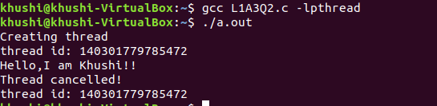
3. Write a program that changes the default properties of newly created posix
threads.(ex: to change default pthread stack size )

Source code:
//Khushi Mordani
//3. Write a program that changes the default properties of newly created posix threads.(ex: to change default pthread stack size )
#include<stdio.h>
#include<pthread.h>
#include<unistd.h>
#include<stdlib.h>
#include<sys/mman.h>

void* change(void* par)
{
sleep(2);
return 0;
}

int main()
{
pthread_attr_t Attr;
pthread_t id;
void *stack;
size_t siz;
int err;
size_t my_stacksize = 0x30000000;
void * my_stack;

pthread_attr_init(&Attr);

pthread_attr_getstacksize(&Attr, &siz);
pthread_attr_getstackaddr(&Attr, &stack);

printf("Default address: %08x Default size: %d\n",stack,siz);

my_stack = (void*)malloc(my_stacksize);

pthread_attr_setstack(&Attr,my_stack,my_stacksize);
pthread_create(&id,&Attr,change,NULL);
pthread_attr_getstack(&Attr,&stack,&siz);
printf("Newly derived stack address:%08x and size:%d\n",stack,siz);
sleep(2);
exit(0);
}

Output:
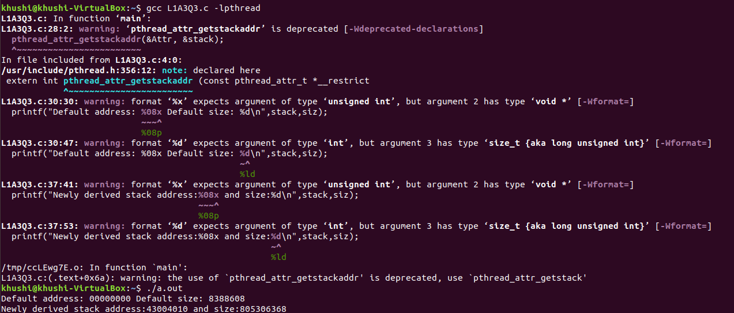
4. Write a program where pthread task displays the thread id and also prints the calling
process pid.

Source code:
//Khushi Mordani
//4. Write a program where pthread task displays the thread id and also prints the calling process pid.

#include<pthread.h>
#include<stdio.h>
pthread_t thread_id;
void *thread_func(void *arg)
{
pid_t pid;
pthread_t thread_id;
pid=getpid();
thread_id=pthread_self();
printf("Process id: %u Thread id:%u \n",(unsigned int)pid,(unsigned int)thread_id);
return 0;
}

int main(void)
{
int create;
create=pthread_create(&thread_id,NULL,thread_func,NULL);
if(create!=0)
printf("Cannot create thread: %s\n",strerror(create));
while(1);
exit(0);
}
Output:
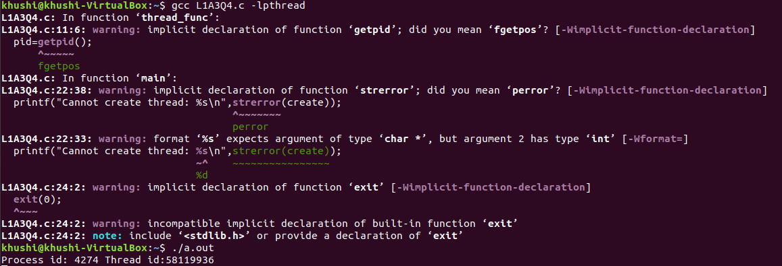

5.Write a program that implements threads synchronization using mutex techniques.

Source code:
//Khushi Mordani
//5.Write a program that implements threads synchronization using mutex techniques.

#include<stdio.h>
#include<stdlib.h>
#include<pthread.h>
#include<semaphore.h>

int sharedvar=87;

pthread_mutex_t my_mutex; //create mutex
void *thread_add(void *arg)
{
pthread_mutex_lock(&my_mutex); //take mutex
int n;
printf("Enter a number to add:\n");
scanf("%d",&n);
sharedvar=sharedvar+n;
printf("After addition,shared variable is %d\n",sharedvar);
pthread_mutex_unlock(&my_mutex); //release mutex
}

void *thread_sub(void *arg)
{
pthread_mutex_lock(&my_mutex); //take mutex
int i;
printf("Enter a number to subtract:");
scanf("%d",&i);
sharedvar=sharedvar-i;
printf("After subtraction,shared variable is %d\n",sharedvar);
pthread_mutex_unlock(&my_mutex); //release semaphore
}

int main()
{
pthread_t thread1,thread2;
pthread_mutex_init(&my_mutex,NULL);
pthread_create(&thread1,NULL,thread_add,NULL);
pthread_create(&thread2,NULL,thread_sub,NULL);
pthread_join(thread1,NULL);
pthread_join(thread2,NULL);
printf("Shared variable final value = %d\n",sharedvar);
return 0;
}

Output:

