Trainee name : Khushi Mordani
Employee id : 150111
Linux Internals – Process Assignment

1.Test whether the process(exec() system call) that replaces old program data , will inherit
the fd’s or not.

Source code:
//Khushi Mordani
//1.Test whether the process(exec() system call) that replaces old program data , will inherit the fd's or not.
#include<stdio.h>
#include<fcntl.h>
#include<sys/types.h>
#include<sys/stat.h>
#include<unistd.h>
#include<stdlib.h>

int main()
{
int fd;
fd=open("data.txt",O_RDONLY,0777);
printf("Inherit File Descriptor: %d\n",fd);
return 0;
}

Output:
2.Write a program such that parent process create two child processes,such that each child executes a separate task.

Source code:
//Khushi Mordani
//2.Write a program such that parent process create two child processes,such that each child executes a separate task.

#include <stdio.h>
#include<sys/types.h>
#include<unistd.h>
int main()
{
pid_t q,q_child;
q = fork();
if(q==0)
{
//wait(NULL);
printf("Child process id: %d\n",getpid());
printf("Parent process id: %d\n",getppid());
execlp("vim", "vim", NULL);
q_child=fork();
if(q_child==0)
{
printf("Grandchild process id: %d\n",getpid());
execlp("ls","-a","-s",NULL);
}
}
else
{
//wait(NULL);
printf("Parent process id: %d\n",getpid());
printf("Child process id: %d\n",q);
}
return 0;
}

Output:
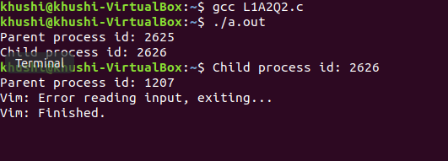
3. A program that replaces old program with new program data and is expected to display
the currently running processes in a hierarchical tree format.

Source code:
//Khushi Mordani
//3. A program that replaces old program with new program data and is expected to display the currently running processes in a hierarchical tree format.

#include<stdio.h>
#include<unistd.h>
int main()
{
execlp("pstree","pstree",NULL);
return 0;
}

Output:
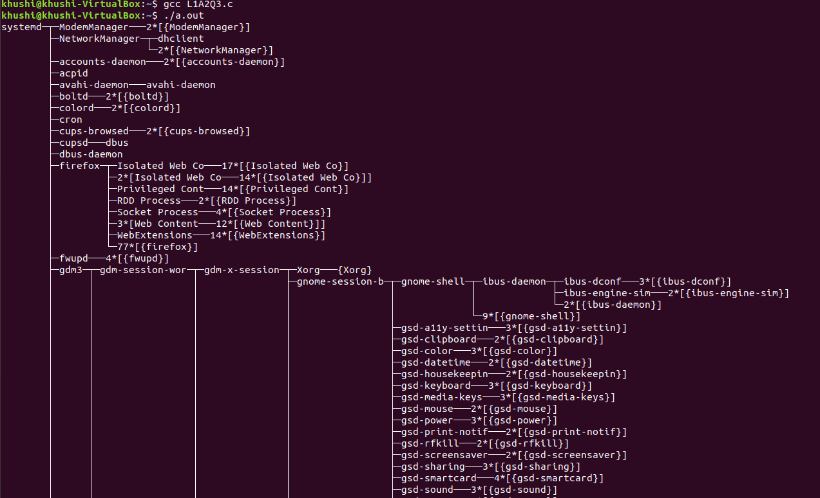
4.A processs using execl() system call should replace a new command line program.

Source code:
//Khushi Mordani
//4.A processs using execl() system call should replace a new command line program.

#include<stdio.h>
#include<stdlib.h>
#include<unistd.h>

int main(int argc, char* argv[])
{
// int ret = execl("/usr/bin/vim", "vim","info1.txt", 0);
int ret = execl(argv[1], argv[2],argv[3], 0);
if(ret == -1)
{
printf("execl returned error %d\n", ret);
}
return(0);
}

Output:
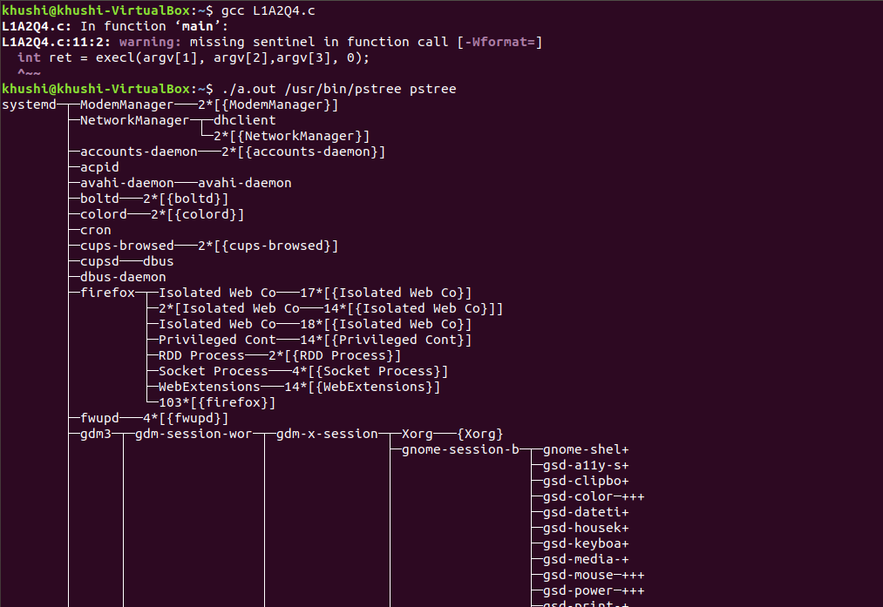
5.Write a program parent process wait untill ,while child process open a file and read file
data into empty buffer.

Source code:
//Khushi Mordani
//5.Write a program parent process wait untill ,while child process open a file and read file data into empty buffer.

#include<stdio.h>
#include<unistd.h>
#include<fcntl.h>

int main()
{
int pid;
char read_buf[100];
pid=fork();
if(pid==0)
{
//child process
printf("Child process is running \n");
int fd;
fd = open("readfile.c",O_RDONLY);
read(fd,read_buf,100);
printf("%s",read_buf);
//it will read data from the readfile and it will print on display
printf("Child process stopped...!\n\n");
}
else
{
wait(0);//parent will wait till child execute
//sleep(5);
printf("Parent running\n");
printf("Parent Process Stopped...!\n");
}
return 0;
}

Output:
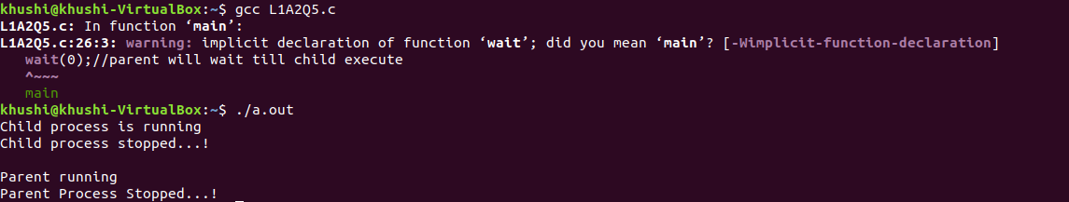
5.Write a program, where functions of the program are called in the reverse order of
their function calls from main().

Source code:
//Khushi Mordani
//5.Write a program, where functions of the program are called in the reverse order of their function calls from main().

#include<stdio.h>
#include<stdlib.h>

void callBack1()
{
printf("callback 1\n");
}
void callBack2()
{
printf("callback 2\n");
}
void callBack3()
{
printf("callback 3\n");
}

int main()
{
printf("registering callback1\n");
atexit(callBack1);
printf("registering callback2\n");
atexit(callBack2);
printf("registering callback3\n");
atexit(callBack3);
printf("exit() main exiting now...\n");
exit(0); //_exit() is not calling the functions which are previously registered using atexit function
}

Output:
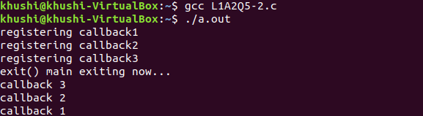
6. Write a program child executes(exec()) a new program , while parent waits for
child task to get complete.

Source code:
//Khushi Mordani
//6. Write a program child executes(exec()) a new program , while parent waits for child task to get complete.

#include<stdio.h>
#include<unistd.h>

int main()
{
int pid;
pid=fork();
if(pid==0)
{
//child process
printf("Child process is running \n");
int ret = execl("/home/ompatel/Linux_Internals/10-03-22/Asignment/6","",NULL);
//5 file will execute
}
else
{
wait(2);//parent will wait till child execute
//sleep(5);
printf("Parent running\n");
printf("Parent Process Stopped...!\n");
}
return 0;
}

Output:
