MySQL

Q1. Create table Employee with the following parameters:
- EMPNO INT PRIMARY KEY
- ENAME VARCHAR
- JOB VARCHAR
- MGR INTEGER
- HIREDATE DATE
- SALARY DECIMAL
- COMM DECIMAL
- DEPTNO INT
Ans.
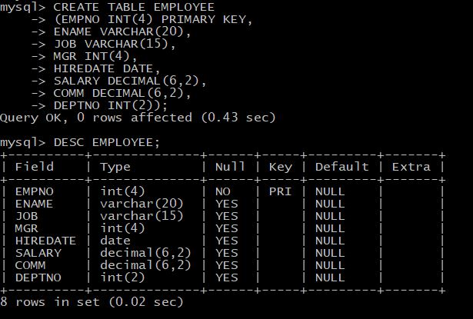

Q2.Create table Student with the following parameters:
- NUMBER INT PRIMARY KEY
- NAME VARCHAR
- STIPEND DECIMAL
- STREAM VARCHAR
- AVGMARK DECIMAL
- GRADE CHAR
- CLASS VARCHAR
Ans.
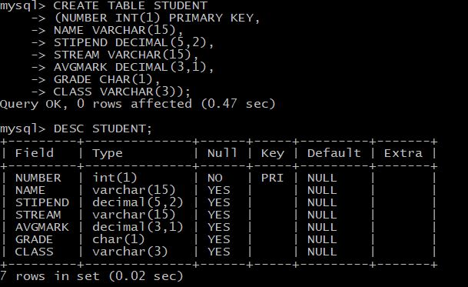

Q3.Insert values into table Employee.
Ans.

Q4.Display the different streams in the table Student.
Ans.
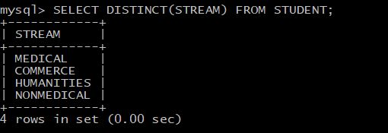

Q5. Display the Employee number, Employee Name from the table Employee where the jobs are President, Manager or Clerk.
Ans.
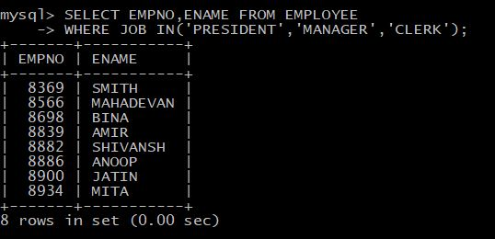

Q6. Display the Name and Stream from the table Student where the second letter of the student name is ‘o’.
Ans.
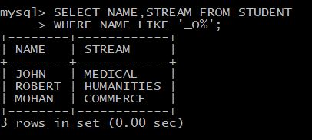

Q7. Display the Number, Name of the student and his/her grade from the table student where the average marks(AVGMARK) is between ’80.0’ and ’90.0’.
Ans.
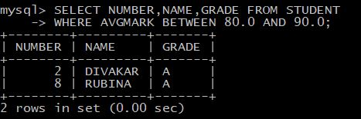

Q8. Display all the records in the table Employee.
Ans.
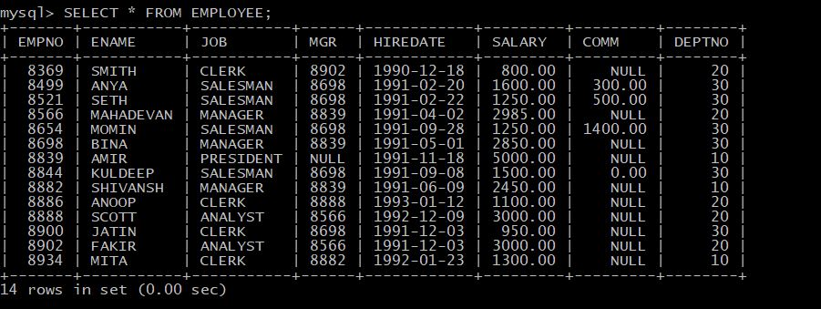
Q9. Display the sum of the stipend of each stream in the table Student.
Ans.
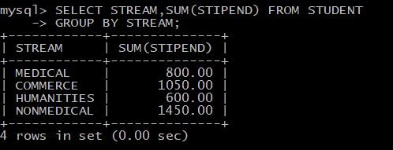
Q10. Display the class, and the maximum average mark obtained where the stipend>300 from the table Student.
Ans.
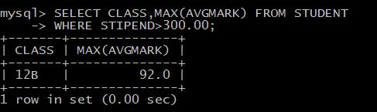
Q11. Display the Job and the hiredate from the table Employee where the commission is not null.
Ans.
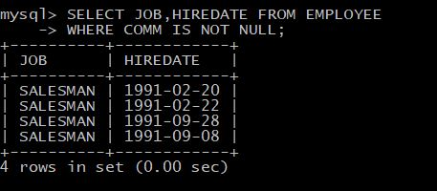
Q12. Display the salary and department no. from the table Employee where the hire date is after 1992-01-01.
Ans.
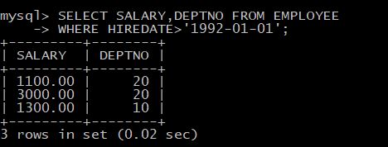

Q13. Display the empno and mgr from the table Employee where the commission is null.
Ans.
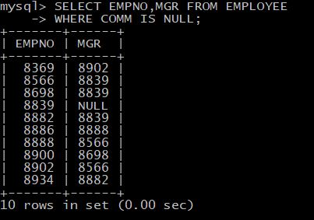
Q14. Round and display the average mark of each student from the table Student where the grade is ‘B’.
Ans.
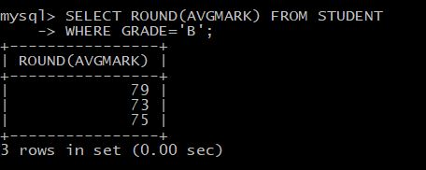

Q15. Concat the name and stream of the students of class 12A from the table Student.
Ans.
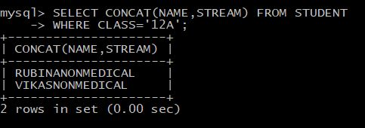
Q16.Display the Deptno, Job ans maximum salary, grouped by deptno and Job and ordered by ascending order of empno from table Employee.
Ans.
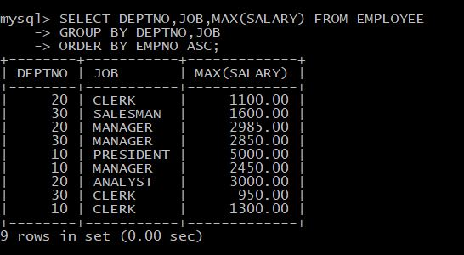

Q17. Display the number, class and name of the student ordered in descending order of the average mark from the table Student.
Ans.
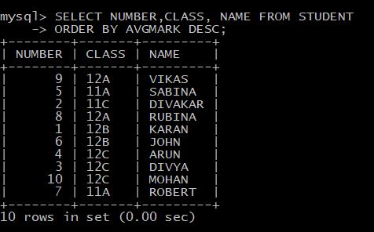
Q18. Display the count of the records from the table Employee where the job is either ‘analyst’ or ‘salesman’.
Ans.
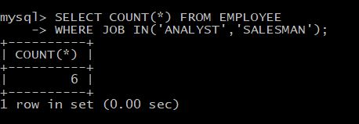

Q19. Update the salary of the ‘President’ by 50 and display the records.
Ans.
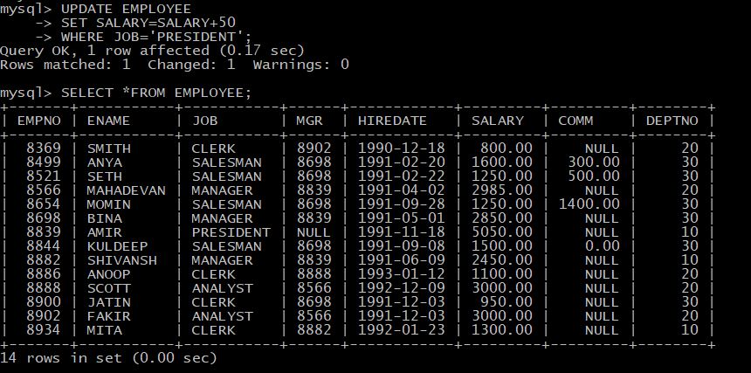
Q20. Add another column Hobby to the table Sudent.
Ans.
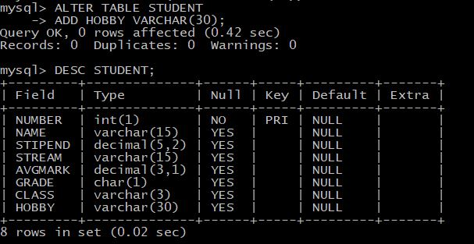

Q21. Change the name of the column ‘Hobby’ and assign a datatype of Varchar.
Ans.
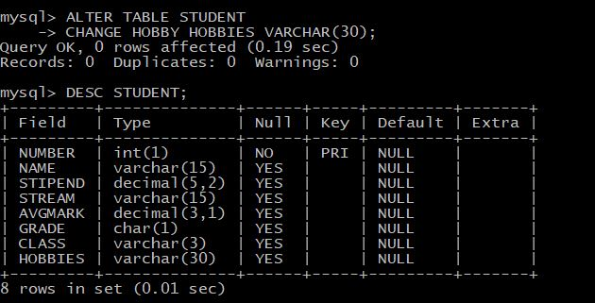
Q22. Display Deptno, average commission , average salary from the table Employee and group it by deptno where the average commission is between 400.00 and 1000.00 .
Ans.
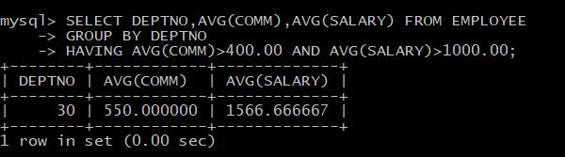

Q23. Display the name and ranking of the student from the tables Student and Ranks.
Ans.
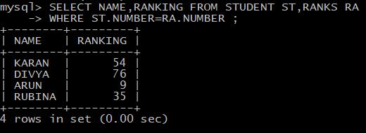
Q24. Display all the records from the tables Student and Ranks where the stipend is greater than 400.00 .
Ans.
