mkdir my-app

cd my-app

First, install NodeJS on your system. Visit nodejs website. [Download](https://nodejs.org/en/download/) and install.

[Node.js (nodejs.org)](https://nodejs.org/en/)

you need to install **MongoDB**. Visit MongoDB[download Center,](https://www.mongodb.com/download-center#community) download and install it on your system.

[MongoDB Community Download | MongoDB](https://www.mongodb.com/try/download/community)

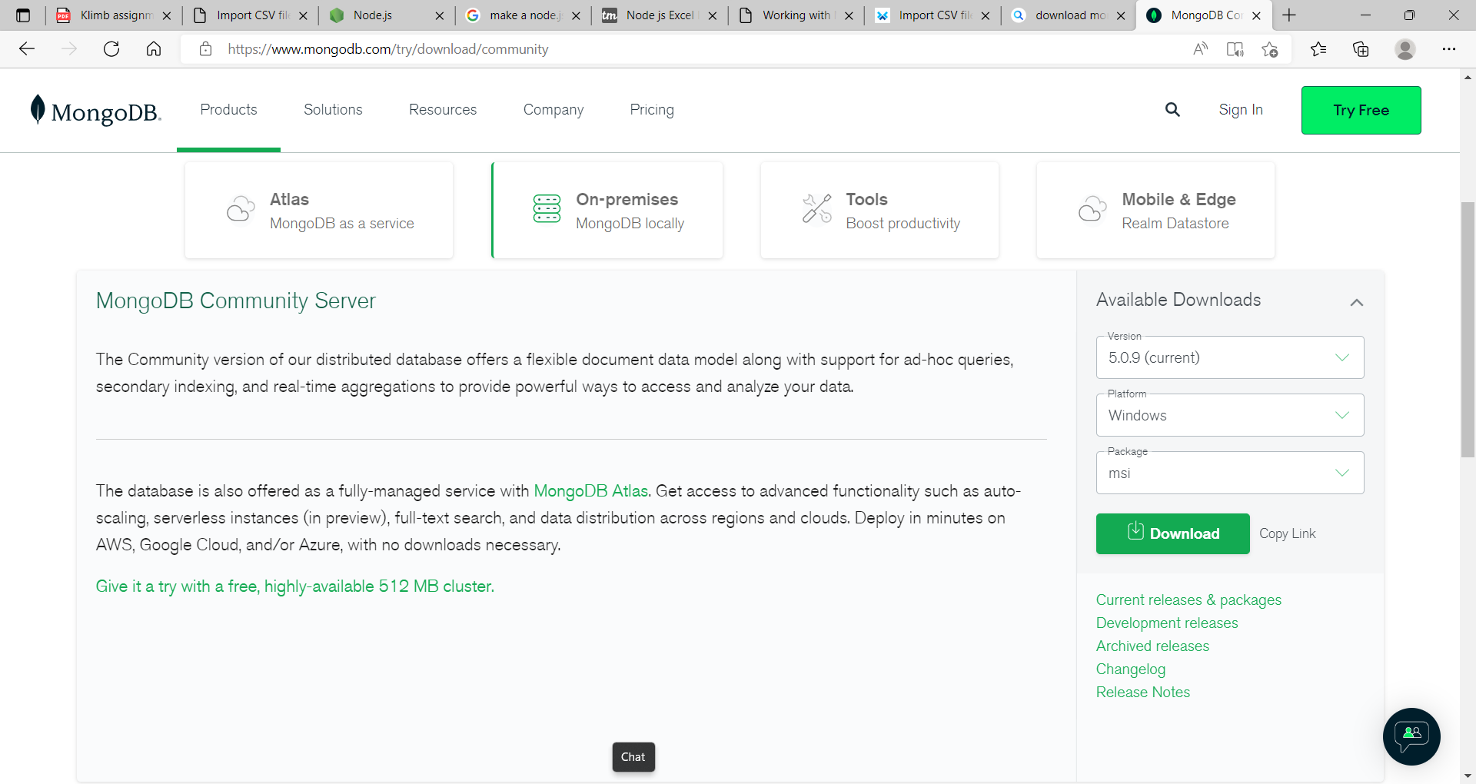

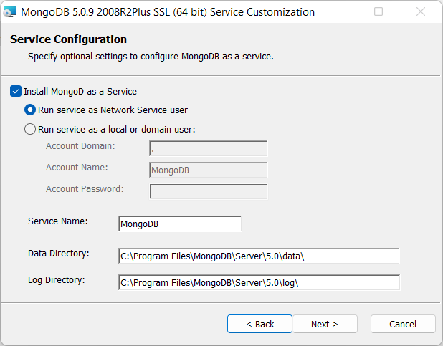

cd C:\Program Files\MongoDB\Server\3.6\bin

Type command **mongod**. MongoDB server starts. Now open another **command line** and go to the same path, type **mongo,**a **mongo shell**starts. Create a database, using **use [database name]**command.

use test1

npm init -y

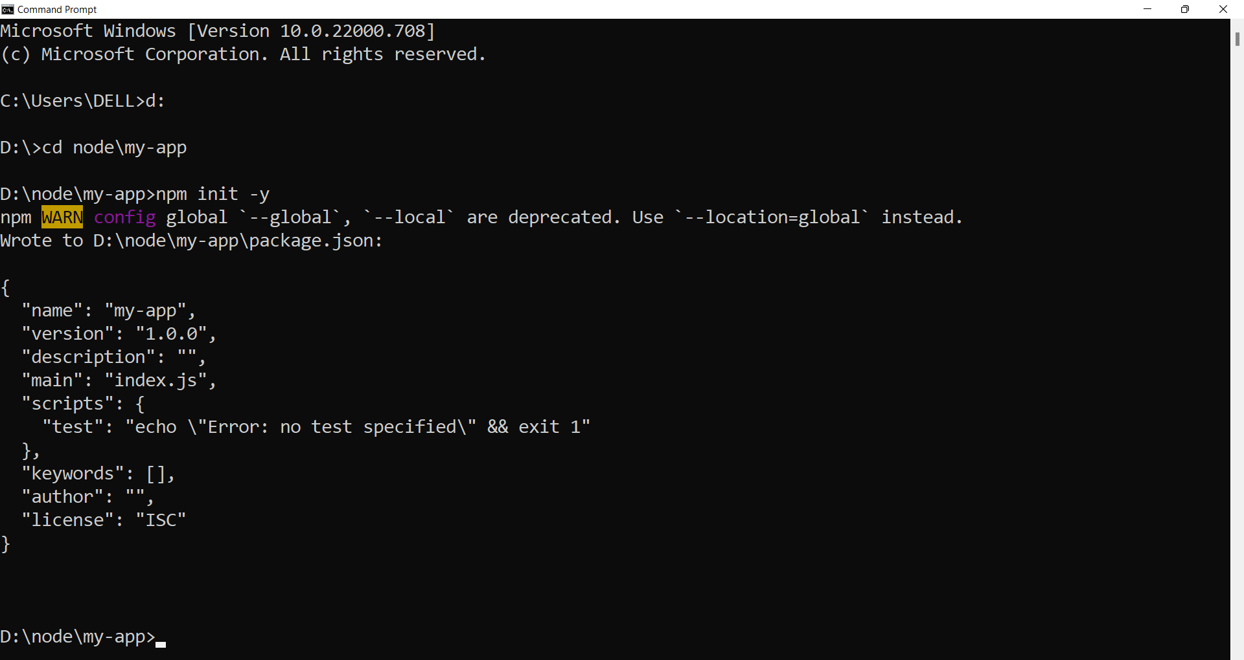

npm install -g express-generator

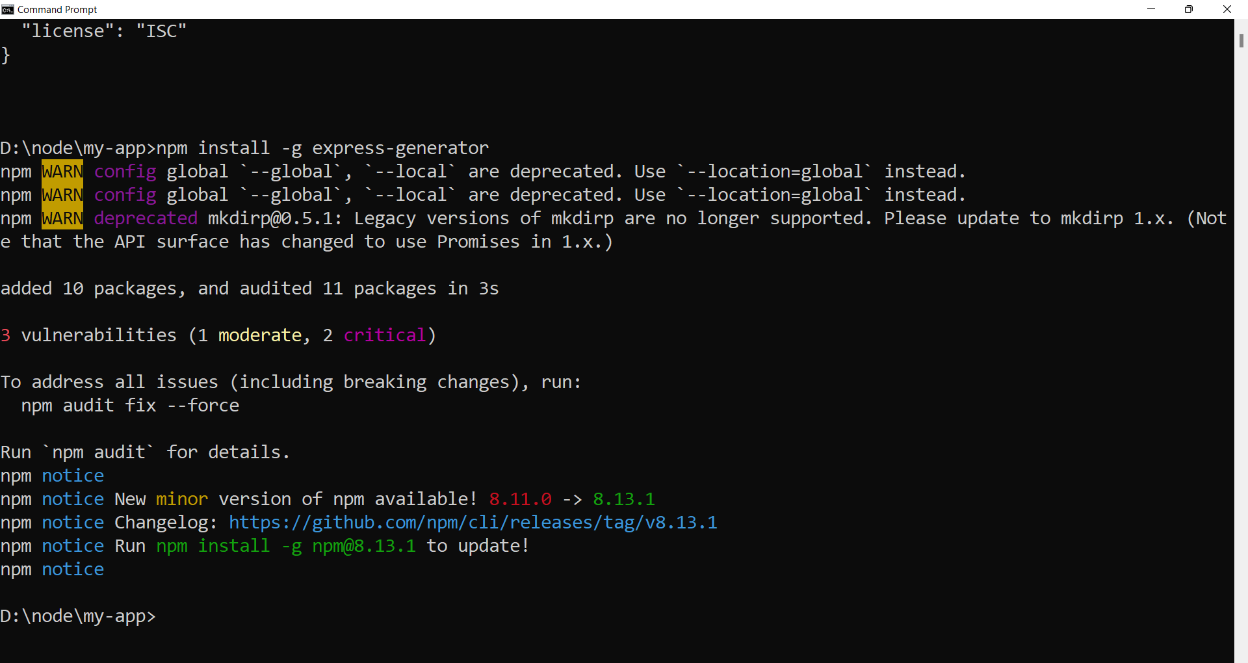

npx express --view=ejs

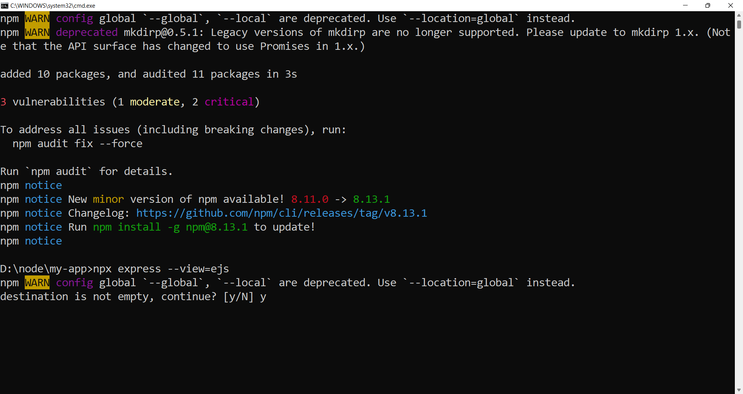

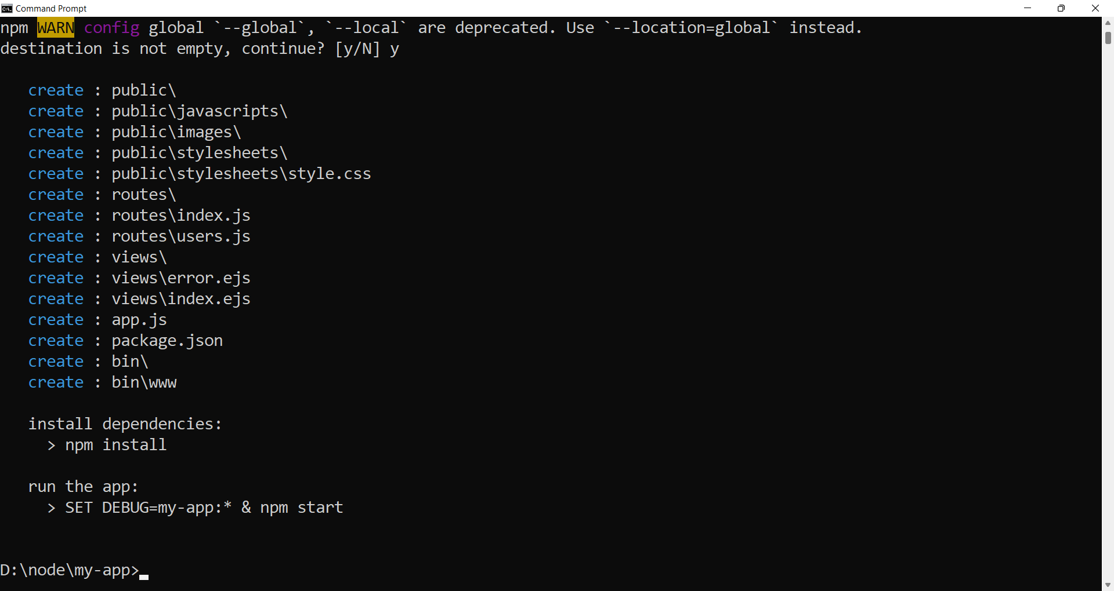

npm install mongoose multer body-parser

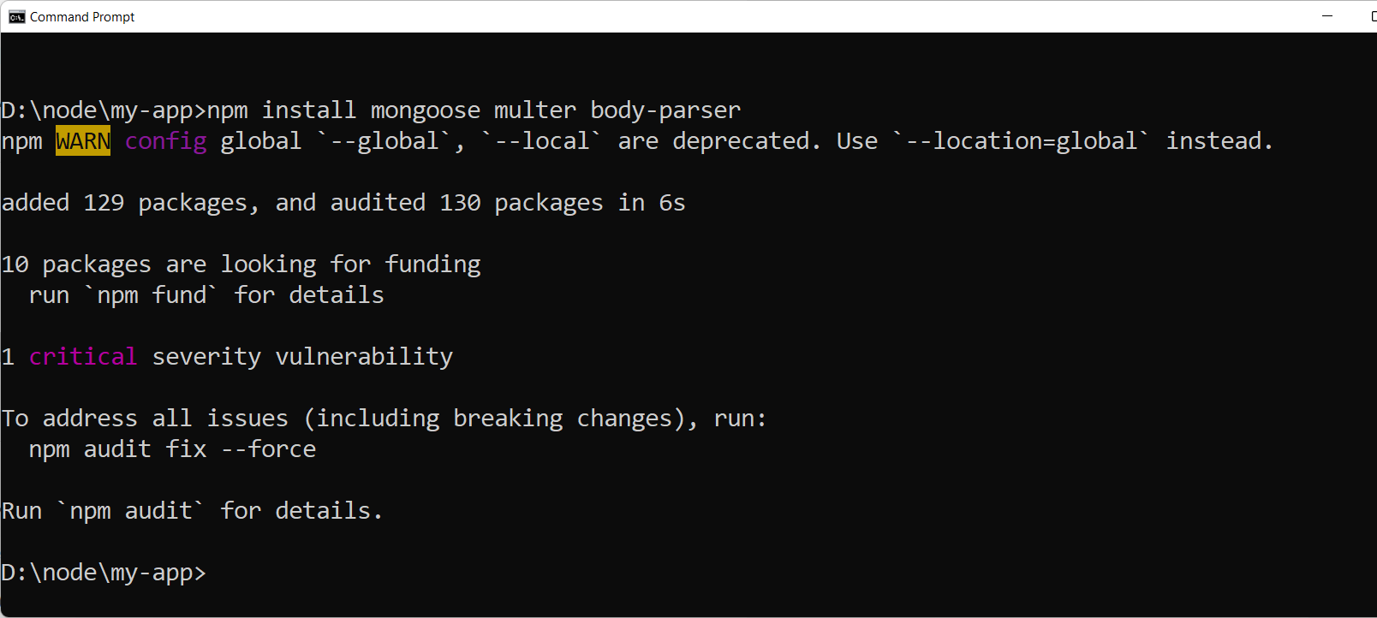

npm install convert-excel-to-json

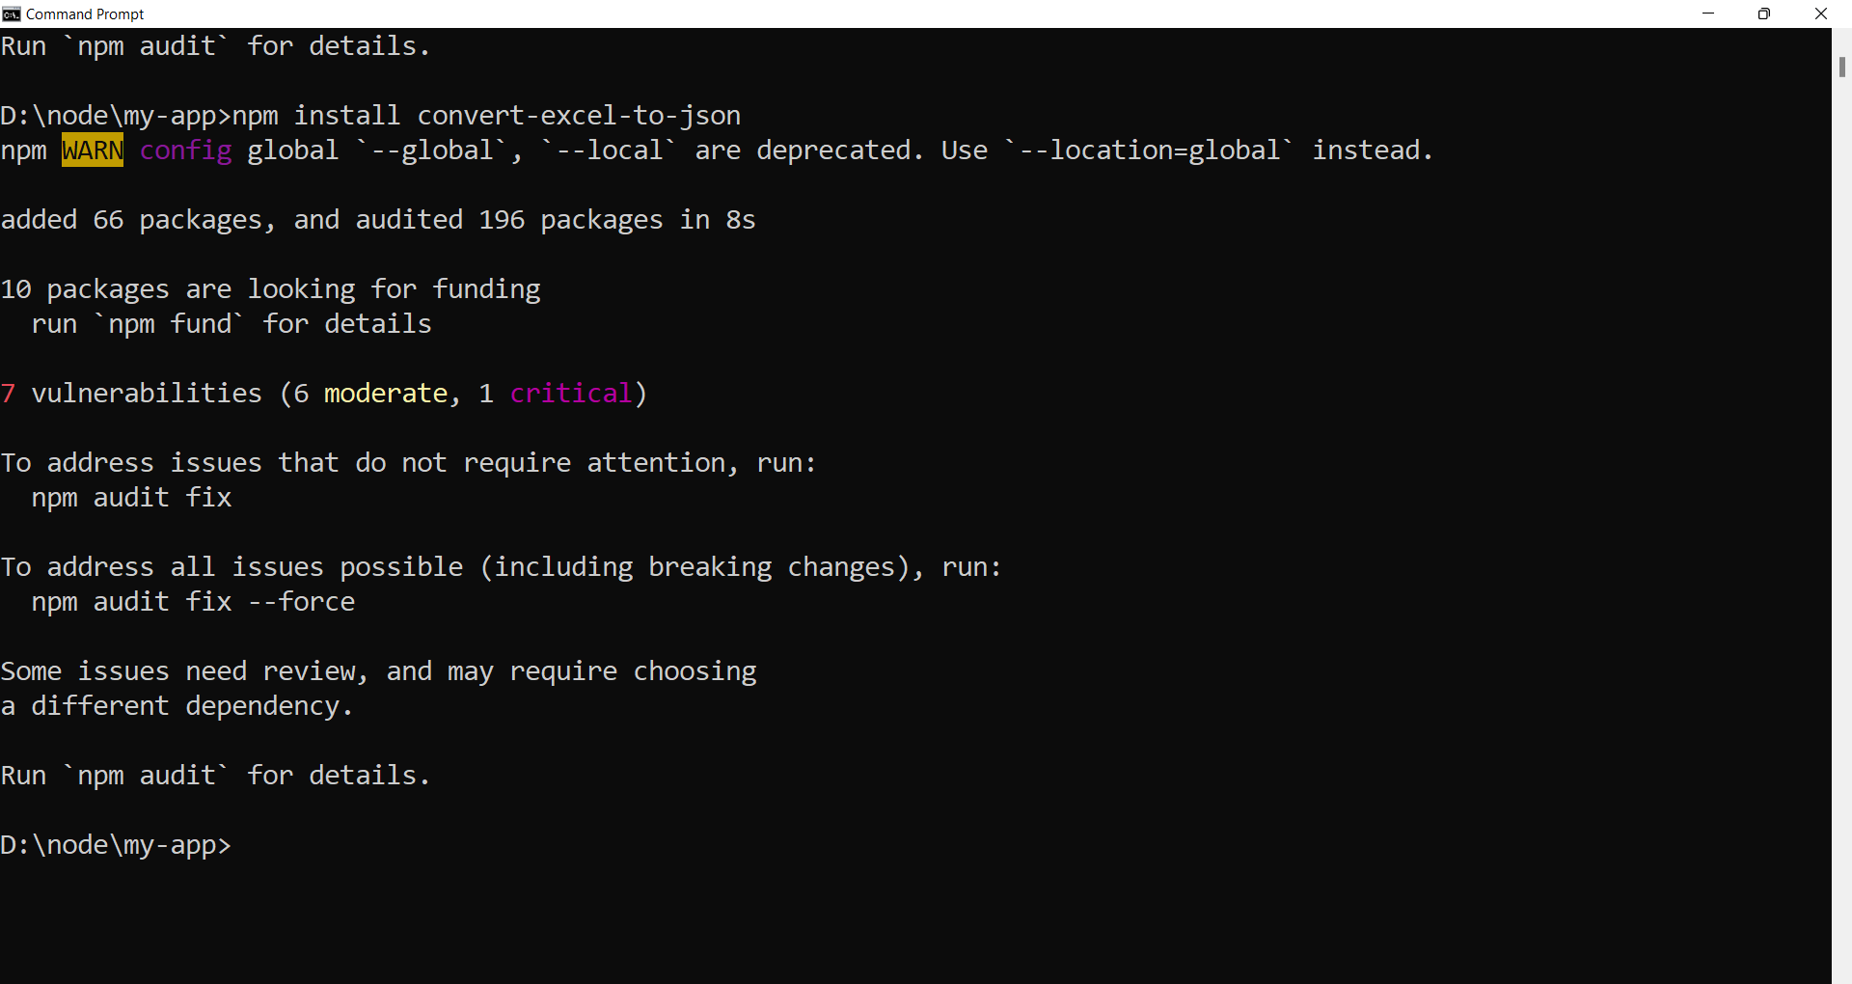

npm i async

[Understanding the mongoose __v field | ObjectRocket](https://kb.objectrocket.com/mongo-db/understanding-the-mongoose-__v-field-1011)

[BSON Types — MongoDB Manual](https://www.mongodb.com/docs/manual/reference/bson-types/#std-label-objectid)

MongoDB stores data records as **BSON documents**. BSON is a binary representation of JSON documents, though it contains more data types than JSON.

[Documents — MongoDB Manual](https://www.mongodb.com/docs/manual/core/document/#:~:text=MongoDB%20stores%20data%20records%20as,more%20data%20types%20than%20JSON.)

Excel

<https://www.npmjs.com/package/convert-xls-files-to-json>

<https://github.com/dhuddell/convert-xls-to-json/>