House Price Prediction – Executive Report
Generated 23 September 2026

Executive summary
A Linear Regression model trained on 800 houses and evaluated on 200 unseen houses explains 99.8% of price variance (MAE $8,175, RMSE $10,071). Ridge and Lasso perform almost identically, so the simpler unregularised model is deployed.

Approach
- Data: house area, number of rooms and sale price.
- Preprocessing: StandardScaler fitted on the training split only.
- Models compared: Linear Regression, Ridge, Lasso (80/20 split, 5-fold CV).
- Serving: Flask REST API (/predict) with a Streamlit front end.

Results
Model | MAE | RMSE | Test R² | CV R²
Linear Regression | 8,175 | 10,071 | 0.998 | 0.999
Ridge (alpha=1.0) | 8,242 | 10,123 | 0.998 | 0.999
Lasso (alpha=1.0) | 8,175 | 10,072 | 0.998 | 0.999

Model coefficients (scaled features)
- Square_Footage: 249,788 per standard deviation
- Num_Bedrooms: 14,525 per standard deviation
- Num_Bathrooms: 6,696 per standard deviation
- Year_Built: 20,662 per standard deviation
- Lot_Size: 19,088 per standard deviation
- Garage_Size: 4,219 per standard deviation
- Neighborhood_Quality: 335 per standard deviation
Intercept: 618,576

Charts
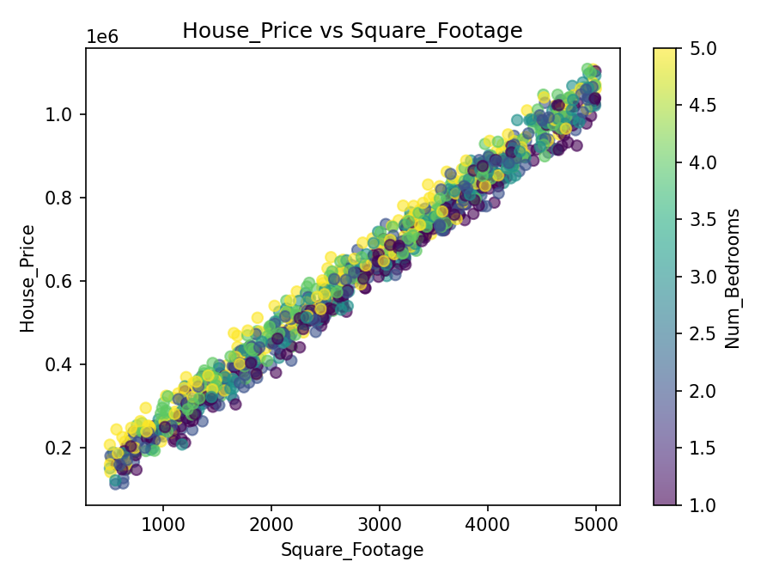
Price vs area, coloured by number of rooms
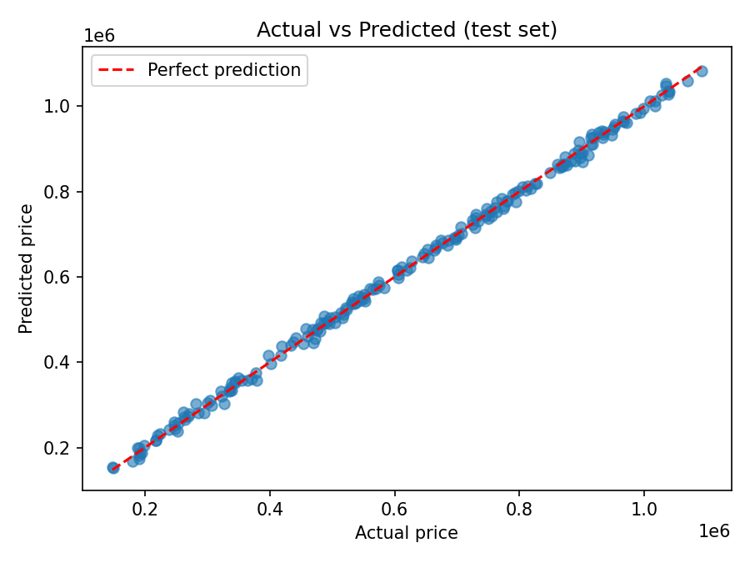
Actual vs predicted prices on the held-out test set
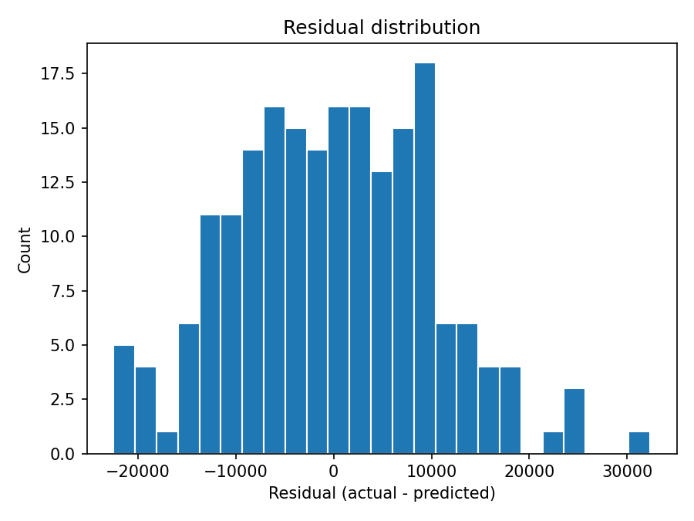
Distribution of residuals
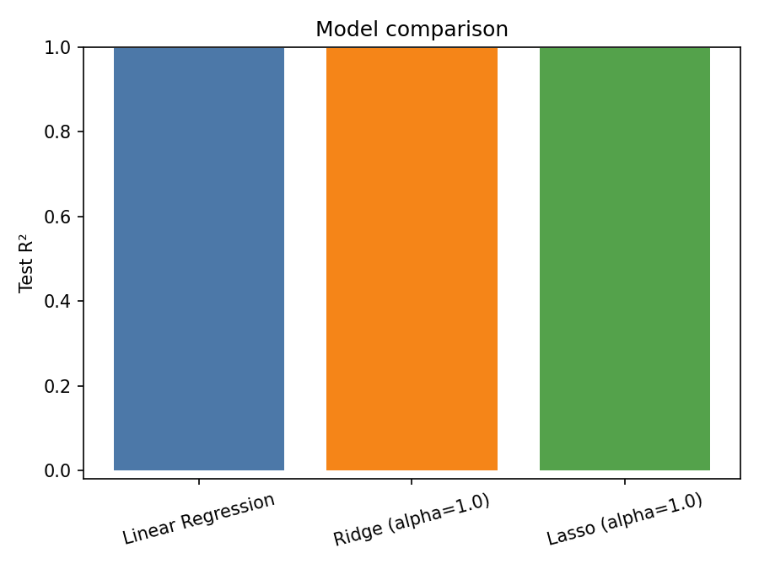
Test R² of Linear, Ridge and Lasso

