Hinglish Sarcasm Detector
Detecting sarcasm in code-mixed Hindi–English text using fine-tuned transformers
Khushi Panchotiya (23BIT112) and Grishma Makwana (23BIT108)
Natural Language Processing Mini Project, ICT Semester 7, Pandit Deendayal Energy University, Gandhinagar
1. Introduction
Sarcasm is one of the hardest things for a machine to understand, because the words say one thing and the speaker means the opposite. The problem is harder in India, where people mix Hindi and English in the same sentence and write Hindi in Roman letters (Hinglish), with spelling that changes from writer to writer. Sentiment tools built for clean English usually fail on such text. For example, “wah kya baat hai, bilkul time pe aaye” uses praise to mock lateness and is sarcastic, whereas “thanks yaar, time pe aaye, maza aa gaya” is genuine thanks and is sincere.
The objective of this project is to build a system that reads a Hinglish comment and predicts whether it is Sarcastic or Sincere, together with a confidence score. We prepare a clean labelled dataset, compare a classical baseline (TF-IDF with Logistic Regression) against three fine-tuned transformer models (MuRIL, XLM-RoBERTa and HingBERT), analyse the errors, and deliver a working web application. The NLP tasks covered are text classification and sentiment analysis.
2. Dataset and Preprocessing
We use the public Hinglish Sarcasm Detection Dataset of Jain and Nagulapalli (2025), which has 8,885 comments. The target is the human-assigned label (the dataset also contains an AI-generated label, which we do not use). Cleaning removed 3 rows with an invalid label, 24 texts that appeared with conflicting labels, and all exact duplicates, leaving 8,464 comments: 4,819 Sincere (56.9%) and 3,645 Sarcastic (43.1%). Because the classes are mildly imbalanced, macro-F1 is our main metric.
Preprocessing decisions were made specifically for sarcasm. Emojis (converted to words) and punctuation are kept because they carry tone, stop words are kept because small words such as “bilkul” and “kya” shape sarcastic meaning, stretched letters are collapsed (“waaaah” becomes “waah”), and links and user mentions are replaced. The data was split in a stratified way into training (6,771), validation (846) and test (847) sets with a fixed seed, and we verified that no text appears in more than one split. The validation set is used for model selection and the test set only for the final evaluation.
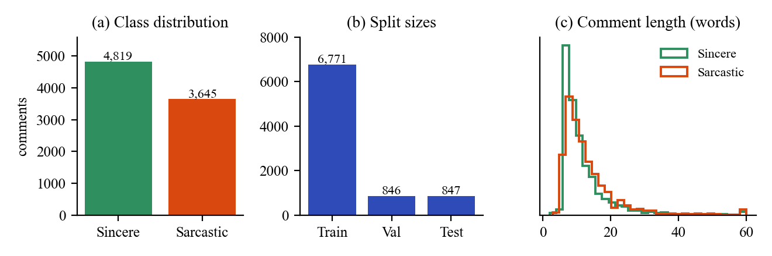
Figure 1. Dataset overview: (a) class distribution after cleaning, (b) train, validation and test sizes, (c) comment length in words for each class (capped at 60).
3. Methodology
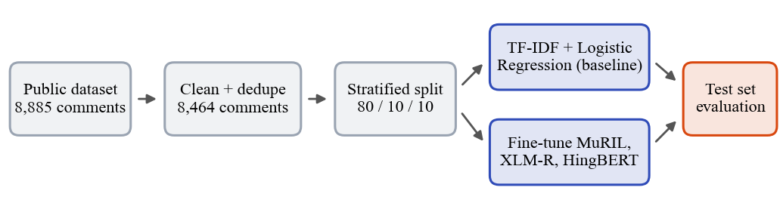
Figure 2. Overall pipeline from the raw dataset to the final test evaluation.
The baseline combines word 1–2-gram and character 2–5-gram TF-IDF features with a class-balanced Logistic Regression. It treats words independently and therefore cannot capture the mismatch between positive words and a negative situation that defines sarcasm. A majority-class predictor is also reported as a reference floor. For the transformers we fine-tuned MuRIL (google/muril-base-cased, pretrained on Indian languages including transliterated text), XLM-RoBERTa base (a strong multilingual model) and HingBERT (l3cube-pune/hing-bert, pretrained on Hinglish text). Each model has a two-class classification layer on top and was trained on a Google Colab GPU with identical settings (Table 1), so the comparison is fair. After every epoch the model is scored on the validation set, and the epoch with the best validation macro-F1 is kept.
Table 1. Training settings used for all three transformers.
Setting | Value | Setting | Value
Max epochs | 5 (early stopping, patience 2) | Learning rate | 2e-5
Batch size | 16 | Max length | 128 tokens
Weight decay | 0.01 | Warm-up | 10% of steps
Model selection | Best validation macro-F1 | Seed / precision | 42 / mixed (fp16)

4. Results
All models were evaluated once on the same 847 held-out test comments (Table 2). HingBERT is the best model with a macro-F1 of 0.694. MuRIL (0.664) and the TF-IDF baseline (0.659) are close to each other, XLM-RoBERTa is slightly lower (0.646), and the majority-class reference scores only 0.363. Our planned target of 0.80 macro-F1 was not reached.
Table 2. Test-set results (847 comments). CI is a 95% bootstrap confidence interval for macro-F1.
Model | Accuracy | Macro-P | Macro-R | Macro-F1 | 95% CI
Majority class | 0.569 | 0.285 | 0.500 | 0.363 | 0.349–0.375
TF-IDF + LR | 0.661 | 0.660 | 0.663 | 0.659 | 0.624–0.691
MuRIL | 0.666 | 0.666 | 0.669 | 0.664 | 0.630–0.698
XLM-R | 0.647 | 0.649 | 0.652 | 0.646 | 0.613–0.677
HingBERT | 0.695 | 0.695 | 0.699 | 0.694 | 0.661–0.726

Because the test set is small, differences between models can partly be luck, so we also computed bootstrap confidence intervals from 1,000 resamples of the test set (Figure 3a). HingBERT improves on the baseline by +0.035 macro-F1 (95% CI +0.004 to +0.067) and is better in 99% of the resamples, a modest but consistent gain. The confidence intervals of MuRIL and XLM-RoBERTa overlap the baseline, so we cannot claim that they are better. All models find Sincere comments easier than Sarcastic ones (Figure 3b), and HingBERT detects 265 of the 365 sarcastic test comments (Figure 4) compared with 248 for the baseline. The numbers here come from predictions recomputed on a CPU and differ by at most 0.002 from those logged at the end of GPU training.
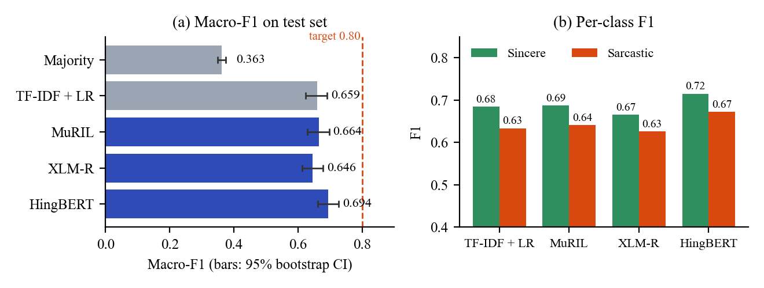
Figure 3. (a) Macro-F1 of every model with 95% bootstrap confidence intervals and the 0.80 target, (b) F1 per class.
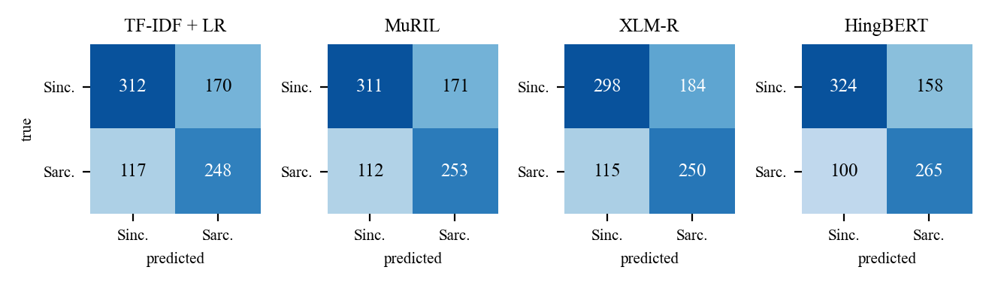
Figure 4. Confusion matrices on the test set (rows: true class, columns: predicted class).
5. Error Analysis
HingBERT made 259 errors on 847 test comments (30.6%): 159 sincere comments predicted as sarcastic and 100 sarcastic comments predicted as sincere (Figure 5b). We read 30 randomly sampled errors and grouped them (Figure 5a). The main patterns were the following. (1) Laughing emojis: the model treats them as a sign of sarcasm even when the comment is sincere, as in “Godi media ki jal rhi h” followed by a laughing emoji. (2) Political and news comments need background knowledge about the event or video that a single line does not contain. (3) Plain abuse or insults without irony are confused between the two classes. (4) Very short comments such as “yeh hai naye daur ka naye natak” give too little evidence. (5) A few examples look like label noise, for instance pure abuse labelled sarcastic, or an ironic comment labelled sincere such as “jab koi bahana nahi hota to bolte hai ‘server down hai’”. This shows that sarcasm is subjective and that single-annotator labels can disagree with how a second reader would label the same comment.
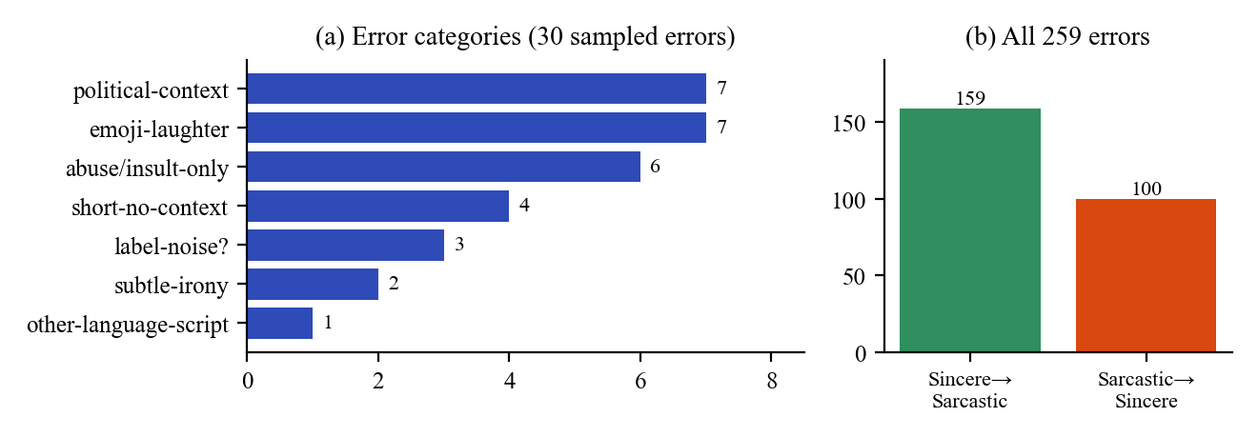
Figure 5. (a) Categories of 30 sampled HingBERT errors, (b) direction of all 259 errors.
6. Web Application
We built a simple web application (Flask backend with an HTML page, plus a Streamlit version) in which the user types a Hinglish line and receives the label Sarcastic or Sincere, a confidence score, and the words that influenced the decision. The influential words are computed with LIME, which perturbs the input and measures how each word pushes the prediction (Figure 6). The Streamlit version also has a “try to fool the model” mode and a feedback button that stores corrections for future retraining. The app runs on the HingBERT model.
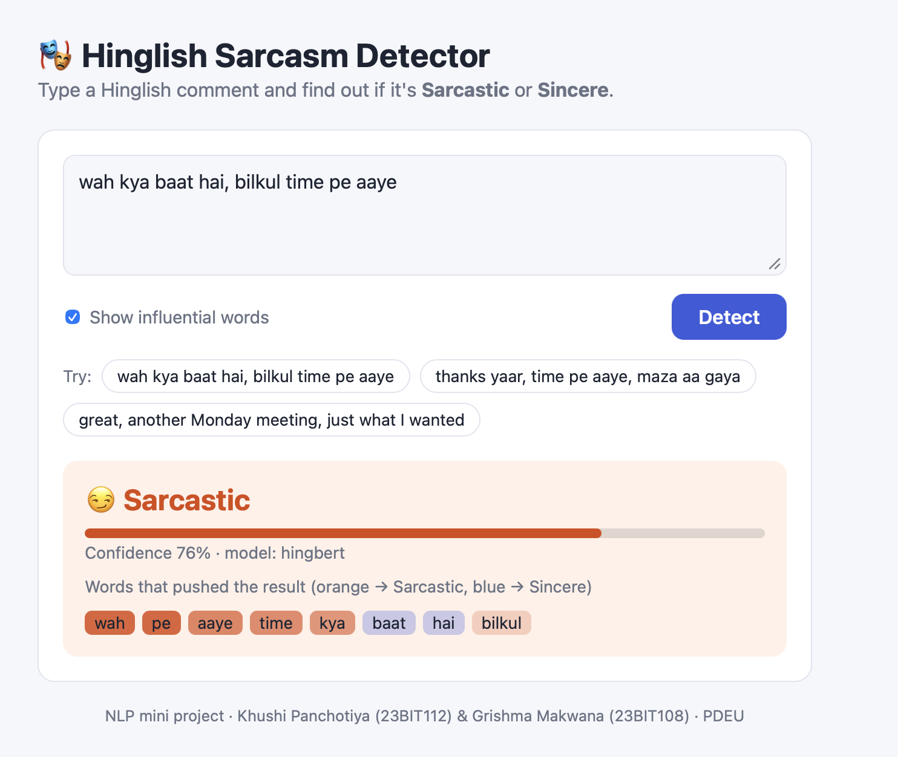
Figure 6. The web application predicting a sarcastic Hinglish comment with confidence and influential words.
7. Conclusion, Limitations and Future Work
We built a complete pipeline for Hinglish sarcasm detection: data cleaning, a baseline, three fine-tuned transformers, evaluation with confidence intervals, error analysis, explanations and a working web application. HingBERT, which is pretrained on Hinglish, performed best (macro-F1 0.694, accuracy 0.695) but the improvement over the TF-IDF baseline (0.659) is modest, and the 0.80 target was not met.
The results should be read with these limitations. The labels come from a single annotator and sarcasm is subjective, so some labels are noisy and we did not measure inter-annotator agreement (Cohen’s kappa). Comments are standalone and lack conversation context. The data is mostly political and news-related social-media text, so results may not transfer to other topics or platforms, and it contains offensive language. The source repository does not specify a license, so permission should be confirmed before redistributing the data. Each model was trained once with one setting, and the 847-comment test set limits precision to about three points. Future work includes double-annotated labels, using conversation context, hyperparameter tuning, combining the baseline with HingBERT, and deploying a public demo.
References
[1] Jain, M. and Nagulapalli, H. (2025). Hinglish Sarcasm Detection Dataset. github.com/mananjen/hinglish_sarcasm_dataset.
[2] Khanuja, S. et al. (2021). MuRIL: Multilingual Representations for Indian Languages. arXiv:2103.10730.
[3] Conneau, A. et al. (2020). Unsupervised Cross-lingual Representation Learning at Scale. ACL 2020.
[4] Nayak, R. and Joshi, R. (2022). L3Cube-HingCorpus and HingBERT: A Code Mixed Hindi-English Dataset and BERT Language Models.
[5] Ribeiro, M. T., Singh, S. and Guestrin, C. (2016). “Why Should I Trust You?”: Explaining the Predictions of Any Classifier. KDD 2016.

