**Project 1: Personal Blog on IBM Cloud Static Web Apps**

**Project Title:** Personal Travel Blog

**Phase 2: Problem Definition and Design Thinking**

**Problem Statement:** Create a personal travel blog hosted on IBM Cloud Static Web Apps. Share your travel adventures, tips, and captivating photos with the world. Use IBM Cloud Static Web Apps to easily update your blog and document your journeys. Inspire others to explore the beauty of the world and forge unforgettable memories!

**Problem Definition:** The project aims to develop a captivating personal travel blog hosted on IBM Cloud Static Web Apps. The primary objective is to inspire and engage readers by sharing enriching travel experiences, insightful tips, and visually stunning photographs. The overarching goal is to motivate and guide individuals to explore the world, create unforgettable memories, and enhance their overall travel experiences. The project involves multifaceted tasks, including designing an intuitive and appealing blog structure, crafting engaging and informative content, configuring and setting up IBM Cloud Static Web Apps for seamless hosting, and establishing an efficient process for updating the blog to keep it current and engaging.

**Innovation:**

1. **Interactive Travel Maps:**

Integrate interactive maps that allow users to explore the destinations you've visited. Users can click on map markers to access related blog posts, photo galleries, and travel tips for specific locations.

1. **User-Generated Content:**

Allow readers to contribute their travel stories, photos, and tips to your blog. This could foster a community of travel enthusiasts and provide diverse perspectives on different destinations.

1. **Personalized Travel Recommendations:**

Implement a recommendation engine that suggests travel destinations, accommodations, or activities based on users' preferences and past interactions with your blog.

1. **Live Streaming and Vlogging:**

Incorporate live streaming or vlogging capabilities to share real-time travel experiences with your audience. Live Q&A sessions from various destinations can engage viewers and build a sense of connection.

1. **Multi-Language Support:**

Make your blog accessible to a global audience by providing content in multiple languages. Use automatic translation tools or work with translators to reach a broader readership.

1. **AI-Powered Content Insights**:

Utilize AI to analyze user interactions and provide insights into what content resonates the most. This data can help you tailor your future travel stories and tips.

1. **Sustainability and Responsible Travel Initiatives:**

Highlight eco-friendly and responsible travel practices, inspiring your audience to explore the world while preserving its beauty and culture.

1. **Collaborations with Local Influencers:**

Partner with local travel influencers or experts when exploring new destinations. This adds authenticity to your content and can provide unique insights.

1. **Podcasts and Audio Content:**

Offer travel-related podcasts or audio guides for users who prefer listening over reading. Covering various travel topics and interviews with fellow adventurers can be engaging.

1. **Micro-Interactions and Gamification:**

Implement micro-interactions and Gamification elements to make the user experience more enjoyable. For example, users can earn badges or points for reading, commenting, or sharing content.

**11.Artificial Intelligence Chat bots:**

Use AI chat bots to provide instant responses to common user queries, offer travel recommendations, and guide users through the blog's features.

**12.Social Integration:**

Allow users to easily share your blog content on their social media platforms, and include social media feeds to connect with your audience on various channels.

**13.Visual Search:**

Implement visual search functionality, allowing users to search for travel destinations or related content by uploading images they find inspiring.

**Implementation Flow Chart:**

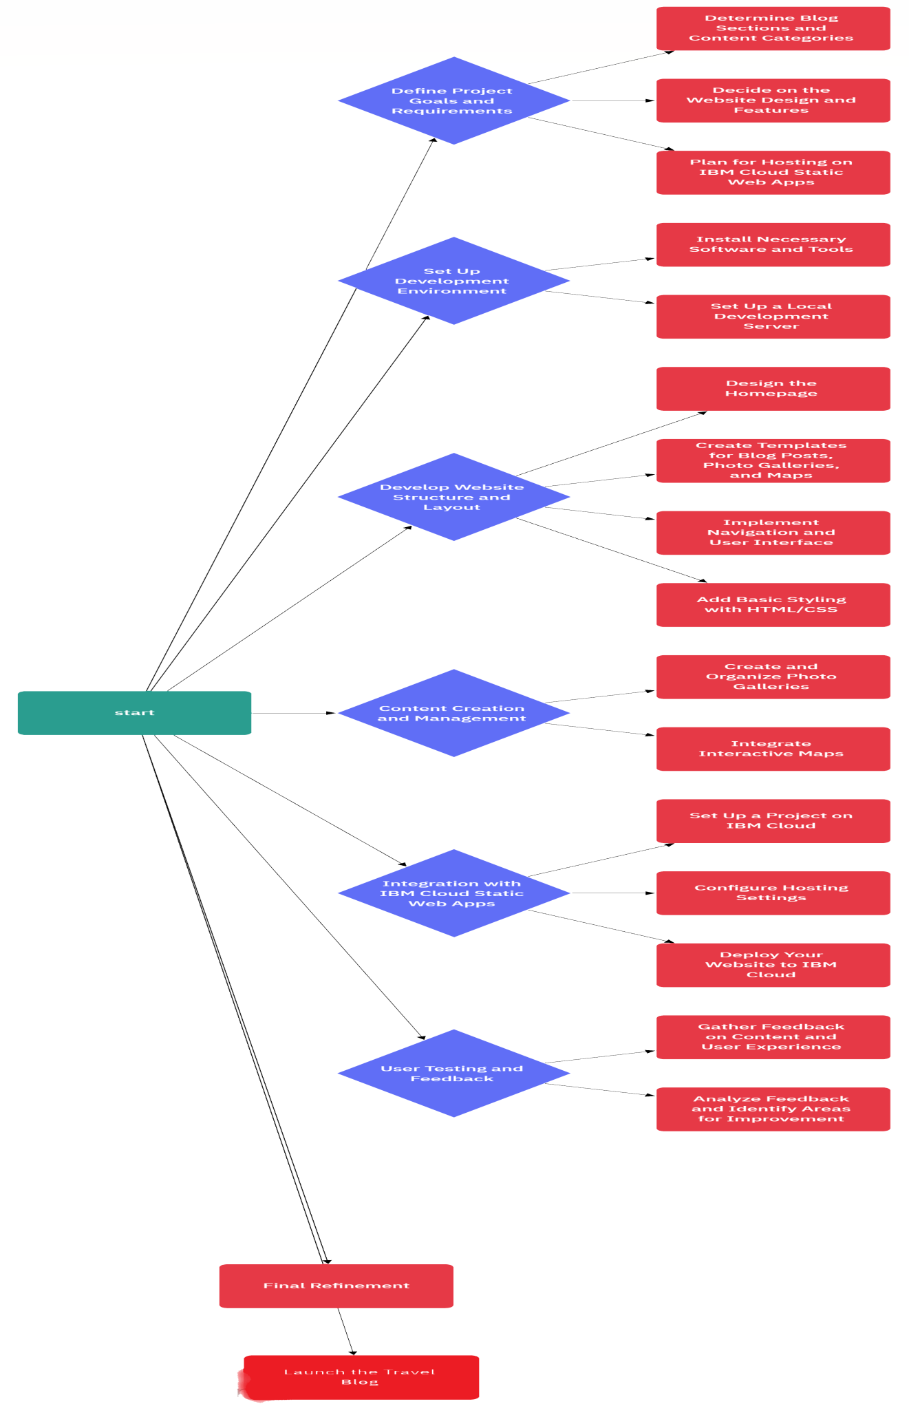

**Conclusion:**

Hosting a personal blog on cloud static web apps is a strategic move, merging speed, reliability, and scalability. These platforms ensure instantaneous loading for an optimal user experience, bolstered security for content protection, and the flexibility to accommodate growing traffic, making them an ideal choice for bloggers seeking both performance and peace of mind.