SOFTWARE ENGINEERING
LAB 1
Name: Khushi Gupta | SRN: PES1UG24AM912 | SEC :F
Requirements Table:
Req ID | Type | Description | Priority | Acceptance Criteria | Rationale
FR-001 | Functional | The system shall ingest household monthly electricity (kWh) and transport (km) logs to compute total monthly carbon equivalent (CO₂e) emissions. | High | Pass: Calculated emissions match the specified EPA conversion factor formulas. Fail: Zero or negative emission values are generated. | This is the core functionality for calculating the household's monthly carbon footprint.
FR-002 | Functional | The system shall allow the Resident to enter and store monthly electricity consumption in kWh and transport distance in km. | High | Pass: Valid electricity and transport values are successfully stored for the selected month and can be retrieved. Fail: Missing, invalid, or negative values are stored. | The system requires monthly consumption data as input for carbon-emission calculation.
FR-003 | Functional | The system shall display the household's calculated monthly CO₂e emissions and historical emission data for comparison. | High | Pass: The system displays the calculated CO₂e value for the selected month and previously recorded monthly values. Fail: The calculated value or historical records are missing or incorrect. | Enables the Resident to understand and compare the household's carbon footprint over time.
FR-004 | Functional | The system shall allow the Resident to define an annual carbon-reduction target and corresponding reduction milestones. | Medium | Pass: A valid annual reduction target is saved and the corresponding milestones are displayed. Fail: The target is not saved or invalid target values are accepted. | Allows the household to establish measurable carbon-reduction goals.
FR-005 | Functional | The system shall track the household's progress toward the defined annual carbon-reduction target and milestones. | High | Pass: After new monthly consumption data is recorded, the system updates the household's progress and correctly indicates achieved milestones. Fail: Progress or milestone status is not updated correctly. | Helps the Resident monitor whether the household is meeting its carbon-reduction goals.

Non-functional requirement(2):
Non-Functional — Performance | The annual carbon reduction milestone chart must render interactive historical comparison graphs in under 200 ms. | High | Pass: Benchmarking tests confirm that the interactive historical comparison graph renders in less than 200 ms under the specified test conditions. Fail: The graph takes 200 ms or longer to render. | Ensures responsive visualization and quick access to historical carbon-footprint comparisons.
Non-Functional — Security | The system shall ensure that household consumption and carbon-footprint data can only be accessed by authorized users. | High | Pass: Authorized users can access the associated household data, while unauthorized access attempts are denied in 100% of security test cases. Fail: Any unauthorized user gains access to household data. | Protects potentially sensitive household consumption and sustainability data from unauthorized access.

UML Use-Case Diagram:
>> Model all actors, primary use cases, and include at least one «include» and one «extend» relationship.

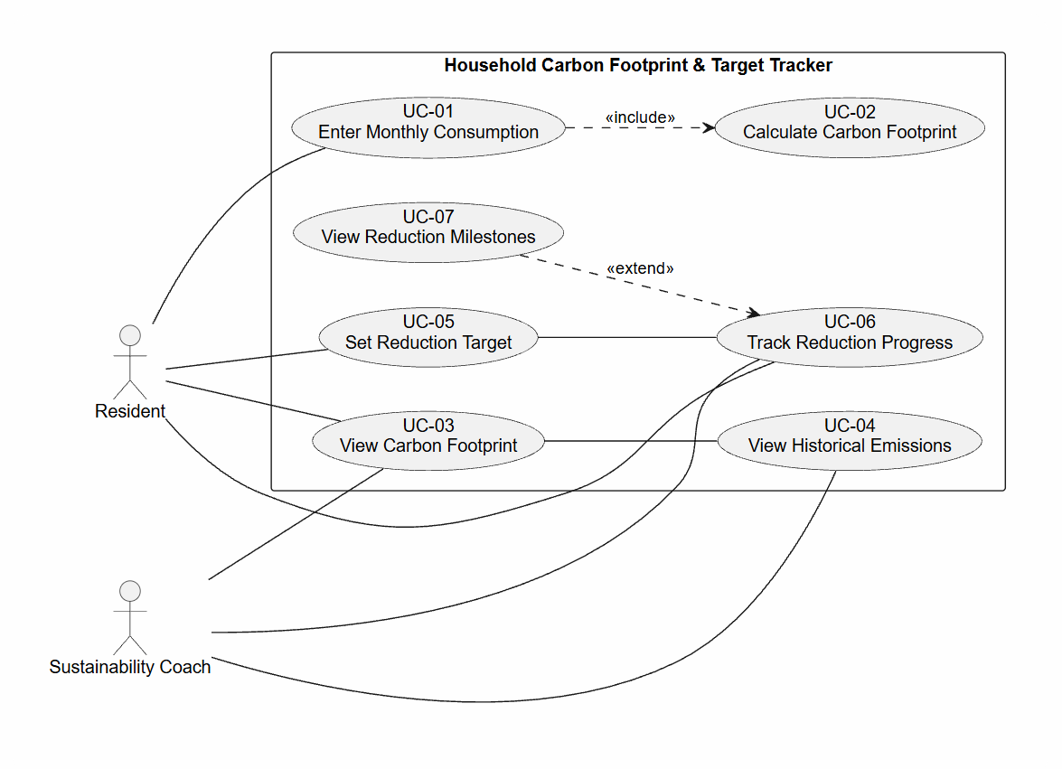
• Use-Case Flow Specification:
>> 1-page document for one core use case detailing Preconditions, Postconditions, Main Success Scenario
>> One Alternate Flow.
Use-Case Flow Specification
UC-01: Enter Monthly Consumption and Calculate Carbon Footprint
Primary Actor: Resident
Supporting Actor: Sustainability Coach
Goal: To record the household's monthly electricity and transport consumption and calculate the corresponding monthly CO₂e emissions.
Preconditions
- The Resident has access to the Household Carbon Footprint & Target Tracker system.
- The Resident is authorized to enter household consumption data.
- The required carbon-emission conversion factors are available in the system.
- The Resident has the monthly electricity consumption in kWh and transport distance in km.
Postconditions
- The valid monthly electricity and transport data are stored in the system.
- The system calculates the household's total monthly CO₂e emissions.
- The calculated monthly CO₂e value is stored and available for historical comparison.
- The updated carbon-footprint information can be viewed by the Resident and authorized Sustainability Coach.
Main Success Scenario
- The Resident selects "Enter Monthly Consumption".
- The system displays a form requesting the household's monthly electricity consumption in kWh and transport distance in km.
- The Resident enters the valid electricity consumption and transport distance for the selected month.
- The Resident submits the consumption data.
- The system validates that the entered values are present, numeric, and non-negative.
- The system stores the monthly electricity and transport consumption data.
- The system applies the configured conversion factors to calculate the household's total monthly CO₂e emissions.
- The system verifies that the calculated emissions are a valid non-negative value.
- The system stores the calculated monthly CO₂e value.
- The system displays the calculated monthly carbon footprint to the Resident.
- The use case ends successfully.
Alternate Flow — Invalid Consumption Data
5a. Invalid or Negative Input
- At Step 5, the system detects that one or more entered values are missing, non-numeric, or negative.
- The system displays an error message identifying the invalid input.
- The system does not store the invalid data or calculate the carbon footprint.
- The Resident corrects the input values.
- The system validates the corrected values.
- The flow resumes from Step 6 of the Main Success Scenario.
Alternate Flow — Calculation Error
7a. Invalid CO₂e Calculation
- At Step 8, the system detects that the calculated CO₂e value is zero or negative.
- The system displays a calculation-error message.
- The system does not save the invalid carbon-footprint result.
- The Resident is prompted to verify the entered consumption data.
- The use case ends without completing the carbon-footprint update.

