HOSPITAL PATIENT
SATISFACTION DASHBOARD
Data Analytics & Visualization Report
Prepared by - Khushi Yadav
Project Objective
To build an interactive Power BI dashboard that analyzes hospital patient satisfaction, survey response rates, completed surveys, state-level performance, satisfaction measures, and trends across reporting periods.
1. Introduction & Project Overview
The Hospital Patient Satisfaction Dashboard is an interactive Power BI solution designed to analyze patient satisfaction and survey-response patterns. It combines KPI cards, state-level comparisons, time-series analysis, measure-level satisfaction, completed survey analysis, interactive slicers, and Key Influencers to provide a concise view of hospital survey performance.
Dataset Information
- Dataset: HCAPS (Hospital Consumer Assessment of Healthcare Providers and Systems) survey data.

- Data Coverage: The dataset contains hospital patient-satisfaction responses, survey measures, response rates, states, and reporting periods.

- Purpose: The dataset was selected to evaluate patient satisfaction, compare state-level performance, analyze survey response patterns, and identify trends over time.

- BI Objective: Power BI was used to transform, model, analyze, and visualize the data through interactive KPIs, charts, slicers, and analytical visuals.

Key Performance Indicators
KPI | Value | Interpretation
Total Surveys | 22,313,731 | Overall survey volume
Average Top Box | 71.33 | High-level patient satisfaction indicator
Average Response Rate | 27 | Average survey response rate
Average Middle Box | 20.27 | Moderate satisfaction indicator
Dashboard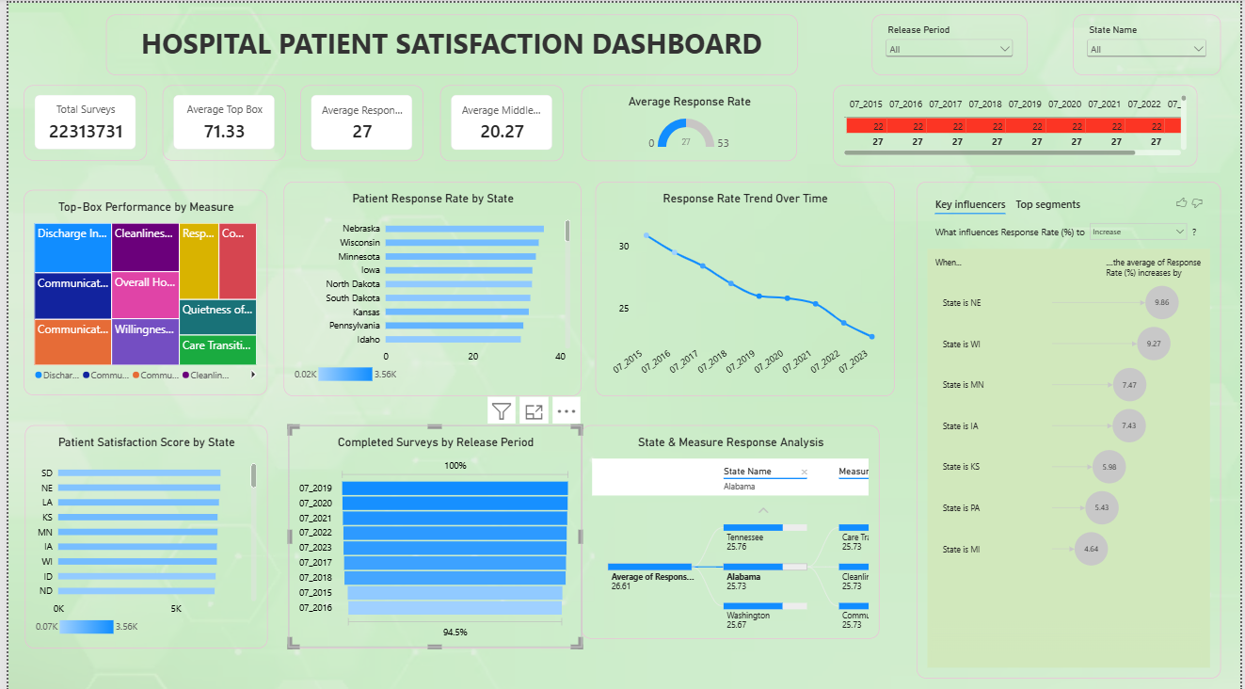
Figure 1: Dashboard KPI Overview
The dashboard includes Release Period and State Name slicers, enabling users to dynamically filter the analysis and investigate specific periods or states.

2. Data Preparation & Data Model

Data Cleaning and Transformation
- Null/blank values were removed from the relevant response-rate field so that incomplete records did not distort the analysis.
- Duplicate Facility IDs were removed from the responses query to reduce duplicate facility-level records.
- Data types were standardized for fields such as Release Period, Response Rate, and survey-related columns.
- Power Query steps were used to prepare the data before loading it into the Power BI data model.

What is M Query?
M Query is the formula language used by Power Query. It records transformation steps such as filtering rows, changing data types, removing errors, replacing values, and removing duplicates. This makes the data-preparation process repeatable whenever the source data is refreshed.

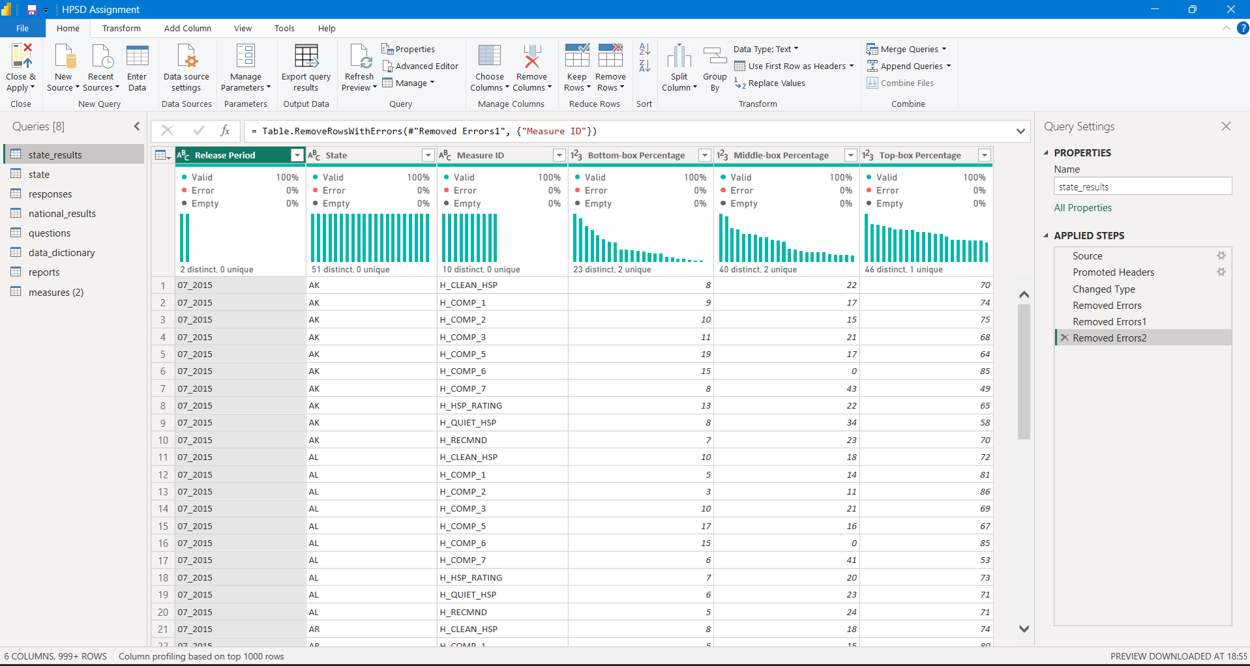
Figure 2: Power Query Data Cleaning and Transformation Steps

Data Model
The model contains tables for responses, state, state_results, national_results, questions, measures, reports, and the data dictionary. Relationships between these tables allow filters and measures to work together and support state-, measure-, and release-period analysis.

Model Component | Role in Analysis
responses | Facility-level survey volume and response-rate information
state | State/region reference information
state_results | State-level Top-, Middle-, and Bottom-Box percentages
national_results | National satisfaction results by release period and measure
questions / measures | Survey questions and measure definitions
reports | Release-period date information

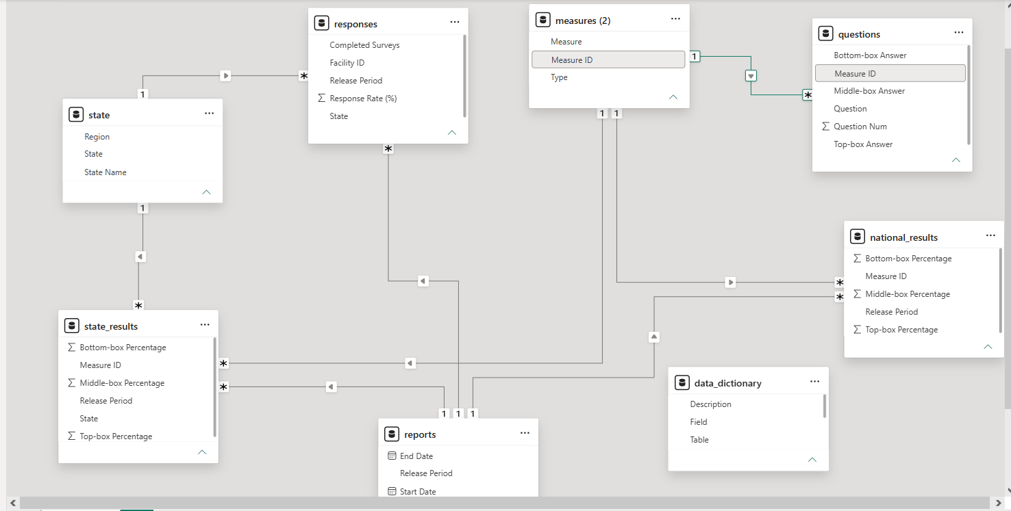
Figure 3: Power BI Data Model and Table Relationships
3. DAX, Visualizations & Insights
DAX Measures
Measure | DAX Formula
Average Top Box | AVERAGE(state_results[Top-box Percentage])
Average Middle Box | AVERAGE(state_results[Middle-box Percentage])
Average Response Rate | AVERAGE(responses[Response Rate (%)])
Total Surveys | SUMX(responses, IFERROR(VALUE(responses[Completed Surveys]), 0))

Visualizations Used
KPI Cards • Treemap • Bar Charts • Line Chart • Decomposition/State & Measure Analysis • Key Influencers • Slicers • Report-page Tooltips
Key Insights

The overall Average Top Box score is 71.33, indicating strong high-level satisfaction across the analyzed measures.
- The Average Middle Box score is 20.27, providing a complementary view of moderate satisfaction.
- The overall Average Response Rate is 27.
- Response rate shows an overall downward trend across the release periods, moving from roughly the low-30% range in 2015 to the low-20% range by 2023.
- Response rates vary across states, enabling comparison of stronger and weaker response-rate performance.
- Discharge Information and communication-related measures appear among the stronger Top-Box satisfaction measures.
- The Release Period and State Name slicers make the dashboard interactive and allow focused analysis.
- The Key Influencers visual highlights states associated with comparatively higher response-rate values

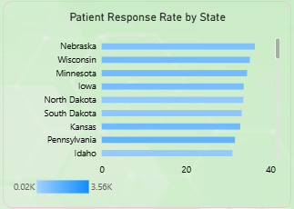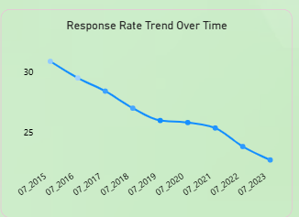
Patient Response Rate by State
The bar chart compares average response rates across states and helps identify states with relatively higher or lower survey response performance.
. Response Rate Trend Over Time
The line chart shows the change in average response rate across release periods and highlights the overall downward trend over time.

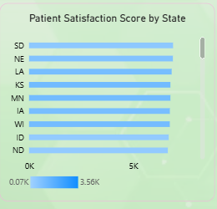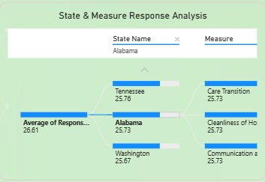
Patient Satisfaction Score by State
The bar chart compares completed survey volumes across states, helping identify differences in survey participation and patient satisfaction coverage.
State & Measure Response Analysis
This visual provides a detailed comparison between states and satisfaction measures, allowing users to explore performance at a more granular level.
Recommendations
- Investigate the decline in survey response rates and identify barriers to patient participation.
- Use high-performing states as benchmarks and study their practices for improving patient engagement.
- Prioritize satisfaction measures with comparatively lower Top-Box performance for targeted improvement.
- Strengthen communication and discharge-related processes because these measures show strong performance and can provide useful best practices.
- Continue monitoring satisfaction and response-rate trends by release period to evaluate improvement initiatives.
Conclusion
The Hospital Patient Satisfaction Dashboard provides a data-driven and interactive view of patient satisfaction and survey response patterns. Power Query supports structured data preparation, DAX provides reusable analytical calculations, and Power BI visualizations communicate the results clearly. The dashboard can help healthcare stakeholders identify performance gaps, compare states and measures, and monitor trends for better patient-experience decisions.

