Assignment – 5

**1. Write a Servlet program to get current time of server machine.**

**# ServerTimeServlet.java :-**

import java.io.IOException;

import java.io.PrintWriter;

import java.time.LocalDateTime;

import java.time.format.DateTimeFormatter;

import javax.servlet.ServletException;

import javax.servlet.annotation.WebServlet;

import javax.servlet.http.HttpServlet;

import javax.servlet.http.HttpServletRequest;

import javax.servlet.http.HttpServletResponse;

@WebServlet("/ServerTime")

public class ServerTimeServlet extends HttpServlet

{

private static final long serialVersionUID = 1L;

protected void doGet(HttpServletRequest request, HttpServletResponse response) throws ServletException, IOException

{

LocalDateTime now = LocalDateTime.now();

DateTimeFormatter formatter = DateTimeFormatter.ofPattern("EEEE, dd MMMM yyyy | HH:mm:ss a");

String formattedTime = now.format(formatter);

response.setContentType("text/html");

PrintWriter out = response.getWriter();

out.println("<html><head><title>Server Time</title>");

out.println("<style>");

out.println("body { font-family: Arial, sans-serif; background: linear-gradient(to right, #6a11cb, #2575fc); ");

out.println("display: flex; align-items: center; justify-content: center; height: 100vh; margin: 0; color: white; }");

out.println(".container { background: rgba(255, 255, 255, 0.1); padding: 30px; border-radius: 10px; ");

out.println("box-shadow: 0px 4px 10px rgba(0, 0, 0, 0.2); text-align: center; backdrop-filter: blur(10px); }");

out.println("h1 { font-size: 28px; margin-bottom: 10px; }");

out.println("h2 { font-size: 22px; font-weight: 300; }");

out.println(".time { font-size: 26px; font-weight: bold; color: #ADB2D4;}");

out.println("</style>");

out.println("</head><body>");

out.println("<div class='container'>");

out.println("<h1>Current Server Time</h1>");

out.println("<h2 class='time'>" + formattedTime + "</h2>");

out.println("</div>");

out.println("</body></html>");

}

}

**# Output :-**

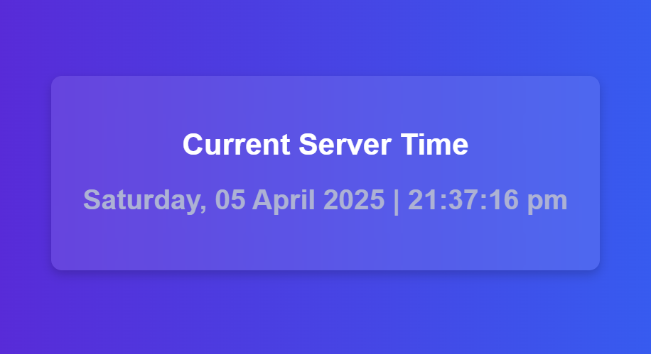

**2. Write a Servlet to send the bookid from client, fetch the book details from server and display the results on client.**

**# BookIdForm.jsp :-**

<%@ **page** language=*"java"* contentType=*"text/html; charset=UTF-8"* pageEncoding=*"UTF-8"* %>

<!**DOCTYPE** html>

<**html**>

<**head**>

<**title**>Search Book</**title**>

<**link** rel=*"stylesheet"* href=*"static/styles1.css"*>

</**head**>

<**body**>

<**div** class=*"container"*>

<**h2**>Search for a Book</**h2**>

<**form** action=*"BookDetails"* method=*"get"*>

<**input** type=*"number"* name=*"bookid"* placeholder=*"Enter Book ID"* required>

<**button** type=*"submit"*>Search</**button**>

</**form**>

</**div**>

</**body**>

</**html**>



**# BookDetails.jsp :-**

<%@ **page** language=*"java"* contentType=*"text/html; charset=UTF-8"* pageEncoding=*"UTF-8"* %>

<%@ **page** import=*"java.util.Map"* %>

<!**DOCTYPE** html>

<**html**>

<**head**>

<**title**>Book Details</**title**>

<**link** rel=*"stylesheet"* href=*"static/styles2.css"*>

</**head**>

<**body**>

<**div** class=*"container"*>

<**h2**>Book Details</**h2**>

<%

boolean isFound = (request.getAttribute("isFound") != null) ? (boolean) request.getAttribute("isFound") : false;

if (!isFound) {

%>

<**p** class=*"not-found"*>Book Not Found</**p**>

<%

} else {

Map<String, Object> book = (Map<String, Object>) request.getAttribute("book_info");

%>

<**div** class=*"details"*>

<%

for (Map.Entry<String, Object> entry : book.entrySet()) {

String columnName = entry.getKey();

Object columnValue = entry.getValue();

%>

<**p**><**strong**><%= columnName %>:</**strong**> <%= columnValue %></**p**>

<% } %>

</**div**>

<%

}

%>

<**br**>

<**a** href=*"BookIdForm.jsp"*>Search Another Book</**a**>

</**div**>

</**body**>

</**html**>

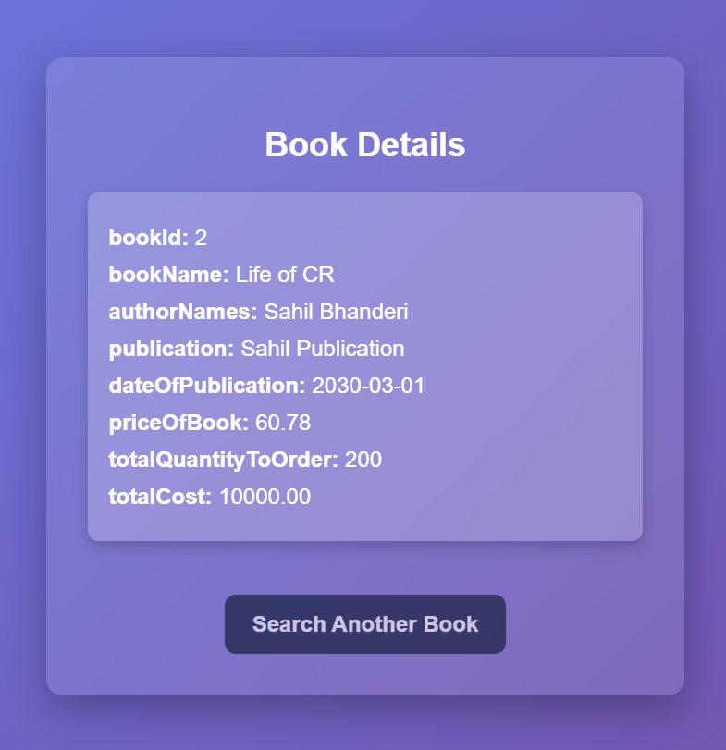

**# BookDetails.java :-**

import java.io.IOException;

import java.sql.Connection;

import java.sql.DriverManager;

import java.sql.PreparedStatement;

import java.sql.ResultSet;

import java.sql.ResultSetMetaData;

import java.util.LinkedHashMap;

import java.util.Map;

import javax.servlet.RequestDispatcher;

import javax.servlet.ServletException;

import javax.servlet.annotation.WebServlet;

import javax.servlet.http.HttpServlet;

import javax.servlet.http.HttpServletRequest;

import javax.servlet.http.HttpServletResponse;

@WebServlet("/BookDetails")

public class BookDetails extends HttpServlet

{

private static final long serialVersionUID = 1L;

public BookDetails() {

super();

}

protected void doGet(HttpServletRequest request, HttpServletResponse response) throws ServletException, IOException {

try

{

int bookId = Integer.parseInt(request.getParameter("bookid"));

request.setAttribute("bookid", bookId);

Class.forName("com.mysql.jdbc.Driver");

Connection con = DriverManager.getConnection("jdbc:mysql://localhost:3306/books?characterEncoding=latin1", "root", "khushi");

PreparedStatement pst = con.prepareStatement("SELECT bookId, bookName, authorNames, publication, dateOfPublication, priceOfBook, totalQuantityToOrder, totalCost FROM book WHERE bookId = ?");

pst.setInt(1, bookId);

ResultSet rs = pst.executeQuery();

ResultSetMetaData metaData = rs.getMetaData();

int columnCount = metaData.getColumnCount();

if(!rs.next())

{

System.out.println("No book found for bookId: " + bookId);

request.setAttribute("isFound", false);

}

else

{

request.setAttribute("isFound", true);

Map<String, Object> book = new LinkedHashMap<>();

for (int i = 1; i <= columnCount; i++)

{

book.put(metaData.getColumnName(i), rs.getObject(i));

}

request.setAttribute("book_info", book);

}

rs.close();

pst.close();

con.close();

RequestDispatcher dispatcher = request.getRequestDispatcher("BookDetails.jsp");

dispatcher.forward(request, response);

}

catch(Exception e)

{

e.printStackTrace();

}

}

protected void doPost(HttpServletRequest request, HttpServletResponse response) throws ServletException, IOException {

doGet(request, response);

}

}

**3. Write a Servlet program (Use Filters) to allow or disallow the user based on the security policies to fetch the data from database and display the contents accordingly.**

**# login.jsp :-**

<%@ **page** language=*"java"* contentType=*"text/html; charset=UTF-8"* pageEncoding=*"UTF-8"* %>

<!**DOCTYPE** html>

<**html**>

<**head**>

<**title**>Login Page</**title**>

<**link** rel=*"stylesheet"* type=*"text/css"* href=*"static/login.css"*>

</**head**>

<**body**>

<**div** class=*"login-container"*>

<**h2**>Login</**h2**>

<**form** action=*"LoginServlet"* method=*"get"*>

<**input** type=*"text"* name=*"username"* placeholder=*"Enter Username"* required>

<**input** type=*"password"* name=*"password"* placeholder=*"Enter Password"* required>

<**button** type=*"submit"*>Login</**button**>

</**form**>

<%

String errorMessage = (String) request.getAttribute("errorMessage");

if (errorMessage != null) {

%>

<**p** class=*"error_message"*><%= errorMessage %></**p**>

<% } %>

</**div**>

</**body**>

</**html**>

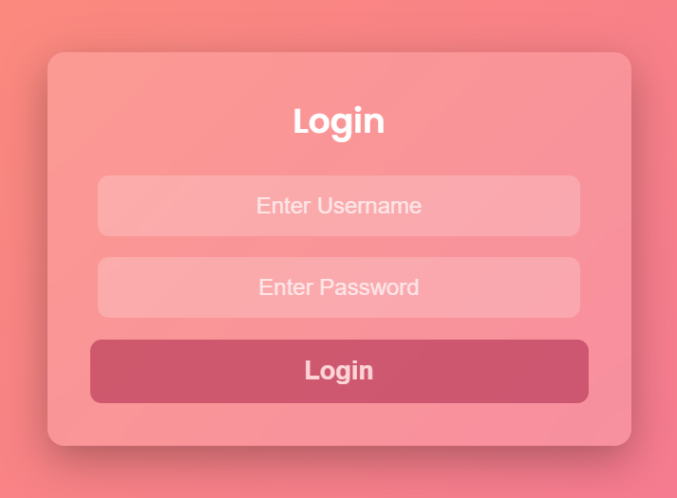

**# accessDenied.jsp :-**

<%@ **page** language=*"java"* contentType=*"text/html; charset=UTF-8"* pageEncoding=*"UTF-8"* %>

<!**DOCTYPE** html>

<**html**>

<**head**>

<**title**>Access Denied</**title**>

<**link** rel=*"stylesheet"* type=*"text/css"* href=*"static/style.css"*>

</**head**>

<**body**>

<**div** class=*"container"*>

<**h2**>Access Denied</**h2**>

<**p**>⚠️ You do not have permission to access this page.</**p**>

<**a** href=*"login.jsp"*>Go to Login</**a**>

</**div**>

</**body**>

</**html**>

**# userBookRequest.jsp :-**

<%@ **page** language=*"java"* contentType=*"text/html; charset=UTF-8"* pageEncoding=*"UTF-8"*%>

<!**DOCTYPE** html>

<**html**>

<**head**>

<**title**>Find Book</**title**>

<**link** rel=*"stylesheet"* type=*"text/css"* href=*"static/login.css"*>

</**head**>

<**body**>

<**div** class=*"login-container"*>

<**h2**>Find a Book</**h2**>

<%

String errorMessage = (String) request.getAttribute("errorMessage");

if (errorMessage != null) {

%>

<**p** class=*"error-message"*><%= errorMessage %></**p**>

<% } %>

<**form** action=*"UserBookServlet"* method=*"get"*>

<**input** type=*"number"* name=*"bookid"* placeholder=*"Enter Book ID"* required>

<**button** type=*"submit"*>Search</**button**>

</**form**>

</**div**>

</**body**>

</**html**>

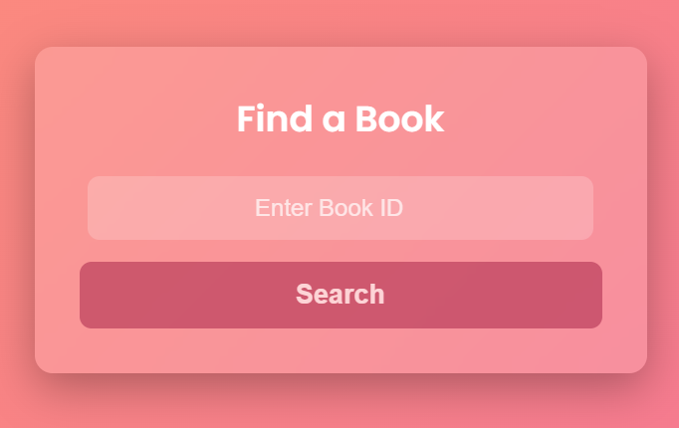

**# userBookDetails.jsp :-**

<%@ **page** language=*"java"* contentType=*"text/html; charset=UTF-8"* pageEncoding=*"UTF-8"*%>

<%@ **page** import=*"java.util.Map"* %>

<!**DOCTYPE** html>

<**html**>

<**head**>

<**title**>Book Details</**title**>

<**link** rel=*"stylesheet"* type=*"text/css"* href=*"static/login.css"*>

</**head**>

<**body**>

<**div** class=*"login-container"*>

<**h2**>Book Details</**h2**>

<%

boolean isFound = (request.getAttribute("isFound") != null) ? (boolean) request.getAttribute("isFound") : false;

if (!isFound) {

%>

<**p** class=*"not-found"*>Book Not Found</**p**>

<%

} else {

Map<String, Object> book = (Map<String, Object>) request.getAttribute("book_info");

%>

<**div** class=*"details"*>

<%

for (Map.Entry<String, Object> entry : book.entrySet()) {

String columnName = entry.getKey();

Object columnValue = entry.getValue();

%>

<**p**><**strong**><%= columnName %>:</**strong**> <%= columnValue %></**p**>

<% } %>

</**div**>

<%

}

%>

<**a** href=*"userBookRequest.jsp"*><**button**>Search Another</**button**></**a**>

</**div**>

</**body**>

</**html**>

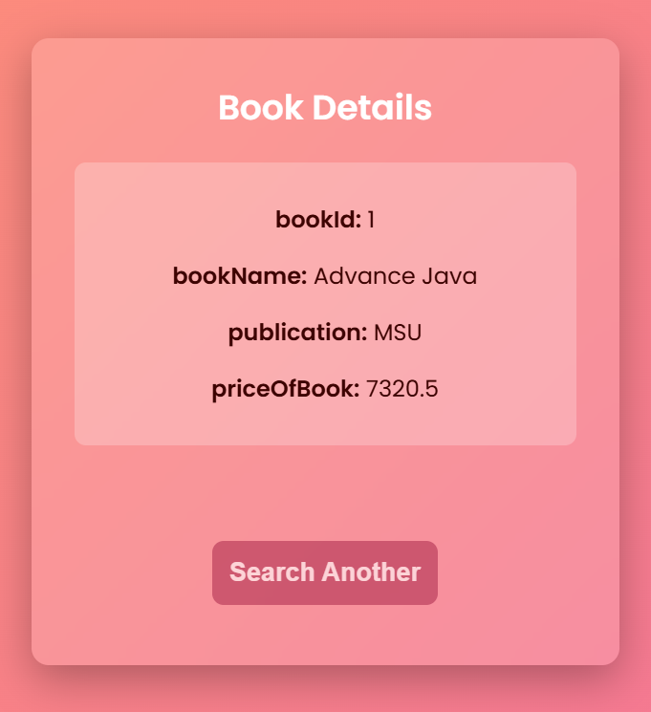

**# adminBookRequest.jsp :-**

<%@ **page** import=*"java.util.*, javax.servlet.http.*, java.math.BigDecimal"* %>

<%@ **page** contentType=*"text/html; charset=UTF-8"* pageEncoding=*"UTF-8"* %>

<!**DOCTYPE** html>

<**html** lang=*"en"*>

<**head**>

<**meta** charset=*"UTF-8"*>

<**meta** name=*"viewport"* content=*"width=device-width, initial-scale=1.0"*>

<**title**>Admin Book Request</**title**>

<**link** rel=*"stylesheet"* href=*"static/login.css"*>

</**head**>

<**body**>

<**div** class=*"container"*>

<**h2**>Admin - Book Requests</**h2**>

<**div** class=*"book-table"*>

<**table**>

<**thead**>

<**tr**>

<%

List<Map<String, Object>> bookList = (List<Map<String, Object>>) session.getAttribute("bookList");

if (bookList != null && !bookList.isEmpty()) {

Map<String, Object> firstRow = bookList.get(0);

for (String column : firstRow.keySet()) {

%>

<**th**><%= column %></**th**>

<%

}

}

%>

</**tr**>

</**thead**>

<**tbody**>

<%

if (bookList != null) {

for (Map<String, Object> book : bookList) {

%>

<**tr**>

<%

for (Map.Entry<String, Object> entry : book.entrySet()) {

Object value = entry.getValue();

String displayValue = (value instanceof BigDecimal) ? ((BigDecimal) value).toPlainString() : String.valueOf(value);

%>

<**td**><%= displayValue %></**td**>

<% } %>

</**tr**>

<%

}

}

%>

</**tbody**>

</**table**>

</**div**>

<**a** href=*"login.jsp"* class=*"button"*>Back to Login</**a**>

</**div**>

</**body**>

</**html**>

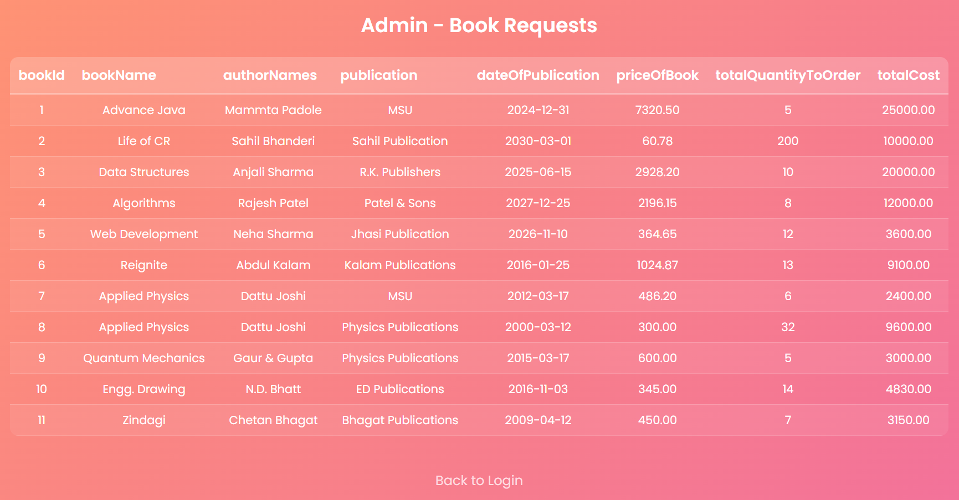

**# AuthenticationFilter.java :-**

import java.io.IOException;

import java.sql.Connection;

import java.sql.DriverManager;

import java.sql.PreparedStatement;

import java.sql.ResultSet;

import javax.servlet.Filter;

import javax.servlet.FilterChain;

import javax.servlet.FilterConfig;

import javax.servlet.ServletException;

import javax.servlet.ServletRequest;

import javax.servlet.ServletResponse;

import javax.servlet.annotation.WebFilter;

import javax.servlet.http.HttpServletRequest;

import javax.servlet.http.HttpServletResponse;

import javax.servlet.http.HttpSession;

@WebFilter("/LoginServlet")

public class AuthenticationFilter implements Filter

{

public void doFilter(ServletRequest request, ServletResponse response, FilterChain chain) throws IOException, ServletException

{

HttpServletRequest req = (HttpServletRequest) request;

HttpServletResponse res = (HttpServletResponse) response;

String username = req.getParameter("username");

String password = req.getParameter("password");

if (username == null || password == null || username.trim().isEmpty() || password.trim().isEmpty())

{

req.setAttribute("errorMessage", "Username and Password are required!");

req.getRequestDispatcher("login.jsp").forward(req, res);

return;

}

try

{

Class.forName("com.mysql.jdbc.Driver");

Connection con = DriverManager.getConnection("jdbc:mysql://localhost:3306/books?characterEncoding=latin1", "root", "khushi");

PreparedStatement pst = con.prepareStatement("SELECT role FROM users WHERE username = ? AND password = ?");

pst.setString(1, username);

pst.setString(2, password);

ResultSet rs = pst.executeQuery();

if (!rs.next())

{

req.setAttribute("errorMessage", "Incorrect Credentials");

req.getRequestDispatcher("login.jsp").forward(req, res);

return;

}

HttpSession session = req.getSession();

session.setAttribute("username", username);

session.setAttribute("role", rs.getString("role"));

chain.doFilter(request, response);

}

catch (Exception e)

{

e.printStackTrace();

res.sendRedirect("login.jsp");

}

}

public void init(FilterConfig fConfig) throws ServletException {}

public void destroy() {}

}

**# LoginServlet.java :-**

import java.io.IOException;

import java.sql.Connection;

import java.sql.DriverManager;

import java.sql.PreparedStatement;

import java.sql.ResultSet;

import java.sql.ResultSetMetaData;

import java.util.ArrayList;

import java.util.HashMap;

import java.util.LinkedHashMap;

import java.util.List;

import java.util.Map;

import javax.servlet.ServletException;

import javax.servlet.annotation.WebServlet;

import javax.servlet.http.HttpServlet;

import javax.servlet.http.HttpServletRequest;

import javax.servlet.http.HttpServletResponse;

import javax.servlet.http.HttpSession;

*@WebServlet*("/LoginServlet")

public class LoginServlet extends HttpServlet

{

private static final long ***serialVersionUID*** = 1L;

public LoginServlet()

{

super();

}

protected void doGet(HttpServletRequest request, HttpServletResponse response) throws ServletException, IOException

{

HttpSession session = request.getSession(false);

if (session == null || session.getAttribute("username") == null)

{

response.sendRedirect("login.jsp");

return;

}

String role = (String) session.getAttribute("role");

if ("admin".equalsIgnoreCase(role))

{

List<Map<String, Object>> bookList = new ArrayList<>();

try

{

Class.*forName*("com.mysql.jdbc.Driver");

Connection con = DriverManager.*getConnection*("jdbc:mysql://localhost:3306/books?characterEncoding=latin1", "root", "khushi");

PreparedStatement pst = con.prepareStatement("SELECT bookId, bookName, authorNames, publication, dateOfPublication, priceOfBook, totalQuantityToOrder, totalCost FROM book");

ResultSet rs = pst.executeQuery();

ResultSetMetaData metaData = rs.getMetaData();

int columnCount = metaData.getColumnCount();

while (rs.next())

{

Map<String, Object> row = new LinkedHashMap();

for (int i = 1; i <= columnCount; i++)

{

row.put(metaData.getColumnName(i), rs.getObject(i));

}

bookList.add(row);

}

session.setAttribute("bookList", bookList);

rs.close();

pst.close();

con.close();

}

catch (Exception e)

{

e.printStackTrace();

}

response.sendRedirect("adminBookRequest.jsp");

}

else

{

response.sendRedirect("userBookRequest.jsp");

}

}

}

**# UserBookServlet.java :-**

import java.io.IOException;

import java.sql.Connection;

import java.sql.DriverManager;

import java.sql.PreparedStatement;

import java.sql.ResultSet;

import java.util.LinkedHashMap;

import java.util.Map;

import javax.servlet.RequestDispatcher;

import javax.servlet.ServletException;

import javax.servlet.annotation.WebServlet;

import javax.servlet.http.HttpServlet;

import javax.servlet.http.HttpServletRequest;

import javax.servlet.http.HttpServletResponse;

*@WebServlet*("/UserBookServlet")

public class UserBookServlet extends HttpServlet {

private static final long ***serialVersionUID*** = 1L;

public UserBookServlet() {

super();

}

protected void doGet(HttpServletRequest request, HttpServletResponse response) throws ServletException, IOException {

try

{

int bookId = Integer.*parseInt*(request.getParameter("bookid"));

Class.*forName*("com.mysql.jdbc.Driver");

Connection con = DriverManager.*getConnection*("jdbc:mysql://localhost:3306/books?characterEncoding=latin1", "root", "khushi");

PreparedStatement pst = con.prepareStatement("SELECT bookId, bookName, authorNames, publication, dateOfPublication, priceOfBook, totalQuantityToOrder, totalCost FROM book WHERE bookId = ?");

pst.setInt(1, bookId);

ResultSet rs = pst.executeQuery();

if(!rs.next())

{

System.***out***.println("No book found for bookId: " + bookId);

request.setAttribute("isFound", false);

}

else

{

request.setAttribute("isFound", true);

Map<String, Object> book = new LinkedHashMap<>();

book.put("bookId", rs.getInt("bookId"));

book.put("bookName", rs.getString("bookName"));

book.put("publication", rs.getString("publication"));

book.put("priceOfBook", rs.getFloat("priceOfBook"));

request.setAttribute("book_info", book);

}

rs.close();

pst.close();

con.close();

RequestDispatcher dispatcher = request.getRequestDispatcher("userBookDetails.jsp");

dispatcher.forward(request, response);

}

catch(Exception e)

{

e.printStackTrace();

}

}

protected void doPost(HttpServletRequest request, HttpServletResponse response) throws ServletException, IOException {

doGet(request, response);

}

}

**4. Write a Servlet program to create and use Session Handling for the user login. Session Handling should be implemented using Cookies and HTTPSession both.**

**# login.jsp :-**

<%@ **page** import=*"javax.servlet.http.Cookie"* %>

<%@ **page** contentType=*"text/html;charset=UTF-8"* language=*"java"* %>

<%

Cookie[] cookies = request.getCookies();

String savedUsername = null;

if (cookies != null) {

for (Cookie c : cookies) {

if (c.getName().equals("username")) {

savedUsername = c.getValue();

break;

}

}

}

if (savedUsername != null) {

response.sendRedirect("dashboard.jsp");

return;

}

%>

<!**DOCTYPE** html>

<**html**>

<**head**>

<**title**>Login</**title**>

<**link** rel=*"stylesheet"* type=*"text/css"* href=*"static/styles.css"*>

</**head**>

<**body**>

<**div** class=*"container"*>

<**h2**>User Login</**h2**>

<% String errorMessage = request.getParameter("error"); %>

<% if (errorMessage != null) { %>

<**p** class=*"error"*>Invalid Username or Password!</**p**>

<% } %>

<**form** action=*"LoginServlet"* method=*"post"*>

<**label**>Username:</**label**>

<**input** type=*"text"* name=*"username"* required>

<**label**>Password:</**label**>

<**input** type=*"password"* name=*"password"* required>

<**button** type=*"submit"*>Login</**button**>

</**form**>

</**div**>

</**body**>

</**html**>

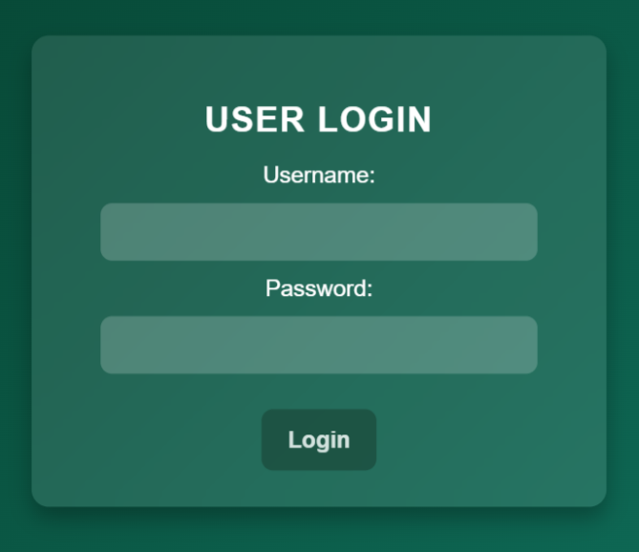

**# logout.jsp :-**

<%@ **page** contentType=*"text/html;charset=UTF-8"* language=*"java"* %>

<!**DOCTYPE** html>

<**html**>

<**head**>

<**title**>Logout</**title**>

<**link** rel=*"stylesheet"* type=*"text/css"* href=*"static/styles.css"*>

</**head**>

<**body**>

<**div** class=*"container"*>

<**h2**>You have been logged out.</**h2**>

<**a** href=*"login.jsp"*>Login Again</**a**>

</**div**>

</**body**>

</**html**>

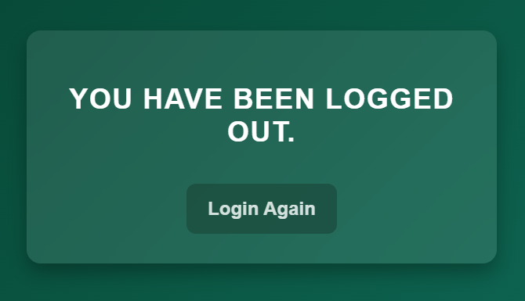

**# dashboard.jsp :-**

<%@ **page** import=*"javax.servlet.http.*, javax.servlet.*"* %>

<%@ **page** contentType=*"text/html;charset=UTF-8"* language=*"java"* %>

<%

HttpSession sessionObj = request.getSession(false);

String username = null;

Cookie[] cookies = request.getCookies();

if (cookies != null) {

for (Cookie cookie : cookies) {

if ("username".equals(cookie.getName())) {

username = cookie.getValue();

break;

}

}

}

if (username == null && sessionObj != null) {

username = (String) sessionObj.getAttribute("user");

}

if (username == null) {

response.sendRedirect("login.jsp");

return;

}

%>

<!**DOCTYPE** html>

<**html**>

<**head**>

<**title**>Dashboard</**title**>

<**link** rel=*"stylesheet"* type=*"text/css"* href=*"static/styles.css"*>

</**head**>

<**body**>

<**div** class=*"container"*>

<**h2**>Welcome, <%= username %>!</**h2**>

<**a** href=*"LogoutServlet"*>Logout</**a**>

</**div**>

</**body**>

</**html**>

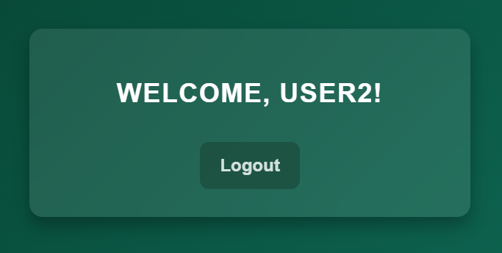

**# LoginServlet.java :-**

import java.io.IOException;

import java.sql.Connection;

import java.sql.DriverManager;

import java.sql.PreparedStatement;

import java.sql.ResultSet;

import javax.servlet.ServletException;

import javax.servlet.annotation.WebServlet;

import javax.servlet.http.*;

@WebServlet("/LoginServlet")

public class LoginServlet extends HttpServlet

{

protected void doPost(HttpServletRequest request, HttpServletResponse response) throws ServletException, IOException

{

HttpSession session = request.getSession(false);

Cookie[] cookies = request.getCookies();

String savedUsername = null;

if (cookies != null)

{

for (Cookie c : cookies)

{

if (c.getName().equals("username"))

{

savedUsername = c.getValue();

break;

}

}

}

if (session != null && session.getAttribute("user") != null)

{

response.sendRedirect("dashboard.jsp");

return;

}

if (savedUsername != null)

{

HttpSession newSession = request.getSession();

newSession.setAttribute("user", savedUsername);

response.sendRedirect("dashboard.jsp");

return;

}

String username = request.getParameter("username");

String password = request.getParameter("password");

Connection con = null;

PreparedStatement pst = null;

ResultSet rs = null;

try

{

Class.forName("com.mysql.jdbc.Driver");

con = DriverManager.getConnection("jdbc:mysql://localhost:3306/books?characterEncoding=latin1", "root", "khushi");

pst = con.prepareStatement("SELECT role FROM users WHERE username = ? AND password = ?");

pst.setString(1, username);

pst.setString(2, password);

rs = pst.executeQuery();

if (!rs.next())

{

response.sendRedirect("login.jsp?error=true");

}

else

{

HttpSession newSession = request.getSession();

newSession.setAttribute("user", username);

newSession.setMaxInactiveInterval(5 * 60);

Cookie userCookie = new Cookie("username", username);

Cookie userRole = new Cookie("role", rs.getString("role"));

userCookie.setMaxAge(5 * 60);

userRole.setMaxAge(5 * 60);

userCookie.setHttpOnly(true);

userRole.setHttpOnly(true);

response.addCookie(userCookie);

response.addCookie(userRole);

response.sendRedirect("dashboard.jsp");

}

}

catch (Exception e)

{

e.printStackTrace();

response.sendRedirect("error.jsp");

}

finally

{

try

{

if (rs != null) rs.close();

if (pst != null) pst.close();

if (con != null) con.close();

}

catch (Exception ex)

{

ex.printStackTrace();

}

}

}

}

**# LogoutServlet.java :-**

import java.io.IOException;

import javax.servlet.ServletException;

import javax.servlet.annotation.WebServlet;

import javax.servlet.http.*;

@WebServlet("/LogoutServlet")

public class LogoutServlet extends HttpServlet

{

protected void doGet(HttpServletRequest request, HttpServletResponse response) throws ServletException, IOException

{

HttpSession session = request.getSession(false);

if (session != null)

{

session.invalidate();

}

Cookie[] cookies = request.getCookies();

if (cookies != null)

{

for (Cookie c : cookies)

{

if (c.getName().equals("username"))

{

c.setMaxAge(0);

response.addCookie(c);

}

}

}

response.sendRedirect("logout.jsp");

}

}

**# DashboardServlet.java :-**

import java.io.IOException;

import javax.servlet.ServletException;

import javax.servlet.annotation.WebServlet;

import javax.servlet.http.*;

*@WebServlet*("/DashboardServlet")

public class DashboardServlet extends HttpServlet {

protected void doGet(HttpServletRequest request, HttpServletResponse response) throws ServletException, IOException {

HttpSession session = request.getSession(false);

Cookie[] cookies = request.getCookies();

String savedUsername = null;

if (cookies != null) {

for (Cookie c : cookies) {

if (c.getName().equals("username")) {

savedUsername = c.getValue();

break;

}

}

}

if (session == null && savedUsername == null) {

response.sendRedirect("login.jsp");

return;

}

if (savedUsername != null) {

HttpSession newSession = request.getSession();

newSession.setAttribute("user", savedUsername);

}

response.sendRedirect("dashboard.jsp");

}

}