Output of Assignments of 8085 Microprocessor

1. Addition of two 8 bit numbers having 16 bit sum.

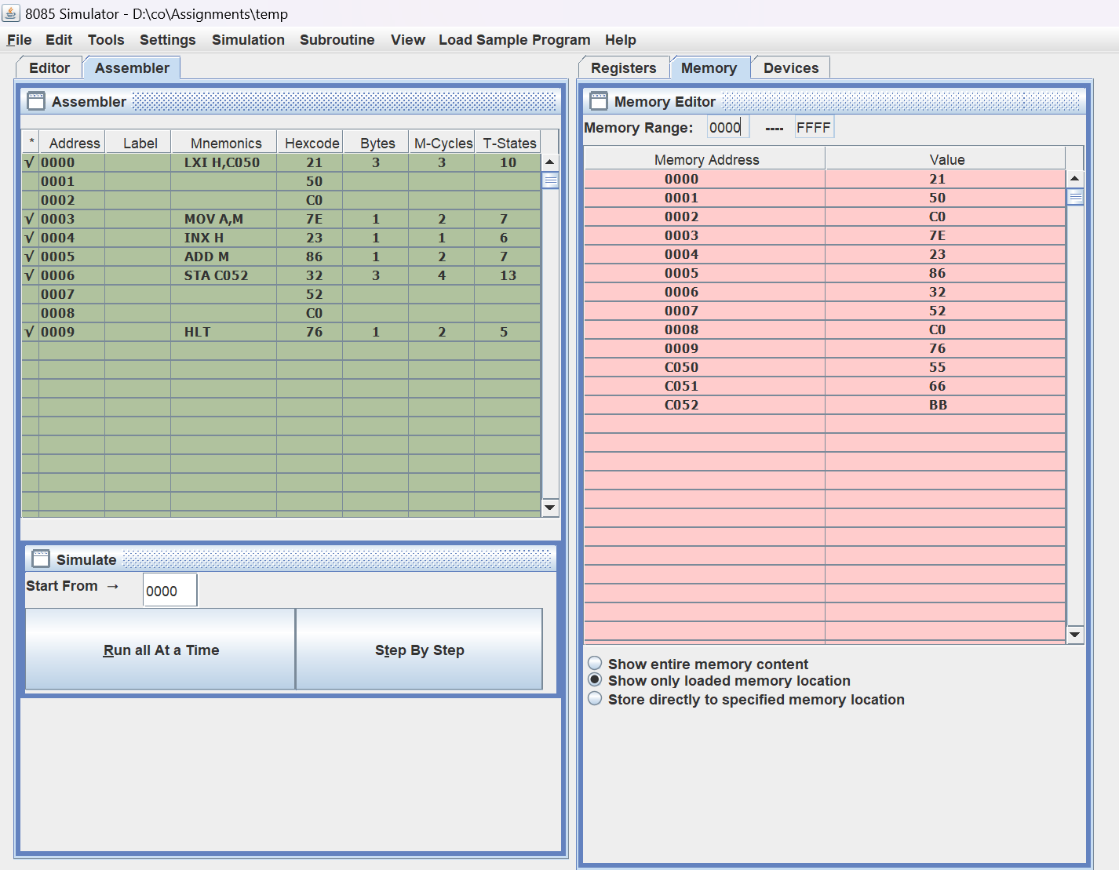

2. Subtraction of two 8 bit numbers (Single program should satisfy the following cases)

Case:1 When minuend is greater than subtrahend

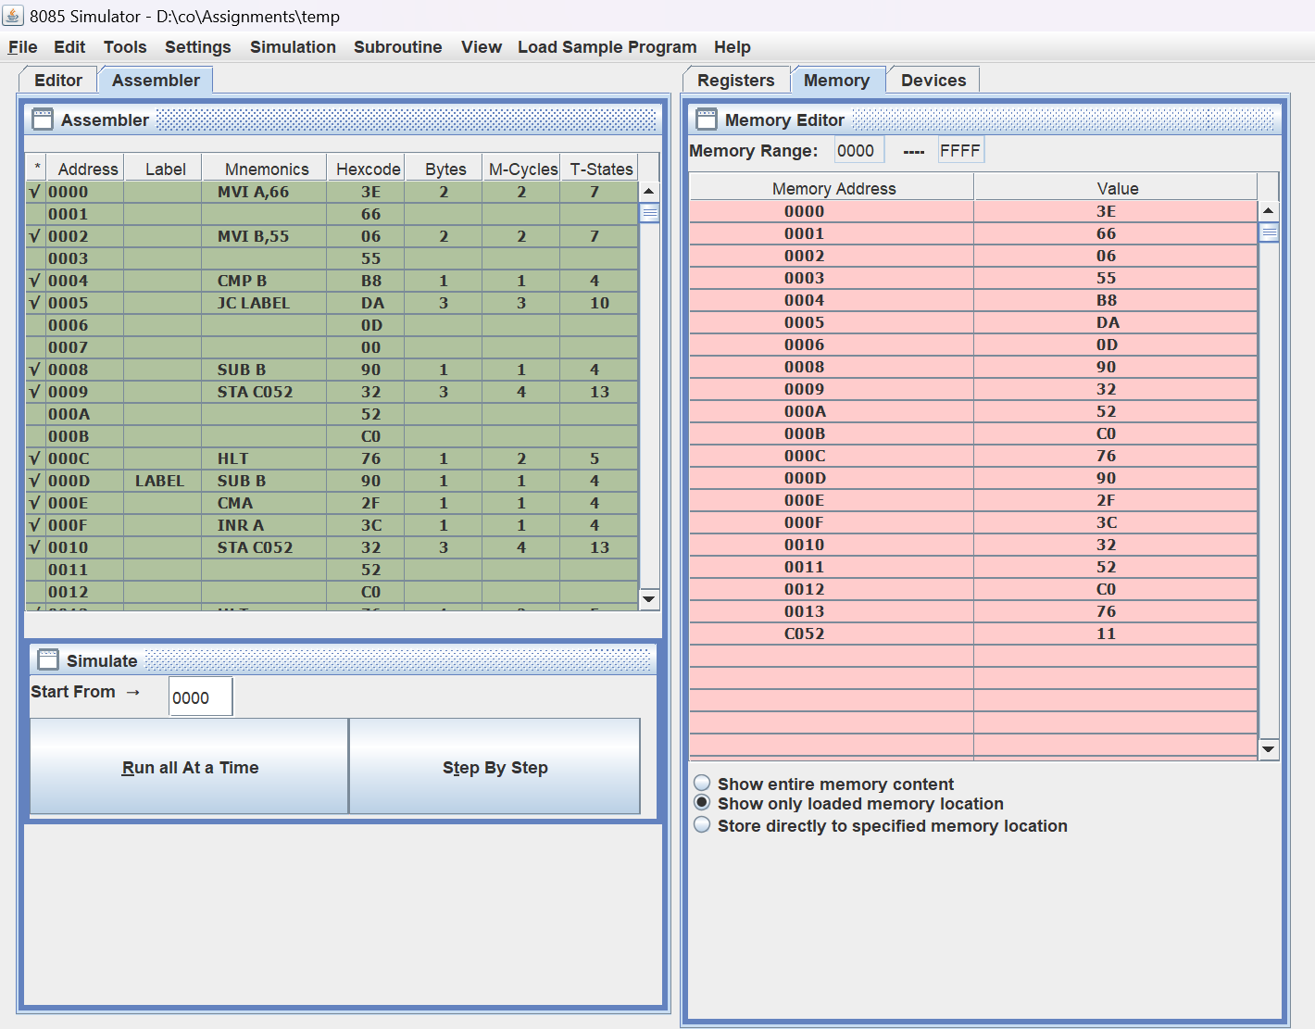

Case 2: When minuend is smaller than subtrahend

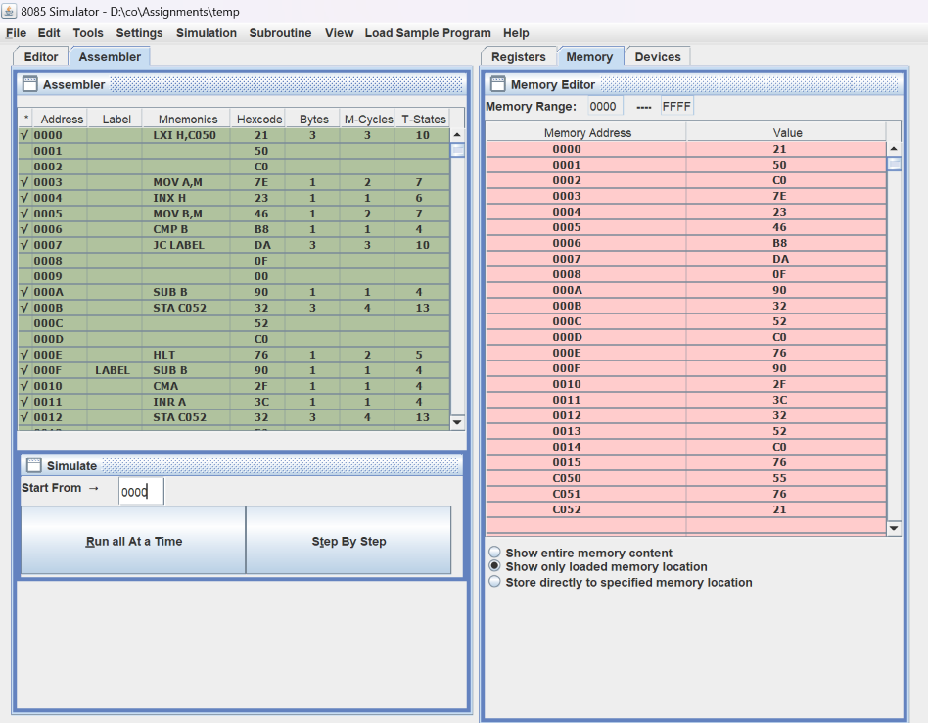

3. Multiplication two 8 bit numbers, result is 16 bit number.

4. Division of two 8 bit number.

5. Write a 8085 program to find largest number in the given array of numbers.

6. Write a 8085 program to find smallest number in the given array of numbers.

6.2 Write a 8085 program to find smallest & largest number in the given array of numbers.

7. Write a 8085 program to sort the given array of numbers in ascending order.

8. Write a 8085 program to sort the given array of numbers in descending order.

9. Write a 8085 program to convert a given hexadecimal number to BCD number.

10. Write a 8085 program to convert a BCD number into hexadecimal number.