**Data Structure Assignment - 1**

**Which sorting techniques are stable sorting techniques ?**

* **What is stable sorting ?**
* Simple Sorting technique is a sorting technique in which ,

If more than one index of array contains same element then the element which appears to be on input is appears to be earlier in the sorted array.

* Let use assume there is an integer array A[], in which any index i and j contains same element.
* Hence we can say that, A[i] = A[j]

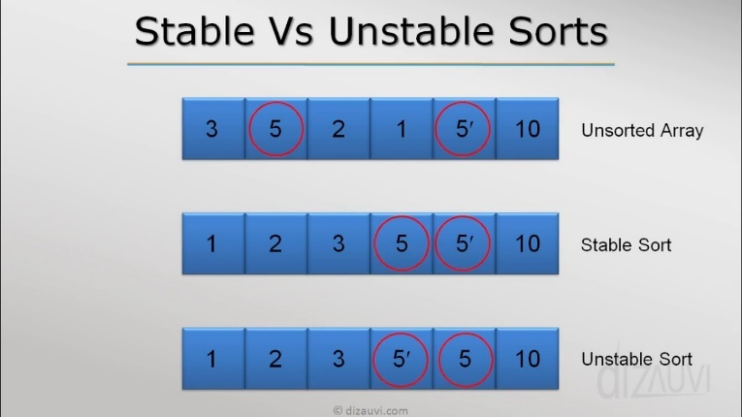

* Let use assume index i < j.
* Then in sorted array A[i] should come before A[j].
* Example :- Bubble sort, Insertion sort, Merge sort, Counting sort,

Radix sort etc.

* **Merge Sort :-**
* Merge sort is a stable sort having time complexity equal to 0(n2).
* In merge sort an array of element is split into two parts recursively till size of array does not become 1.
* After that operation array is sorted and merged recursively.
* In this sorting technique two individual array are merged together by comparing elements of both array.
* Let us assume an integer array A[] is split into two array

B[] and C[] which may or may not have same size.

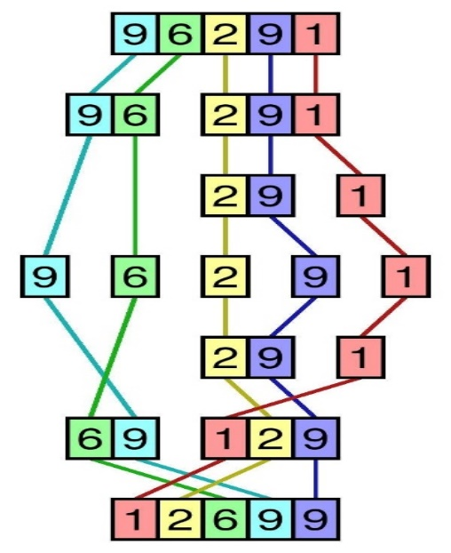

* Now let us assume both array contains element 9 as shown in the figure.
* Let us assume B[i] and C[j] has same elements.
* From comparison B[i] <= C[j] , the element B[i] will be restored in A[] earlier than C[j].
* Hence, we can conclude that Merge Sort is a stable sort.
* **Bubble Sort :-**
* Bubble sort is a stable sort having time complexity O(n2).
* In bubble sort every element of an array is compared to the element next to it’s index.
* And if that element is lesser than current element than both elements switch positions.
* If both index contains same element then swapping will not take place.
* Hence element which comes earlier in input will be earlier in it’s sorted position.

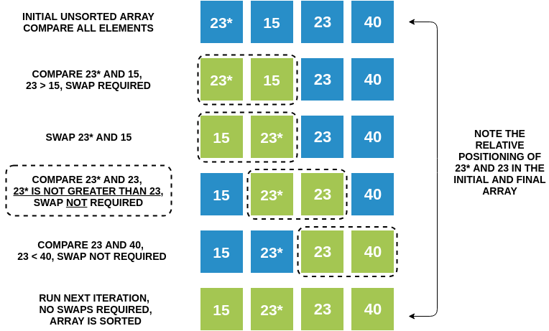

* In above figure we can see that 23 and 23* are not swapped because 23 > 23* returns false and they retain its position.
* Hence bubble sort is a stable sort.
* **Insertion Sort :-**
* Insertion sort is a stable sort having time complexity O(n2).
* In insertion sort a key element is compared to the every element of an array which is left side of a key.
* Here we can say that array which is in left side of key is sorted.
* Then we compare key with left side elements using comparison key < A[i] in a while loop, where A[] is an integer array.
* When condition key < A[i] becomes false then loop will break.
* And key is inserted at (i+1)th index of array.

Step 1: 4 2 4* 1 3

Step 2: 2 4 4* 1 3

Step 3: 2 4 4* 1 3

Step 4: 1 2 4 4* 3

Step 5: 1 2 3 4 4*

* If a key element and A[i] element contains same value then condition key < A[i] will stay false and loop will break and key element is inserted on (i+1)th index.
* Hence A[i] element which comes earlier in input stays earlier in sorted array.
* Hence insertion array is a stable array.
* In above figure we can see that both 4 comes earlier than 4* in input and also in sorted array.
* **Counting Sort :-**
* Counting sort is a stable sort having time complexity is O(n).
* This sorting technique counts the number of key whose key values are same.
* It is used only when difference between elements of array are near by.
* In this sorting technique three arrays are used.
* Input and output are contained in a two different arrays.
* Remaining array is used to keep count of elements.
* Input array is then read from last index and that element written in output array at according index.
* This index is determined using array which keeps track of count of all the keys.
* Hence element which comes last in input will be placed last .

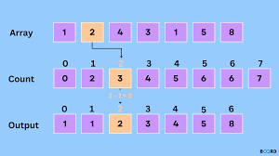

* Here first of all 1 which appears to be late will be placed at 1th index of output array then earlier 1 of input array will be placed at 0th index.
* Hence we can conclude that counting sort is a stable sort.
* **Radix Sort :-**
* Radix sort is a stable sort having time complexity O(nd).

Where n = size of array

d = total number of digits in the largest element

* The Radix sort handles the work of sorting , By sorting one digit at a time.
* This ensures that number that appear before other numbers in the input array will maintain that same order in the final sorted array.

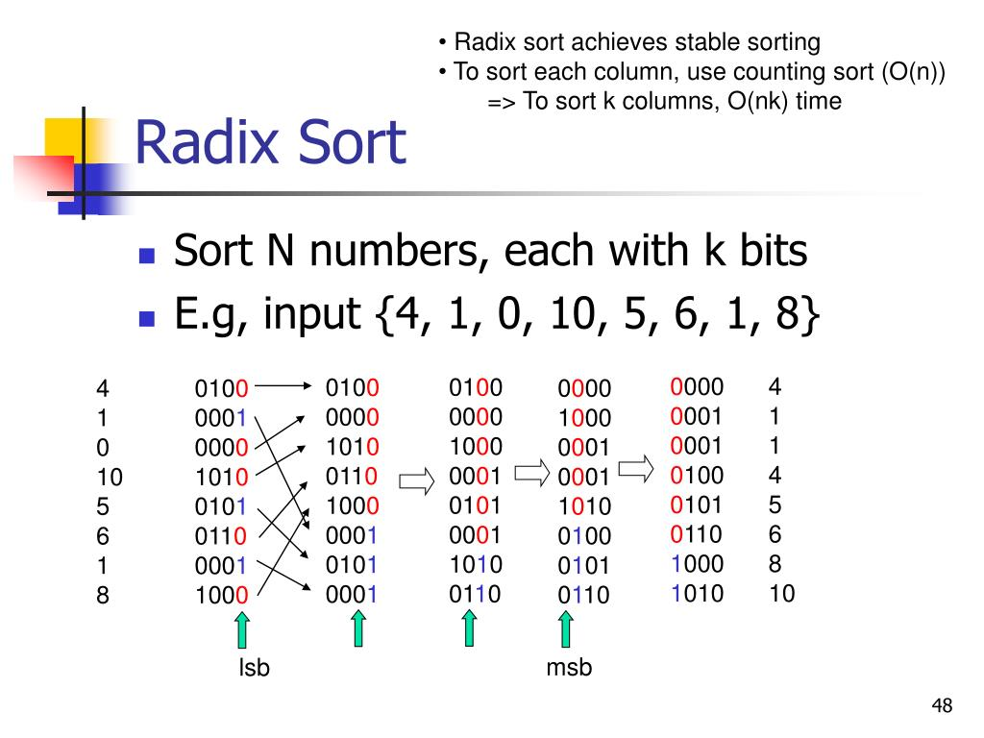

* Here we can see that 0001 that comes earlier in input comes earlier in output.
* Hence we can conclude that Radix array is a sorted array.