Lab – 1

1. Line drawing with using simple equation y=mx+c.

#include <stdio.h>

#include <graphics.h>

#include <math.h>

int main()

{

    int gd = DETECT, gm, color;

    initgraph(&gd, &gm, "");

    int x0 = 30, y0 = 100;

    int x1 = 400, y1 = 50;

    int dx = x1 - x0;

    int dy = y1 - y0;

    float m = (float)dy / dx;

    float c = y0 - m * x0;

    if (x0 < x1)

    {

        while (x0 <= x1)

        {

            putpixel(x0, round(m * x0 + c), GREEN);

            x0++;

        }

    }

    else

    {

        while (x0 >= x1)

        {

            putpixel(x0, round(m * x0 + c), GREEN);

            x0--;

        }

    }

    getch();

    closegraph();

    return 0;

}

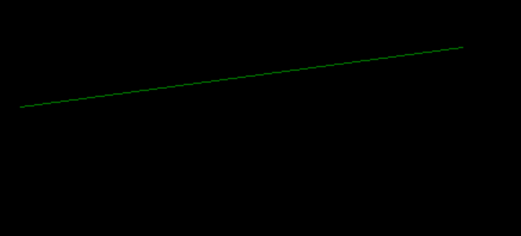

2. DDA Line Drawing algorithm.

#include <stdio.h>

#include <graphics.h>

#include <math.h>

int main()

{

    int gd = DETECT, gm, color;

    initgraph(&gd, &gm, "");

    int x0 = 30, y0 = 100;

    int x1 = 400, y1 = 50;

    int dx = x1 - x0;

    int dy = y1 - y0;

    int step = (abs(dx) > abs(dy)) ? abs(dx) : abs(dy);

    float x_inc = (float)dx / step;

    float y_inc = (float)dy / step;

    float x = x0;

    float y = y0;

    for (int i = 0; i < step; i++)

    {

        x += x_inc;

        y += y_inc;

        putpixel(round(x), round(y), RED);

    }

    getch();

    closegraph();

    return 0;

}

