Lab – 1

1. Line drawing with using simple equation y=mx+c.
#include <stdio.h>
#include <graphics.h>
#include <math.h>

int main()
{
int gd = DETECT, gm, color;
initgraph(&gd, &gm, "");
int x0 = 30, y0 = 100;
int x1 = 400, y1 = 50;
int dx = x1 - x0;
int dy = y1 - y0;
float m = (float)dy / dx;
float c = y0 - m * x0;
if (x0 < x1)
{
while (x0 <= x1)
{
putpixel(x0, round(m * x0 + c), GREEN);
x0++;
}
}
else
{
while (x0 >= x1)
{
putpixel(x0, round(m * x0 + c), GREEN);
x0--;
}
}
getch();
closegraph();
return 0;
}
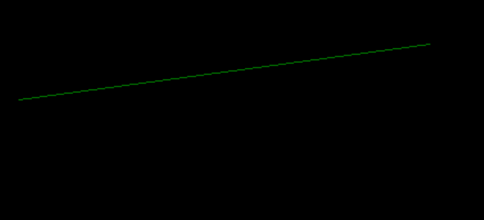

2. DDA Line Drawing algorithm.
#include <stdio.h>
#include <graphics.h>
#include <math.h>

int main()
{
int gd = DETECT, gm, color;
initgraph(&gd, &gm, "");
int x0 = 30, y0 = 100;
int x1 = 400, y1 = 50;
int dx = x1 - x0;
int dy = y1 - y0;
int step = (abs(dx) > abs(dy)) ? abs(dx) : abs(dy);
float x_inc = (float)dx / step;
float y_inc = (float)dy / step;
float x = x0;
float y = y0;
for (int i = 0; i < step; i++)
{
x += x_inc;
y += y_inc;
putpixel(round(x), round(y), RED);
}
getch();
closegraph();
return 0;
}
