Lab – 2

3. Bresenham line drawing algorithm.
#include <stdio.h>
#include <graphics.h>
#include <math.h>

int main()
{
int gd = DETECT, gm, color;
initgraph(&gd, &gm, "");
int x0 = 30, y0 = 50;
int x1 = 400, y1 = 100;
int dx = x1 - x0;
int dy = y1 - y0;
int yk = y0;
int xk = x0;
float m = (float)abs(dy) / (float)abs(dx);
if (m < 1.0)
{
int pk = 2 * abs(dy) - abs(dx);
for (int i = 0; i < abs(dx) - 1 && xk != x1; i++)
{
xk++;
if (pk < 0)
{
pk += 2 * dy;
}
else
{
pk += 2 * dy - 2 * dx;
yk++;
}
putpixel(xk, yk, RED);
}
}
else
{
int pk = 2 * abs(dx) - abs(dy);
for (int i = 0; i < abs(dy) - 1 && yk != y1; i++)
{
yk++;
if (pk < 0)
{
pk += 2 * dx;
}
else
{
pk += 2 * dx - 2 * dy;
xk++;
}
putpixel(xk, yk, RED);
}
}
getch();
closegraph();
return 0;
}
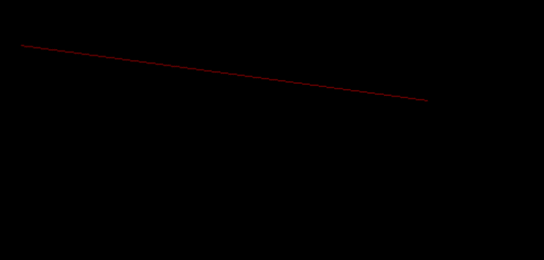
4.1 ⁠draw the football ground using computer graphics functions.
#include <graphics.h>
#include <conio.h>
int main()
{
int gd = DETECT, gm;
initgraph(&gd, &gm, "");
setfillstyle(SOLID_FILL, GREEN);
bar(40, 40, 600, 440);
rectangle(40, 40, 600, 440);
line(320, 40, 320, 440);
rectangle(40, 110, 150, 370);
rectangle(490, 110, 600, 370);
circle(320, 240, 60);
rectangle(40, 160, 70, 320);
rectangle(570, 160, 600, 320);
setfillstyle(SOLID_FILL, WHITE);
fillellipse(320, 240, 2, 2);
fillellipse(110, 240, 2, 2);
fillellipse(530, 240, 2, 2);
arc(110, 240, 315, 45, 60);
arc(530, 240, 135, 225, 60);
getch();
closegraph();
return 0;
}
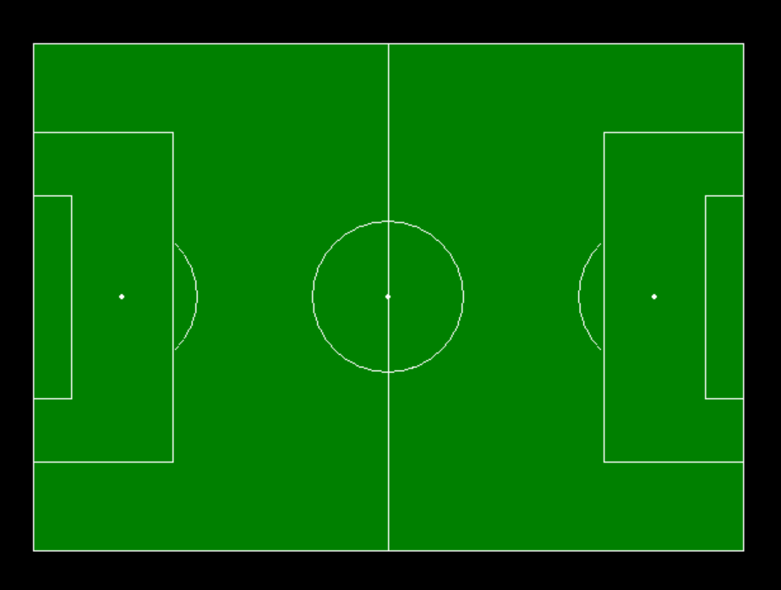
4.2 ⁠draw the Cricket ground using computer graphics functions.
#include <graphics.h>
#include <conio.h>
int main()
{
int gd = DETECT, gm;
initgraph(&gd, &gm, "");
setfillstyle(SOLID_FILL, GREEN);
fillellipse(320, 240, 200, 200);
fillellipse(320, 240, 180, 180);
fillellipse(320, 240, 120, 100);
setfillstyle(SOLID_FILL, YELLOW);
bar(240, 210, 400, 270);
setlinestyle(0, 0, 1);
line(260, 155, 260, 325);
line(380, 155, 380, 325);
getch();
closegraph();
return 0;
}
