Lab – 3

5. Midpoint line drawing.
#include <stdio.h>
#include <graphics.h>
#include <math.h>

int main()
{
int gd = DETECT, gm, color;
initgraph(&gd, &gm, "");
int x0 = 30, y0 = 50;
int x1 = 400, y1 = 100;
int dx = x1 - x0;
int dy = y1 - y0;
int yk = y0;
int xk = x0;
float m = (float)abs(dy) / (float)abs(dx);
if (m < 1.0)
{
int pk = abs(dy) - (abs(dx) / 2);
while (xk != x1 || yk != y1)
{
xk++;
if (pk < 0)
{
pk += dy;
}
else
{
pk += dy - dx;
yk++;
}
putpixel(xk, yk, RED);
}
}
else
{
int pk = abs(dx) - (abs(dy) / 2);
while (xk != x1 || yk != y1)
{
yk++;
if (pk < 0)
{
pk += dx;
}
else
{
pk += dx - dy;
xk++;
}
putpixel(xk, yk, RED);
}
}
getch();
closegraph();
return 0;
}

6. ⁠midpoint circle drawing.
#include <stdio.h>
#include <graphics.h>
#include <math.h>

int main()
{
int gd = DETECT, gm;
initgraph(&gd, &gm, "");
int xc = 350;
int yc = 140;
int r = 80;
int yk = r;
int xk = 0;
int pk = 1 - r;
while (xk <= yk)
{
xk++;
if (pk < 0)
{
pk += 2 * xk + 3;
}
else
{
yk--;
pk += 2 * xk - 2 * yk + 5;
}
putpixel(xc + xk, yc + yk, GREEN);
putpixel(xc + yk, yc + xk, RED);
putpixel(xc - xk, yc + yk, GREEN);
putpixel(xc - yk, yc + xk, RED);
putpixel(xc + xk, yc - yk, GREEN);
putpixel(xc + yk, yc - xk, RED);
putpixel(xc - xk, yc - yk, GREEN);
putpixel(xc - yk, yc - xk, RED);
}
getch();
closegraph();
return 0;
}
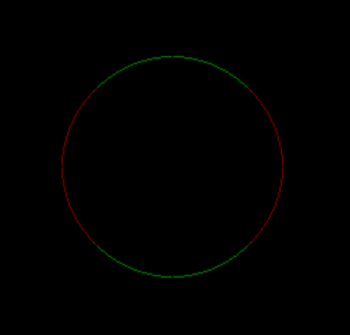

7. ⁠draw the olympic logo using graphics function.
#include <graphics.h>
#include <conio.h>
int main()
{
int gd = DETECT, gm;
initgraph(&gd, &gm, "");
setbkcolor(WHITE);
cleardevice();
for (int i = 0; i < 5; i++)
{
setcolor(BLUE);
circle(160, 210, 60 + i);
setcolor(YELLOW);
circle(240, 270, 60 + i);
setcolor(BLACK);
circle(320, 210, 60 + i);
setcolor(GREEN);
circle(400, 270, 60 + i);
setcolor(RED);
circle(480, 210, 60 + i);
}
getch();
closegraph();
return 0;
}
