Lab – 5

10.1. Line clipping algorithm (Cohen-Sutherland).
#include <graphics.h>
#include <conio.h>

void and_operation(int c1[4], int c2[4], int c[4])
{
for (int i = 0; i < 4; i++)
{
c[i] = (c1[i] == 0 || c2[i] == 0) ? 0 : 1;
}
}

void or_operation(int c1[4], int c2[4], int c[4])
{
for (int i = 0; i < 4; i++)
{
c[i] = (c1[i] == 0 && c2[i] == 0) ? 0 : 1;
}
}

void code(int x, int y, int Xmin, int Ymin, int Xmax, int Ymax, int c[4])
{
c[0] = (y > Ymax) ? 1 : 0;
c[1] = (y < Ymin) ? 1 : 0;
c[2] = (x > Xmax) ? 1 : 0;
c[3] = (x < Xmin) ? 1 : 0;
}

int main()
{
int gd = DETECT, gm;
initgraph(&gd, &gm, "");
int x1 = 56, y1 = 117;
int x2 = 425, y2 = 385;
int Xmin = 150, Ymin = 100, Xmax = 500, Ymax = 350;
line(x1, y1, x2, y2);
rectangle(Xmin, Ymin, Xmax, Ymax);
setcolor(RED);
int c1[4];
int c2[4];
int c[4];
code(x1, y1, Xmin, Ymin, Xmax, Ymax, c1);
code(x2, y2, Xmin, Ymin, Xmax, Ymax, c2);
or_operation(c1, c2, c);
int sum = 0;
for (int i = 0; i < 4; i++)
{
sum += c[i];
}
if (sum == 0)
{
line(x1, y1, x2, y2);
}
else
{
int cc[4];
and_operation(c1, c2, cc);
sum = 0;
for (int i = 0; i < 4; i++)
{
sum += cc[i];
}
if (sum == 0)
{
float m = (float)(y2 - y1) / (x2 - x1);
int x = x1, y = y1, xx = x2, yy = y2;
if (c[0] == 1)
{
xx = x1 + (Ymax - y1) / m;
yy = Ymax;
}
if (c[1] == 1)
{
x = x1 + (Ymin - y1) / m;
y = Ymin;
}
if (c[2] == 1)
{
yy = y1 + (Xmax - x1) * m;
xx = Xmax;
}
if (c[3] == 1)
{
y = y1 + (Xmin - x1) * m;
x = Xmin;
}
line(x, y, xx, yy);
line(x + 1, y + 1, xx + 1, yy + 1);
line(x - 1, y - 1, xx - 1, yy - 1);
}
}
getch();
closegraph();
return 0;
}
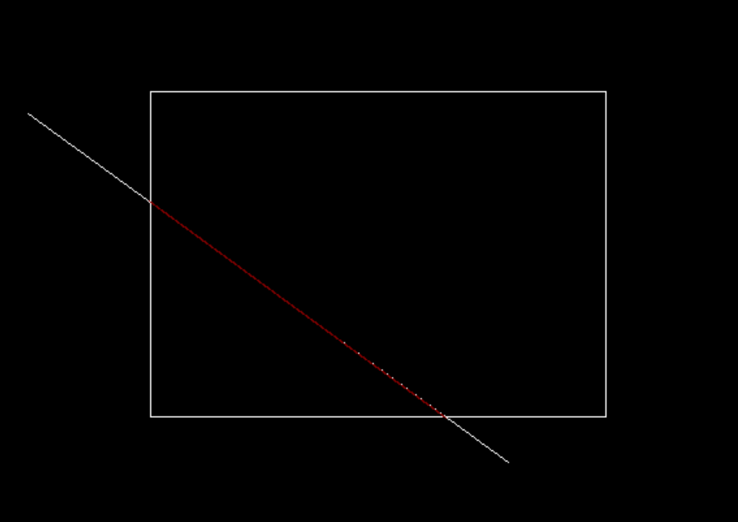

10.2. Line clipping algorithm (Liang-Barsky).
#include <graphics.h>
#include <conio.h>

float max(float a, float b)
{
return (a > b) ? a : b;
}

float min(float a, float b)
{
return (a < b) ? a : b;
}

int main()
{
int gd = DETECT, gm;
initgraph(&gd, &gm, "");
int x1 = 56, y1 = 117;
int x2 = 425, y2 = 385;
int Xmin = 150, Ymin = 100, Xmax = 500, Ymax = 350;
line(x1, y1, x2, y2);
rectangle(Xmin, Ymin, Xmax, Ymax);
setcolor(RED);
float p[4];
p[0] = x1 - x2;
p[1] = x2 - x1;
p[2] = y1 - y2;
p[3] = y2 - y1;
float q[4];
q[0] = x1 - Xmin;
q[1] = Xmax - x1;
q[2] = y1 - Ymin;
q[3] = Ymax - y1;
float t1 = 0, t2 = 1;
int flag = 1;
for (int i = 0; i < 4; i++)
{
if (p[i] == 0)
{
printf("\nLine is parallel");
for (int i = 0; i < 4; i++)
{
if (q[i] < 0)
{
flag = 0;
printf("\nLine is Completely Outside");
break;
}
}
break;
}
else
{
float t = q[i] / p[i];
if (p[i] < 0)
{
t1 = max(t1, t);
}
if (p[i] > 0)
{
t2 = min(t2, t);
}
}
}
if (flag)
{
if (t1 < t2)
{
int x = x1, y = y1, xx = x2, yy = y2;
if (t1 != 0)
{
x = x1 + t1 * (x2 - x1);
y = y1 + t1 * (y2 - y1);
}
if (t2 != 1)
{
xx = x1 + t2 * (x2 - x1);
yy = y1 + t2 * (y2 - y1);
}
line(x, y, xx, yy);
line(x + 1, y + 1, xx + 1, yy + 1);
line(x - 1, y - 1, xx - 1, yy - 1);
}
else if (t1 > t2)
{
printf("\nLine is Outside the window");
}
}
getch();
closegraph();
return 0;
}
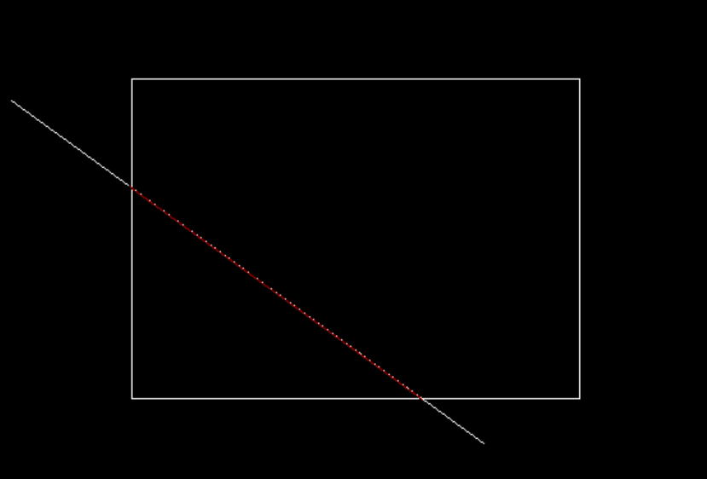

11. ⁠create any one cartoon character and apply any one transformation technique.
#include <stdio.h>
#include <graphics.h>
#include <math.h>

void drawFace(int x, int y, int radius)
{
setcolor(YELLOW);
setfillstyle(SOLID_FILL, YELLOW);
fillellipse(x, y, radius, radius);
setcolor(WHITE);
setfillstyle(SOLID_FILL, WHITE);
fillellipse(x - radius / 3, y - radius / 3, radius / 6, radius / 6);
fillellipse(x + radius / 3, y - radius / 3, radius / 6, radius / 6);
setcolor(BLACK);
setfillstyle(SOLID_FILL, BLACK);
fillellipse(x - radius / 3, y - radius / 3, radius / 12, radius / 12);
fillellipse(x + radius / 3, y - radius / 3, radius / 12, radius / 12);
setcolor(RED);
arc(x, y + radius / 4, 200, 340, radius / 3);
}
void scaleFace(int x, int y, int radius, float scaleX, float scaleY)
{
int newRadiusX = radius * scaleX;
int newRadiusY = radius * scaleY;
drawFace(x, y, newRadiusX < newRadiusY ? newRadiusX : newRadiusY);
}
int main()
{
// Translation & Scaling
int gd = DETECT, gm;
initgraph(&gd, &gm, "");
int x = 300, y = 200, radius = 100;
float sx = 0.5, sy = 0.6;
int tx = 250, ty = 80;
drawFace(x, y, radius);
scaleFace(x + tx, y + ty, radius, sx, sy);
getch();
closegraph();
return 0;
}

