Lab – 7

14. Draw solar system using computer graphics functions.
#include <graphics.h>
#include <conio.h>
#include <math.h>

void drawPlanet(int x, int y, int radius, int color, char name[])
{
setcolor(color);
setfillstyle(SOLID_FILL, color);
fillellipse(x, y, radius, radius);
setcolor(WHITE);
outtextxy(x - radius - 2, y + radius + 5, name);
}

void drawSolarSystem(int centerX, int centerY)
{
setcolor(YELLOW);
setfillstyle(SOLID_FILL, YELLOW);
fillellipse(centerX, centerY, 50, 50);
outtextxy(centerX + 60, centerY - 10, "Sun");

setcolor(WHITE);
circle(centerX, centerY, 100);
circle(centerX, centerY, 150);
circle(centerX, centerY, 200);
circle(centerX, centerY, 250);
circle(centerX, centerY, 300);
circle(centerX, centerY, 350);
circle(centerX, centerY, 400);
circle(centerX, centerY, 450);

drawPlanet(centerX + 100, centerY, 5, LIGHTGRAY, "Mercury");
drawPlanet(centerX + 150, centerY, 12, LIGHTGREEN, "Venus");
drawPlanet(centerX + 200, centerY, 15, BLUE, "Earth");
drawPlanet(centerX + 250, centerY, 10, RED, "Mars");
drawPlanet(centerX + 300, centerY, 20, BROWN, "Jupiter");
drawPlanet(centerX + 350, centerY, 18, CYAN, "Saturn");
drawPlanet(centerX + 400, centerY, 15, LIGHTBLUE, "Uranus");
drawPlanet(centerX + 450, centerY, 14, BLUE, "Neptune");
}

int main()
{
int gd = DETECT, gm;
initgraph(&gd, &gm, NULL);
int centerX = getmaxx() / 2;
int centerY = getmaxy() / 2;
drawSolarSystem(centerX, centerY);
getch();
closegraph();
return 0;
}
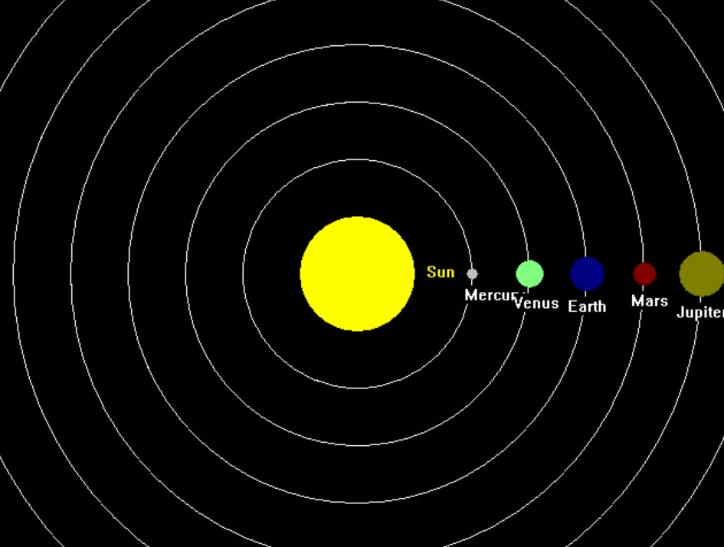
15. ⁠design ludo board using computer graphics functions.
#include <graphics.h>
#include <conio.h>

void drawLudoBoard(int startX, int startY, int cellSize)
{
// Colors for each player's base
int redBaseColor = RED;
int greenBaseColor = GREEN;
int yellowBaseColor = YELLOW;
int blueBaseColor = BLUE;
int pathColor = LIGHTGRAY;

// Draw the red base
setfillstyle(SOLID_FILL, redBaseColor);
rectangle(startX, startY, startX + 4 * cellSize, startY + 4 * cellSize);
floodfill(startX + 1, startY + 1, WHITE);

// Draw the green base
setfillstyle(SOLID_FILL, greenBaseColor);
rectangle(startX + 5 * cellSize, startY, startX + 9 * cellSize, startY + 4 * cellSize);
floodfill(startX + 5 * cellSize + 1, startY + 1, WHITE);

// Draw the yellow base
setfillstyle(SOLID_FILL, yellowBaseColor);
rectangle(startX + 5 * cellSize, startY + 5 * cellSize, startX + 9 * cellSize, startY + 9 * cellSize);
floodfill(startX + 5 * cellSize + 1, startY + 5 * cellSize + 1, WHITE);

// Draw the blue base
setfillstyle(SOLID_FILL, blueBaseColor);
rectangle(startX, startY + 5 * cellSize, startX + 4 * cellSize, startY + 9 * cellSize);
floodfill(startX + 1, startY + 5 * cellSize + 1, WHITE);

// Draw paths and center
setfillstyle(SOLID_FILL, pathColor);

// Vertical path on the left (red to blue)
rectangle(startX + 4 * cellSize, startY, startX + 5 * cellSize, startY + 5 * cellSize);
floodfill(startX + 4 * cellSize + 1, startY + 1, WHITE);

// Horizontal path on the top (red to green)
rectangle(startX, startY + 4 * cellSize, startX + 5 * cellSize, startY + 5 * cellSize);
floodfill(startX + 1, startY + 4 * cellSize + 1, WHITE);

// Vertical path on the right (green to yellow)
rectangle(startX + 5 * cellSize, startY + 4 * cellSize, startX + 9 * cellSize, startY + 5 * cellSize);
floodfill(startX + 5 * cellSize + 1, startY + 4 * cellSize + 1, WHITE);

// Horizontal path on the bottom (blue to yellow)
rectangle(startX + 4 * cellSize, startY + 5 * cellSize, startX + 5 * cellSize, startY + 9 * cellSize);
floodfill(startX + 4 * cellSize + 1, startY + 5 * cellSize + 1, WHITE);

// Center square (safe zone)
setfillstyle(SOLID_FILL, WHITE);
rectangle(startX + 4 * cellSize, startY + 4 * cellSize, startX + 5 * cellSize, startY + 5 * cellSize);
floodfill(startX + 4 * cellSize + 1, startY + 4 * cellSize + 1, WHITE);

// Drawing the diagonal lines in the center
setcolor(WHITE);
line(startX + 4 * cellSize, startY + 4 * cellSize, startX + 5 * cellSize, startY + 5 * cellSize);
line(startX + 4 * cellSize, startY + 5 * cellSize, startX + 5 * cellSize, startY + 4 * cellSize);
setfillstyle(SOLID_FILL, WHITE);

// Red Quadrant
for (int i = 0; i < 2; i++)
{
for (int j = 0; j < 2; j++)
{
fillellipse(startX + (i * 2 + 1) * cellSize, startY + (j * 2 + 1) * cellSize, cellSize / 3, cellSize / 3);
}
}

// Green Quadrant
for (int i = 0; i < 2; i++)
{
for (int j = 0; j < 2; j++)
{
fillellipse(startX + (5 + i * 2 + 1) * cellSize, startY + (j * 2 + 1) * cellSize, cellSize / 3, cellSize / 3);
}
}

// Yellow Quadrant
for (int i = 0; i < 2; i++)
{
for (int j = 0; j < 2; j++)
{
fillellipse(startX + (5 + i * 2 + 1) * cellSize, startY + (5 + j * 2 + 1) * cellSize, cellSize / 3, cellSize / 3);
}
}

// Blue Quadrant
for (int i = 0; i < 2; i++)
{
for (int j = 0; j < 2; j++)
{
fillellipse(startX + (i * 2 + 1) * cellSize, startY + (5 + j * 2 + 1) * cellSize, cellSize / 3, cellSize / 3);
}
}
}

int main()
{
int gd = DETECT, gm;
initgraph(&gd, &gm, "");
int startX = 200, startY = 100;
int cellSize = 30;
drawLudoBoard(startX, startY, cellSize);
getch();
closegraph();
return 0;
}
