Lab-3

1. Design Covid-19 Article using HTML and CSS.

Css File :-

body {

  font-family: "Arial", sans-serif;

  line-height: 1.6;

  margin: 0;

  padding: 0;

  background-color: #f4f4f4;

  color: #333;

}

*.back* {

  background-size: cover;

  background-position: center;

  position: absolute;

  top: 0;

  background-attachment: fixed;

  background-image: url("image/back.jpg");

  left: 0;

  position: fixed;

  width: 100%;

  height: 100%;

  z-index: 1;

}

*.content* {

  padding-top: 40px;

  position: relative;

  z-index: 1;

  opacity: 0.85;

}

header {

  background-color: #2c3e50;

  color: #ecf0f1;

  padding: 8px 0;

  position: fixed;

  top: 0;

  left: 0;

  width: 100%;

  z-index: 2;

  box-shadow: 0 2px 4px rgba(0, 0, 0, 0.5);

}

header *.container* {

  display: flex;

  justify-content: space-between;

  align-items: center;

}

header h1 {

  margin: 0;

  font-size: 2rem;

  opacity: 1;

}

nav ul {

  list-style: none;

  margin: 0;

  padding: 0;

  display: flex;

}

nav li {

  margin-left: 1rem;

}

nav a {

  color: #ecf0f1;

  text-decoration: none;

  font-weight: bold;

  padding: 0.5rem 1rem;

  border-radius: 4px;

  transition: color 0.3s ease, background-color 0.3s ease;

}

nav a*:hover* {

  color: #2c3e50;

  background-color: #ecf0f1;

}

*.content-section* {

  padding: 3rem 0;

  background: #fff;

  border-bottom: 1px solid #e4e4e4;

}

*.content-section* h2 {

  margin-top: 0;

  font-size: 2rem;

  color: #2c3e50;

  margin-bottom: 10px;

}

*.content-section* p {

  font-size: 1.1rem;

  line-height: 1.8;

  color: #555;

  margin: 1rem 0;

  text-align: justify;

}

*.content-section* img {

  max-width: 100%;

  height: auto;

  margin: 2rem 0;

  border-radius: 15px;

  box-shadow: 0 4px 8px rgba(0, 0, 0, 0.2);

  transition: transform 0.3s ease, box-shadow 0.3s ease;

  display: block;

}

*.content-section* img*:hover* {

  transform: scale(1.05);

  box-shadow: 0 8px 16px rgba(0, 0, 0, 0.5);

}

*.container* {

  width: 80%;

  margin: 0 auto;

  max-width: 1200px;

}

*.resources-heading* {

  font-size: 1.5rem;

  color: #2c3e50;

  font-weight: bold;

  margin-bottom: 1rem;

}

footer {

  background-color: #2c3e50;

  color: #ecf0f1;

  text-align: center;

  padding: 1rem 0;

  z-index: 2;

  box-shadow: 8px 4px 6px rgba(0, 0, 0, 0.5);

  position: relative;

}

footer p {

  margin: 0;

}

ul {

  list-style: disc inside;

  padding-left: 0;

}

*.content-section* ul {

  list-style: disc outside;

  padding-left: 1.5rem;

}

*.content-section* ul li {

  margin: 0.5rem 0;

}

*.content-section* a {

  color: #3498db;

  text-decoration: none;

  font-weight: bold;

  transition: color 0.3s ease, background-color 0.3s ease;

}

*.content-section* a*:hover* {

  color: #fff;

  background-color: #3498db;

  padding: 0.2rem 0.5rem;

  border-radius: 4px;

}

*.symptom* {

  display: flexbox;

  justify-content: center;

  align-content: center;

  align-items: center;

}

*.symptom* img {

  height: 250px !important;

  float: left;

  margin: 0px 20px 20px 20px;

  justify-content: center;

  align-content: center;

  align-items: center;

}

*.prevention* {

  display: flexbox;

  justify-content: center;

  align-content: center;

  align-items: center;

}

*.prevention* img {

  height: 300px !important;

  float: left;

  margin: 0px 30px 20px 30px;

  justify-content: center;

  align-content: center;

  align-items: center;

}

*.resource* {

  display: flexbox;

  justify-content: center;

  align-content: center;

  align-items: center;

}

*.resource* img {

  height: 200px !important;

  float: left;

  margin: 0px 15px 20px 15px;

  justify-content: center;

  align-content: center;

  align-items: center;

}

hr {

  height: 2px;

  background-color: #2c3e50;

  margin-bottom: 50px;

  opacity: 0.7;

  margin-top: 0;

}

@media (max-width: 768px) {

  header *.container* {

    flex-direction: column;

  }

  nav ul {

    flex-direction: column;

  }

  nav li {

    margin-left: 0;

    margin-top: 0.5rem;

  }

*.container* {

    width: 90%;

  }

}

Html File :-

<!DOCTYPE *html*>

<html *lang*="en">

  <head>

    <meta *charset*="UTF-8" />

    <meta *name*="viewport" *content*="width=device-width, initial-scale=1.0" />

    <title>COVID-19 Updates</title>

    <link *rel*="stylesheet" *href*="CovidCSS.css" />

  </head>

  <body>

    <div *class*="back"></div>

    <header>

      <div *class*="container">

        <h1>COVID-19 Updates</h1>

        <nav>

          <ul>

            <li><a *href*="#overview">Overview</a></li>

            <li><a *href*="#symptoms">Symptoms</a></li>

            <li><a *href*="#prevention">Prevention</a></li>

            <li><a *href*="#resources">Resources</a></li>

          </ul>

        </nav>

      </div>

    </header>

    <div *class*="content">

      <main>

        <section *id*="overview" *class*="content-section">

          <div *class*="container">

            <h2>Overview</h2>

            <hr />

            <img

*src*="image/over.gif"

*style*="height: 300px"

*alt*="COVID-19 Virus"

            />

            <p>

              COVID-19 is a respiratory illness caused by the coronavirus

              SARS-CoV-2. It was first identified in December 2019 in Wuhan,

              China, and has since spread globally, leading to a worldwide

              pandemic. The virus spreads primarily through droplets of saliva

              or discharge from the nose when an infected person coughs or

              sneezes.

            </p>

            <p>

              The rapid spread of the virus has overwhelmed healthcare systems

              around the world, leading to significant morbidity and mortality.

              Efforts to control the spread include social distancing measures,

              lockdowns, and the development of vaccines and treatments. The

              pandemic has had far-reaching impacts on global health, economies,

              and daily life.

            </p>

            <p>

              Governments and health organizations continue to work together to

              understand the virus, implement measures to control its spread,

              and mitigate its effects. Public health campaigns emphasize the

              importance of hygiene, wearing masks, and getting vaccinated to

              protect individuals and communities.

            </p>

          </div>

        </section>

        <section *id*="symptoms" *class*="content-section">

          <div *class*="container">

            <h2>Symptoms</h2>

            <hr />

            <div *class*="symptom">

              <img *src*="image/sym4.jpg" *alt*="" />

              <img *src*="image/sym1.jpg" *alt*="" />

              <img *src*="image/sym2.jpg" *alt*="" />

              <img *src*="image/sym3.jpg" *alt*="" />

            </div>

            <p>

              Common symptoms of COVID-19 include fever, dry cough, and

              tiredness. Other symptoms that are less common and may affect some

              patients include aches and pains, nasal congestion, headache,

              conjunctivitis, sore throat, diarrhea, loss of taste or smell, a

              rash on the skin, or discoloration of fingers or toes.

            </p>

            <p>

              In more severe cases, the infection can cause pneumonia, severe

              acute respiratory syndrome, kidney failure, and death. People with

              underlying medical conditions and older adults are at a higher

              risk of developing serious complications from the virus.

            </p>

            <p>

              Symptoms typically appear 2-14 days after exposure to the virus.

              It is important to seek medical attention if you experience

              difficulty breathing, persistent pain or pressure in the chest,

              confusion, inability to stay awake, or bluish lips or face. Early

              diagnosis and treatment can improve outcomes and reduce the risk

              of severe illness.

            </p>

          </div>

        </section>

        <section *id*="prevention" *class*="content-section">

          <div *class*="container">

            <h2>Prevention</h2>

            <hr />

            <div *class*="prevention">

              <img *src*="image/pre1.jpg" *alt*="" />

              <img *src*="image/pre2.jpg" *alt*="" />

              <img *src*="image/pre3.jpg" *alt*="" />

            </div>

            <p>

              To prevent infection and to slow transmission of COVID-19, do the

              following:

            </p>

            <ul>

              <li>

                Wash your hands regularly with soap and water, or clean them

                with an alcohol-based hand rub.

              </li>

              <li>Maintain at least a 1-meter distance from others.</li>

              <li>Avoid touching your face.</li>

              <li>Cover your mouth and nose when coughing or sneezing.</li>

              <li>Stay home if you feel unwell.</li>

              <li>

                Refrain from smoking and other activities that weaken the lungs.

              </li>

              <li>

                Practice physical distancing by avoiding unnecessary travel and

                staying away from large groups of people.

              </li>

            </ul>

            <p>

              Wearing a mask in public settings, especially when social

              distancing is difficult to maintain, can help reduce the spread of

              the virus. Masks should be worn properly, covering both the nose

              and mouth, and should be used in conjunction with other preventive

              measures.

            </p>

            <p>

              Vaccination is a critical tool in controlling the pandemic.

              Vaccines have been developed and distributed globally, providing

              protection against severe illness and death caused by COVID-19.

              Staying informed about vaccination opportunities and getting

              vaccinated when eligible is essential for personal and public

              health.

            </p>

          </div>

        </section>

        <section *id*="resources" *class*="content-section">

          <div *class*="container">

            <h2>Resources</h2>

            <hr />

            <div *class*="resource">

              <img *src*="image/res0.jpg" *alt*="" />

              <img *src*="image/res1.jpg" *alt*="" />

              <img *src*="image/res2.jpg" *alt*="" />

              <img *src*="image/res3.jpg" *alt*="" />

            </div>

            <p>For more information, visit the following resources:</p>

            <ul>

              <li>

                <a *href*="https://www.who.int" *target*="_blank"

                  >World Health Organization (WHO)</a

                >

              </li>

              <li>

                <a *href*="https://www.cdc.gov" *target*="_blank"

                  >Centers for Disease Control and Prevention (CDC)</a

                >

              </li>

              <li>

                <a *href*="https://www.nih.gov" *target*="_blank"

                  >National Institutes of Health (NIH)</a

                >

              </li>

            </ul>

            <p>

              These organizations provide up-to-date information on COVID-19,

              including guidance on prevention, symptoms, treatment, and

              vaccination. They also offer resources for healthcare

              professionals, researchers, and the general public to stay

              informed and safe during the pandemic.

            </p>

            <p>

              Local health departments and governments also provide valuable

              information and resources tailored to specific communities.

              Staying connected with local health authorities ensures that you

              receive accurate and relevant updates and support.

            </p>

          </div>

        </section>

      </main>

    </div>

    <footer>

      <div *class*="container">

        <p>&copy; 2024 COVID-19 Updates. All rights reserved.</p>

      </div>

    </footer>

  </body>

</html>

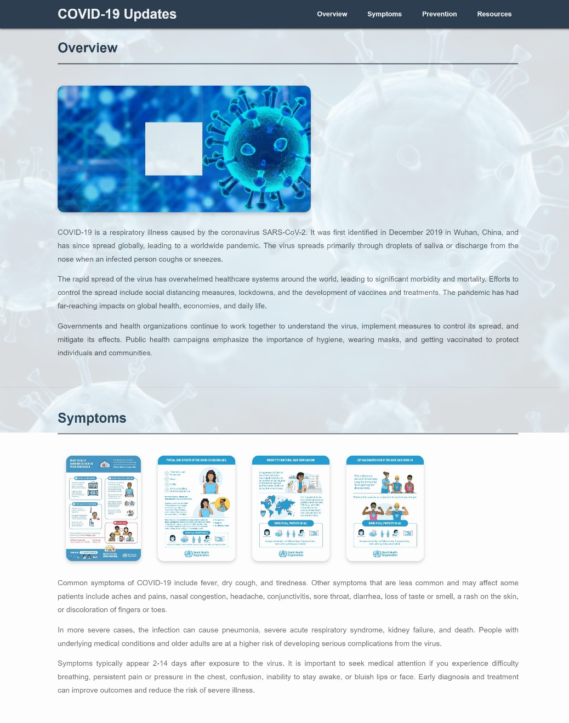

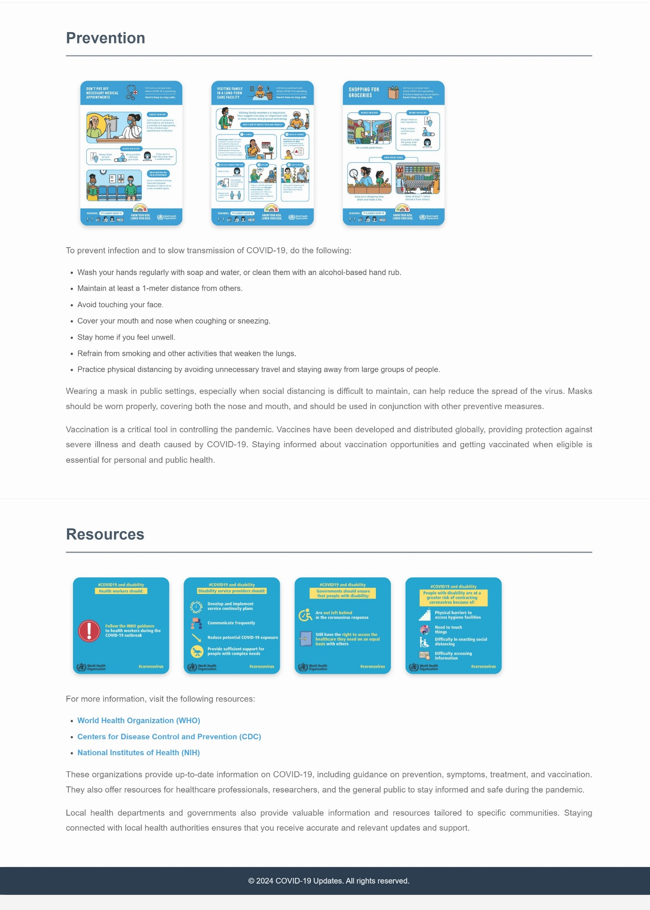

2. Design vertical navigation bar like following.

Html File :-

<!DOCTYPE *html*>

<html *lang*="en">

  <head>

    <meta *charset*="UTF-8" />

    <meta *name*="viewport" *content*="width=device-width, initial-scale=1.0" />

    <title>Document</title>

    <link

*href*="https://cdn.jsdelivr.net/npm/bootstrap@5.3.3/dist/css/bootstrap.min.css"

*rel*="stylesheet"

*integrity*="sha384-QWTKZyjpPEjISv5WaRU9OFeRpok6YctnYmDr5pNlyT2bRjXh0JMhjY6hW+ALEwIH"

*crossorigin*="anonymous"

    />

    <script

*src*="https://cdn.jsdelivr.net/npm/bootstrap@5.3.3/dist/js/bootstrap.bundle.min.js"

*integrity*="sha384-YvpcrYf0tY3lHB60NNkmXc5s9fDVZLESaAA55NDzOxhy9GkcIdslK1eN7N6jIeHz"

*crossorigin*="anonymous"

    ></script>

  </head>

  <body *class*="p-0">

    <div *class*="container m-0 p-0">

      <div *class*="row m-0 p-0 mt-3 ms-3">

        <div *class*="col-md-2 m-0 p-3 bg-success">

          <div *class*="navbar-togle text-uppercase text-white mx-auto">

            <div *class*="nav-link text-center">Home</div>

            <div *class*="nav-link text-center">News</div>

            <div *class*="nav-link text-center">Contact</div>

            <div *class*="nav-link text-center">About</div>

          </div>

        </div>

      </div>

    </div>

  </body>

</html>



3. Design horizontal navigation bar like following.

Html File :-

<!DOCTYPE *html*>

<html *lang*="en">

  <head>

    <meta *charset*="UTF-8" />

    <meta *name*="viewport" *content*="width=device-width, initial-scale=1.0" />

    <title>Document</title>

    <link

*href*="https://cdn.jsdelivr.net/npm/bootstrap@5.3.3/dist/css/bootstrap.min.css"

*rel*="stylesheet"

*integrity*="sha384-QWTKZyjpPEjISv5WaRU9OFeRpok6YctnYmDr5pNlyT2bRjXh0JMhjY6hW+ALEwIH"

*crossorigin*="anonymous"

    />

    <script

*src*="https://cdn.jsdelivr.net/npm/bootstrap@5.3.3/dist/js/bootstrap.bundle.min.js"

*integrity*="sha384-YvpcrYf0tY3lHB60NNkmXc5s9fDVZLESaAA55NDzOxhy9GkcIdslK1eN7N6jIeHz"

*crossorigin*="anonymous"

    ></script>

  </head>

  <body *class*="p-0">

    <div *class*="container mt-3 ms-3 m-0 p-0">

      <div *class*="row m-0 p-0">

        <div *class*="col-md-8 m-0 bg-success">

          <div *class*="navbar text-white px-5 text-uppercase mx-auto">

            <div *class*="nav-link text-center">Home</div>

            <div *class*="nav-link text-center">News</div>

            <div *class*="nav-link text-center">Contact</div>

            <div *class*="nav-link text-center">About</div>

          </div>

        </div>

      </div>

    </div>

  </body>

</html>

