KLE TECHNOLOGICAL UNIVERSITY,HUBBALLI.
DEPARTMENT OF BACHELORE IN COMPUTER APPLICATION
KLE Society’s


A Project SRS document
Fresh First – Perishable Stock Verification Register
Submitted in partial fulfilment of the requirement for degree
BACHELORE OF COMPUTER APPLICATION
Submitted by:
Rutika – 01FE24BCA320
Khushi Emmi – 01FE24BCA319
Srushti – 01FE24BCA261
Bassamma – 01FE24BCA265

Under the Guidance of
Prof. Pavankumar Vadavi
Prof. Sayeeda Anjum

Introduction
Many stores handle perishable products such as milk, bread, fruits and vegetables, which have a short shelf life. These products must be checked regularly for expiry date, quantity and storage condition. When these checks are done manually, expired or near-expiry products can be missed, which leads to wastage, financial loss and the risk of selling unsafe products.
The proposed project, Fresh First – Perishable Stock Verification Register, applies fixed, human-written rules to verify every perishable product record. It checks the expiry date, quantity, storage temperature and missing data, assigns a priority to each product, and suggests a suitable action such as priority sale, quick usage, redistribution, further inspection or disposal. Every verification and action is stored so that the history of each product can be traced.
The system provides a simple web interface with role-based login for the Admin, Store Manager and Staff. It is a rule-based system and does not use Machine Learning or Artificial Intelligence. The main theme of the project is Rule-Checked Records, and the supporting theme is Reporting and MIS. It applies foundational concepts from Database Management Systems (DBMS), Data Structures and Programming, Object-Oriented Programming (OOP), Web Technologies and Software Engineering to develop a manageable and maintainable system.

1.1 Purpose
The purpose of this document is to specify the requirements of Fresh First – Perishable Stock Verification Register. It is meant for the project guide, developers and testers, and is the base for design, coding and testing. The purpose of the system is to reduce wastage of perishable products by verifying stock records against fixed rules, identifying the products that need attention first, and suggesting what should be done with them.

1.2 Scope
In scope:
- Add, view, edit and delete perishable product records.
- Verify expiry, quantity, storage condition and missing data using fixed rules.
- Assign priority and suggest an action (priority sale, quick usage, redistribution, inspection, disposal).
- Store verification, action and history records; generate stock and MIS reports.
- Role-based login for Admin, Store Manager and Staff.
Out of scope:
- Machine Learning or Artificial Intelligence of any kind (no expiry prediction or demand forecasting).
- Automatic reading of temperature sensors or barcode scanners (temperature is typed in).
- Online ordering, billing or payment handling.

1.3 Objectives
The main objectives of the project are:
- To maintain perishable product records systematically.
- To verify expiry, quantity, storage condition and missing data using fixed rules.
- To assign a priority to each product and order products by priority and days left.
- To suggest a suitable action for each product, including redistribution of near-expiry stock.
- To store verification, action and history records for tracking and verification.
- To provide stock reports and MIS reports for decision making.
- To apply foundational concepts of DBMS, OOP, Web Technologies and Software Engineering in developing a reliable, rule-based system.

1.4 Intended Audience
This document is intended for the project guide, faculty members, evaluators, developers, testers and students who want to understand the requirements and functionality of the proposed system. It describes the purpose, scope, features, constraints and technical requirements of Fresh First. It can also be used as a reference during system design, development, testing and maintenance.

1.5 Document Overview
This Software Requirements Specification (SRS) describes the requirements of Fresh First – Perishable Stock Verification Register. Section 1 gives the introduction, Section 2 gives the overall description of the product, and Section 3 lists the specific requirements: functional and non-functional requirements, database requirements, business rules, modularity requirements, an example scenario, an appendix and requirement traceability. Section 4 describes the hardware and software requirements, Section 5 gives the system models (diagrams), Section 6 lists possible future enhancements, Section 7 gives the conclusion and Section 8 lists the references.

1.6 Foundational Concepts Used
The project applies the following foundational concepts:
- Database Management Systems (DBMS): Used to store and manage user, product, verification, action and history records in a MySQL database in third normal form.
- Data Structures and Programming: Used to organize records and implement the rule logic; a priority queue is used to order products by priority and days left.
- Object-Oriented Programming (OOP): Used to organize the application into classes and objects such as User, Product, Verification, Priority, Action and Report, with inheritance (Admin and Staff extend User; DairyProduct and FruitVegetable extend Product).
- Web Technologies: Used to develop the user interface and enable users to interact with the system through web pages.
- Software Engineering and SDLC: Used to follow a systematic development process involving requirement analysis, design, implementation, testing and maintenance.
- Data Validation and Integrity: Used to reject missing, negative or illogical values and to keep records consistent through foreign keys and validation.
- Rule-Based Decision Making: Used to apply fixed, human-written rules (R1 to R7) for expiry, quantity, storage, missing data and date logic; no Machine Learning is used.

1.7 Definitions and Abbreviations
Term | Meaning
Perishable | Product with a short shelf life, such as milk, bread, fruits and vegetables
Near Expiry | Product expiring within the threshold number of days
Threshold | Number of days before expiry at which a product is called near expiry
MIS | Management Information System; summary reports for decision making
CRUD | Create, Read, Update, Delete
SRS | Software Requirements Specification

Overall Description

2.1 Product Perspective
Fresh First is a stand-alone web application with a browser front end, a server-side application layer and a relational database. It is built as six loosely coupled modules: Stock, Verification, Priority, Redistribution / Action, History and Reporting.

2.2 Product Functions (Summary)
- Login and role-based access.
- Stock management (add, view, update, delete, search).
- Rule-based verification of each record.
- Priority calculation and sorting.
- Suggested action and redistribution.
- History logging.
- MIS report generation.

2.3 User Classes
User | Responsibilities | Technical skill
Admin | Manages users, sets thresholds and temperature ranges, views all reports | Medium
Store Manager | Runs verification, reviews priority, confirms actions, views reports | Basic
Staff | Adds and updates product records, views stock details | Basic

2.4 Operating Environment
The system runs in any modern browser (Chrome, Edge, Firefox) on a PC or mobile. On the server side it needs a web server with a server-side language and a MySQL database. In this project the server-side language is Python with the Flask framework.

2.5 Design and Implementation Constraints
- The system must be rule-based; Machine Learning and AI are not allowed.
- Rules, thresholds and temperature ranges must be changeable without changing code.
- Each module must work without the other modules.

2.6 Assumptions and Dependencies
- Users enter correct product details.
- The server date and time are correct.
- Staff have basic computer knowledge.

Specific Requirements
This section describes the functional and operational requirements of the Perishable Stock Verification Register. It specifies the main features and operations that the system must support for rule-checked verification of perishable stock.

3.1 External Interface Requirements
Interface | Requirement
User interface | Nine web pages (Login, Dashboard, Add Product, Stock Details, Verification, Priority, Redistribution / Action, History, Reports); forms with validation messages; colour-coded status (red = expired, amber = near expiry, green = valid)
Hardware | PC, laptop or mobile with a browser; a server or hosting space
Software | Web server, server-side language, MySQL database
Communication | HTTP/HTTPS between browser and server

3.2 Functional Requirements
Functional requirements describe the operations that the system must perform. Each requirement is written as a “shall” statement and has a unique ID. Priority: M = must have, H = high, L = low.

3.2.1 User and Login Module
Requirement ID | Functional Requirement | Description | Pri.
FR-US-01 | Login | The system shall allow login using username and password. | M
FR-US-02 | Role-Based Access | The system shall give access to pages according to the user role. | M
FR-US-03 | Manage Users | The Admin shall be able to add, edit and deactivate users. | H
FR-US-04 | Logout | The system shall log out users on request and after a period of inactivity. | H

3.2.2 Stock Module
Requirement ID | Functional Requirement | Description | Pri.
FR-ST-01 | Add Product | The system shall add a product with name, category, quantity, purchase date, expiry date and storage condition. | M
FR-ST-02 | Reject Invalid Records | The system shall reject a record with missing, negative or illogical values before saving. | M
FR-ST-03 | View Stock List | The system shall display all products in a list. | M
FR-ST-04 | Edit Product | The system shall allow editing a product. | M
FR-ST-05 | Delete Product | The system shall allow deleting a product after confirmation. | H
FR-ST-06 | Search and Sort | The system shall search products by name or category and sort by expiry date. | H

3.2.3 Verification Module
Requirement ID | Functional Requirement | Description | Pri.
FR-VR-01 | Check Expiry | The system shall compare the expiry date with today and mark the product EXPIRED, NEAR EXPIRY or VALID. | M
FR-VR-02 | Set Threshold | The system shall use a near-expiry threshold that the Admin can set per category. | H
FR-VR-03 | Check Quantity | The system shall check that quantity is a positive whole number. | M
FR-VR-04 | Check Storage | The system shall compare the recorded temperature with the allowed range and mark STORAGE ISSUE when outside it. | M
FR-VR-05 | Detect Missing Data | The system shall detect blank mandatory fields and illogical dates. | M
FR-VR-06 | Derive Overall Status | The system shall derive an overall status (Valid, Attention Required or Invalid). | M
FR-VR-07 | Verify and Save | The system shall verify one product or all products and save each result with date and user. | M

3.2.4 Priority Module
Requirement ID | Functional Requirement | Description | Pri.
FR-PR-01 | Assign Priority | The system shall assign Critical, High, Medium, Low or Inspection priority using the priority rules. | M
FR-PR-02 | Order by Priority | The system shall order products by priority and then by days left using a priority queue. | H
FR-PR-03 | Colour Codes | The system shall display priority with colour codes. | L

3.2.5 Redistribution / Action Module
Requirement ID | Functional Requirement | Description | Pri.
FR-AC-01 | Suggest Action | The system shall suggest an action (priority sale, quick usage, redistribution, further inspection or disposal). | M
FR-AC-02 | Suggest Redistribution | The system shall suggest redistribution when a near-expiry product has a large quantity. | H
FR-AC-03 | Confirm or Change Action | The Manager shall be able to confirm or change the suggested action. | H
FR-AC-04 | Record Action Status | The system shall record action status (Pending or Done) and action date. | M

3.2.6 History Module
Requirement ID | Functional Requirement | Description | Pri.
FR-HS-01 | Log Verification and Actions | The system shall log every verification and action with date and time. | M
FR-HS-02 | View History | The system shall allow viewing history by product or by date range. | H
FR-HS-03 | Protect History | History records shall not be editable or deletable by any user. | M

3.2.7 Reporting Module
Requirement ID | Functional Requirement | Description | Pri.
FR-RP-01 | Total Stock Report | The system shall generate the total stock report. | M
FR-RP-02 | Expired, Near-Expiry and Storage-Issue Reports | The system shall generate expired, near-expiry and storage-issue reports. | M
FR-RP-03 | Attention Report | The system shall generate a report of products requiring attention. | M
FR-RP-04 | Summaries | The system shall generate category-wise and action-wise summaries. | H
FR-RP-05 | Filter, Print and Export | The system shall filter reports by date and category and allow printing or export. | H

3.3 Non-Functional Requirements
ID | Category | Requirement
NFR-01 | Performance | Verification of 1,000 records shall finish within a few seconds; pages shall load within 3 seconds on a normal network.
NFR-02 | Security | Passwords shall be stored in hashed form; pages shall check the user role; database queries shall be protected against SQL injection.
NFR-03 | Reliability | The system shall give the same result for the same input; a daily database backup shall be possible.
NFR-04 | Availability | The system shall be available during store working hours.
NFR-05 | Usability | Forms shall be simple, with clear error messages and colour-coded status, so that a new user can work after short training.
NFR-06 | Maintainability | Code shall be divided into modules and classes; rules and thresholds shall be stored as settings.
NFR-07 | Modularity | Removing any one module shall not stop the other modules.
NFR-08 | Portability | The system shall run on any modern browser and on common operating systems.
NFR-09 | Data Integrity | Foreign keys and validation shall prevent invalid or orphan records.

3.4 Database Requirements
The system uses five tables (User, Product, Verification, Action and History) in third normal form. One Product has many Verifications, Actions and History entries, and one User performs many Verifications. The tables are linked only through product_id and user_id. The ER diagram is given in Section 5.1.

3.5 Business Rules and System Constraints
The following predefined rules are applied by the system. They are fixed, human-written rules; no Machine Learning is used.
Verification rules
Rule | Check | Condition | Result
R1 | Expiry | expiry_date < today | EXPIRED
R2 | Near expiry | 0 <= days_left <= threshold (for example 3 days; set per category) | NEAR EXPIRY
R3 | Valid expiry | days_left > threshold | VALID
R4 | Quantity | quantity <= 0 or not a whole number | INVALID QUANTITY
R5 | Storage | recorded temperature outside the allowed range (for example milk 2 to 8 °C) | STORAGE ISSUE
R6 | Missing data | name, category, dates or storage is blank | INCOMPLETE RECORD
R7 | Date logic | expiry_date <= purchase_date | INVALID DATES

Priority rules
Priority rule | Priority
Expired | Critical
Near expiry together with a storage issue | High
Near expiry only (High if 1 to 2 days left, otherwise Medium) | High / Medium
Storage issue only | Medium
Invalid or incomplete record | Inspection needed
All rules passed | Low

Action rules
Condition | Suggested action
Expired | Remove / Dispose
Near expiry and large quantity | Redistribution
Near expiry, small quantity | Priority Sale or Quick Usage
Storage issue or invalid data | Further Inspection
All rules passed | No action

System constraints
- The system shall be rule-based; Machine Learning and AI shall not be used.
- Rules, thresholds and temperature ranges shall be changeable without changing code.
- Each user, product, verification, action and history record shall have a unique identifier.
- The system shall use Python, Flask, MySQL Connector/Python, MySQL, HTML, CSS and JavaScript.
- The system shall require a compatible Python environment, a MySQL database and a web server to operate.

3.6 Modularity Requirements
If this module is removed | The rest of the system still works because
Stock | Products can still be read from the database for verification and reports.
Verification | Stock and reports still show the stored data.
Priority | Verification still marks expired and invalid products.
Redistribution / Action | Verification and priority lists still work.
History | Current verification and reports still work; only past records are missing.
Reporting | Stock, verification and priority work as normal.

Modules exchange data only through the database (using product_id) and through function interfaces. No module depends on the internal code of another.

3.7 Example Scenario
Milk, 20 packets
Step | Detail
Input | Milk, Dairy, 20 packets, purchased 1 day ago, expiry tomorrow, stored at 5 °C (allowed 2 to 8 °C).
Processing | R1 not expired; R2 days left = 1, so NEAR EXPIRY; R4 valid; R5 valid; R6 complete.
Output | Overall status = Attention Required; Priority = High; Action = Priority Sale / Redistribution; result saved in Verification, Action and History.

3.8 Appendix
Item | Detail
Requirement priority | M = must have, H = high, L = low
Status values | EXPIRED, NEAR EXPIRY, VALID, INVALID QUANTITY, STORAGE ISSUE, INCOMPLETE RECORD, INVALID DATES
Priority values | Critical, High, Medium, Low, Inspection needed
Action values | Dispose, Redistribution, Priority Sale, Quick Usage, Further Inspection, No action

3.9 Requirement Traceability
Module | Requirements | Database table | Web page
User / Login | FR-US-01 to 04 | User | Login
Stock | FR-ST-01 to 06 | Product | Add Product, Stock Details
Verification | FR-VR-01 to 07 | Verification | Verification
Priority | FR-PR-01 to 03 | Action | Priority
Redistribution / Action | FR-AC-01 to 04 | Action | Redistribution / Action
History | FR-HS-01 to 03 | History | History
Reporting | FR-RP-01 to 05 | All (read only) | Reports, Dashboard

Hardware and Software Requirements
This section describes the basic hardware and software needed to develop and run the proposed system.

4.1 Hardware Requirements
- Computer or laptop capable of running a web browser, Python development tools, and MySQL.
- Minimum 4 GB RAM recommended; 8 GB is preferable for smoother development.
- Sufficient disk space for Python, VS Code, MySQL, required libraries, and project files.
- A processor capable of running the required development tools and database software.
- For users: a PC, laptop or mobile with a web browser; for deployment: a server or hosting space.

4.2 Software Requirements
- Operating System: Windows.
- Programming Language: Python.
- Frontend/Web Technologies: HTML5, CSS3, and JavaScript.
- Backend Framework: Flask.
- Database: MySQL.
- Database Connectivity: MySQL Connector for Python.
- Database Tool: MySQL Workbench.
- Development Tool: Visual Studio Code (VS Code).
- Web Browser: Google Chrome, Microsoft Edge or Firefox.
Purpose of the Technologies
- Python is used to implement the application logic and the verification rules.
- Flask is used to handle web requests and connect the user interface with the application logic.
- HTML, CSS and JavaScript are used to develop the web pages and user interactions.
- MySQL is used to store user, product, verification, action and history records.
- MySQL Connector/Python is used to connect the Flask application with the MySQL database.
- VS Code is used for writing and managing the project code.
- MySQL Workbench is used to design the database tables and to run and check queries.

System Models (Diagrams)
The following diagrams model the requirements given above. Each diagram is on its own page, followed by a short note on how to read it.
Diagram | What it shows
ER Diagram | Tables, keys and relationships
Use Case Diagram | Who uses the system and what each user can do
Rule-Checking Flowchart | Rule-checking logic step by step
Class Diagram | Classes, attributes, methods and inheritance
Sequence Diagram | Order of messages during verification
DFD Level 0 (Context) | The whole system as one process with external entities
DFD Level 1 | The six modules, data stores and data flows

5.1 ER Diagram
The Entity Relationship Diagram represents the database structure of the system. It has five tables in third normal form: User, Product, Verification, Action and History. The Product table stores the basic details of each perishable product, including category, quantity, purchase date, expiry date, storage condition and recorded temperature. The Verification table stores the result of each verification, the Action table stores the priority and suggested action, and the History table logs every verification and action with date and time.
One Product has many Verifications, Actions and History entries; one User performs many Verifications and approves many Actions. Primary keys (PK) uniquely identify records, while foreign keys (FK) such as product_id and user_id maintain the relationships between the tables.
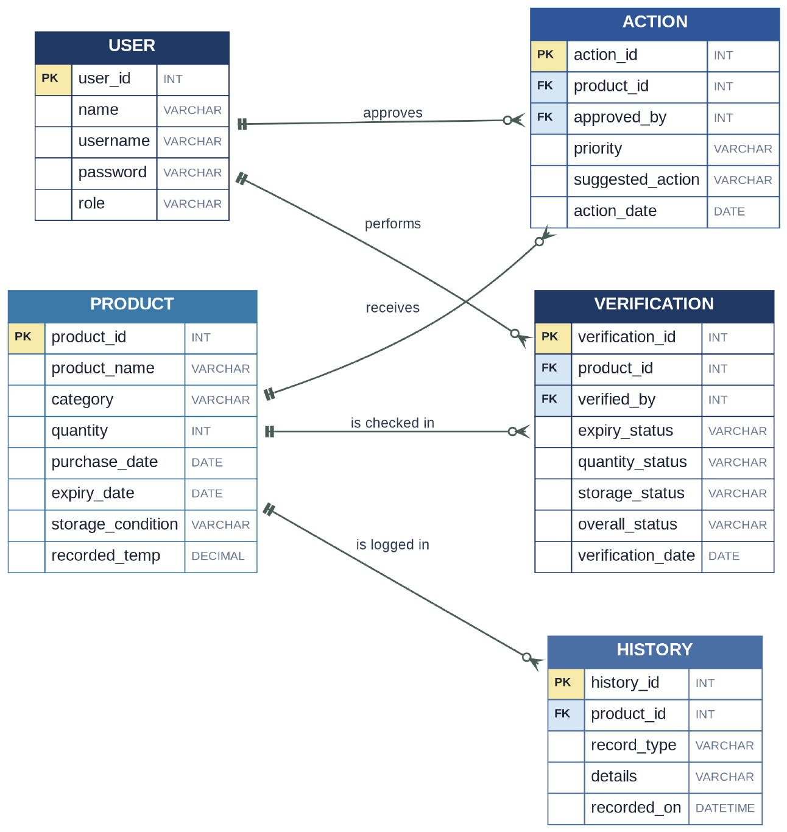
How to read this diagram: Each box is a table. PK = primary key, FK = foreign key. One Product has many Verifications, Actions and History entries.

5.2 Use Case Diagram
The Use Case Diagram shows who uses the system and what each user can do. All three users (Admin, Staff and Store Manager) log in. The Admin manages users, sets rules and thresholds, and generates reports. The Staff add or update products and view stock details. The Store Manager views stock details, verifies stock, views the priority list, takes action or redistributes stock, views history and generates reports.
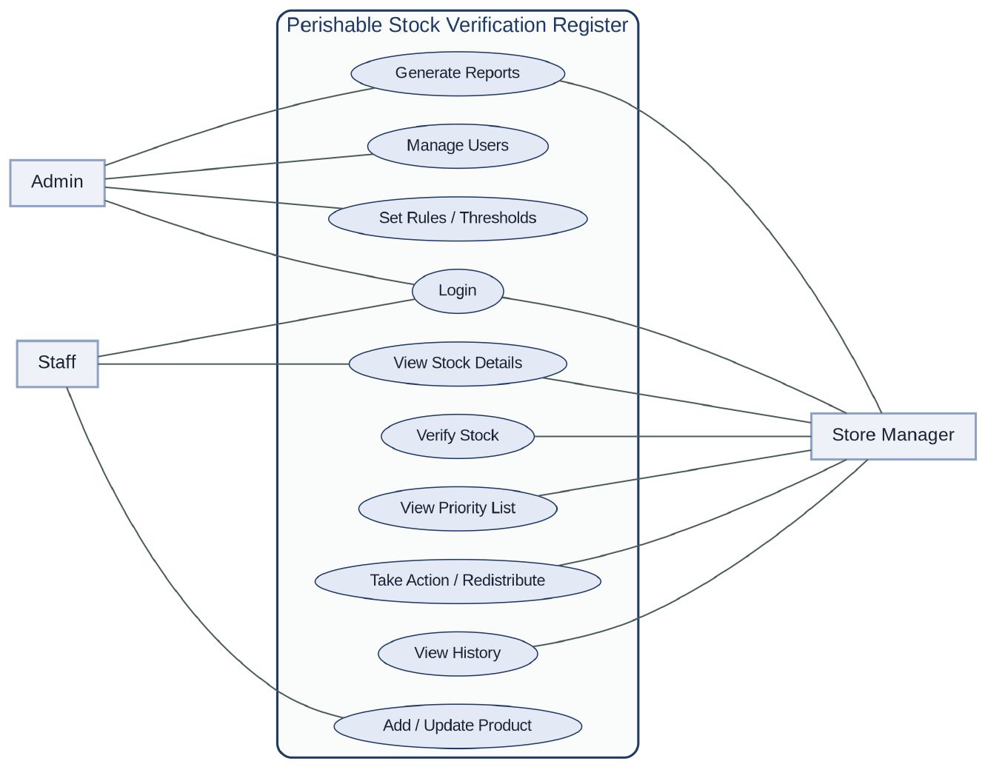
How to read this diagram: Actors (Admin, Staff, Store Manager) are connected to the functions they can use. Everything inside the boundary belongs to the system.

5.3 Rule-Checking Flowchart
The Rule-Checking Flowchart shows the step-by-step logic applied to each product record. The record is first checked for blank required fields (INCOMPLETE RECORD), and then for invalid quantity or invalid dates (INVALID DATA); both give Inspection priority. Next the expiry date is compared with today: an expired product gets Critical priority and the Dispose action. Otherwise the days left are compared with the threshold to mark the product NEAR EXPIRY or VALID, and the recorded temperature is compared with the allowed range to mark STORAGE ISSUE (which raises the priority) or storage OK. Finally the priority and suggested action are assigned, and the verification, action and history are saved.
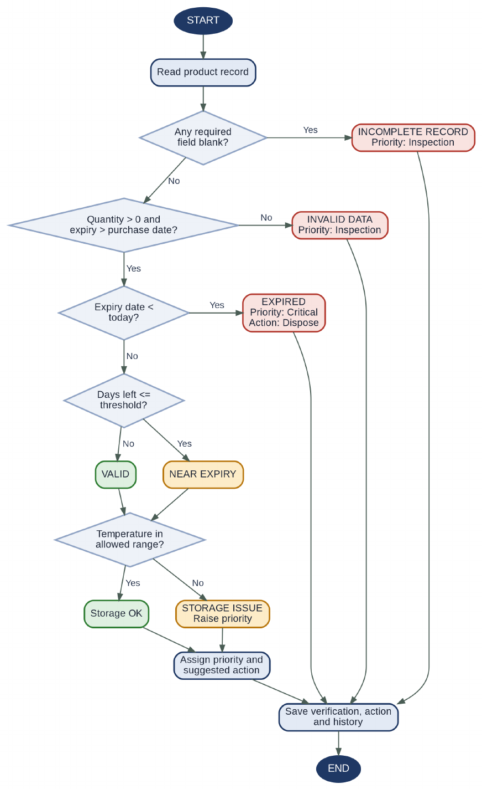
How to read this diagram: Blue diamonds are decisions. Red boxes are error or expired results, amber are warnings and green are normal results. Every path ends by saving verification, action and history.

5.4 Class Diagram
The Class Diagram represents the main classes, their attributes, methods and relationships. User is the parent class of Admin and Staff, and Product is the parent class of DairyProduct and FruitVegetable, which define their own allowed temperature range and near-expiry days. The Verification class checks expiry, quantity, storage and missing data and gets the overall status; it is performed by one User and checks one Product. The Priority class calculates and sorts priority, the Action class suggests and saves actions, and the Report class generates the stock, expired, near-expiry, storage-issue and attention reports.
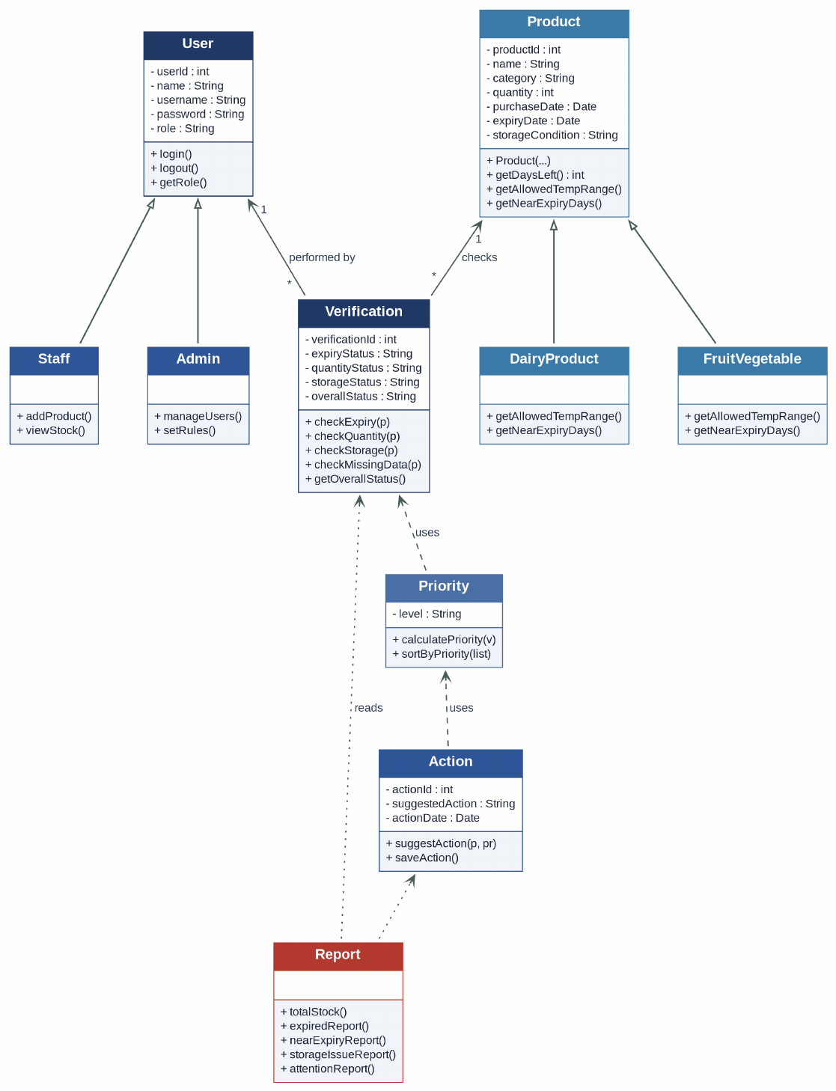
How to read this diagram: Hollow arrows show inheritance (Admin and Staff extend User; DairyProduct and FruitVegetable extend Product). Dashed arrows show use or dependency.

5.5 Sequence Diagram: Verification Process
The Sequence Diagram shows the order of messages during the verification process. When the Store Manager clicks Verify Stock, the Web Interface asks the Stock Module for the products, which are read from the Database and passed to the Verification Module. For each product, the Verification Module applies rules R1 to R7 and saves the verification result, then sends the status to the Priority Module, which calculates the priority and sends it to the Action Module. The Action Module suggests an action, saves it in the Database and asks the History Module to log the verification and action. Finally the sorted priority and action list is returned to the Web Interface and displayed to the Store Manager.
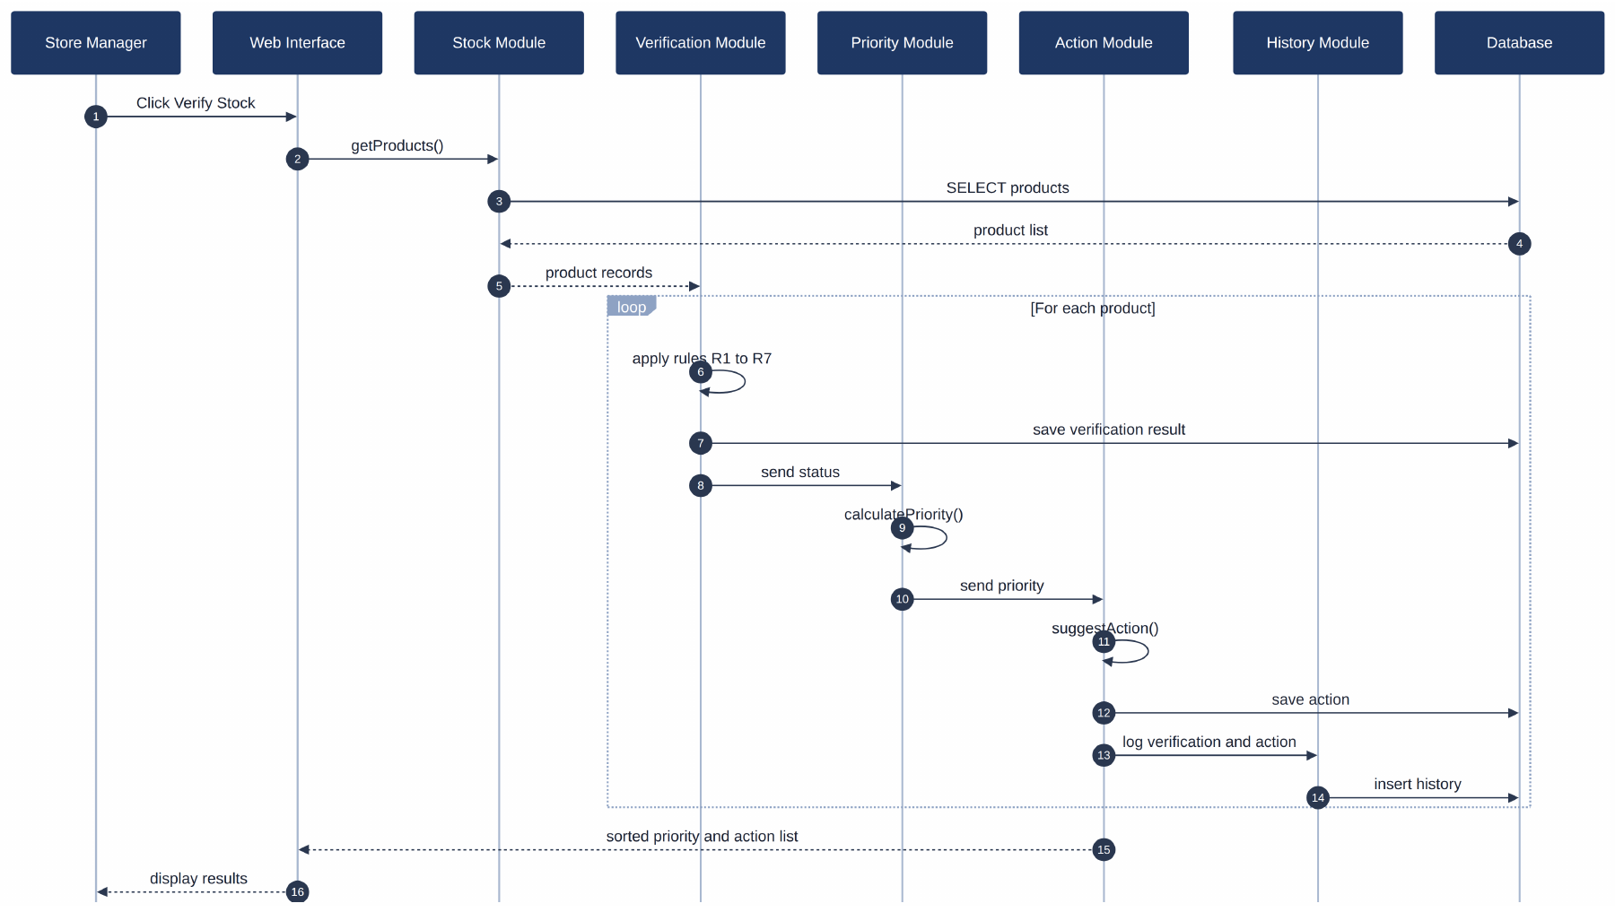
How to read this diagram: Time flows from top to bottom. Each arrow is a message between modules. The loop repeats the steps for every product.

5.6 DFD Level 0 (Context Diagram)
The Level 0 DFD shows the whole system as one process, with the Admin, Staff and Store Manager as external entities. The Admin sends user details and rule settings and receives confirmation. The Staff send product details and receive the stock list and validation messages. The Store Manager sends verify requests and action decisions and receives status, priority, action and reports.
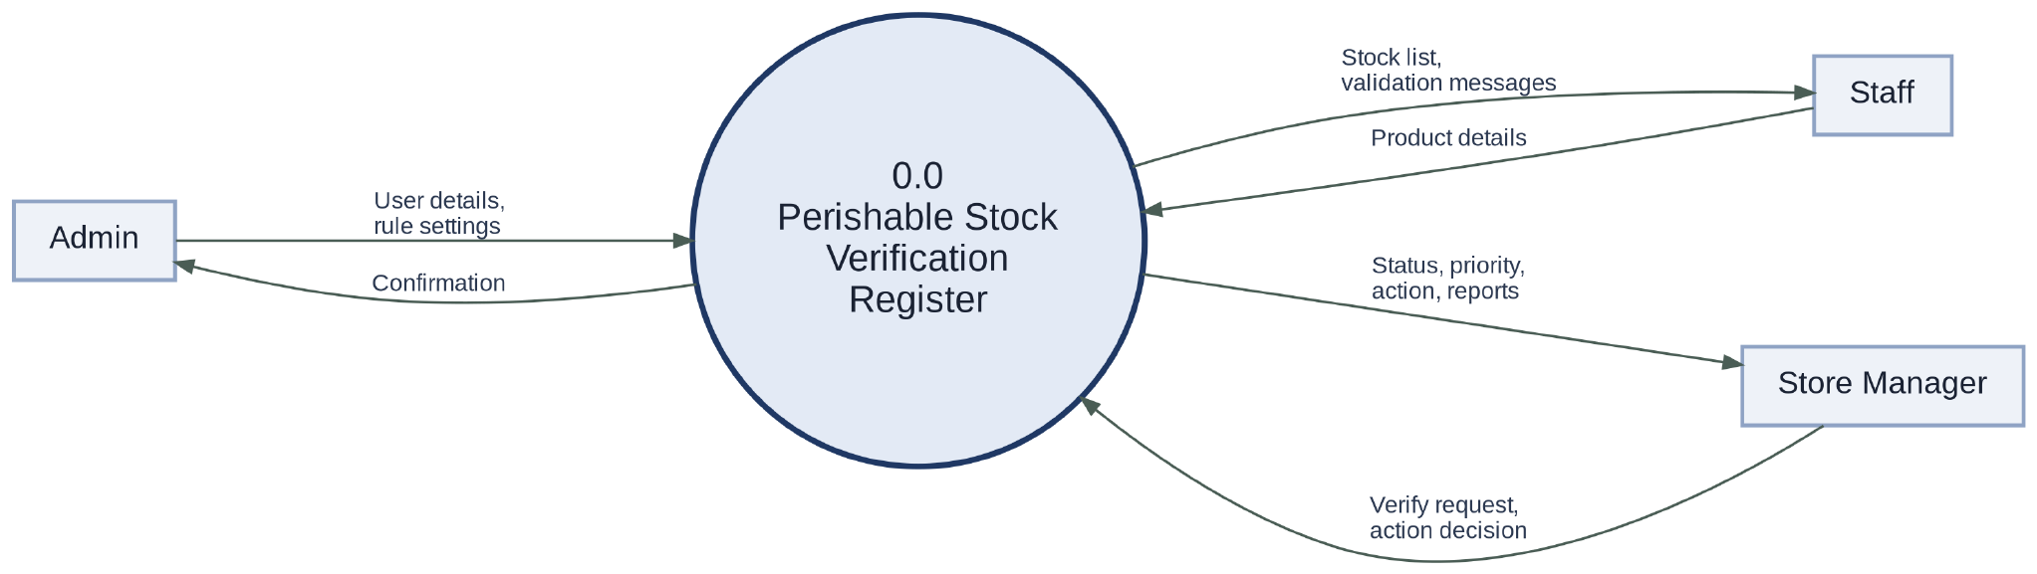
How to read this diagram: The whole system is one process. Arrows show which data enters from and leaves to each external user.

5.7 DFD Level 1
The Level 1 DFD divides the system into six processes (modules): Stock (1.0), Verification (2.0), Priority (3.0), Action (4.0), History (5.0) and Reporting (6.0). It uses five data stores: D1 Product, D2 Verification, D3 Action, D4 User and D5 History. Product details from the Staff go to the Stock Module and are saved in D1. The Verification Module reads the product records and stores the status results in D2; the Priority Module uses these statuses to find the priority level, which the Action Module uses to store the suggested action in D3 and to send the action list to the Store Manager. The History Module stores history records in D5, and the Reporting Module only reads the stored records and sends reports to the Store Manager. The Admin sets up users and rules in D4, which is also used for the login check.
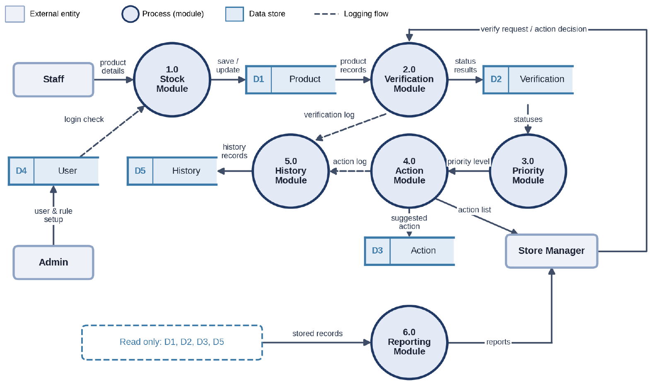
How to read this diagram: Six numbered processes (modules). Open-ended boxes are data stores. Dashed arrows are logging flows; the Reporting module only reads stored data.

Future Enhancement
The current project focuses on rule-based verification of perishable stock records. The system can be improved in the future by adding the following features:
- Sensor and Barcode Integration: Temperature can be read automatically from sensors and product details can be entered by scanning barcodes, instead of being typed in.
- Online Ordering and Billing: Ordering, billing and payment handling can be added to connect stock verification with purchase and sale.
- Alerts and Notifications: Near-expiry and storage-issue alerts can be sent to the Store Manager by email or SMS.
- Multi-Store Redistribution: Near-expiry stock can be redistributed between several stores, with the transfer tracked in the system.
- Mobile Application: A mobile app can be provided so that staff can update stock and view status easily.
- Advanced Search and Reports: More search options, charts and detailed MIS reports can be added to make decision making easier.
These features are not included in the current project. They may be added in future versions of the system.

Conclusion
Fresh First – Perishable Stock Verification Register aims to provide a structured, rule-based method of verifying perishable stock records. The system checks every product against fixed rules for expiry, quantity, storage condition and missing data, and stores the verification, action and history records so that every decision can be traced.
The system assigns a priority to each product and suggests an action such as priority sale, quick usage, redistribution, further inspection or disposal. This helps the store reduce wastage and handle the most urgent products first, while the stock and MIS reports support decision making. All rules are human-written, and no Machine Learning or AI is used.
The project applies the foundational concepts of DBMS, Data Structures and Programming, OOP, Web Technologies, and Software Engineering and SDLC. The proposed system will be developed using Python, Flask and MySQL, with testing and validation carried out to check its correctness and consistency.

References
- Python Software Foundation. Python Documentation. Python Documentation
- Pallets Projects. Flask Documentation. Flask Documentation
- Oracle. MySQL Reference Manual. MySQL Reference Manual
- Oracle. MySQL Connector/Python Developer Guide. MySQL Connector/Python Documentation
- Microsoft. Visual Studio Code Documentation. Visual Studio Code Documentation
- Course materials for Database Management Systems (DBMS), Data Structures and Algorithms (DSA), Web Technologies, Object-Oriented Programming (OOP), Software Engineering and Software Testing.
- BCA Mini Project Framework and Gate Assessment Guidelines provided by the department.

