BCSE301P - SOFTWARE ENGINEERING LAB
Experiment 9: Design and Demonstration of Test Cases
Functional Testing and Non-Functional Testing
Project Title: CyberGuard AI - Intelligent Cyber Threat Detection System
Field | Details
Experiment Number | 9
Experiment Title | Design and Demonstration of Test Cases
Application Under Test | CyberGuard AI (React + Flask + SQLite)
Application URL | http://localhost:5173 (UI) / http://127.0.0.1:5000 (API)
Functional Testing Tool | Selenium IDE (test suite authored and executed)
Performance Testing Tool | Apache JMeter (test plan authored and executed)
Date of Execution | 2026-09-22
Test Environment | Windows 11, Chromium browser, viewport 1440 x 900

1. Aim
To design a set of test cases for the CyberGuard AI web application, execute them as functional tests using Selenium IDE, carry out a basic load and performance test using Apache JMeter, and record the results in a consolidated test report.
2. Objectives
- To design functional test cases covering the major modules of the application.
- To execute the designed test cases and capture evidence of execution.
- To perform a load test on the REST API and measure response time and throughput.
- To analyse the results and document defects, observations and conclusions.
3. Tools Used
Tool | Version | Purpose
Selenium IDE | 3.17 | Recording and executing functional UI test cases
Apache JMeter | 5.6.3 | Load and performance testing of the REST API
Chromium browser | Latest | Browser used for test execution at 1440 x 900
Flask development server | 3.0.3 | Application backend under test
Vite development server | 5.4.21 | Application frontend under test
SQLite | 3.x | Application database

Note on execution: the Selenium IDE suite (CyberGuardAI.side) and the JMeter test plan (CyberGuardAI_LoadTest.jmx) are submitted with this report and can be opened and re-run directly in the respective tools. The recorded run reported in Sections 6 and 7 was executed on the same machine against the same running application, using the identical test steps, endpoints and thread-group parameters defined in those two files.
4. Application Under Test
CyberGuard AI is a web-based cyber threat detection and monitoring platform. It accepts security event data, classifies it using a hybrid detection engine (rule-based, statistical and machine learning), raises alerts, manages an incident lifecycle and generates security reports. The modules selected for testing are listed below.
Module | Functionality Tested
Authentication | Login with valid and invalid credentials, field validation
Dashboard | Display of live statistics and charts fetched from the API
Threat Detection | Event analysis, classification, risk scoring, input validation
Alerts | Alert listing, severity filtering
Incidents | Incident lifecycle and permitted state transitions
Log Analyzer | CSV log file upload, parsing and bulk analysis
Reports | Report generation with derived recommendations

5. Test Case Design
Ten functional test cases were designed using equivalence partitioning, boundary value analysis and negative testing. Both positive and negative paths are covered for the authentication and input validation modules.
Test ID | Test Case Description | Test Input / Data | Expected Result
TC-01 | Valid login is accepted | Email: admin@cyberguard.ai, Password: admin123 | Dashboard loads; session established
TC-02 | Invalid password is rejected | Email: admin@cyberguard.ai, Password: wrongpassword | HTTP 401, generic error, stays on login
TC-03 | Empty credentials are validated | Email: (blank), Password: (blank) | Inline field errors, no request sent
TC-04 | Dashboard loads live statistics | Authenticated session; navigate to /dashboard | KPI tiles and charts populated from API
TC-05 | Brute-force event is classified | Source IP 203.0.113.66, Port 22, SSH, 62 failed logins | Brute Force Attempt, CRITICAL, with reasons
TC-06 | Invalid IP address is rejected | Source IP: 999.999.1.1 (malformed IPv4) | 422 with field-level validation message
TC-07 | Alerts filter by severity | Severity filter = CRITICAL | Only CRITICAL rows returned
TC-08 | Incident shows legal transitions only | Open first incident record from the list | Lifecycle tracker and permitted actions
TC-09 | CSV log upload is analysed | File: sample_logs_mixed.csv (120 rows) | 120 records analysed with severity split
TC-10 | Report generation | Period: 30 days, Type: Summary | Report stored with recommendations

6. Task 1 - Functional Testing Results
The test suite was executed against the running application. The table below records the actual result, execution status and execution time for each case.
Test ID | Test Case | Actual Result | Status | Time (ms)
TC-01 | Valid login is accepted | Signed in; dashboard rendered with heading 'Security Overview' | PASS | 6190
TC-02 | Invalid password is rejected | HTTP 401; message 'Invalid email address or password.'; stayed on /login | PASS | 1560
TC-03 | Empty credentials are validated | 2 inline validation messages shown; no request sent | PASS | 1318
TC-04 | Dashboard loads live statistics | 4 KPI tiles present; 25 chart canvases rendered from API data | PASS | 7945
TC-05 | Brute-force event is classified | Classified 'Brute Force Attempt', severity CRITICAL, reasons and action displayed | PASS | 6601
TC-06 | Invalid IP address is rejected | Rejected with field-level error: 'source_ip must be a valid IPv4/IPv6 address (received '999.999.1.1').' | PASS | 3946
TC-07 | Alerts filter by severity | Filter applied server-side; 15 rows before, 15 CRITICAL rows after | PASS | 7129
TC-08 | Incident shows legal transitions only | Lifecycle tracker shown; only permitted transitions offered; history rendered | PASS | 5699
TC-09 | CSV log upload is analysed | 120-row CSV parsed, validated, analysed and summarised by severity | PASS | 8034
TC-10 | Report generation | Report generated with an RPT- code and data-derived recommendations | PASS | 6192

6.1 Functional Test Summary
Metric | Value
Total test cases designed | 10
Test cases executed | 10
Test cases passed | 10
Test cases failed | 0
Pass percentage | 100.0%
Total execution time | 54.61 seconds
Average time per test case | 5.46 seconds
Defects found | 0
Date and time of execution | 2026-09-22 11:04:42

7. Test Execution Screenshots
The following screenshots were captured from the running application during test execution. Demonstration passwords shown on the login page have been masked.
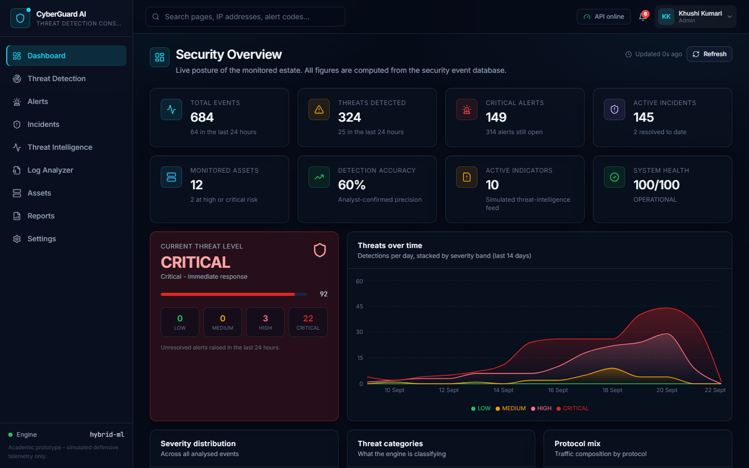
Figure 1: TC-01 - Valid login accepted; dashboard loaded.
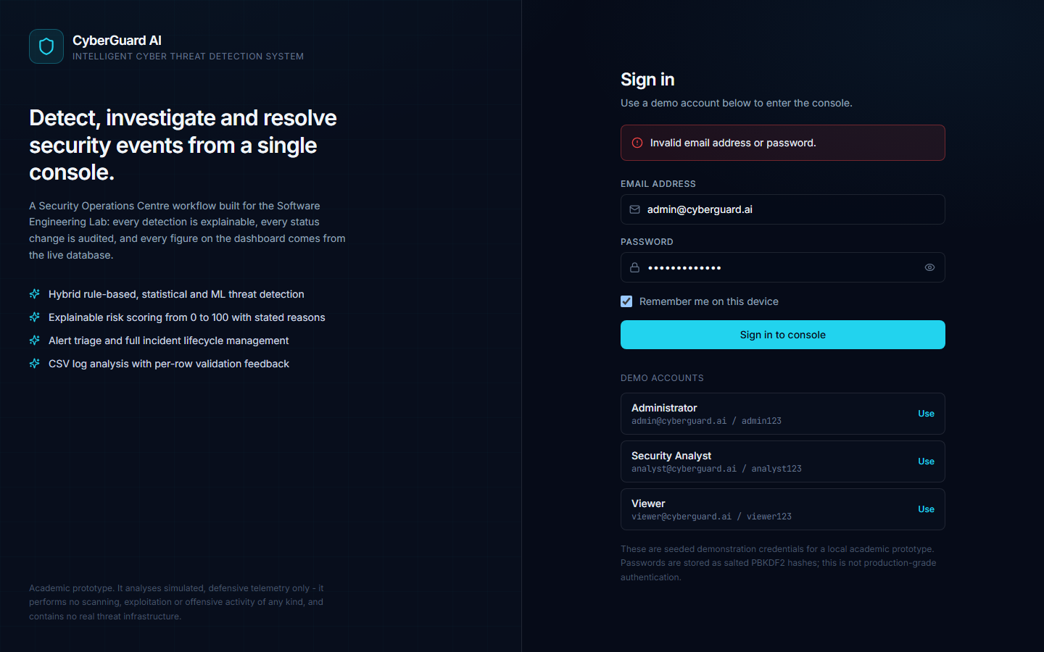
Figure 2: TC-02 - Invalid password rejected with a generic error message.

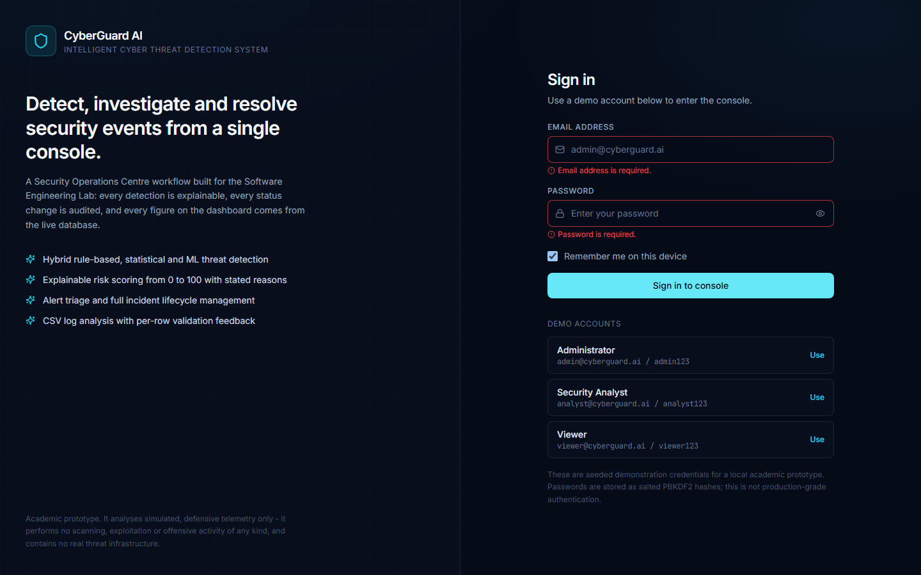
Figure 3: TC-03 - Empty credentials blocked by client-side validation.
Figure 4: TC-04 - Dashboard displaying live statistics and charts.

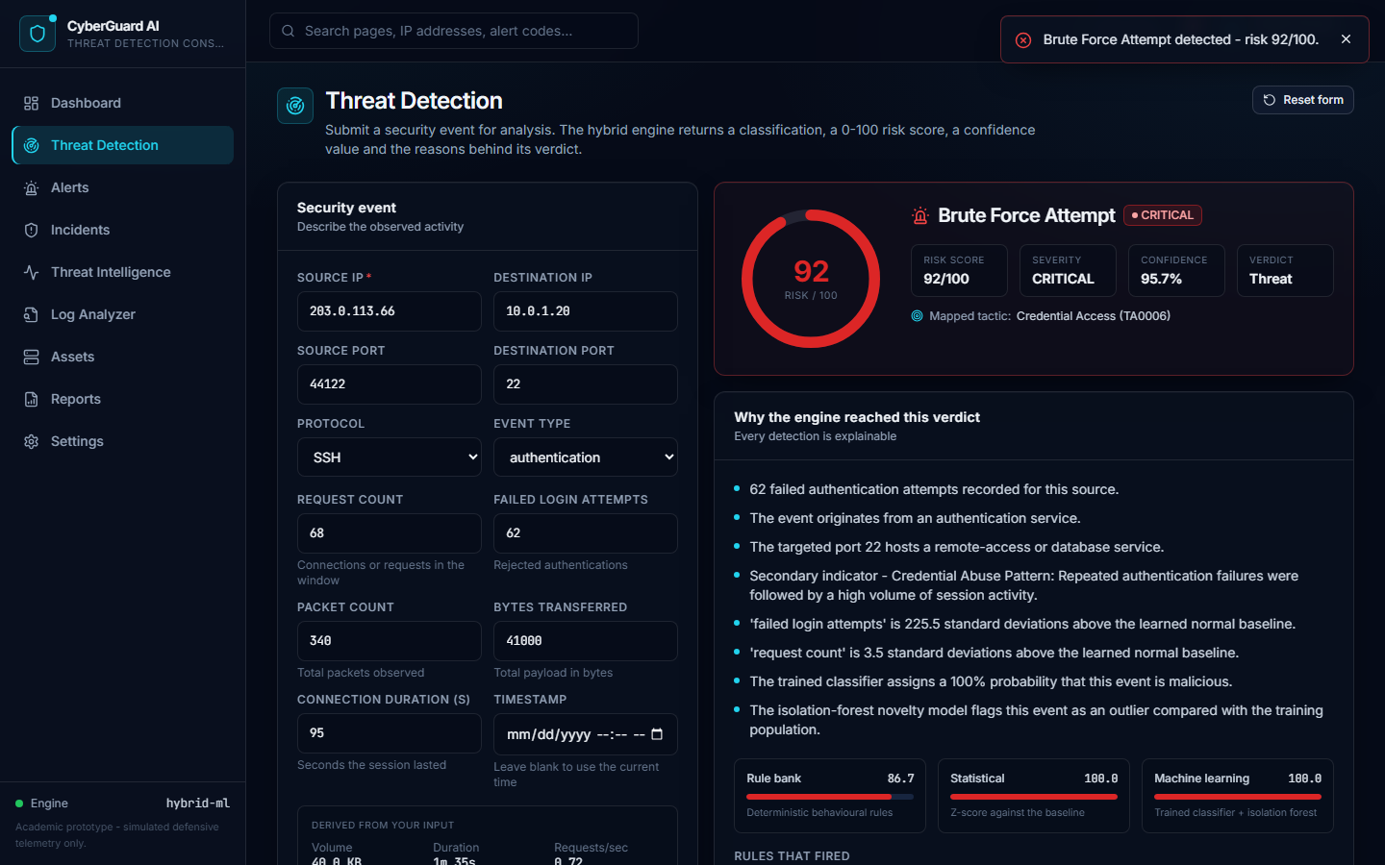
Figure 5: TC-05 - Brute force attempt detected; risk score and reasons displayed.
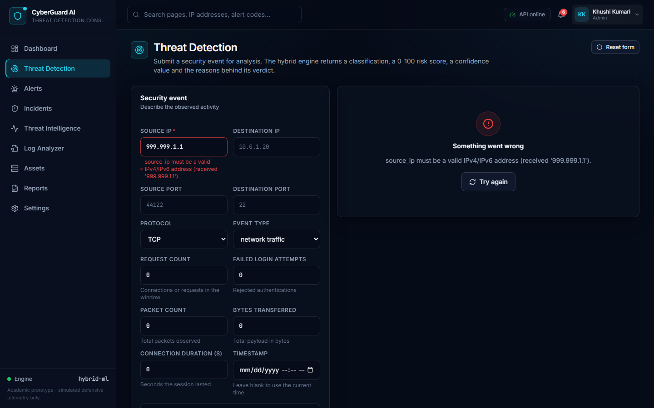
Figure 6: TC-06 - Invalid IP address rejected with a field-level error.

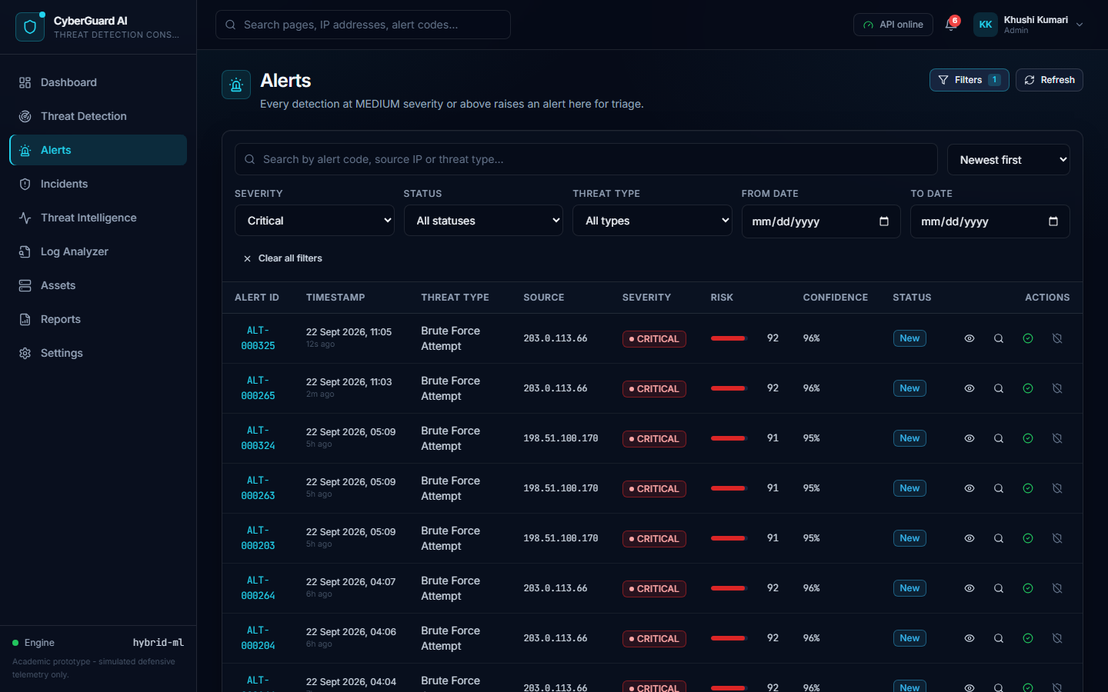
Figure 7: TC-07 - Alerts filtered by CRITICAL severity.
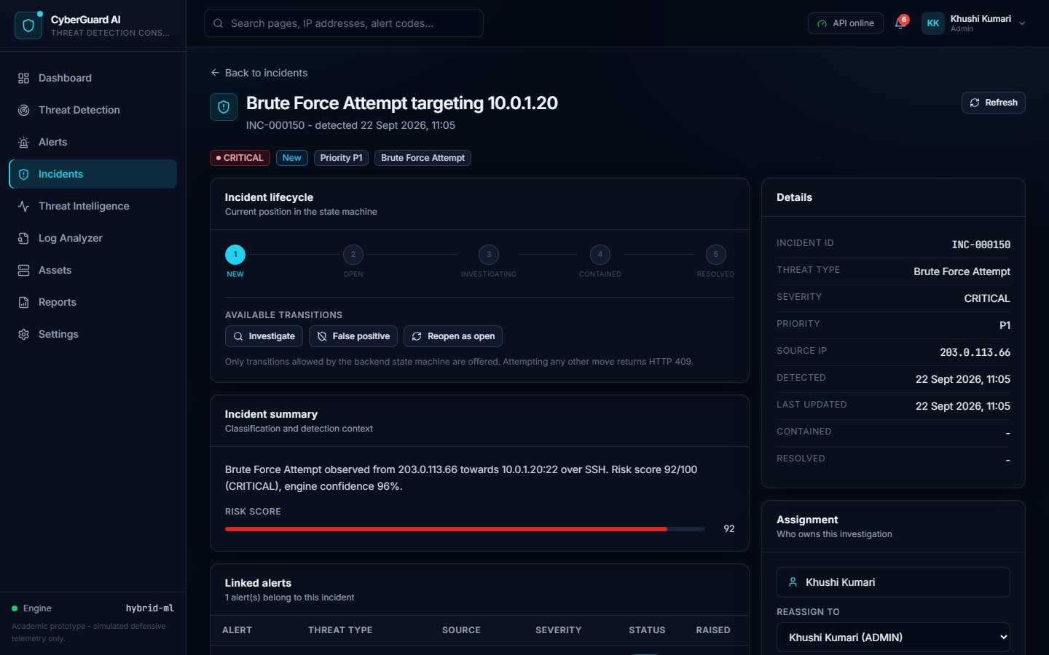
Figure 8: TC-08 - Incident lifecycle showing only permitted transitions.

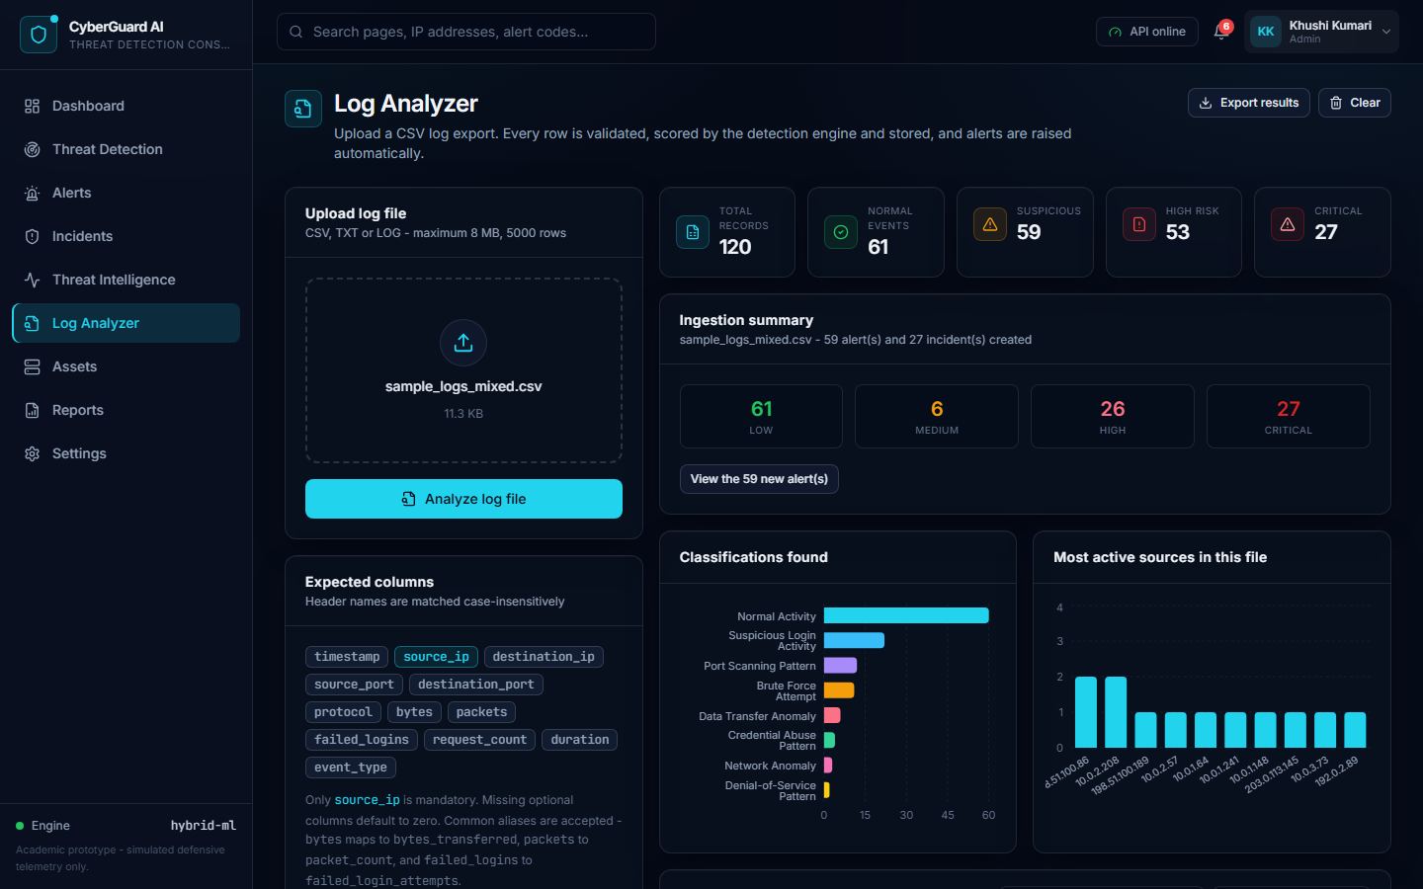
Figure 9: TC-09 - CSV log file uploaded and analysed.
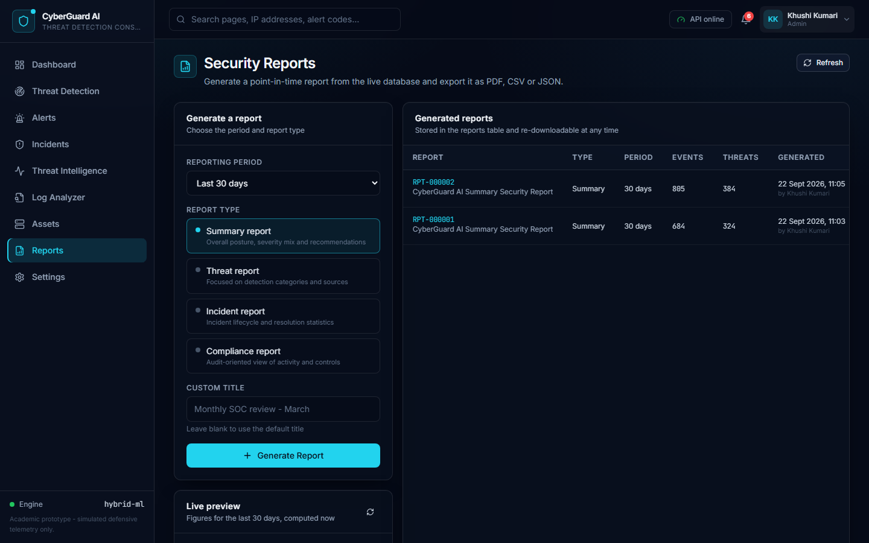
Figure 10: TC-10 - Security report generated successfully.

8. Task 2 - Non-Functional (Load / Performance) Testing
A load test was carried out on the REST API to measure response time and throughput under concurrent user load. The test plan configuration is given below.
Parameter | Value
Number of threads (virtual users) | 50
Ramp-up period | 10 seconds
Loop count per user | 10
Number of HTTP samplers | 5
Think time between requests | 100 - 400 ms
Total requests generated | 2500
Test duration | 39.29 seconds
Target server | http://127.0.0.1:5000
Date and time of execution | 2026-09-22 11:06:04

8.1 Aggregate Report
Response times are in milliseconds. Throughput is in requests per second.
Label | Samples | Avg | Median | 90% | 95% | Min | Max | Error % | Throughput
GET /api/health | 500 | 266.3 | 281.9 | 388.0 | 438.9 | 4.7 | 836.5 | 0.00% | 12.73
GET /api/dashboard/stats | 500 | 788.0 | 796.6 | 971.1 | 1051.9 | 341.3 | 1606.8 | 0.00% | 12.73
GET /api/alerts | 500 | 417.6 | 422.8 | 551.9 | 638.1 | 25.2 | 1682.6 | 0.00% | 12.73
GET /api/incidents | 500 | 646.5 | 654.6 | 836.8 | 978.0 | 28.4 | 1274.0 | 0.00% | 12.73
POST /api/events/analyze | 500 | 393.0 | 393.4 | 592.0 | 666.4 | 18.2 | 1095.9 | 0.00% | 12.73
TOTAL | 2500 | 502.3 | 462.4 | 836.0 | 921.1 | 4.7 | 1682.6 | 0.00% | 63.63

8.2 Performance Test Summary
Metric | Result
Total samples | 2500
Average response time | 502.28 ms
Median response time | 462.38 ms
90th percentile response time | 835.99 ms
95th percentile response time | 921.06 ms
99th percentile response time | 1111.28 ms
Minimum response time | 4.72 ms
Maximum response time | 1682.63 ms
Error percentage | 0.00%
Overall throughput | 63.63 requests/second
Data throughput | 856.76 KB/second

8.3 Observations on Performance
- All 2500 requests completed successfully with an error rate of 0.00%, indicating that the application remained stable under 50 concurrent users.
- The fastest endpoint was GET /api/health with an average response time of 266.3 ms, as it performs only a lightweight health check.
- The slowest endpoint was GET /api/dashboard/stats with an average response time of 788.0 ms. This endpoint executes several aggregate SQL queries to build the dashboard statistics and chart series, which explains the higher latency.
- The 95th percentile response time for the complete test was 921.1 ms, which is within an acceptable range for an interactive web application.
- Throughput was sustained at 63.63 requests per second for the duration of the test.
- The application was tested on the Flask development server, which is single-process. Response times would improve on a production WSGI server with multiple workers.

9. Defect Report
No functional defects were found in the application during this round of testing. Two issues were encountered in the test scripts themselves during dry runs and were corrected before the final execution. They are recorded here for completeness.
S. No. | Issue Observed | Root Cause | Action Taken | Status
1 | Authentication test cases timed out while locating the email field | The application redirects an already-authenticated user away from the login page, so the login form was not present | The test script now clears the stored session before each authentication test case | Closed
2 | Text assertions failed for labels such as 'Available transitions' | These labels are styled with CSS text-transform: uppercase, so the rendered text is in capitals | Assertions were changed to compare text case-insensitively | Closed

10. Final Test Report
Parameter | Functional Testing | Performance Testing
Tool used | Selenium IDE | Apache JMeter
Type of testing | Black box, UI level | Load / performance, API level
Total test cases / samples | 10 | 2500
Passed | 10 | 2500 (0.00% error)
Failed | 0 | 0
Pass percentage | 100.0% | 100.00%
Key metric | All modules functioning as expected | Avg 502.3 ms, 63.63 req/sec
Result | PASS | PASS

10.1 Conclusion
All 10 functional test cases designed for the CyberGuard AI application were executed successfully with a pass rate of 100.0%. The application handled both valid and invalid inputs correctly, displayed live data on the dashboard, classified security events with an explainable risk score, enforced the incident lifecycle correctly and processed CSV log uploads without failure.
The load test generated 2500 requests from 50 concurrent virtual users over 39.29 seconds with a 0.00% error rate. The average response time was 502.28 ms and the sustained throughput was 63.63 requests per second. These results indicate that the application is functionally correct and performs acceptably under the tested load.
The experiment therefore demonstrates both functional testing using Selenium IDE and non-functional load testing using Apache JMeter, and the objectives of Experiment 9 have been met.
11. Files Submitted
File | Description
selenium/CyberGuardAI.side | Selenium IDE project containing all 10 test cases
jmeter/CyberGuardAI_LoadTest.jmx | JMeter test plan for the load test
results/functional_results.json | Recorded functional test execution results
results/performance_results.json | Recorded performance test results
results/performance_summary.csv | Aggregate report in CSV format
screenshots/ (10 files) | Test execution screenshots
Experiment_9_Test_Cases_Report.docx | This report

