**TABLE OF CONTENTS**

Title of the project………………………………………………………2

Introduction & Objective of the Project………..................3-4

Tools /Environment Used……………………………………………5-6

Requirement and Analysis

* 1. Problem Definition….……………………………………...7
  2. Feasibility Study ………………………………………………8-9
  3. S/W model used…….……..…………………………………10
  4. Data Flow Diagram………..…………………………………11-14

Complete Structure

1. Modules and their description………………………………15
2. Data Integrity Constraint….……………………………………16
3. ER Diagram…..………………………………………………………20
4. Data structure………………………………………………………21-24

**ACKNOWLEDGEMENT**

This project bears the imprint of many persons and it gives me great pleasure to express my heartiest gratitude towards them.

I take this opportunity to express my deep sense of obligation to Mr. Faisal for giving me an opportunity to undergo this training.

I would like to show my sincere thanks to Mr. Faisal for his ample guidance. He encouraged me on each and every step.

Lastly, I would like to convey my reverential salutations to my friends and other member of the staff for their valuable suggestions and unending support.

Place: Lucknow

Date :

1. Title of the project

DeskSavvy

1. Introduction

In the fast changing world, information technology and information management are going to play an important role. We are living in the computer age during past some year .The computer has gaining popularity. Computer revolution found its way into almost every aspect of human life and living. A computer is admirably suited to handle any information and hence is an information processor that is, it can receive data, perform some basic operations on that data and produces results according to a predetermined program.

DeskSavvy is a well-planned system designed in order to provide well-structured mechanism to store record of all employees and their salary. It maintains complete record of employees, their salary data of past etc.

This proposed application will manage all the needs from both ends from employees end as well as from management end.

Advantages Of DeskSavvy

**Save Effort:**DeskSavvy System is easy to understand and simple to use. Its main advantage is no Prior payroll experience required.

**Save Money:** Save money by cutting down your expenses on additional

Man- power, paper, printing courier.

**Save Time:** Process monthly payroll and generates challans in seconds.

Save Environment: No Papers used,

1. Objectives

In the background DeskSavvy the entire manual and paper work which was done in the past,has to be removed by the use the web technology of the present scenario.The old conventional technique of recording data and processing would be removed and web enabled software would replace that. Management should be able to know the record of all employees past attendance. Their salary data can also be generated. If the management introduces some new salary structure, new courses, new designation etc these changes can also be done very easily.

1. H/W& S/W REQUIREMENT specification

Some software & hardware for running our software smoothly on a computer or laptop. Minimum Requirements are given below:

Hardware Requirements

* Pentium IV Processor
* 512 MB RAM
* 40 GB HDD
* Color Monitor
* Keyboard, Mouse

Software Requirements

**Front-end Tool:** - JSP, HTML, JAVASCRIPT.

* + - * + User friendly
        + Low Cost Solution
        + GUI feature
        + Better designing aspects.

**Back-end Tool:**- MySQL

**IDE:**- NetBeans, My-SQL

**Features are**:

* + - The graphical management tools make it extremely easy to manage the server.
    - Security
    - Portability
    - Performance
    - Scalability
    - Reliability

1. SYSTEM ANALYSIS
   1. IDENTIFICATION OF NEED

**Definitions of problems**

• **Not User Friendly:** The existing system is not user friendly because the retrieval of data is very slow and data is not maintained efficiently.

• **Difficulty in report generating:** We require more calculations to generate the final result so it is generated at the end of the session. And the Company not get a single chance to change his\her Employee Status.

• **Time consuming**: Every work is done manually so we cannot generate report in the middle of the session or as per the requirement because it is very time consuming.

To create or develop a new system first we have to study the prior system, Analysis difficult problems faced by the operator of that system. System Analysis therefore understands such problems and proposes a new system in which the above problems are rectified.

* 1. FEASIBILITY STUDY

The feasibility of the project is analyzed in this phase and business proposal is put forth with a very general plan for the project and some cost estimates. During system analysis the feasibility study of the proposed system is to be carried out. This is to ensure that the proposed system is not a burden to the company. For feasibility analysis, some understanding of the major requirements for the system is essential.

Three key considerations involved in the feasibility analysis are

* ECONOMICAL FEASIBILITY
* TECHNICAL FEASIBILITY
* OPERATIONAL FEASIBILITY

**ECONOMICAL FEASIBILITY**

This study is carried out to check the economic impact that the system will have on the organization. The amount of fund that the company can pour into the research and development of the system is limited. The expenditures must be justified. Thus the developed system as well within the budget and this was achieved because most of the technologies used are freely available. Only the customized products had to be purchased.

### TECHNICAL FEASIBILITY

This study is carried out to check the technical feasibility, that is, the technical requirements of the system. Any system developed must not have a high demand on the available technical resources. This will lead to high demands on the available technical resources. This will lead to high demands being placed on the client. The developed system must have a modest requirement, as only minimal or null changes are required for implementing this system.

**OPERATIONAL FEASIBILITY**

In this test, the operational scope of the system is checked. The system under consideration should have enough operational reach. It is observed that the proposed system is very user friendly and since the system is built with enough help, even persons with little knowledge of windows can find the system very easy.

* 1. S/W MODEL USED

Software will undoubtedly undergo changes after it is delivered to the customer. Changes will occur because errors have been encountered, because the software must be adapted to accommodate changes in its external environment, or because the customer requires functional or performance enhancements. Software support/maintenance reapplies each of the preceding phases to an existing program rather than a new one.

Linear sequential modal (water fall modal)

Testing

Coding

Designing

Analysis

Implementation

* 1. Flow Diagram Of Project

Report

Payment

No Payment

Problem

START

Sell Product

Customer Registration

Check warranty

STOP

yes yes

No

No

* 1. DATA FLOW DIAGRAM

DATA FLOW DIAGRAMS are graphical representation of the flow of data through an information system,modeling its process aspects.

The data flow diagram shows the flow of data within any system. It is an important tool for designing phase of software engineering.

Larry Constantine first developed it. It represents graphical view of flow of data. It’s also known as BUBBLE CHART.

The purpose of DFD is major transformation that will become in system design symbols used in DFD:-

In the DFD, **four** symbols are used and they are as follows.

* A square defines a source (originator) or destination of system data.
* An arrow identifies data flow-data in motion. It is 2a pipeline through which information flows.
* A circle or a “bubble “(Some people use an oval bubble) represents a process that transfers informing data flows into outgoing data flows.
* An open rectangle is a data store-data at rest, or a temporary repository of data.

**Context Diagram**

This level shows the overall context of the system and its operating environment and shows the whole system as just one process.

The context diagram plays important role in understanding the system and determining the boundaries.

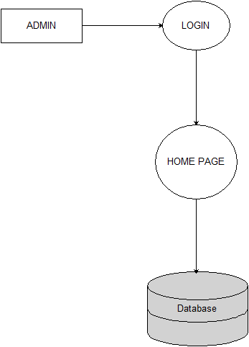

**0 LEVEL**

**1 LEVEL**

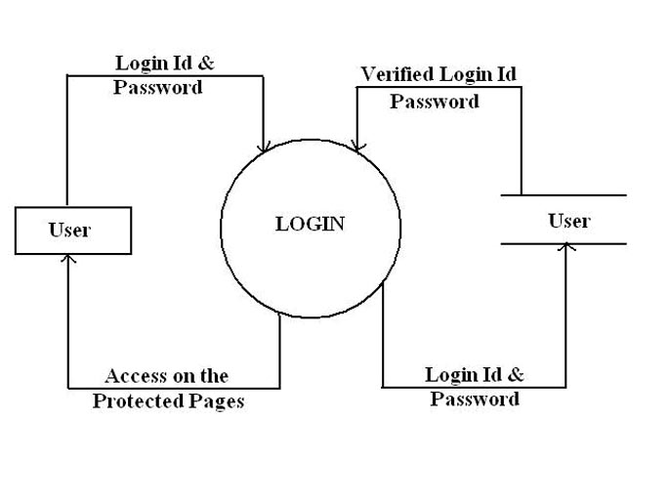

**2 LEVEL**



1. System Design

5.1Module Details

This software is designed such way that it will generate the salary automatically every month .The admin starts off from filling up the entire Employee related information and the department he is recruited. Manager assigns the employee a salary structure. And to ensure that generating and managing payroll processes for that particular Employee. There are mainly three modules in the proposed system:

**1. Administrator**: - It is concerned with all the activates in a company.

**Add Manager**- It will register all the manager of Company.

**Add salary structure**: - It will provide the salary structure.

**Add new department** :- It will add the new departments

**2. Company**: - It is mainly concerned with salary of employee.

**Add Employee**- It will register all the employee.

**Generate pay slip**: - Can generate the pay slip.

**Messages** :- can view the messages generated by employee.

**Leave Allotment** :- can allot leaves of employees.

**3. Employee**: -

1. can view their pay slip .
2. can send message to manager.
3. Can apply for leave.

5.2Database Design

5.2(i)Data Integrity Constraints

Primary Key Constraints :

A Primary key is a minimal set of candidate key that uniquely identifies all the other attributes in the relation. When declared primary key, the attribute automatically becomes unique and not null.

NOT NULL Constraints :

In websites sometimes, we would like to create an attribute that can not be left blank, i.e. we have to put some value for an attribute in order to insert a new record. This can be enforced by making use of NOT NULL Constraints.

**5.3(i) ENTITY RELATIONSHIP DIAGRAM (ERD)**

Admin

**Add**

Employee

SalaryStructure

Company

**Generate**

Payslip

5.3(ii)Database Tables

**addempTable :**