K.R. MANGALAM UNIVERSITY
SCHOOL OF ENGINEERING AND TECHNOLOGY


LAB FILE

COURSE NAME: COMPUTER NETWORK
COURSE CODE: ENCS302
SUBMITTED BY: KHUSHI YADAV
ROLL NUMBER: 2301730262
COURSE: BTECH CSE (AI and ML)
SUBMITTED TO: MS. JYOTI KAURAV

INDEX
S.No. | Experiments | Date | Page no. | Remarks/sign
1 | A. Studying the Cisco Packet Tracker (CPT) Interface. | 12-06-2026 | 3
 | B. Implementing a Peer-to-Peer Network. | 12-06-2026 | 3
2 | Visualizing the various Network Topologies:  - Mesh Topology  - Bus Topology  - Ring Topology  - Tree Topology  - Star Topology
3 | A. LAN using a Hub. | 02-03-2026
 | B. LAN using a Switch. | 02-03-2026
4 | Tracert and Ping commands-Network Diagnostic | 23-03-2026
5 | - Designing the Network (CAN) | 30-03-2026
 | - Static IP Address Assignment to devices in network | 06-04-2026
6 | IP and Subnetting- IP Configuration | 06-04-2026
7 | Wireless Home Network: Setting up a Router. | 13-04-2026
8 | Capstone Project. | 20-04-2026

EXPERIMENT 1
INTRODUCTION TO COMPUTER NETWORKS AND THE CISCO PACKET TRACER (CPT)
- CPT Platform Overview
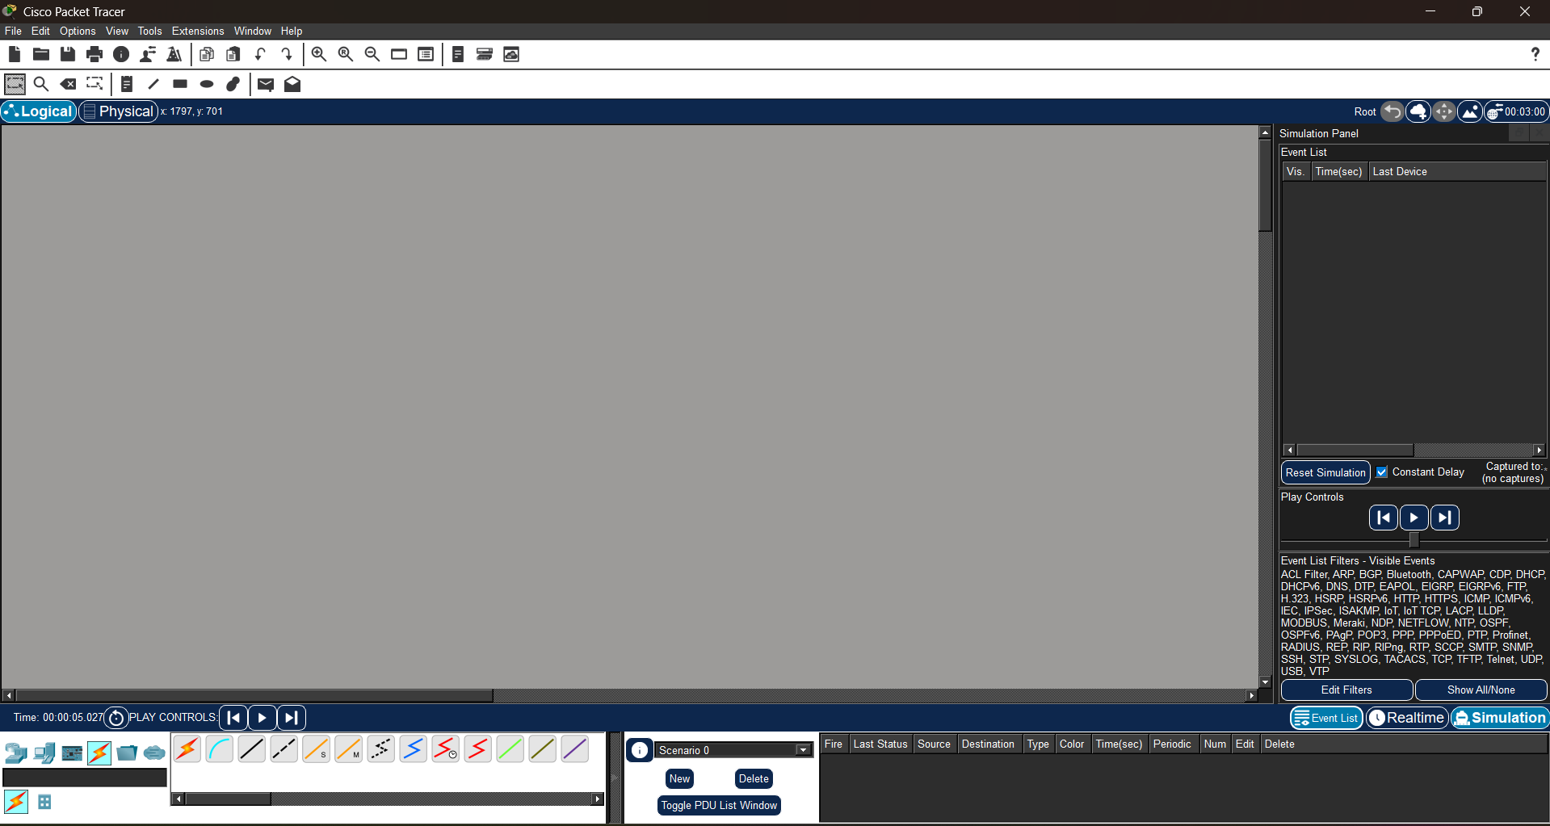

- peer to peer network
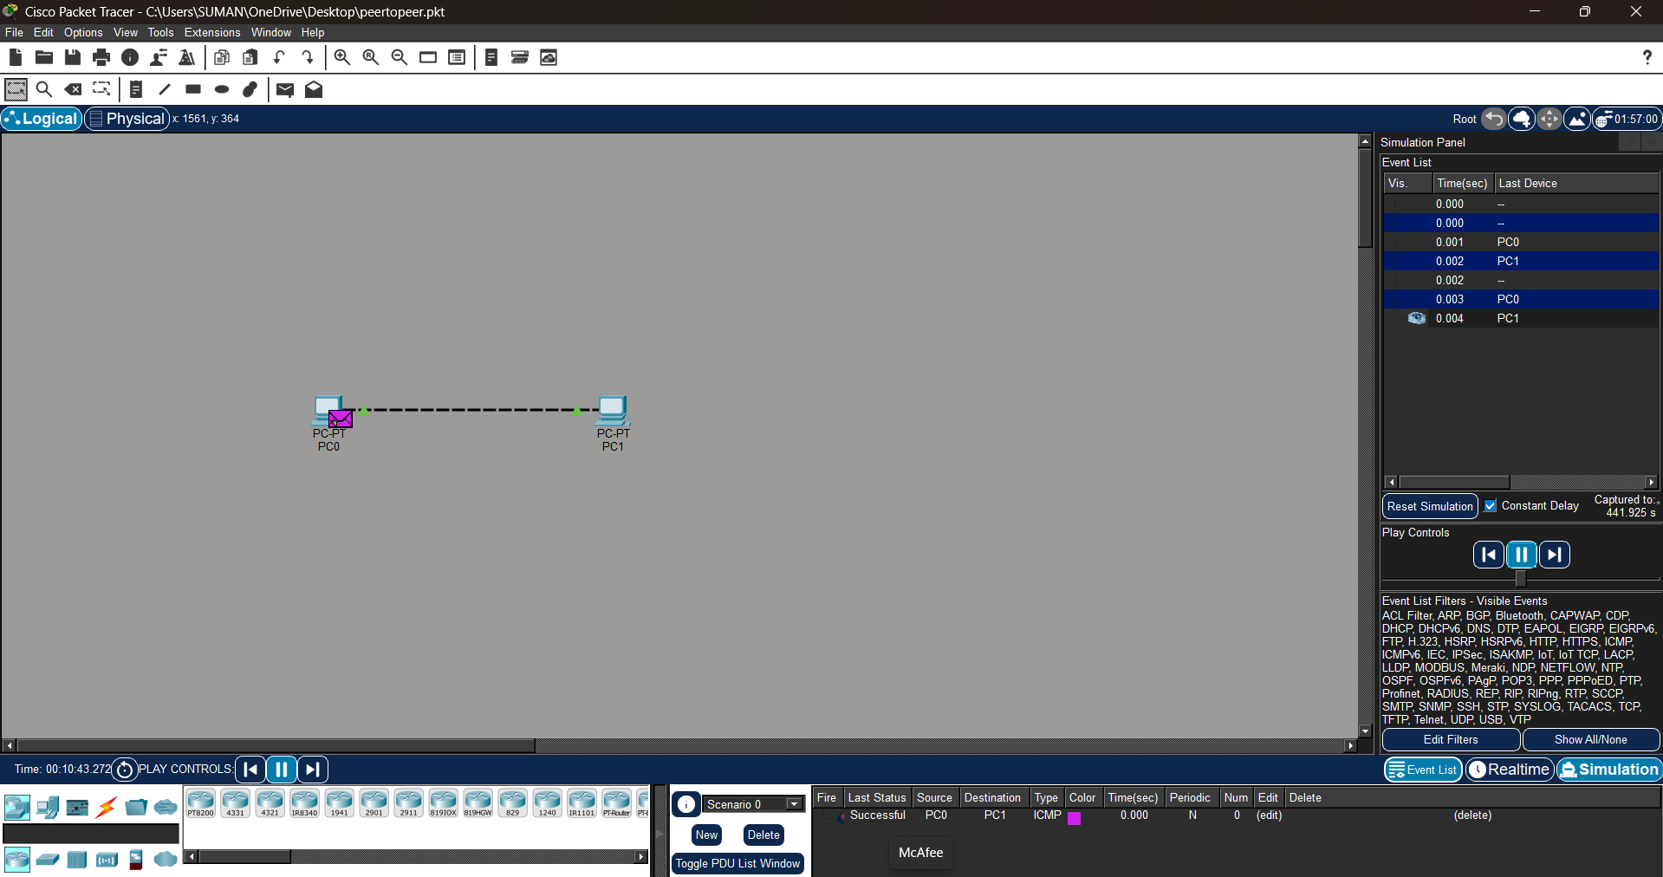

EXPERIMENT2
Network Topologies
- Star Topology
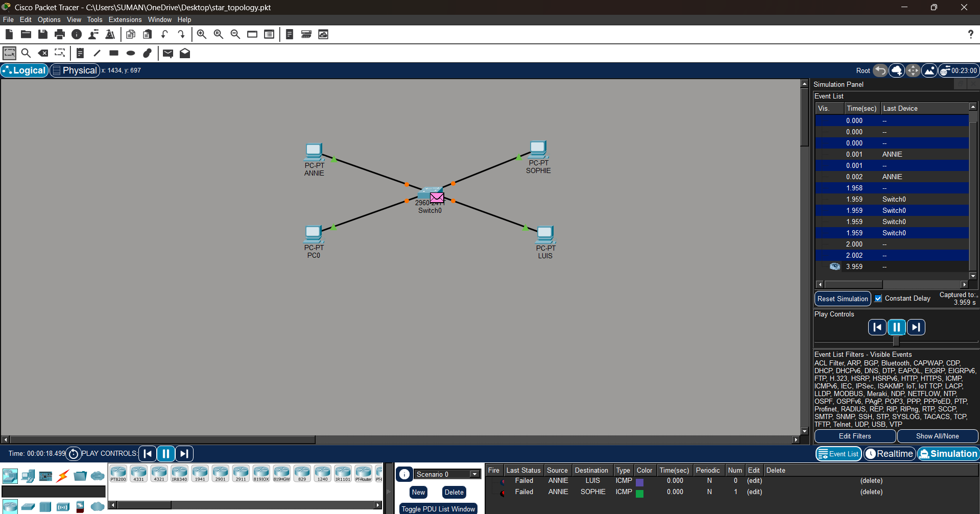
- Ring Topology
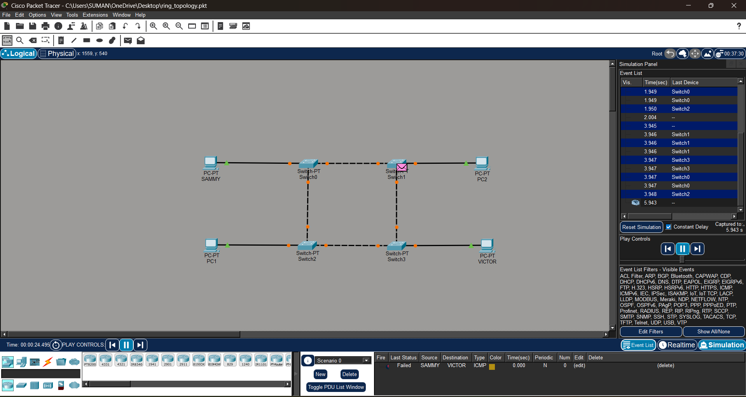

- Mesh Topology
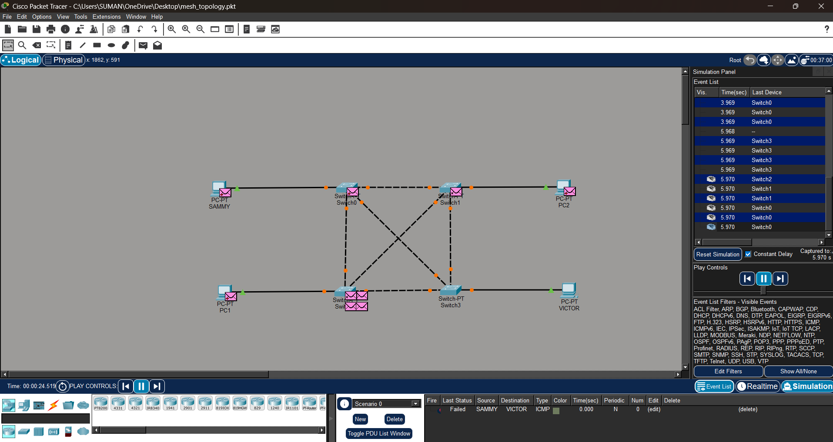
d. Tree Topology
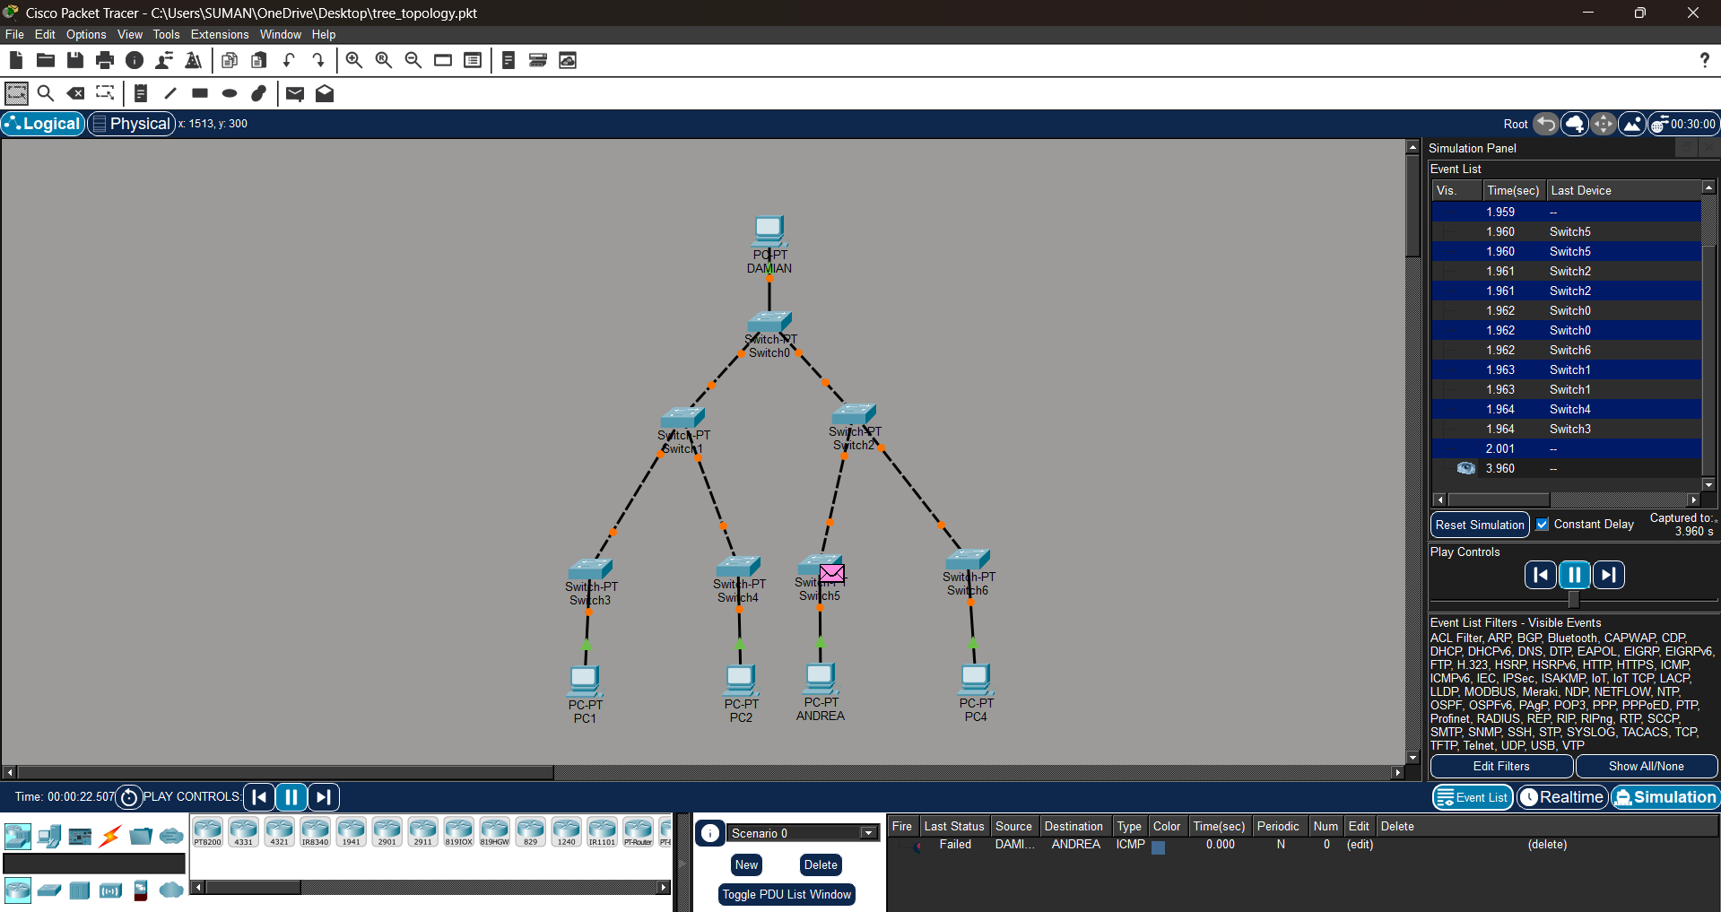

EXPERIMENT3
A. LAN using Hub
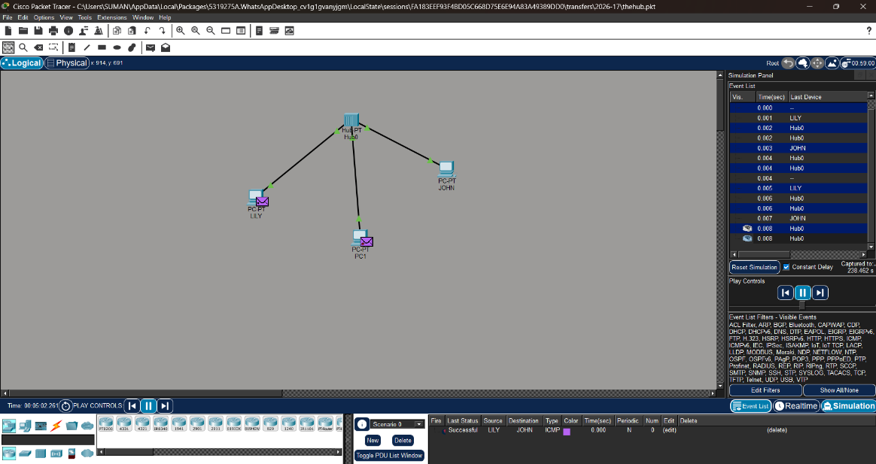

B. LAN using switch
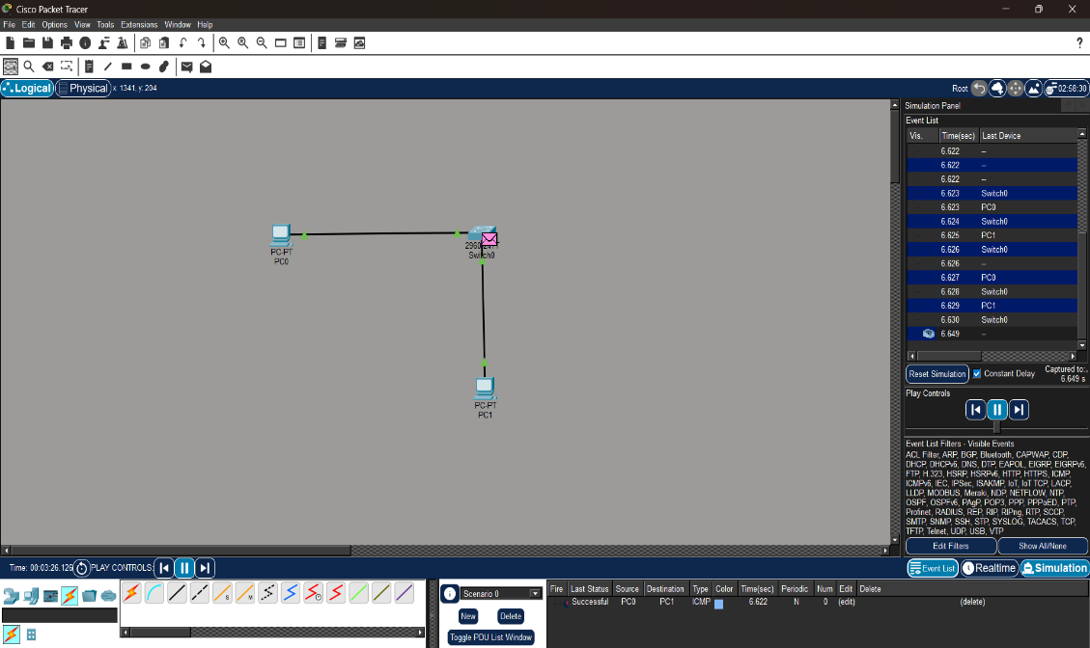

EXPERIMENT4
Tracer and Ping commands-Network Diagnostic
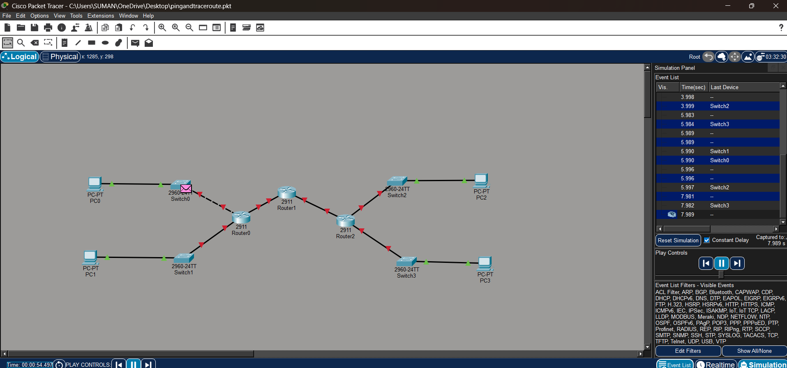

EXPERIMENT5
Design a campus area network
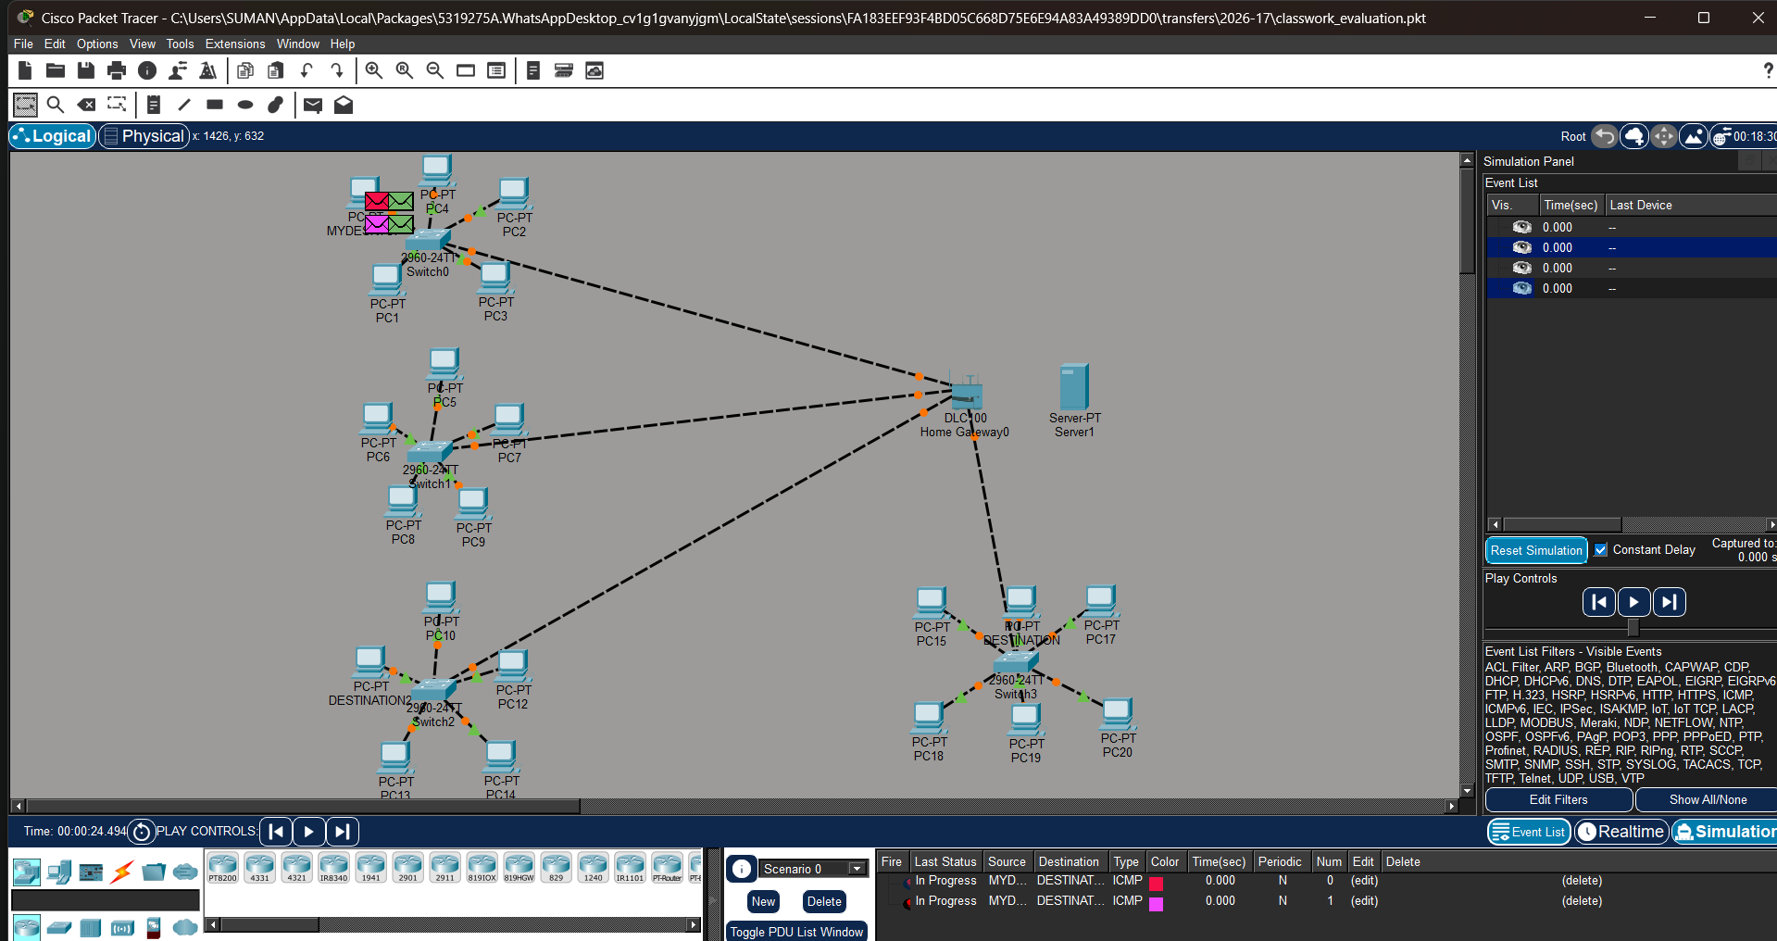

EXPERIMENT6
IP and Subnetting-IP Configuration
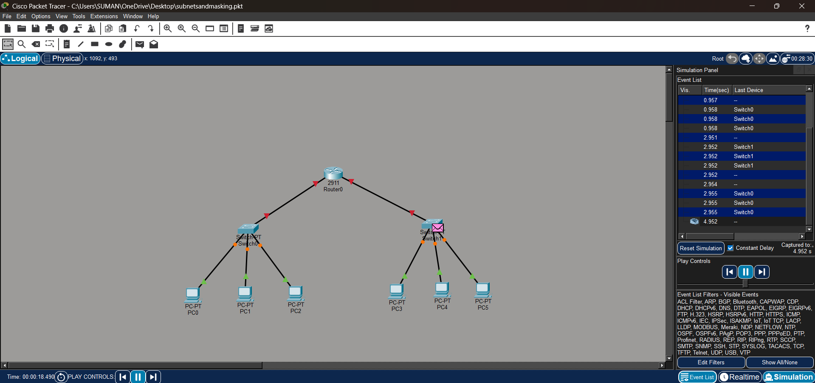

EXPERIMENT7
Wireless Home Network-Router configuration
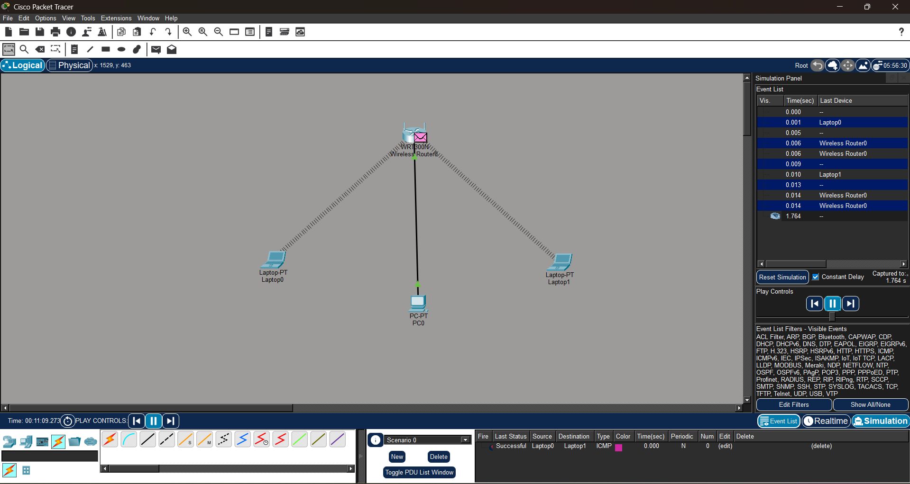

EXPERIMENT8
Capstone Project-Smart City Network
