Game Design Document

Fill up the following document

1. Write the title of your project.

Plinko 2.0

1. What is the goal of the game?

To get the highest score each time you play.

1. Write a brief story of your game.

You are at a carnival and are trying to play the game to get points.

1. Which are the playing characters of this game?

* Playing characters are the ones who respond to the user based on the input from the user.
* Cars, monkeys, dinos, wizards, etc., are the playing characters in the game.

|  |  |  |
| --- | --- | --- |
| Number | Character Name | What can this character do? |
| 1 | Balls | We pick a spot to launch it and it collides with the obstacles to get into a bin. |
| 2 |  |  |
| 3 |  |  |
| 4 |  |  |
| 5 |  |  |
| 6 |  |  |
| 7 |  |  |
| 8 |  |  |

1. Which are the Non-Playing Characters of this game?

* Non-Playing characters are the ones that don't have an action or behavior when the user interacts with the game.
* Hurdles, stones, bananas, coins, etc., are non-playing characters in the game.

|  |  |  |
| --- | --- | --- |
| Number | Character Name | What can this character do? |
| 1 | Bins |  |
| 2 | Obstacle Balls |  |
| 3 |  |  |
| 4 |  |  |
| 5 |  |  |
| 6 |  |  |
| 7 |  |  |
| 8 |  |  |

Draw your imagination of this game. What does this game look like?

* Draw the game either on your computer or on paper.
* Add images of the game scenes to show each of the playing and non-playing characters at least once.

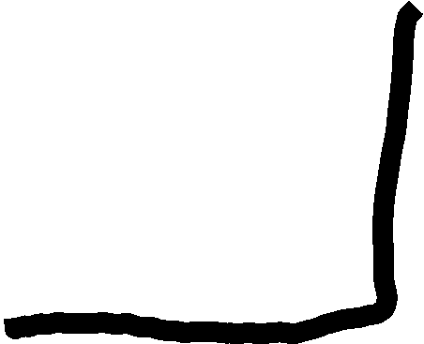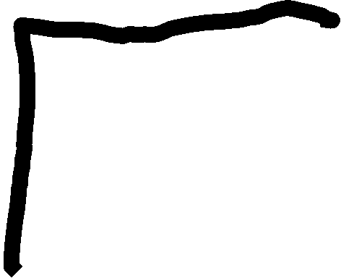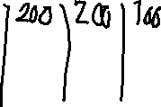

How do you plan to make your game engaging?

I will add more color give more feedback and sounds.