**1.server.js**

**const http = require('http');**

**const fs = require('fs');**

**const path = require('path');**

**// Port to listen on**

**const PORT = 3000;**

**// Helper function to serve HTML files asynchronously**

**const serveFile = (filePath, contentType, response, statusCode = 200) => {**

**fs.readFile(filePath, (err, content) => {**

**if (err) {**

**response.writeHead(500, { 'Content-Type': 'text/plain' });**

**response.end('500 - Internal Server Error');**

**} else {**

**response.writeHead(statusCode, { 'Content-Type': contentType });**

**response.end(content);**

**}**

**});**

**};**

**// Create server**

**const server = http.createServer((req, res) => {**

**console.log(`Requested URL: ${req.url}`);**

**if (req.url === '/home' || req.url === '/') {**

**serveFile(path.join(__dirname, 'pages', 'home.html'), 'text/html', res);**

**} else if (req.url === '/about') {**

**serveFile(path.join(__dirname, 'pages', 'about.html'), 'text/html', res);**

**} else if (req.url === '/contact') {**

**serveFile(path.join(__dirname, 'pages', 'contact.html'), 'text/html', res);**

**}**

**else {**

**serveFile(path.join(__dirname, 'pages', '404.html'), 'text/html', res, 404);**

**}**

**});**

**// Start server**

**server.listen(PORT, () => {**

**console.log(`Server running at http://localhost:${PORT}/`);**

**});**

**2.css/style.css**

**body {**

**font-family: Arial, sans-serif;**

**background-color: #f0f0f0;**

**text-align: center;**

**padding: 50px;**

**}**

**h1 {**

**color: #333;**

**}**

**p {**

**color: #555;**

**}**

**3.pages/home.html**

**<!DOCTYPE html>**

**<html lang="en">**

**<head>**

**<meta charset="UTF-8">**

**<title>Home</title>**

**<link rel="stylesheet" href="/css/style.css">**

**</head>**

**<body>**

**<h1>Welcome to the Home Page</h1>**

**<p>This is the home route of our Node.js server.</p>**

**</body>**

**</html>**

**4.pages/about.html**

**<!DOCTYPE html>**

**<html lang="en">**

**<head>**

**<meta charset="UTF-8">**

**<title>About</title>**

**<link rel="stylesheet" href="/css/style.css">**

**</head>**

**<body>**

**<h1>About Us</h1>**

**<p>This is the about page of our Node.js server.</p>**

**</body>**

**</html>**

**5.pages/contact.html**

**<!DOCTYPE html>**

**<html lang="en">**

**<head>**

**<meta charset="UTF-8">**

**<title>Contact</title>**

**<link rel="stylesheet" href="/css/style.css">**

**</head>**

**<body>**

**<h1>Contact Us</h1>**

**<p>This is the contact page of our Node.js server.</p>**

**</body>**

**</html>**

**6.pages/404.html**

**<!DOCTYPE html>**

**<html lang="en">**

**<head>**

**<meta charset="UTF-8">**

**<title>404 Not Found</title>**

**<link rel="stylesheet" href="/css/style.css">**

**</head>**

**<body>**

**<h1>404 - Page Not Found</h1>**

**<p>Oops! The page you are looking for does not exist.</p>**

**</body>**

**</html>**

**7.Images**

**1.Home Page**

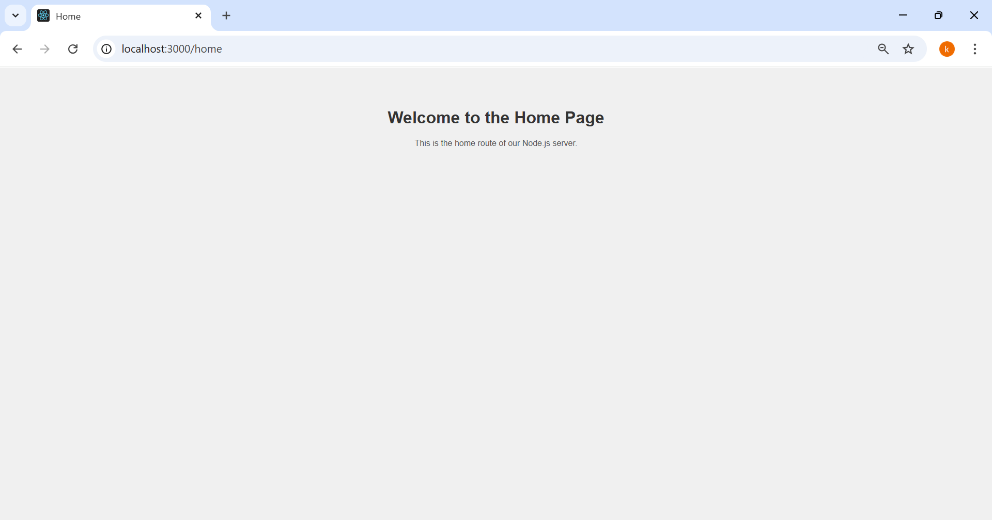

**2.About Page**

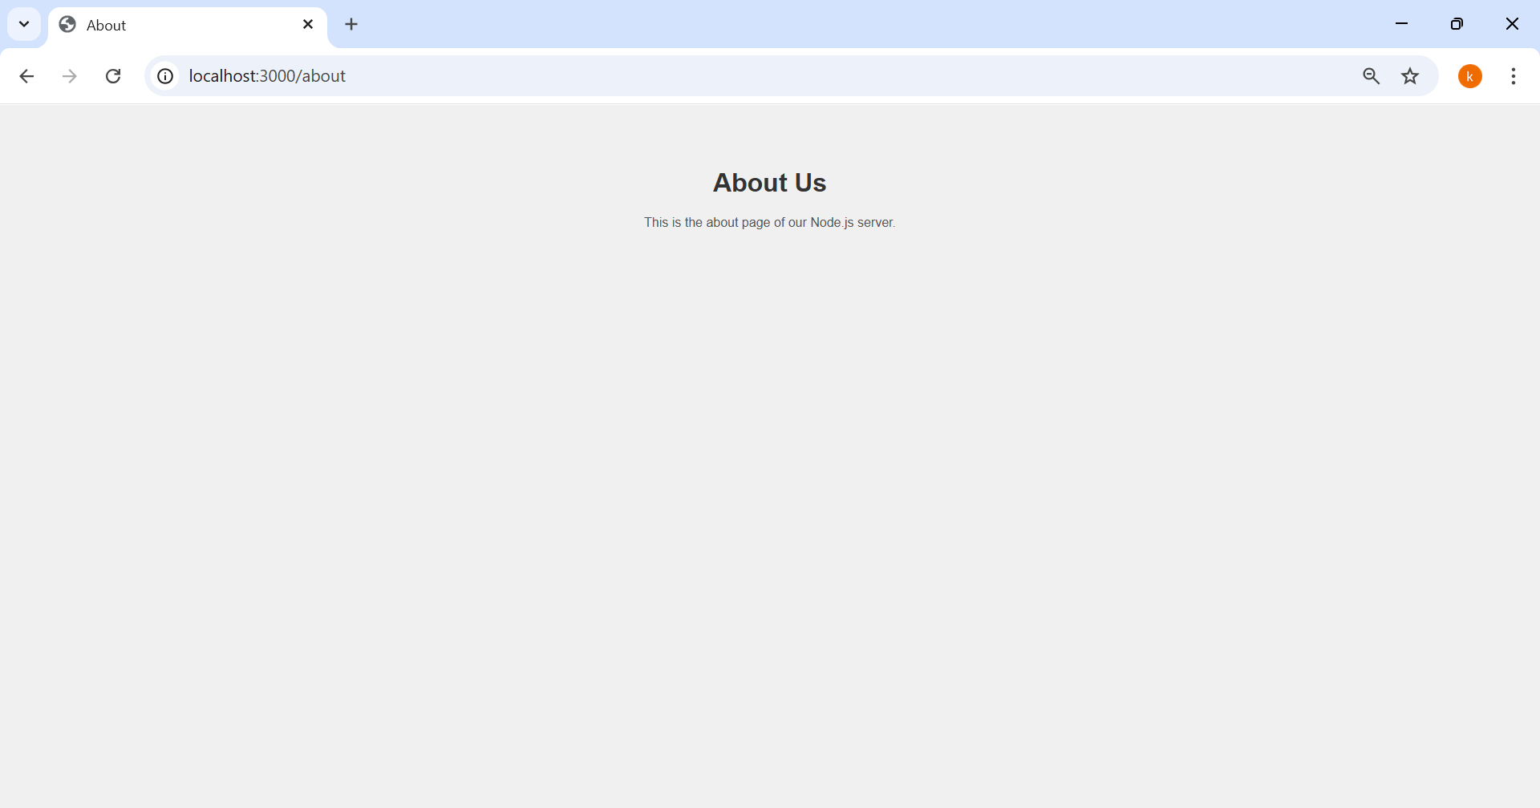

**3.Contact Page**

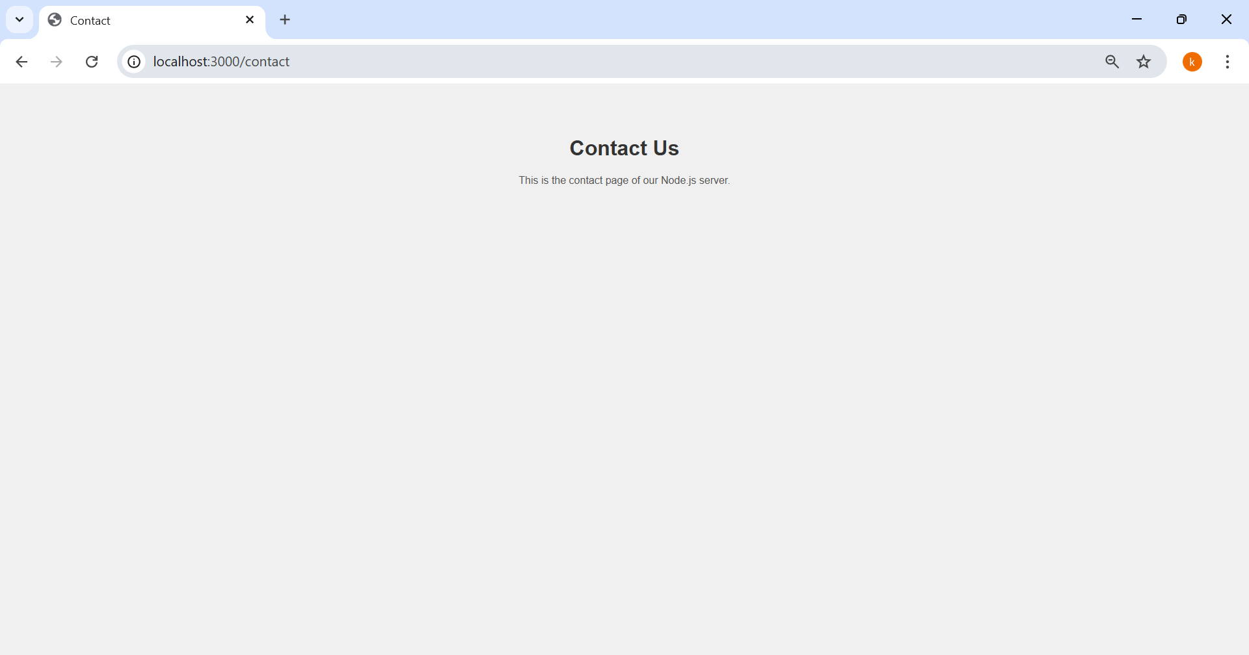

**4. 404 Page (If url is mismatched)**

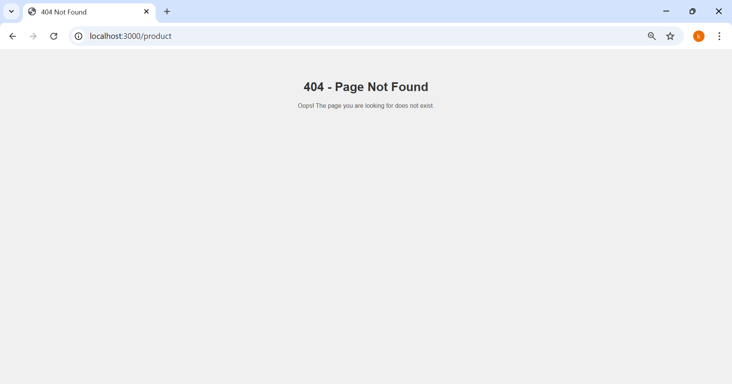

**Brief Explanation of How the Server Works**

This Node.js server uses the built-in http module to handle incoming HTTP requests. It serves different HTML pages based on the requested URL path, implementing simple routing:

1. **Server Creation**:
   * The server is created using http.createServer() and listens on port 3000.
2. **Routing**:
   * The server checks the requested URL (req.url) and serves the corresponding HTML page:
     + /home → home.html
     + /about → about.html
     + /contact → contact.html
   * Any unknown route returns a custom 404 page with a 404 HTTP status code.
3. **File Handling**:
   * HTML and CSS files are read asynchronously using fs.readFile() for better performance.
   * CSS is served for styling, and all pages link to the same stylesheet.
4. **HTTP Status Codes**:
   * Valid pages return **200 OK**.
   * Invalid routes return **404 Not Found**.
   * Server errors return **500 Internal Server Error**.
5. **Testing**:
   * When the server is running, users can navigate to http://localhost:3000/home, /about, or /contact to see the corresponding pages.
   * Any invalid URL automatically shows the 404 page.