Graded Assignment – Week 14

* index.jsp

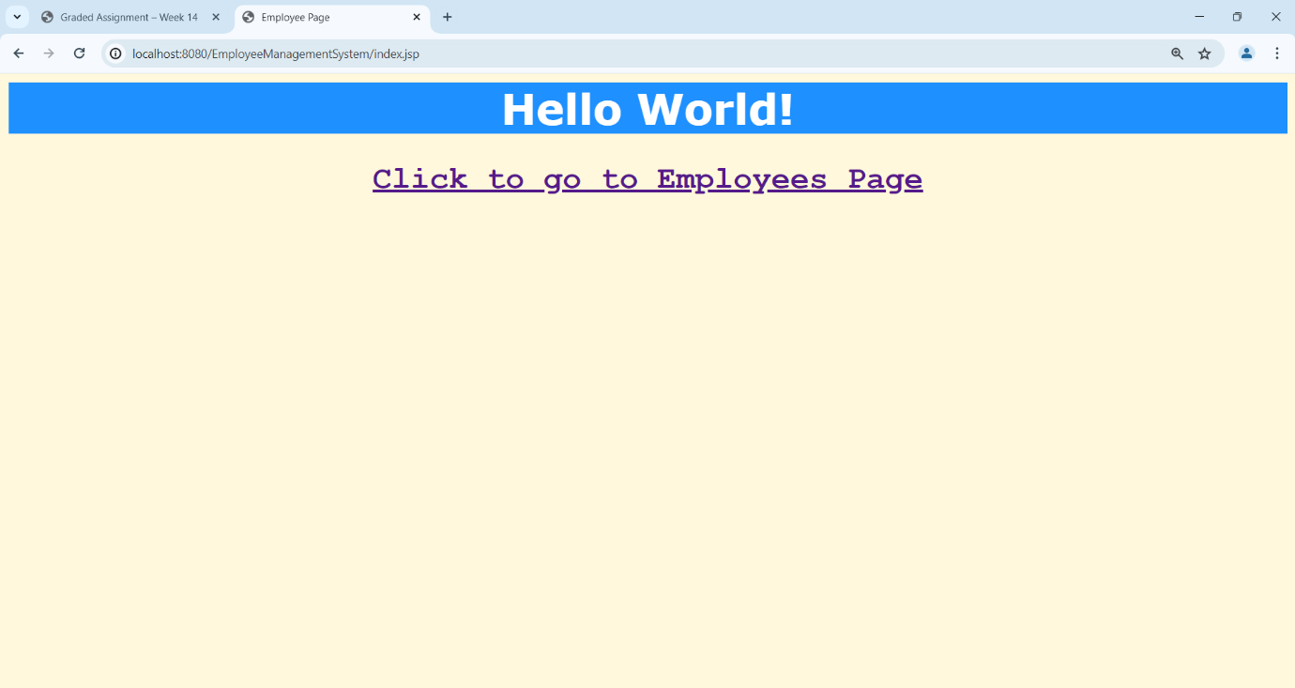

* users.jsp

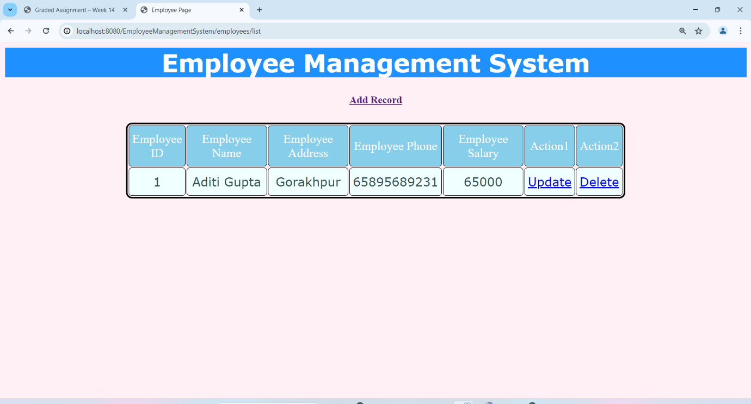

* register.jsp (after clicking “Add Record” from users.jsp)

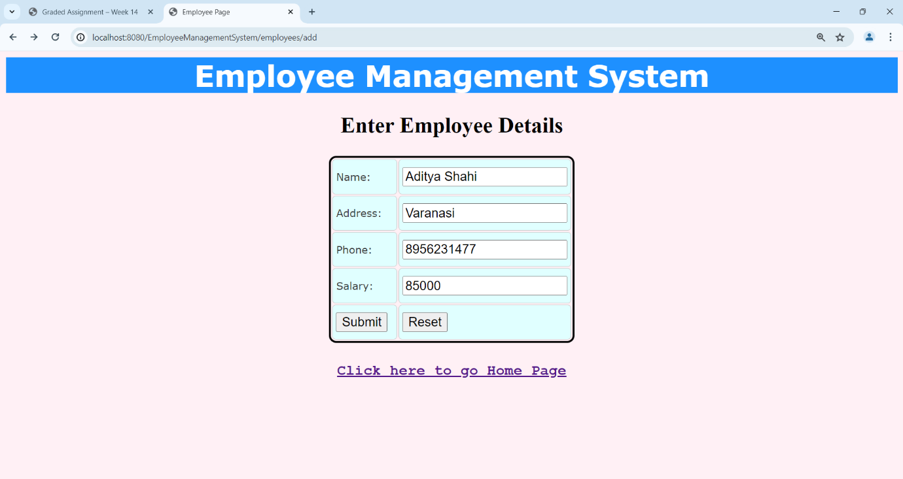

* users.jsp(After clicking submit button on register.jsp)

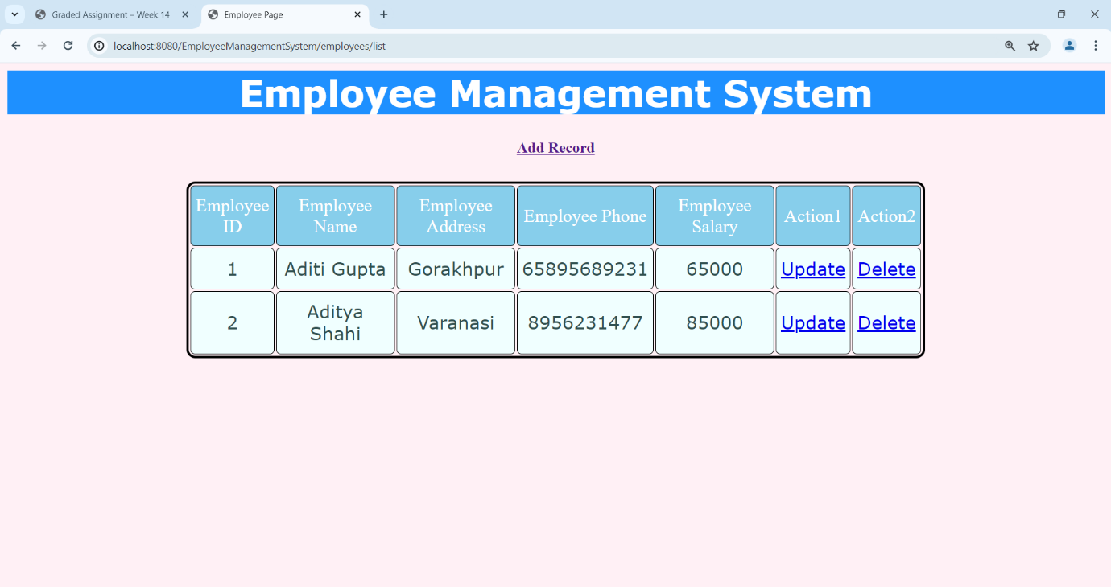

* show.jsp(After clicking on “update” of Employee Id = 1)

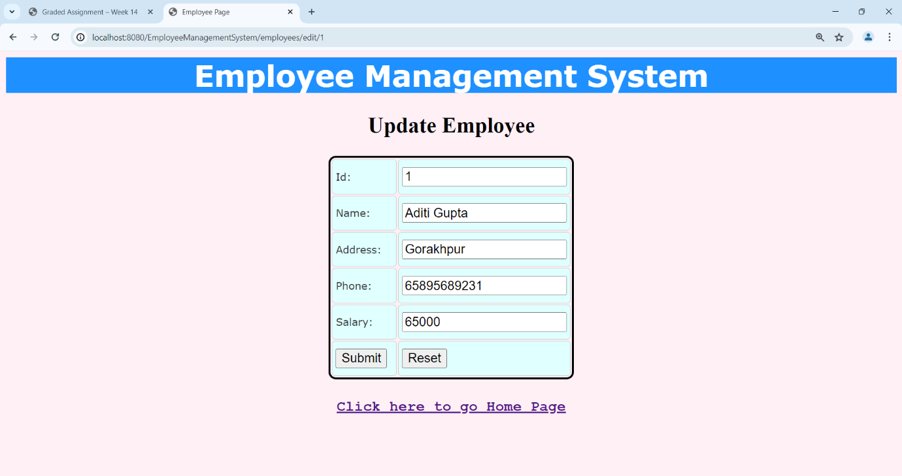

* Updating the existing employee

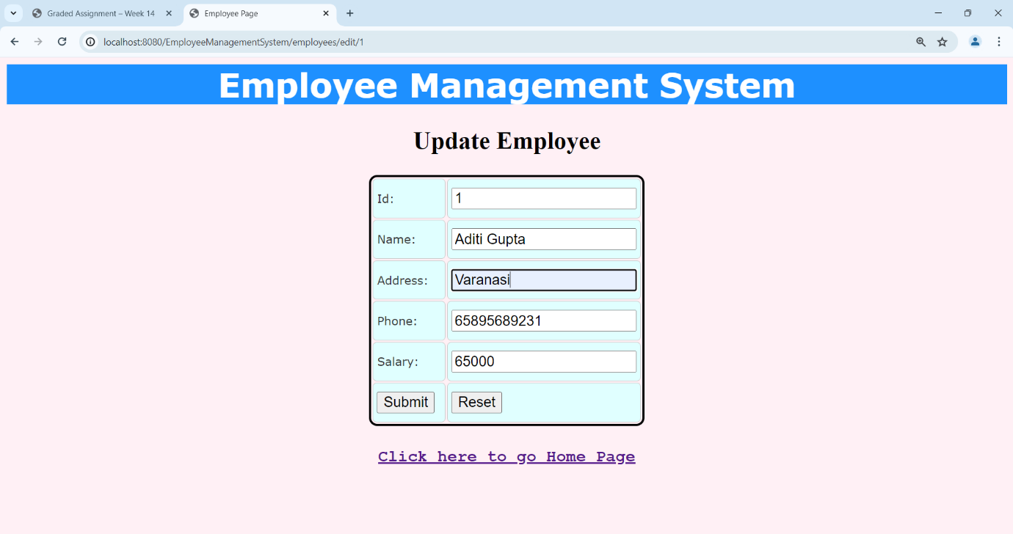

* users.jsp(After clicking “submit” button on show.jsp)

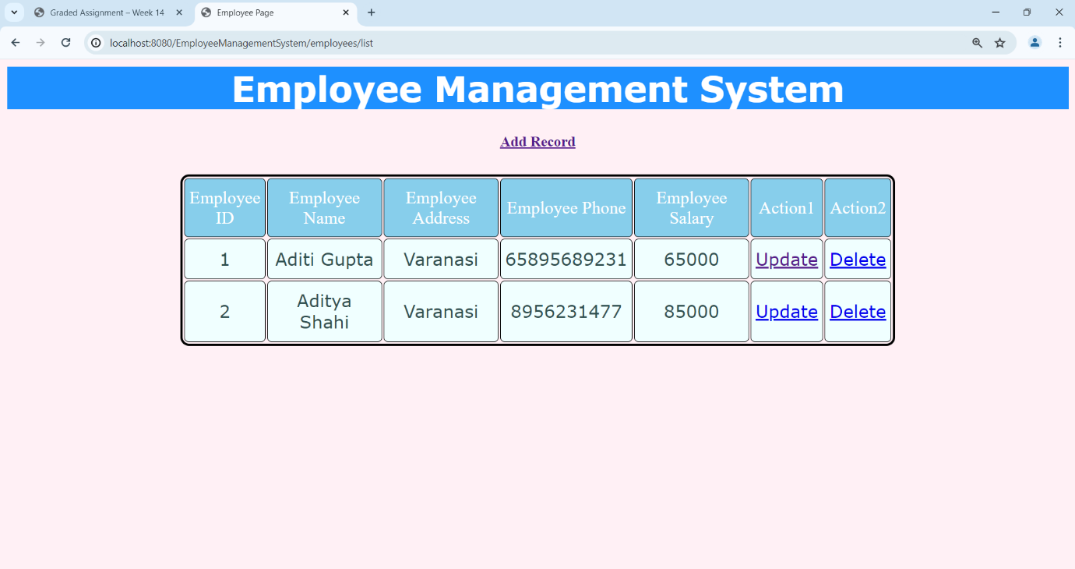

* users.jsp(After clicking on “delete” of Employee Id = 2)

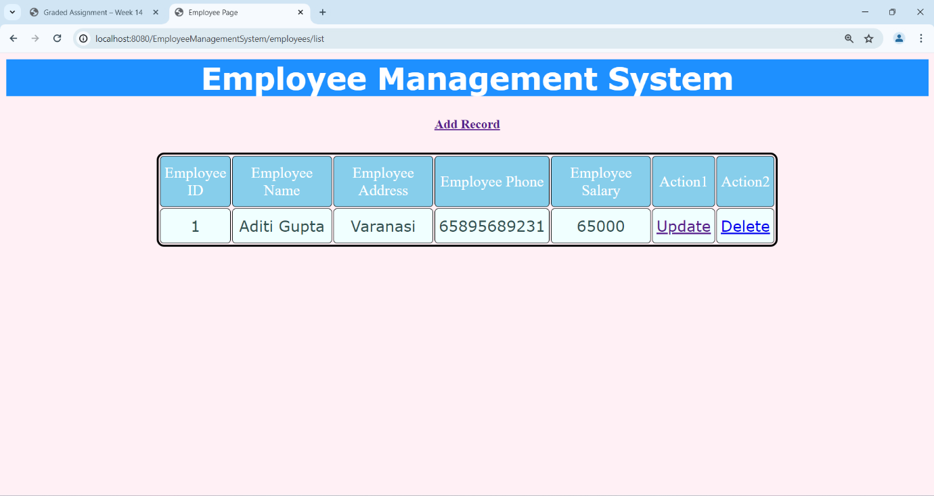

* Again adding a new record

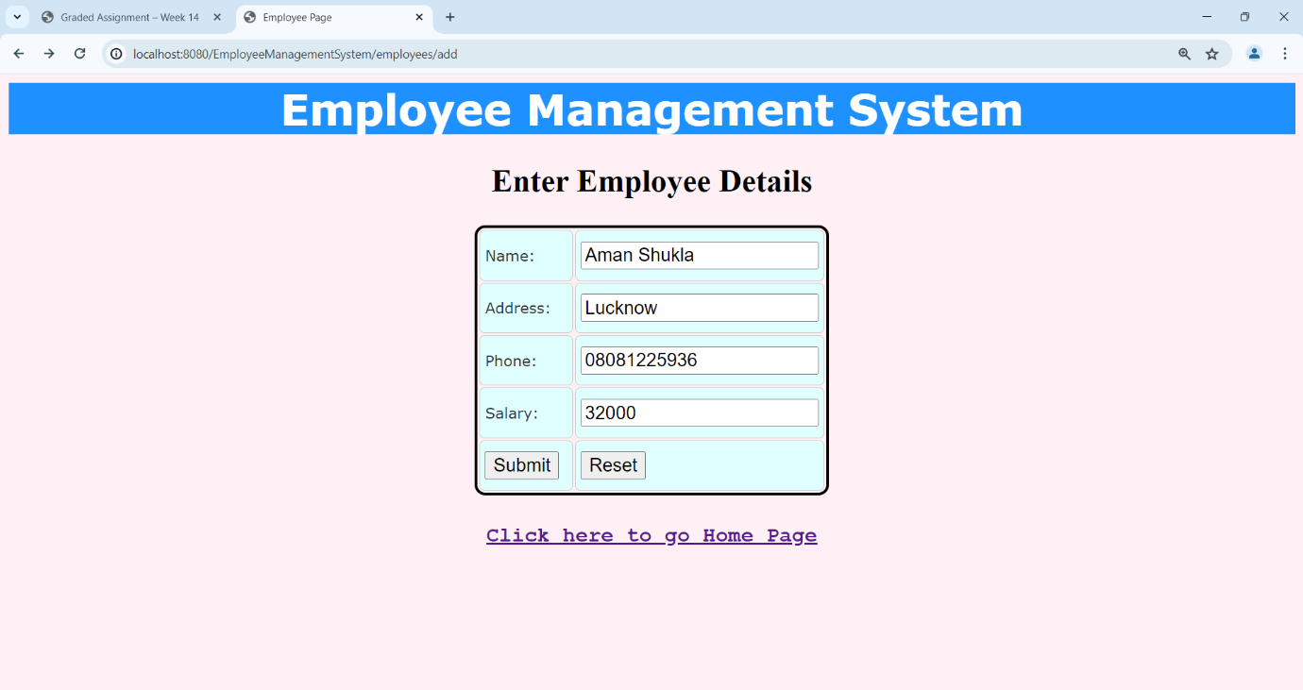

* Updated list

