**--INDEX--**

**CHAPTER-1: INTRODUCTION**

**1.1 About Organization**

**1.2 About Project**

**1.3 Existing System**

**1.4 Limitation of Existing System**

**1.5 Proposed System**

**1.6 Objectives**

**CHAPTER-2: NEED OF COMPUTERIZATION**

**CHAPTER-3: FEASIBILITY STUDY**

**3.1 Introduction**

**3.2 Technical feasibility**

**3.3 Economical Feasibility**

**3.4 Operational of Behavioural feasibility**

**CHAPTER-4: SYSTEM REQUIREMENT**

**4.1 Requirement of Specification**

**4.2 About Hardware and Software**

**4.3 VB.net**

**4.5 MS-Access Word**

**CHAPTER-5: SYSTEM ANALYSIS**

**5.1 System Analysis**

**5.2 Fact Finding**

**5.3 System Diagram**

**CHAPTER-6: DATABASE**

**6.1 Database Analysis**

**6.2 Database Normalization**

**CHAPTER-7: SCREEN SHOTS**

**7.1 Database Tables**

**7.2 Forms**

**CHAPTER-8 TESTING AND DEBUGGING**

**8.1 What is testing?**

**8.2 Types of Testing**

**8.3 Debugging**

**CONCLUSION**

**REFERENCES**

**CHAPTER – 1**

**INTRODUCTION**

**1.1) About Organization**

The software project is initiated by a client need. In the beginning , these needs in the minds of various people in the client organization. The requirement analysis has to identify the requirements by talking to these people and understanding their need. For such systems, the requirement problems is complicated by the facts that the need and requirements of the system many not to be known even to the user - they have to be visualized and created. Hence, identifying requirement necessarily involves specifying what some people have in their minds. When inputs from multiple people are to be gathered, as is often the case, there inputs are likely to be inconsistent as well. the process of ordering, storing, using, and selling a company's inventory. This includes the management of raw materials, components, and finished products, as well as warehousing and processing of such items.

one of its most valuable assets. In retail, manufacturing, food services, and other inventory-intensive sectors, a company's inputs and finished products are the core of its business. A shortage of inventory when and where it's needed can be extremely detrimental.

For these reasons, Digital management is important for businesses of any size. Knowing when to restock , what amounts to purchase or produce, what price to pay—as well as when to sell and at what price—can easily become complex decisions. Small businesses will often keep track of stock manually and determine the reorder points and quantities using spread-sheet (Excel) formulas. Larger businesses will use specialized software. The largest corporations use highly customized software as a services (saas) applications.

Digital Shop Management System (DSMS) is such a service which provides all services for an industry to make your life easier and faster by assuring its performance. Easy User Management System, Easy stock Process, Easy invoice System.

We use database and database technology are having a major impact on the growing use of computers. The implementation of the system was done using VB.Net and MS-Access technologies, allowing system to be run in Windows OS.

**1.2) About Project**

The difference area where we can use this application as:

* Maintain every record for purchase and sales transition
* It can be used in offices and modifications can be easily done according to requirements.
* This is very easy to use for each user.
* Increase Efficiencies and Reduce Costs .
* Transform IT for Higher Education .
* Easy Solution .
* Easy Handling Process .
* Secure All Data .
* Easy Account Maintenance .
* Transaction History .
* Easy restock Process .
* The user of the database can see all information and also can edit if necessary.
* Manual generate of sale bill.

**1.3) Existing System**

The system is completed under the guidance of the theory and methods of management information systems, database technology support. This paper first discusses the structure of the background, purpose and significance of the graduate design topics. Then describes the development platform and database technology and the advantages of each, followed by more devoted a system requirements analysis, design, implementation, and the implementation of the tasks, techniques and tools. End system to complete the information input, output, data modification, query and statistics, as well as print statements, make operation simple and quick.

In this project, we try to build up sound software which can operate any challenging situation in the modern time. Administrator and users information are making effective decisions. The decisions are more accurate, relevant and timely the information stored or process is more effective.

**1.4) Limitation of existing system**

1. Unable to generate sales and billing reports. He generate billing by manual.

2. Difficult to maintain every record for purchase and sales transition.

3. Manual generate of sale bill.

4. No method to maintain stock.

5. Chance of mistake in calculations.

**1.5) proposed system**

The system is proposed due to the problem associated with Digital Shop Management System . The proposed system will remove some draw-backs of the existing system. The system is menu driven and command button driven, even an operator does not have any knowledge of the computer other than keyboard and mouse and he can handle comfortably end user just have to choose menu using mouse and shortcut keys form keyboard.

**1.6) objectives**

The main objectives of this project is to develop Digital Shop System for chalisgaon. And some other objectives are also considered.

* Better service to the owner.
* User friendly system.
* Effective use of resources.
* Less time required.
* Maintain the customer, supplier information.
* Maintain payment and receipt transition.
* Maintain stock.
* Data can be easily accessed.

**CHAPTER 2**

**NEED OF COMPUTERIZATION**

To get the information at the proper time with the least effort arises the need of computerization. The use of the information should be effective with computer. We get better quality information and can take particular action and that contributes towards effective decision making.

Now a days, computer are being widely used in any system because of its learning, operating and getting result. Also the cost is decreased and they are easily available.

So the small organization, because business and every department get opportunity to improve performance. They can cut down the requirement of manpower.

It gives better information, which again reduces the efforts. All the above advantages make computers a “NEED” in the system.

Its characteristics like storage, speed automation diligence and capability of doing any type of job makes attractive.

**CHAPTER 3**

**FEASIBILITY STUDY**

**3.1) INTRODUCTION**

Preliminary investing examines the project feasibility; the likelihood of the system will be useful to the organization. There are basic tests of feasibility study for computerization of a system. These tests are---

1. Technical feasibility
2. Economic feasibility
3. Operational / behavioural feasibility

The main objectives of the feasibility study is to testing the technical, social and economic feasibility for developing computerized system.

This done by investigating the existing system.

**3.2) TECHNICAL FEASIBILITY**

It involves hardware requirement of software. The automates system can easily run on Pentium.

Technical issues were also raised during the feasibility. The required for the proposed system is also easily available and it has the technical capacity to hold the volume of data required for the new system.

The system can also be expanded if the need arise. There are technical guarantees of accuracy of data security and reliability. The proposed system was evaluated form the technical point of view and it was found to be technical feasible.

**3.2) ECONOMICAL FEASIBILITY**

Justification for any capital is that it will increase profit, reduce expenditure or improve the quality of service, which is in turn, may be executed to provide increased profit. The finical and economical questions raised during the preliminary investigation ,investigation are for the purpose of estimating the following. ---

* The cost to conduct a full system investigation.
* The cost of hardware and software for the class of application.
* The cost of the proposed system is not implemented. To judge a project proposal, it must pass all these tests otherwise it is not a feasible report.

**3.4) OPERATIONAL OR BEHAVIOURL FEASIBILITY**

The proposed project is beneficial only if they can be turned into information system that will meet the organization operating requirements. It has to be seen whether there is sufficient form management and form the users. If the system is well linked and used to extents, that person will be able to the user they welcome a changes.

Lastly it has to be seen that the proposed system does not harm the organisation in any way. Therefore all operational aspects have been considered carefully and we know that a reactions are to be in favour of proposed system. In addition to that we are going to train the concerned staff and e also provide them with the user’s manual to operate the proposed system.

**CHAPTER 4**

**SYSTEM REQUIREMENT**

**4.1) REQUIREMENT SPECIFICATION**

SRC document should clearly document the following functional requirement of the system.

* **Non-functional requirement of system**
* **Constraints on the system**

Thus the SRC document should specific the external behaviour of the system only and retained form discussing any implementations. The SRC document should view the symbol developed as a black box should specify the externally behaviour of the system.

**4.2) ABOUT HARDWARE AND SOFTWARE**

A major element in building system is selection of compatible hardware and software. Hardware selection begins with requirement analysis followed by a request for proposal validation and evaluations, vendor selection.

While selecting software various critical is considered as reliability, functionality, capacity, flexibility, usability, security, ownership, minimum cost.

**HARDWARE REQUIREMENT—**

Hardware of computer means all physical components of computer system. Computer hardware consist of input devices, CPU and output devices input device are connected directly to the computer system.

The following hardware is required to operate the project ---

* **CPU - Intel® Core™ i5-7200U CPU @2.50GHz 2.70GHz**
* **Hard disk - 1 TB**
* **Monitor - Any**
* **Keyboard and**

**Mouse - Any**

* **Printer - Any**

**SOFTWARE REQUIREMENT**

The software requirement for this project is –

* **Operating system - windows 10 pro**
* **Front end - Microsoft VB.NET**
* **Back end - MS Access 2010**
* **Visual studio 2012**

**4.3) VB.NET**

Visual Basic .NET is part of grand new intiative by Microsoft. It is a complete re-engineering of Visual Basic for the Microsoft.NET framework. With Visual Basic .NET , you are able to quickly build windows-based applications (the emphasis in this course), web-based application and eventually software for other devices, such as palm computers.

Windows application built using Visual Basic .NET feature a Graphical User Interface (GUI). Users interact with a set of visual tools (buttons, textboxes , tool bars , and menu items) to make an application do its required tasks. The application have a familiar appearance to the user. As you develop as a Visual Basic .NET programmer , you will begin to look at Windows application in a different light. You will recognize and understands how various elements of Word , Excel , Access and other application work. You will develop a new vocabulary to describe the elements of Windows applications.

Visual Basic .NET Windows applications are event-driven, meaning nothing happens until an application is called upon to respond to some event (button pressing , menu selection,). Visual Basic .NET is governed by an event processor. As mentioned , nothing happens until an event is detected , a corresponding event procedure are executed . those instructions are the code written by the programmer. In Visual Basic .NET , that code is written using a version of the BASIC programming language . Once an event procedure is completed , program control is then returned to the event processor .

**4.4) MICROSOFT ACCESS 2010**

Microsoft Access is a relational database that stores data in fields , which are then groped together into records which are all the same type and the structure fields are the smallest unit of data addressable in Access. Like Visual Basic fields are the smallest in the random access file type , Access fields also need to assign a data type.

* Text
* Memo
* Number
* Date/Time
* Currency
* OlE Object

Microsoft Access is a very powerful database with its own basic language built in .

**CHAPTER 5**

**SYSTEM ANALYSIS**

**5.1) SYSTEM ANALYSIS**

System analysis is the process of totally understanding the current system by gathering interpreting facts, diagnosing problems and using the facts to improve the current system.

This phase is detail appraisal of the existing system. This appraisal

Includes how the system works and what it does. It also includes finding out in more details about what the system problems are and what user requires form new system or any new change in the system. After this phase analyst should be familiar with the details operation of the system and what is required by the system.

The output of this phase result the details of the model describe the system function, data flow in the system. The phase also contain the details set of user required manual and these requirements are used to set of objects for new system.

**5.2) FACT FINDING**

The method for collecting data about requirements are called fact finding techniques. This includes –

* Interviews
* Observation

**INTERVIEWS**

Interviews with managers of the firm gave the details information of function.

**Observation**

Observation include an observing standard operating procedure that gave the information about the activities carried out.

Thus this data gave the required data for the system as well as help to design the new system.

Following are the points to be noted—

1. The existing system was carefully studied.
2. The requirements of various procedures were noted after interviewing the manger.
3. While developing the system various suggestions and changing requirements are concerned.

**5.3) SYSTEM DIAGRAM**

* Flow Chart
* Data flow diagram
* ER diagram

Diagrams

Flow Chart

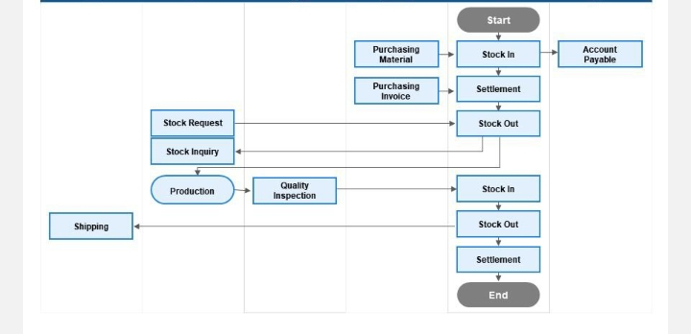

**Figure 1:** Flow Chart

## Data Flow Diagram (DFD)

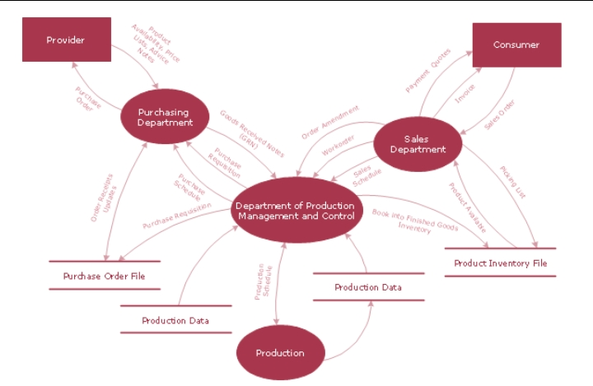

**Figure 2:** DFD Diagram

## ER Diagram

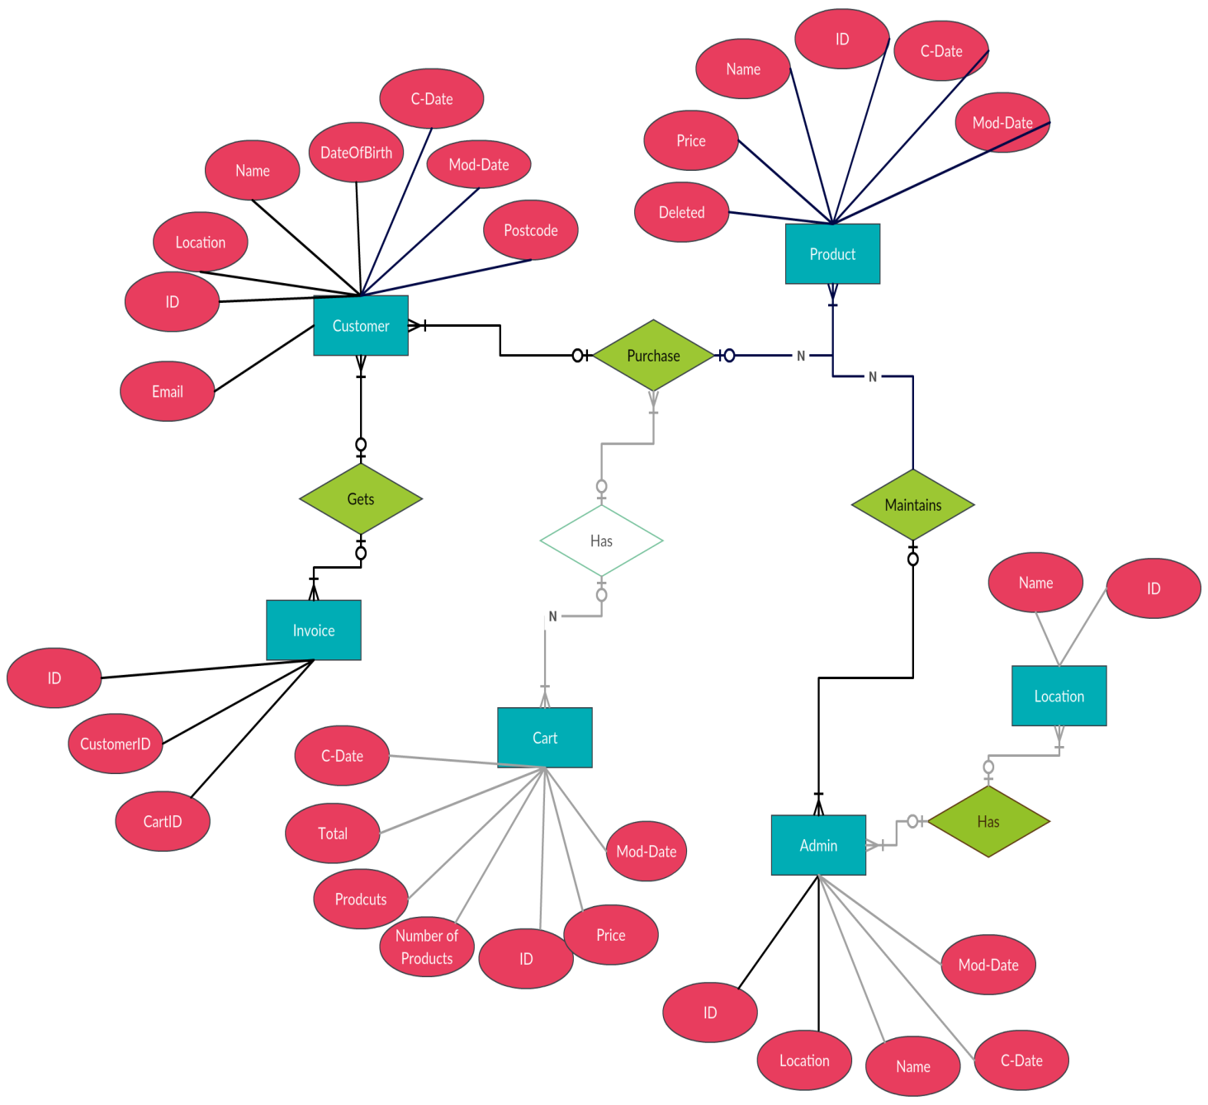

**Figure 3:** ER Diagram

CHAPTER 6

DATABASE

6.1) DATA BASES ANALYSIS

Server technical and tools are available to help with decision supports serves tools for data analysis to view data in different ways. Other recomputed summaries of very large amounts of data in order to give fast response to queries. Another approach to getting knowledge form data is to use data mining, which aims at detecting various types of patterns in large volume of data. Data volume supplements various type’s techniques with similar goals.

6.2) DATABSE NORMALIZATION

It is as per the database management system, which shows the simplest form between the relation data and entity. The main consideration function o normalization is data redundancy.

In normalization, we group that attribute in server ways that elimination these type of problems. The goal of the normalization is to reduce the redundancy and function dependency. Functional dependency occurs when the value of one attribution can be determined by the value of another attribute. By definition all non-key attributes will be functional dependant on the primary key in every relation.

**CHAPTER-7**

**SCREEN SHOTS**

**7.1) DATA BASE TABLES:**

**Stock Table :-**

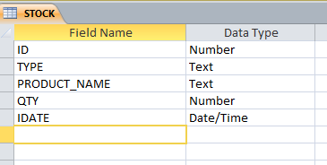

**Inward Detail Table :-**

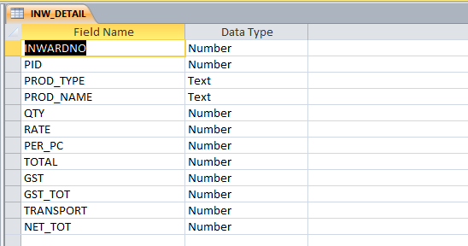

**Customer Account Table:-**

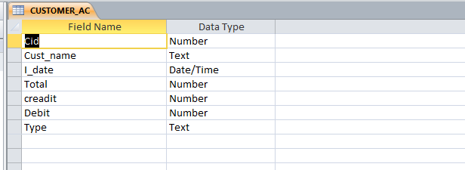

**Dealer Account Table:-**

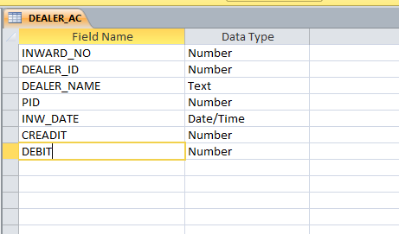

**Invoice Table:-**

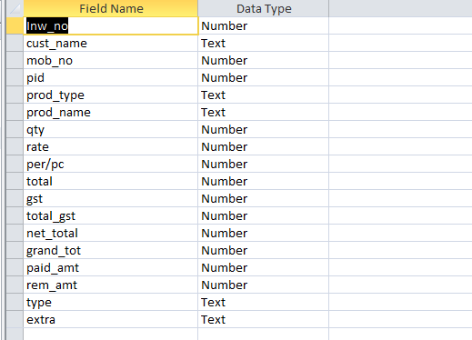

**7.2) FORMS**

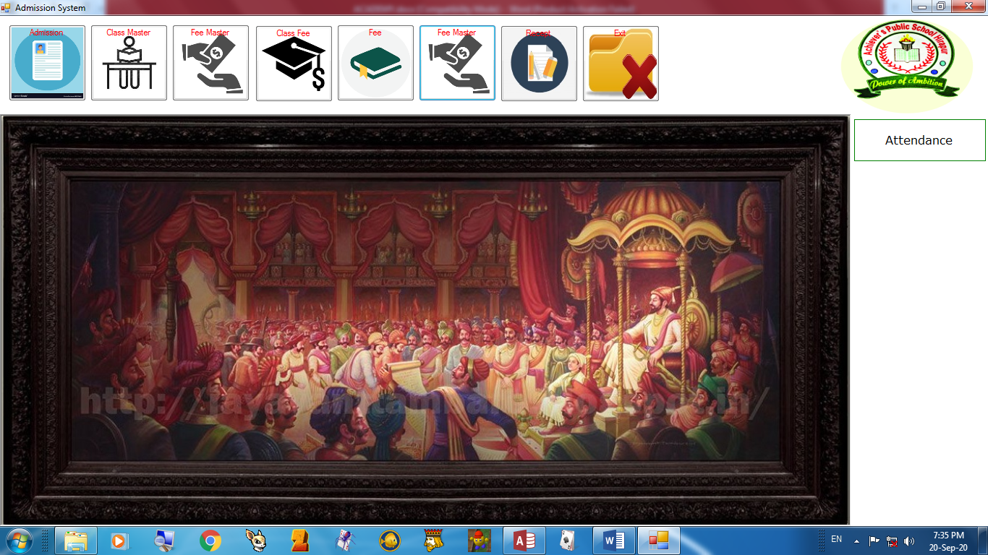**MDI Parent Form:-**

**Inward Form:-**

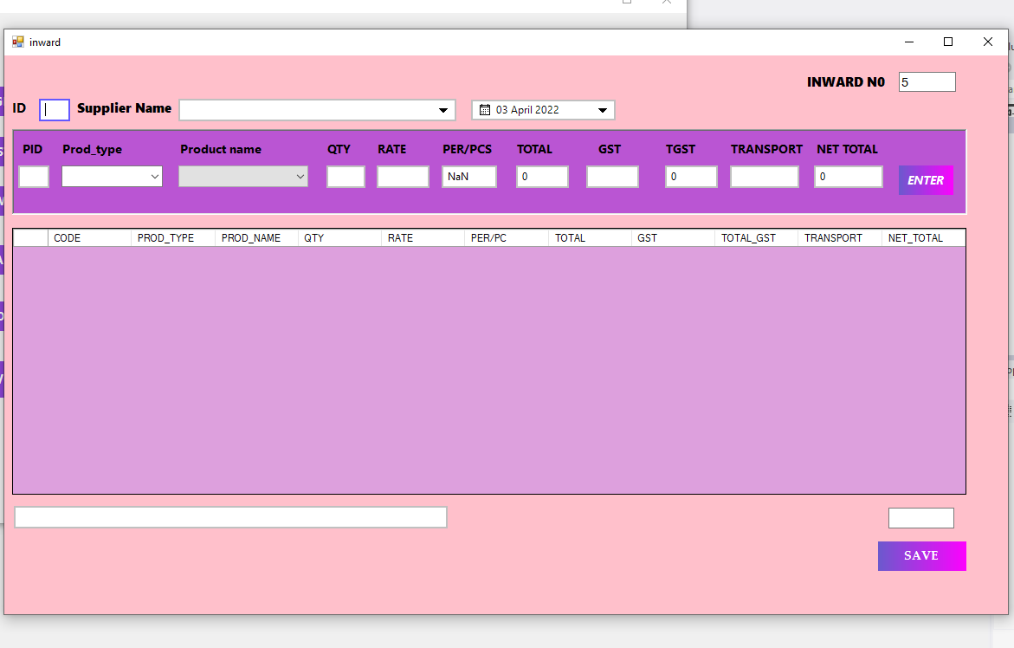

**Customer Information form :-**

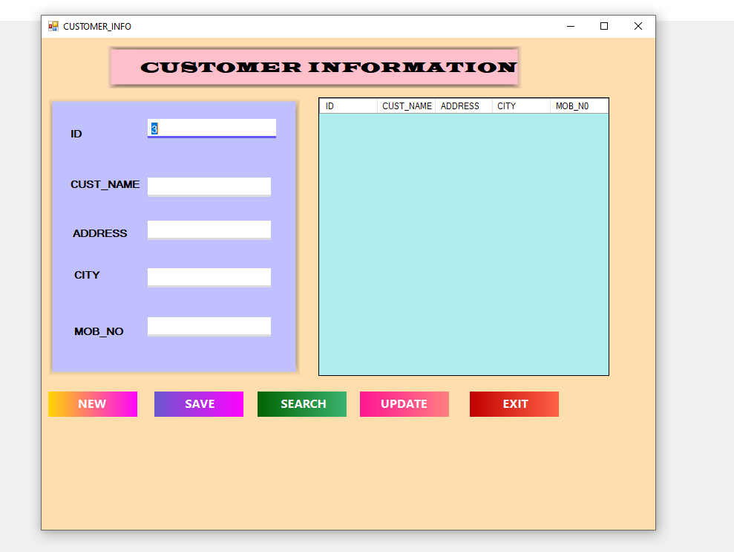

**Dealer Information Form:-**

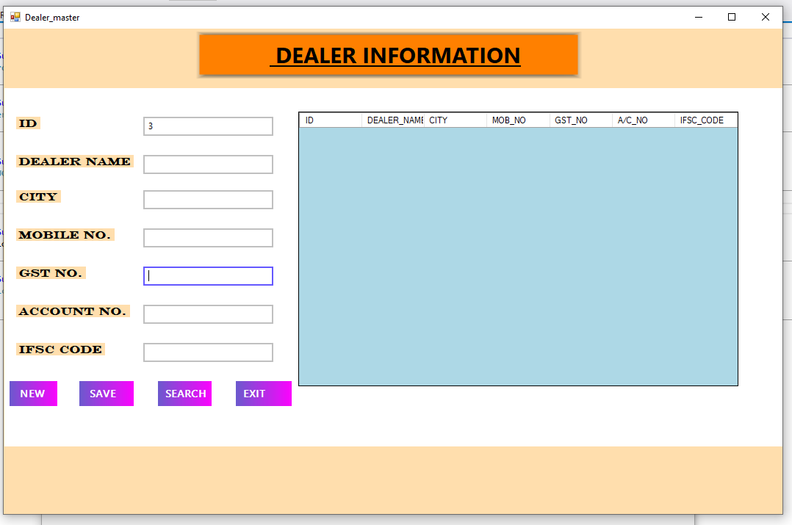

**Invoice Form:-**

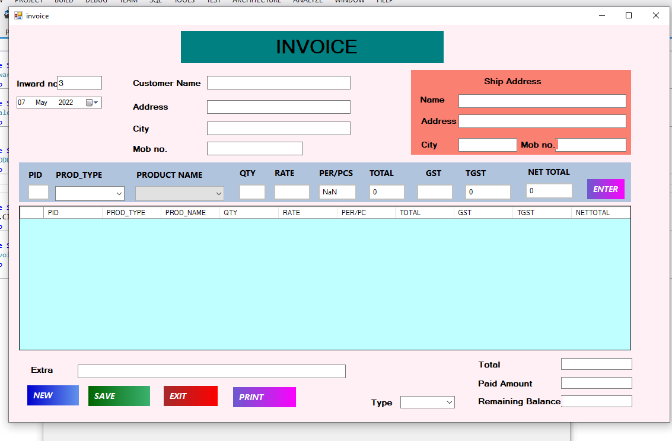

**Product Entry Form:-**

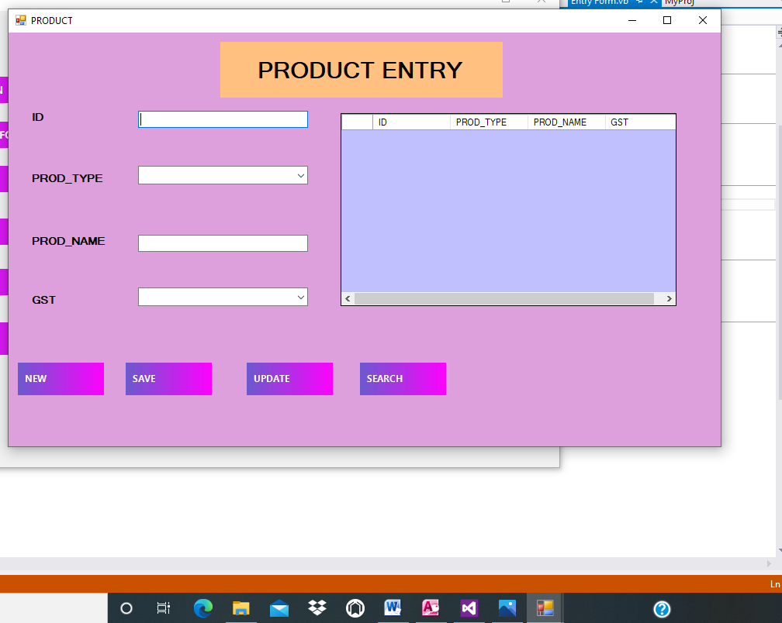

**CHAPTER 8**

**TESTING**

**8.1 What is Testing?**

Testing is a process for making the sure that the system performs intended task. During system testing, the system is used experimentally to ensure that the software does not fail; it will run according to its specification and the way the user expects.

**8.2 Types of Testing**

* White Box Testing
* Module Testing
* Black Box Testing
* Validation Testing
* Recovery Testing
* Security Testing

**White Box Testing :**

[White Box testing](https://www.softwaretestinghelp.com/white-box-testing-techniques-with-example/) is based on the knowledge about the internal logic of an application’s code.

It is also known as Glass box Testing. Internal software and code working should be known for performing this type of testing. Under these tests are based on the coverage of code statements, branches, paths, conditions etc.

**Module Testing :**

This was carried during the programming stage it self. Individual program were tested at the time of codding and necessary changes are made there onto make sure that the modules in the form program that is all choices available were properly tested.

**Black Box Testing :**

After module and string testing the system was tested as whole system test were undertaken to check bundles modules for errors found in the couple system as were corrected. The testing on actual date of the company followed this. During this phases existing system and the package was running in parallel to enable us to verify and compare the result sets. The following criterion was to be used while testing the system.

1. **Output Testing –**

No system could be useful if it does not produce required output. For that matter output was taken in required format. The output generated or displayed by the system under consideration was tested by asking the user about the format required by them.

1. **User Acceptance Testing –**

User acceptance of system is a key factor for the successes of any system. The system under consideration was tested for user acceptance by constantly keeping in touch with the project system user at the time of developing and making changes wherever required. This was done in regard to in the user satisfaction.

**Validation Testing :**

The process of evaluating software during the development process or at the end of the development process to determine whether it satisfies specified business requirements.

Validation Testing ensures that the product actually meets the client's needs. It can also be defined as to demonstrate that the product fulfills its intended use when deployed on appropriate environment.

**Recovery Testing :**

It is a type of testing which validates that how well the application or system recovers from crashes or disasters.

Recovery testing determines if the system is able to continue the operation after a disaster. Assume that application is receiving data through the network cable and suddenly that network cable has been unplugged.

Sometime later, plug the network cable; then the system should start receiving data from where it lost the connection due to network cable unplugged.

**Security Testing :**

It is a type of testing performed by a special team of testers. A system can be penetrated by any hacking way.

[Security Testing](https://www.softwaretestinghelp.com/how-to-test-application-security-web-and-desktop-application-security-testing-techniques/) is done to check how the software or application or website is secure from internal and external threats. This testing includes how much software is secure from the malicious program, viruses and how secure and strong the authorization and authentication processes are.

It also checks how software behaves for any hackers attack and malicious programs and how software is maintained for data security after such a hacker attack.

**System Testing:**

The system testing is the stage of implementation that is aimed at the ensuring that that the system works efficiently and accurately before the live operation commences.

The developed system has all the pieces in working order but in reality, each piece work independently. During testing all the piece are put together into one system and testing to determine whether it meets user’s requirements . Testing phases is the last chance given for any correction of errors before the system is installed for user acceptance.

The purpose of the system is to system is to consider all the likely variations to which it will be subjected and then push the system to its limit.

It is necessary step in the development and implementation. System testing makes a logical assumption if all the parts of the system are correct;

The goal will be successfully achieved.

**System testing consists of the following steps….**

1. Programming planning
2. String testing
3. System documentation
4. User acceptance testing

The programs were validated during the system testing. The system testing process made sure that the programs written were according to the design specification.

Testing was completed only when all the desired verification was performed. In the installation it was checked whether the system operation correctly and the result were studied before installation.

**8.3 Debugging**

Debugging is a process of removal of a defect. It occurs as a consequence of successful testing.

Debugging process starts with execution of test cases. The actual case results are compared with the expected results. The debugging process attempts to find the lack of correspondence between actual & expected results. The suspected causes are identified & additional tests or regression tests are performed to make the system to work as per requirement.

**Common approaches in debugging are:**

**1.Brute force method:** The memory dumps & runtime traces are examined & program with write statements is loaded to obtain clues to error causes.

In this method “let computer find the error” approach is used.

This is the least efficient method of debugging.

**2.Backtracking method :** This method is applicable to small programs. In this method, the source code is examined by looking backwards from symptom to potential causes of errors.

**3.Cause elimination method :** This method uses binary portioning to reduce the number of location where error can exist.

Thus testing is an essential activity carried out during software development process for improving quality of product.

**CONCLUSION**

The project report on **“Digital Shop Management System ”** clears output all the disadvantage that the existing system holds. The application Digital Shop Management Software is the total package for shop day-today requirements. With the help of menu bar users can interact with software very easily almost every object has been provided with tool bar.

This application is also supports terminal services so that database will be more secure by centralized the database.  
In fine we want to say we are not yet an experienced system analyst, but tried our best to fulfill this project. Which all makes up **Digital Shop management system**. The effort of developing the system in VB.NET And Microsoft access 2010 is definitely going to benefit the shop. The developing system is user friendly. Any person with minimum knowledge of computer can easily work the system.

The front end tool VB.NET Windows application is a graphical interface environment is very user friendly. The back end tool Microsoft access 2010 offers highest portability with security. The security is very important. New developed system overcomes all the problem and drawback of the existing system.

The main highlight of the system is that it is very easy to use, as it user friendly and properly validation are provided requirement. The reports are well detailed and at any point of time many generalised reports can be produced.

**REFERENCE**

1. Website :- **Academia**

<https://www.kashipara.com/4443/SIMPLE_DIGITAL_SHOP_SYSTEM>

2.**Slidshare**

<https://www.slideshare.net/Tuvshuud/smart-shop-system-> documentation

3.**Microsoft Access**

<https://en.wikipedia.org/wiki/Microsoft_Access>

4) System Analysis and Design in Changing World by

Sat zinger.

5) Software Engineering – A Practitioners Approach 7/e,

By Roger S. Pressman.