WEEK 4: COMPREHENSIVE DATA SCIENCE REPORT & INSIGHTS PRESENTATION PLAN
Facility Climate Risk Assessment: Findings, Insights & Recommendations
An executive-ready report translating a data science analysis into clear findings, visual evidence, and actionable recommendations for a non-technical audience
Prepared by: Khushi Mahato
Data Science Program — Week 4 Deliverable
August 2026

1. Executive Summary
This report summarises a facility climate risk assessment covering 12 manufacturing sites, undertaken to answer a simple business question: which facilities are most exposed to climate and air-quality risk, and what should be done about it? Using historical climate data, air-quality readings, and facility-level operational information, a composite risk score was calculated and validated for each site, then used to rank facilities and identify the factors driving their risk.
Five facilities emerged as high-risk, disproportionately driven by historical downtime incidents, peak temperature exposure, and local air quality — not by any single factor alone. Risk is also projected to increase across all facility tiers over the next decade, with high-risk facilities' scores rising fastest. These findings translate into a clear set of near-term actions: prioritising mitigation investment where it matters most, moving to a recurring risk-monitoring cadence, and closing specific data gaps that would sharpen the model's accuracy going forward. The remainder of this report walks through the methodology, findings, visual evidence, communication approach, and detailed recommendations behind this summary.

2. Methodology Overview
The assessment combined climate, air-quality, and facility-level data into a single analytical dataset, which was cleaned, checked for missing values and outliers, and explored to understand each variable's distribution and relationships with others. A composite risk score was then developed, combining the most relevant indicators into a single 0–100 scale, and evaluated through a modeling process that compared several algorithms before settling on an approach that balanced predictive strength with explainability — an important requirement for a result meant to be understood by non-technical decision-makers, not just modelers.
Model outputs were validated using a held-out portion of the data to confirm the risk score generalises reasonably beyond the facilities and time periods used to build it, and every step — from data cleaning decisions to modeling choices — was documented so the process can be reviewed, repeated, or extended by others.

3. Insights and Analysis

3.1 Facility Risk Ranking
The chart below ranks all 12 facilities by their composite risk score, grouped into High, Medium, and Low risk tiers. This is the primary output stakeholders are expected to act on.
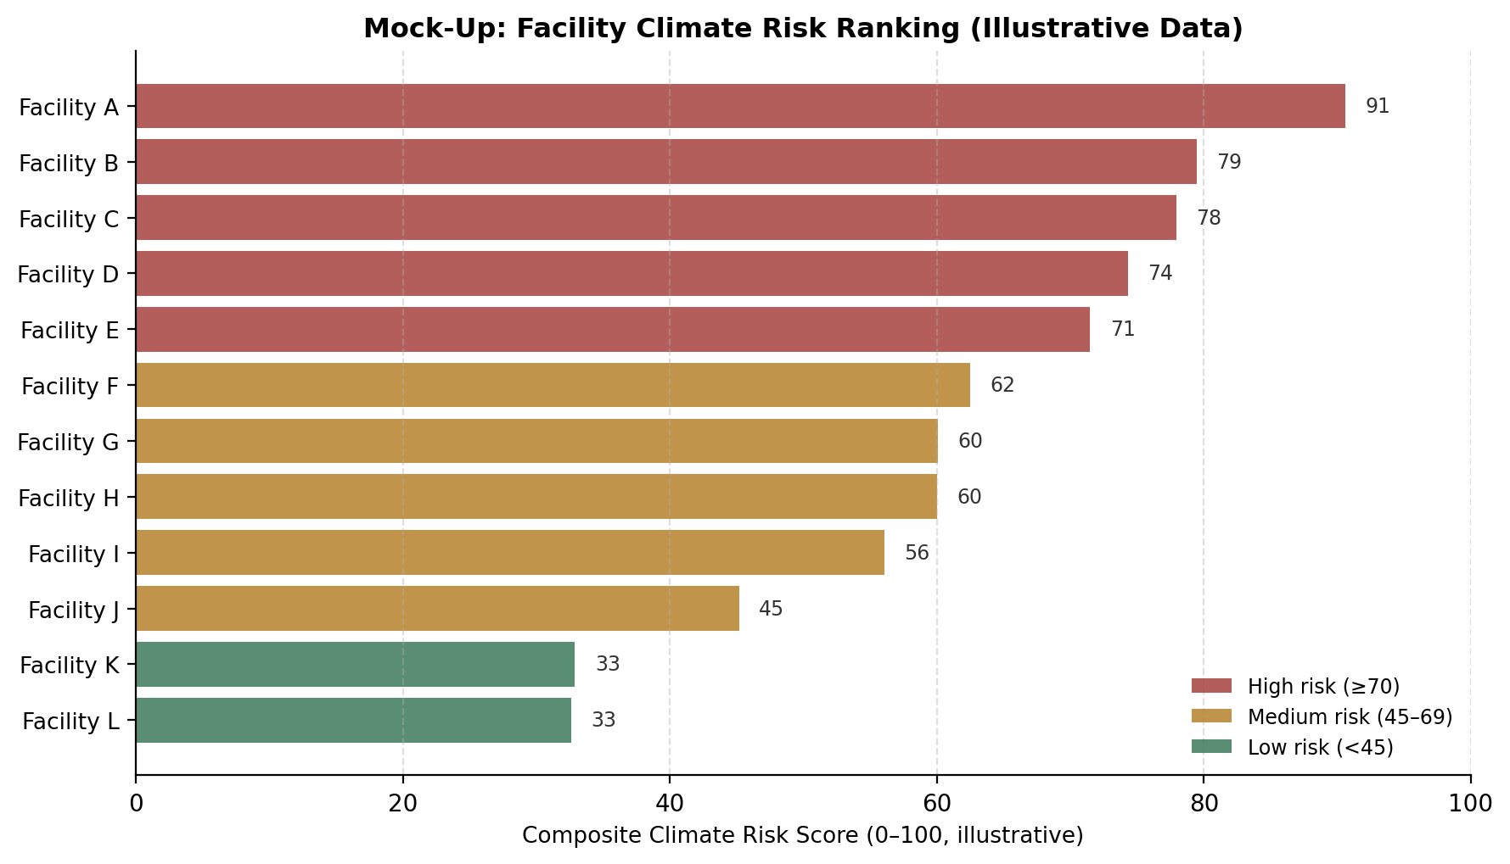
Figure 1. Mock-up: facility climate risk ranking (illustrative data).
Facility A stands out as the single highest-risk site, with a score meaningfully above the rest of the High-risk tier — this facility alone likely warrants an individual review rather than being handled only as part of a broader tier-level plan.

3.2 Projected Risk Trend
Beyond a single point-in-time snapshot, the analysis also projects how risk is expected to evolve. This view answers a different, forward-looking question: not just “who is at risk today,” but “is the situation improving or worsening?”
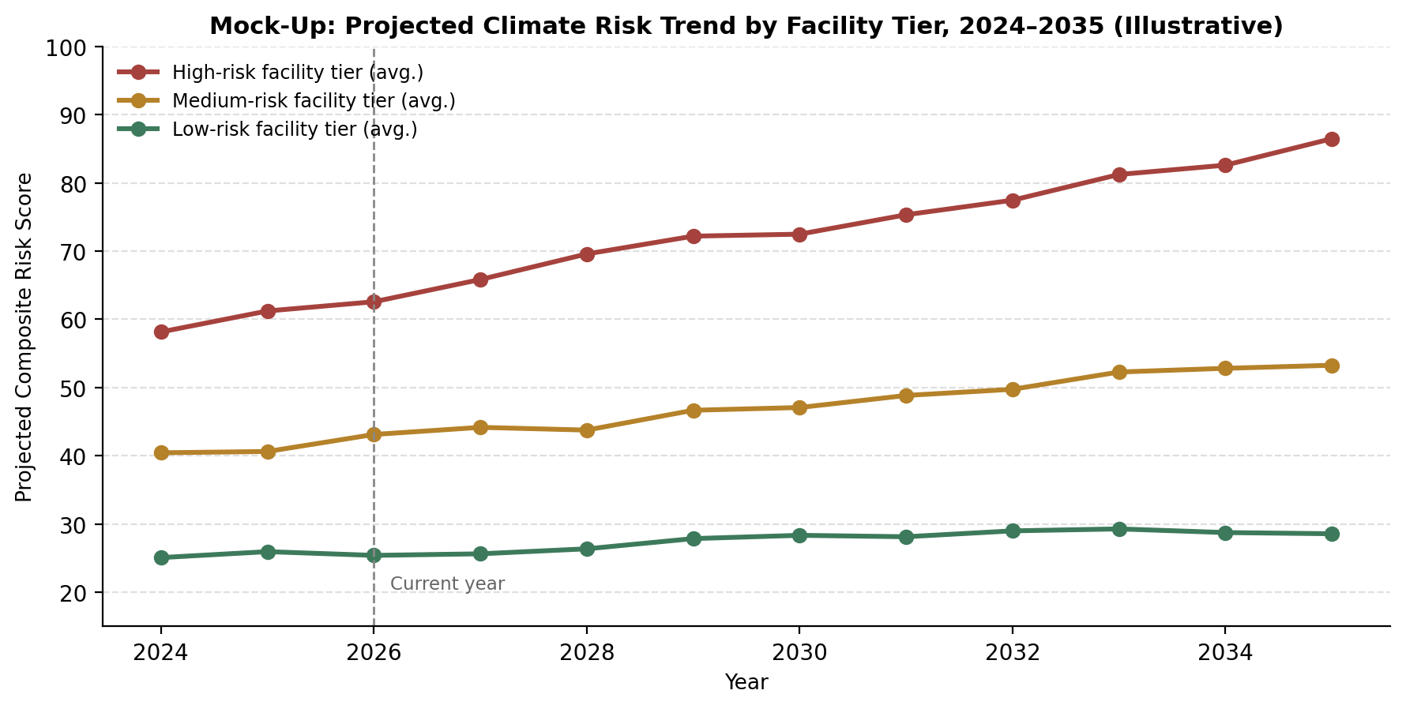
Figure 2. Mock-up: projected climate risk trend by facility tier, 2024–2035 (illustrative).
The High-risk tier's trajectory is notably steeper than the Medium- and Low-risk tiers, suggesting the gap between high- and low-exposure facilities will widen over the next decade absent intervention — reinforcing the case for near-term action rather than a wait-and-see approach.

3.3 Key Risk Drivers
To keep the risk score explainable rather than a black box, the relative contribution of each underlying factor was also examined.
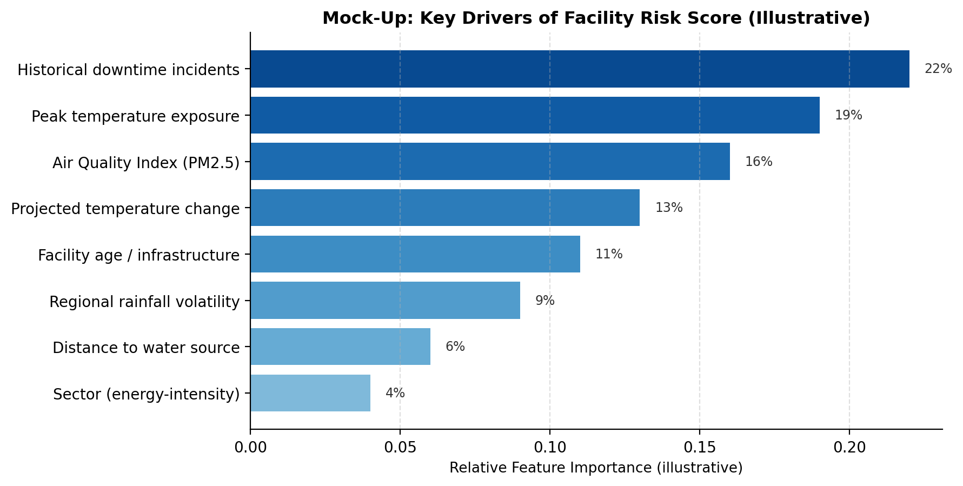
Figure 3. Mock-up: key drivers of facility risk score (illustrative).
Historical downtime incidents and peak temperature exposure together account for over 40% of the score's variation, ahead of air quality and projected temperature change — indicating that mitigation efforts focused on heat exposure and operational resilience are likely to move the needle more than air-quality-only interventions.

4. Presentation Strategy
Technical findings only create business value if they are understood and acted on by people who did not build the model. This report is designed around a simple narrative arc — Context, Complication, Insight, Recommendation — rather than a chronological walk through the analysis, because decision-makers respond to “what does this mean for us” before “how was this calculated.”
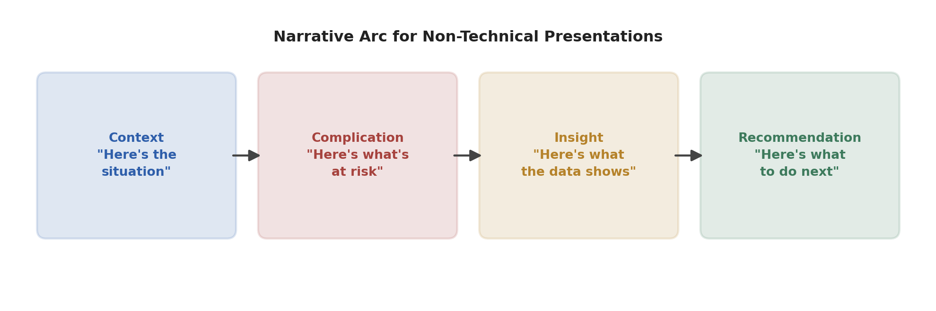
Figure 4. Narrative arc used to structure findings for a non-technical audience.

4.1 Communication Principles
- Lead with the business question, not the method — open with “which facilities are most at risk”, not “we built a Random Forest classifier.”
- One key takeaway per visual — every chart in this report is designed to support a single, clearly stated insight rather than inviting the reader to interpret it themselves.
- Use color and ranking, not raw numbers, as the primary signal — stakeholders remember “five facilities are high-risk” far more reliably than a table of decimal scores.
- Reserve technical detail (methodology, metrics, model choice) for an appendix or a follow-up technical discussion, available on request but not central to the main narrative.
- Close every finding with an implied or explicit “so what” — pairing each insight with what it means for a decision, not leaving that connection to the audience to infer.

4.2 Delivery Format
For an executive audience, this report is designed to also translate directly into a short slide presentation (5–7 slides): one slide per section of the narrative arc, each built around a single visual from Section 3. For a working session with a technical or operations audience, the same underlying dashboard (referenced in Section 2's methodology) supports live drill-down into any individual facility, for questions the summary slides cannot anticipate.
The table below expands on why each visualization in this report was chosen for this specific audience and purpose.
Visualization | What It Shows | Why This Choice
Facility risk ranking (bar chart) | All 12 facilities ordered by composite risk score, color-coded by tier | A ranked bar chart is immediately scannable — executives can see who's highest-risk in seconds, without reading a table
Projected risk trend (line chart) | How average risk is expected to evolve by facility tier through 2035 | Trend lines communicate urgency and directionality — answering “is this getting worse?” at a glance
Key risk drivers (feature importance) | Which factors contribute most to a facility's risk score | Turns a “black box” model into an explainable one; helps stakeholders trust and act on the score
Facility map with risk overlay | Geographic distribution of facilities, shaded by risk tier | Location matters for logistics and regional planning; a map answers “where” faster than a table

5. Recommendations
Based on the findings above, five concrete next steps are recommended, ordered roughly by priority and urgency.
Recommendation | Rationale | Suggested Timeframe
Prioritise risk-mitigation investment at the 5 highest-scoring facilities | These facilities account for a disproportionate share of projected downtime risk; early investment has the highest expected return | Next 2 quarters
Establish a quarterly risk-score refresh cycle | Climate and air-quality conditions shift; a static one-time score loses relevance within months | Ongoing, starting immediately
Validate the model against real incident/downtime records once available | The current risk score is illustrative; real outcome data would let the model be calibrated and trusted with confidence | Within 6 months, as data becomes available
Expand data collection to include facility-level operational data (e.g. equipment age, maintenance logs) | Feature-importance analysis suggests infrastructure age matters; better data here could meaningfully improve model accuracy | Next 3–6 months
Pilot the dashboard with one regional team before full rollout | Early user feedback on a smaller group surfaces usability issues before a costly full-scale rollout | Next quarter

5.1 Further Research
- Investigate whether facility age and infrastructure condition data (not currently available) would materially improve model accuracy, given its emergence as a moderately important driver.
- Explore whether a finer-grained, sub-annual risk score (e.g. seasonal rather than annual) would better support operational planning, since heat and air-quality risk are likely to be seasonal rather than constant.
- Once real incident data becomes available, formally back-test the risk score's predictions against actual downtime events to quantify its practical accuracy, not just its statistical validation metrics.

6. Conclusion
This report consolidates a full data science process — from raw data through to a validated risk score — into a form built for decision-makers rather than analysts: a clear executive summary, a concise methodology recap, visual evidence tied directly to specific insights, a deliberate communication strategy, and prioritised, actionable recommendations. Presented this way, the underlying analysis becomes something a business can actually act on, which is ultimately the standard any data science project should be held to.

