WEEK 1: DATA SCIENCE PROJECT PLANNING & STRATEGY DESIGN
Project Plan for the Climate Risk & Business Impact Analyzer
A hypothetical, Python-driven data science project assessing climate and air-quality risk across 12 manufacturing facilities in India
Prepared by: Khushi Mahato
Data Science Program — Week 1 Deliverable
August 2026

1. Introduction & Background

1.1 The Problem
Manufacturing facilities are increasingly exposed to physical risks driven by climate change — extreme heat, erratic rainfall, water stress, and deteriorating air quality. In India, a country with a large manufacturing base spread across climatically diverse regions, these risks translate directly into business impact: production downtime, worker health and safety issues, increased operating costs, and regulatory exposure. Yet many organisations still assess facility risk qualitatively, relying on anecdotal reports rather than a structured, data-driven view.
This project addresses that gap by designing a Climate Risk & Business Impact Analyzer: a Python-driven analytical pipeline and dashboard that quantifies climate and air-quality risk for a portfolio of 12 manufacturing facilities located across India, and translates that risk into terms a business audience can act on.

1.2 Motivation
Python (supplemented by R for one data source) is well suited to this problem because it offers mature libraries for pulling data from scientific and public APIs, handling multi-dimensional climate datasets, and building interactive dashboards — all within a single, reproducible workflow. A hypothetical but realistic project of this kind is valuable practice because it combines several core data science skills in one place: API-based data collection, multi-source data integration, geospatial handling, feature engineering, lightweight modeling, and communication of results to a non-technical audience.

1.3 Why This Problem Is Worth Solving
- It has a clear, non-technical stakeholder (facility or operations managers) who need an answer, not just a chart.
- It naturally combines multiple public data sources, which is realistic of most real-world data science work.
- It has a bounded, well-defined scope (12 facilities, a fixed set of risk indicators) that fits a 30-35 hour effort.
- It produces a tangible, demonstrable output — an interactive dashboard — rather than only a static report.

2. Project Objectives & Scope

2.1 Objectives
- Collect and integrate climate, air-quality, and climate-projection data for 12 Indian manufacturing facilities from NASA POWER, OpenAQ, and the World Bank Climate Change Knowledge Portal (CCKP).
- Clean and merge these heterogeneous sources into a single, facility-level analytical dataset.
- Explore the data to identify which facilities face the highest current and projected climate exposure.
- Design and calculate a composite climate risk score per facility that a business user can interpret at a glance.
- Evaluate the risk score for robustness and communicate the key drivers behind it.
- Present the findings through an interactive dashboard that supports facility-level drill-down.

2.2 In Scope
- 12 pre-selected manufacturing facilities across India (fixed list, not expanded mid-project).
- Three data sources: NASA POWER (temperature/precipitation), OpenAQ (air quality), World Bank CCKP (climate projections).
- A composite risk-scoring approach (not a full forecasting model).
- A single interactive dashboard as the primary deliverable.

2.3 Out of Scope
- Real-time/live data streaming — the project uses periodic API pulls, not a live feed.
- Financial quantification of business impact (e.g. exact rupee cost of downtime) — flagged as future work.
- Facilities outside the initial list of 12, and any data sources beyond the three named above.
- Deployment to a production server — the dashboard is built and validated locally/in a notebook environment.

3. Methodology & Strategy
The project follows a standard five-stage data science process, adapted to this problem. The diagram below shows the flow from raw data collection through to a reportable outcome.
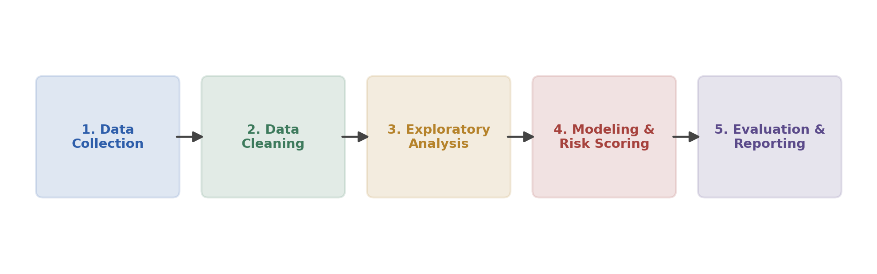
Figure 1. Five-stage methodology for the Climate Risk & Business Impact Analyzer.

3.1 Data Collection
Climate variables (temperature, precipitation, humidity) are pulled from the NASA POWER API for each facility's coordinates. Air quality readings (PM2.5, PM10, NO2) are pulled from the OpenAQ API using an R-based ingestion script, since OpenAQ's R client offers convenient station-matching utilities. Forward-looking climate projections are pulled from World Bank CCKP data staged on AWS S3, read into Python using xarray for the underlying NetCDF/gridded format. Facility metadata (name, location, sector, coordinates) is maintained as a small reference table.

3.2 Data Cleaning
- Standardise all timestamps to a common facility-month granularity.
- Convert units to a consistent system (e.g. metric, °C, µg/m³).
- Handle missing values: interpolate short gaps; flag facilities with persistent data gaps rather than silently dropping them.
- Join the R-derived OpenAQ dataset and the Python-derived NASA/CCKP dataset on facility ID and month.

3.3 Exploratory Data Analysis (EDA)
- Visualise temperature and precipitation trends per facility over time.
- Map all 12 facilities with an overlay of regional air-quality severity (geopandas / folium).
- Examine correlations between climate exposure and air-quality indicators.
- Identify outlier facilities that warrant closer inspection before scoring.

3.4 Modeling & Risk Scoring
Because the goal is an interpretable business metric rather than a predictive forecast, the core “model” is a composite risk index: each facility's climate, air-quality, and projected-change indicators are normalised and combined into a weighted score using scikit-learn preprocessing utilities. Weights are chosen deliberately and documented, with a sensitivity check to show how the ranking changes under alternative weightings.

3.5 Evaluation & Reporting
- Sanity-check the risk score against known high-exposure regions to confirm it behaves sensibly.
- Use SHAP or simple decomposition to show which factors (heat, air quality, projected change) drive each facility's score.
- Package the results into an interactive Streamlit/Dash dashboard with facility-level drill-down.

3.6 Data Architecture
The diagram below summarises how the three source systems feed into the two ingestion pipelines (R for OpenAQ, Python for NASA POWER and CCKP), which converge into a single merged dataset that powers the dashboard.
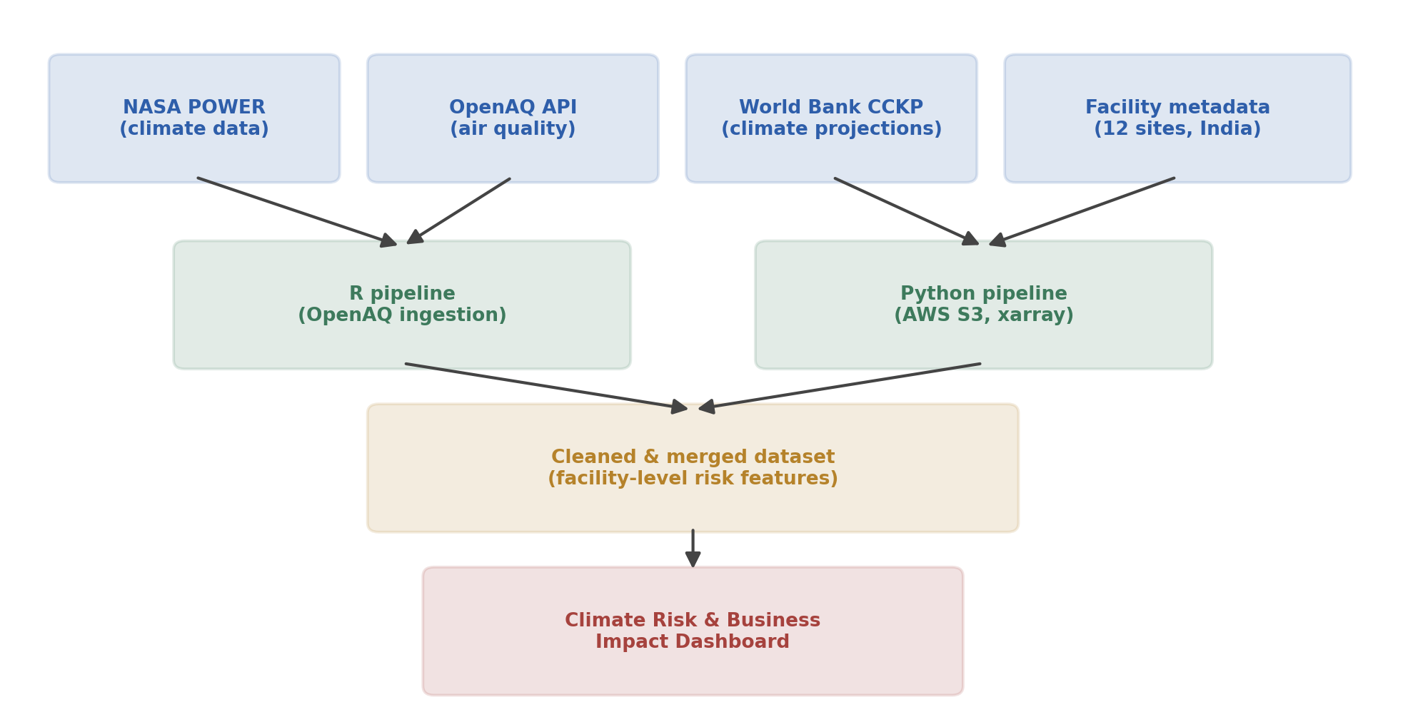
Figure 2. Data architecture from source APIs to the final dashboard.

4. Timeline & Tools

4.1 Timeline (≈ 34 hours total)
The project is planned as a sequential, single-contributor effort spread across roughly one to two weeks of part-time work. The chart below shows the planned hour allocation per stage.
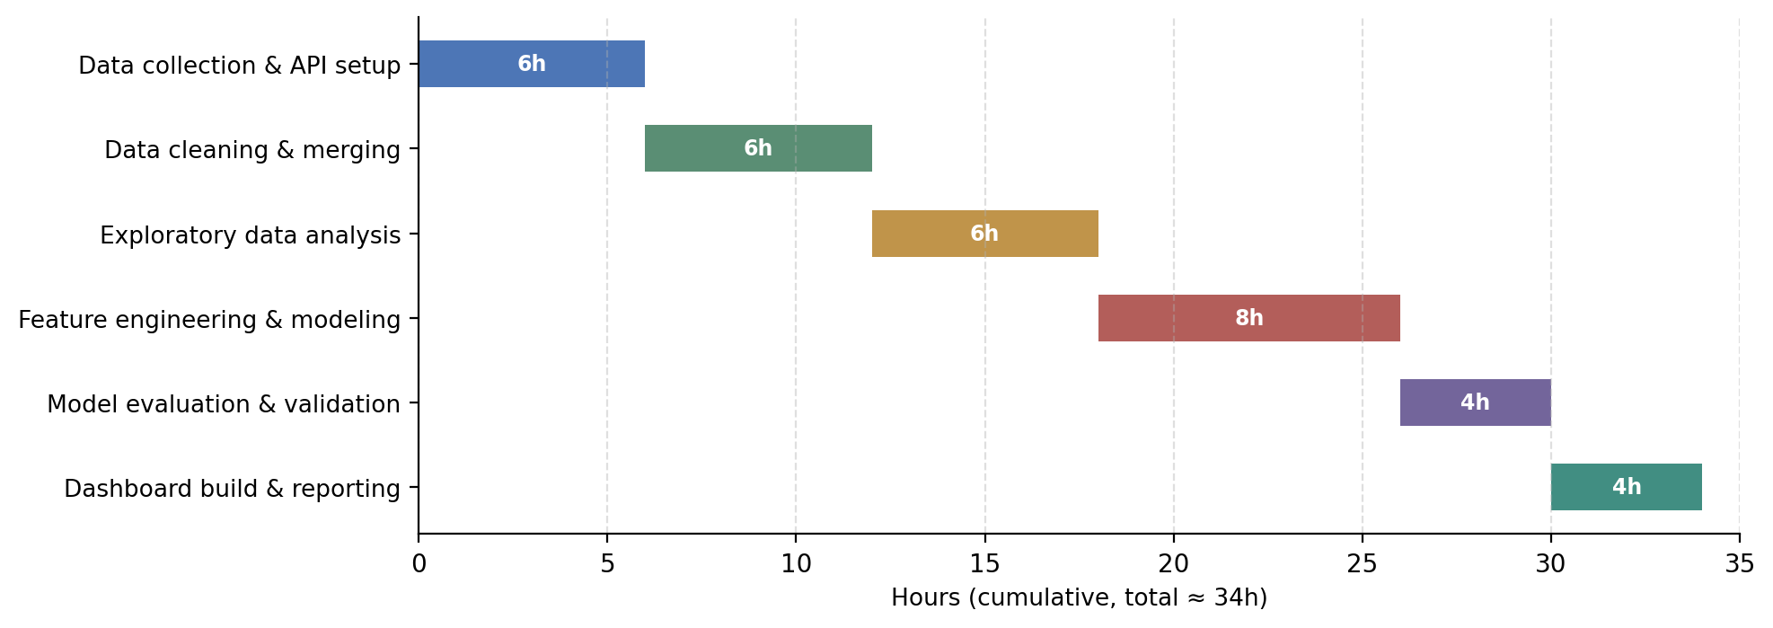
Figure 3. Planned effort allocation across project stages (≈ 34 hours).
- Data collection & API setup — 6 hours: register for API access, write and test collection scripts for all three sources.
- Data cleaning & merging — 6 hours: unit standardisation, missing-value handling, joining R and Python outputs.
- Exploratory data analysis — 6 hours: trend charts, facility maps, correlation checks.
- Feature engineering & modeling — 8 hours: build the composite risk index, test alternative weightings.
- Model evaluation & validation — 4 hours: sanity checks, SHAP-based driver analysis.
- Dashboard build & reporting — 4 hours: assemble the interactive dashboard and final write-up.

4.2 Tools & Libraries
Stage | Python Library / Tool | Purpose
Data collection | requests, R httr, boto3 (AWS S3) | Pull data from NASA POWER, OpenAQ, and World Bank CCKP APIs; access S3-hosted climate rasters
Data handling | pandas, NumPy, xarray | Merge tabular and gridded (NetCDF) climate data into a single facility-level dataset
Data cleaning | pandas, missingno | Handle missing values, standardise units, de-duplicate facility records
Exploratory analysis | matplotlib, seaborn, plotly | Visualise trends, correlations, and facility-level risk distributions
Geospatial work | geopandas, folium | Map the 12 facilities and overlay regional climate risk layers
Modeling | scikit-learn | Build a composite risk-scoring model (e.g. weighted index or regression) per facility
Evaluation | scikit-learn.metrics, SHAP | Validate the risk score and explain which factors drive it
Dashboard / reporting | Streamlit or Dash, Plotly | Turn the analysis into an interactive Climate Risk & Business Impact dashboard
Environment & workflow | Jupyter Notebook, Git/GitHub, virtualenv | Reproducible development, version control, and collaboration

5. Expected Outcomes & Challenges

5.1 Expected Outcomes
- A ranked list of the 12 facilities by composite climate risk score, with clear drivers for each.
- An interactive dashboard that lets a business stakeholder filter by facility and see the underlying climate, air-quality, and projection data behind each score.
- A documented, reusable data pipeline that could be re-run with updated data or extended to additional facilities in future work.

5.2 Benefits of This Approach
- Replaces qualitative, anecdotal risk assessment with a transparent, reproducible score.
- Combines multiple public data sources, demonstrating an end-to-end multi-source data science workflow.
- Keeps the modeling stage interpretable, which matters for a business audience that needs to trust and act on the output.

5.3 Anticipated Challenges & Mitigation
Potential Challenge | Likely Cause | Mitigation Strategy
Inconsistent data formats across sources | NASA POWER, OpenAQ, and CCKP use different resolutions, units, and time granularities | Build a standardisation layer early; document unit conversions and align all data to a common facility-month grid
Missing or sparse air-quality readings near some facilities | OpenAQ station coverage varies across Indian regions | Use nearest-station interpolation or satellite-derived proxies; flag low-confidence facilities in the dashboard
API rate limits or downtime | Free-tier public APIs can throttle or go offline | Cache raw pulls locally after the first successful call; add retry logic with exponential backoff
Subjectivity in the composite risk score | Weighting climate, air quality, and exposure factors involves judgment calls | Document the weighting rationale explicitly; run a sensitivity analysis showing how rankings shift under different weights
Scope creep beyond the 30-35 hour budget | Temptation to add more facilities, models, or dashboard features | Lock the Week 1 scope in writing (Section 2) and treat extensions as a documented “future work” list, not mid-project additions

6. Conclusion
This plan lays out a complete, scoped strategy for building the Climate Risk & Business Impact Analyzer using Python (with R for one ingestion step): a clear problem and motivation, well-defined objectives and boundaries, a five-stage methodology supported by a documented data architecture, a realistic 34-hour timeline, and an honest accounting of the challenges most likely to arise. With this plan in place, the following weeks can move directly into implementation — data collection, cleaning, analysis, and dashboard development — without needing to re-litigate scope or approach along the way.

