WEEK 3: PYTHON-BASED MACHINE LEARNING MODEL DEVELOPMENT & EVALUATION PLAN
Predicting Facility-Level Climate Risk Category with Machine Learning
A structured plan covering problem definition, preprocessing, model selection, training, evaluation, and deployment considerations
Prepared by: Khushi Mahato
Data Science Program — Week 3 Deliverable
August 2026

1. Problem Definition

1.1 The Problem
Building on the Climate Risk & Business Impact Analyzer from Week 1, this plan targets a concrete, hypothetical machine learning task: predicting a facility's climate risk category (Low / Medium / High) from its climate, air-quality, and operational features, rather than relying solely on a manually-weighted composite score. This reframes the earlier project's risk index as a supervised multi-class classification problem, where historical data — once a facility's realised risk category is known in hindsight (e.g. based on downtime incidents or damage reports) — can train a model to flag high-risk facilities earlier and more consistently.

1.2 Justification
- A classification model can combine many correlated signals (temperature, precipitation, air quality, historical downtime) more consistently than a manually-tuned weighted formula.
- Once trained, the model generalises to new or updated facility data without re-deriving weights by hand each time.
- Risk category (Low/Medium/High) is more directly actionable for business stakeholders than a raw numeric score, and maps cleanly to a classification framing.
- This is a realistic, tabular-data problem well suited to the classical ML techniques covered in this plan, without requiring deep learning or unstructured data.

2. Data Preprocessing
Before any model can be trained, the raw facility-level dataset (climate variables, air-quality readings, climate projections, and a historical risk-category label) needs to be cleaned, standardised, and transformed into model-ready features.

2.1 Data Cleaning
- Remove or correct duplicate facility-month records.
- Validate ranges (e.g. temperature and humidity within physically plausible bounds) and flag sensor/API anomalies.
- Confirm the target label (risk category) is consistently defined across all facilities and time periods.

2.2 Normalization & Feature Engineering
- Scale numeric features (temperature, AQI, rainfall) so no single feature dominates distance- or gradient-based models.
- Engineer derived features: rolling averages (e.g. 3-month mean temperature), year-over-year change, and interaction terms (e.g. heat × air quality).
- Encode facility sector or region as categorical features where relevant to risk.

2.3 Feature Selection
- Use correlation analysis (building on the Week 2 EDA framework) to identify and drop redundant, highly-correlated features.
- Use a quick baseline model's feature-importance output to rank features and drop consistently low-importance ones.

2.4 Preprocessing Challenges & Solutions
Challenge | Solution
Missing values | Impute numeric features with median (robust to outliers) or use model-based imputation (e.g. KNNImputer); impute categorical features with the mode or an explicit “Missing” category
Class imbalance (classification) | Use stratified train/test splits; apply resampling (SMOTE, undersampling) or class-weighting in the model rather than accuracy alone as the metric
Inconsistent feature scales | Apply StandardScaler or MinMaxScaler for scale-sensitive models (SVM, logistic regression, KNN); tree-based models are scale-invariant and can skip this
Categorical variables | One-hot encode low-cardinality categories; use target or frequency encoding for high-cardinality categories to avoid a dimensionality explosion
Irrelevant or redundant features | Use correlation analysis and feature-importance scores (from a quick tree-based model) to drop low-value features before final training
Data leakage | Fit all preprocessing steps (scalers, encoders, imputers) only on the training fold, never on validation/test data, using a scikit-learn Pipeline to enforce this automatically

3. Model Selection & Training
Several classical ML approaches are worth considering for this tabular, multi-class classification problem. The table below compares candidates on their strengths and limitations for this specific use case.
Candidate Model | Strengths | Limitations
Logistic / Linear Regression | Fast, interpretable, good baseline; coefficients explain feature impact | Assumes linear relationships; struggles with complex, non-linear patterns
Decision Tree | Interpretable, handles non-linear relationships, no scaling required | Prone to overfitting; unstable to small data changes
Random Forest (ensemble) | Reduces overfitting via bagging, handles non-linearity, robust to outliers | Less interpretable than a single tree; slower to train and predict
Gradient Boosting (e.g. XGBoost) | Often highest raw accuracy on tabular data; handles complex interactions | More hyperparameters to tune; higher risk of overfitting if untuned; slower training
Support Vector Machine | Effective in high-dimensional spaces; strong with clear margin of separation | Slower on large datasets; sensitive to feature scaling and kernel choice

3.1 Chosen Approach
A Random Forest classifier is proposed as the primary model, with Gradient Boosting (XGBoost) as a stretch goal for comparison. Random Forest is chosen as the primary model because it handles non-linear relationships and feature interactions well, is naturally robust to outliers and unscaled features (a good fit given the mixed climate/air-quality/operational feature set), and offers built-in feature-importance scores that support interpretability for business stakeholders — an important requirement given the project's non-technical audience. Logistic Regression is retained as an interpretable baseline to confirm the more complex model is actually adding value.

3.2 Training Process
The end-to-end workflow — from problem definition through to deployment and monitoring — is summarised in the diagram below.
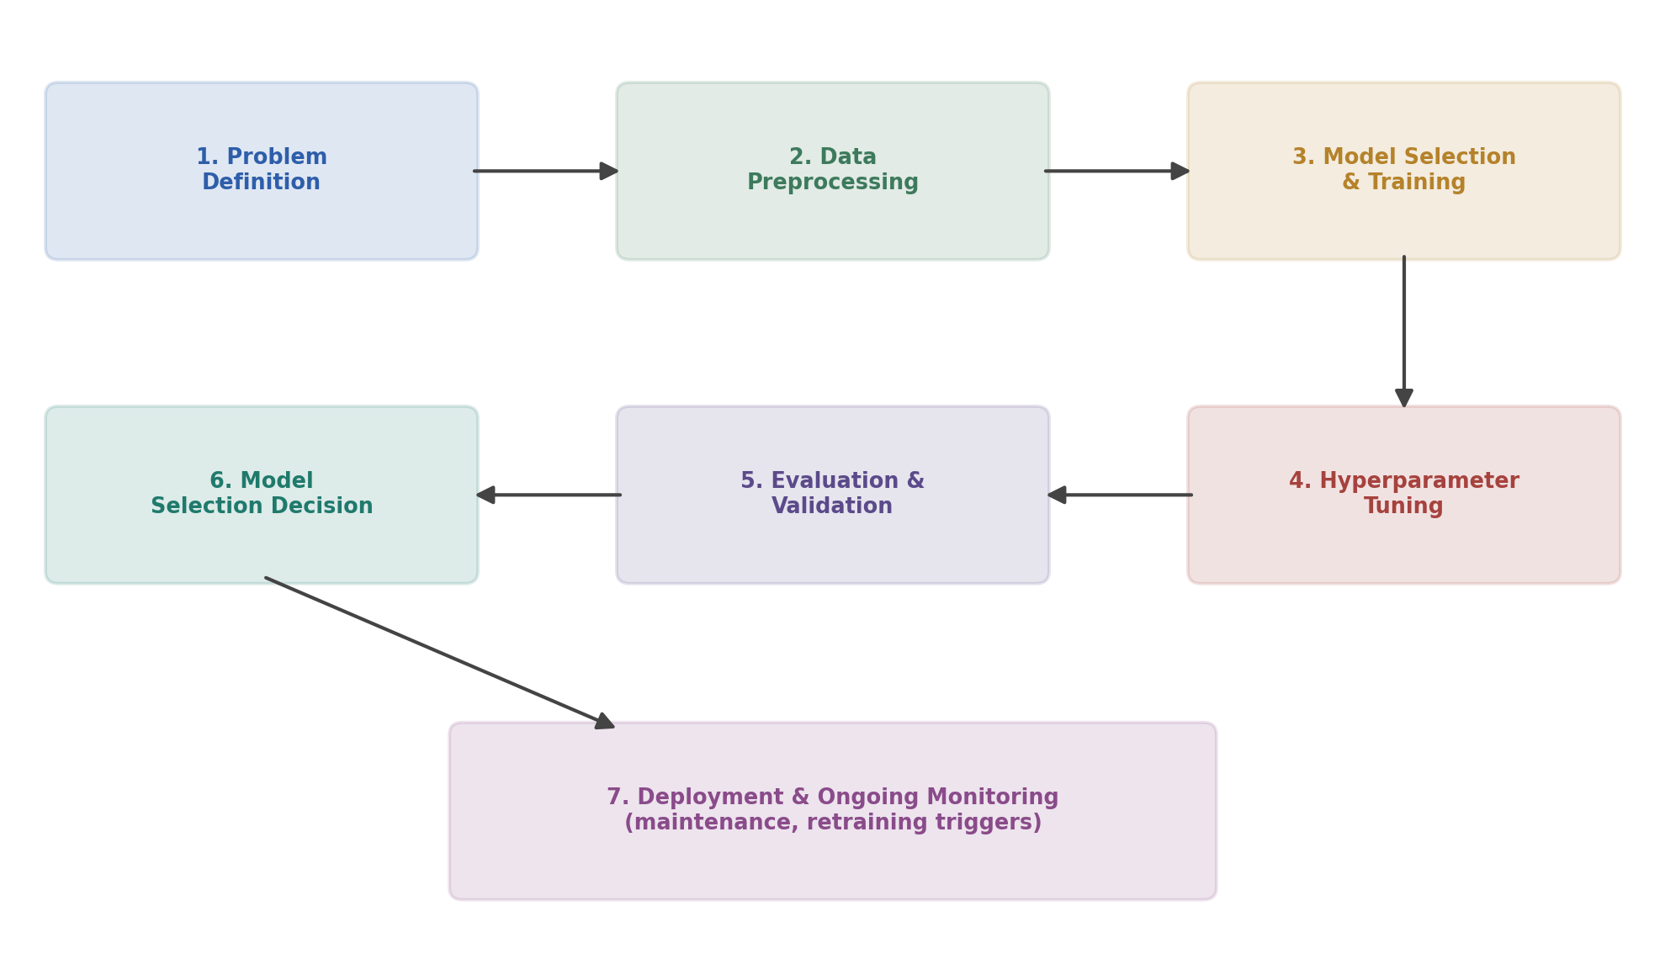
Figure 1. End-to-end machine learning workflow for the risk-category classifier.
- Split the dataset into training (60%), validation (20%), and test (20%) sets, stratified by risk category to preserve class balance across splits.
- Fit preprocessing steps (scaling, encoding, imputation) on the training data only, using a scikit-learn Pipeline to prevent data leakage into validation/test sets.
- Train each candidate model on the training set and compare initial validation performance before committing to one for tuning.

3.3 Hyperparameter Tuning
- Use GridSearchCV or RandomizedSearchCV over key Random Forest parameters: n_estimators, max_depth, min_samples_split, and max_features.
- Tune against cross-validated performance on the training set only — never against the held-out test set — to avoid overfitting to test data.
- Favor RandomizedSearchCV over an exhaustive grid search when the parameter space is large, to keep tuning time reasonable within the ~34-hour budget.

4. Evaluation Metrics & Validation Strategy
Because this is a multi-class classification problem where misclassifying a High-risk facility as Low-risk is more costly than the reverse, evaluation goes beyond simple accuracy. The diagram below summarises the confusion-matrix-based metrics used to evaluate the model, shown here in their binary form for clarity; the same logic extends to the three-class case via a one-vs-rest breakdown per class.
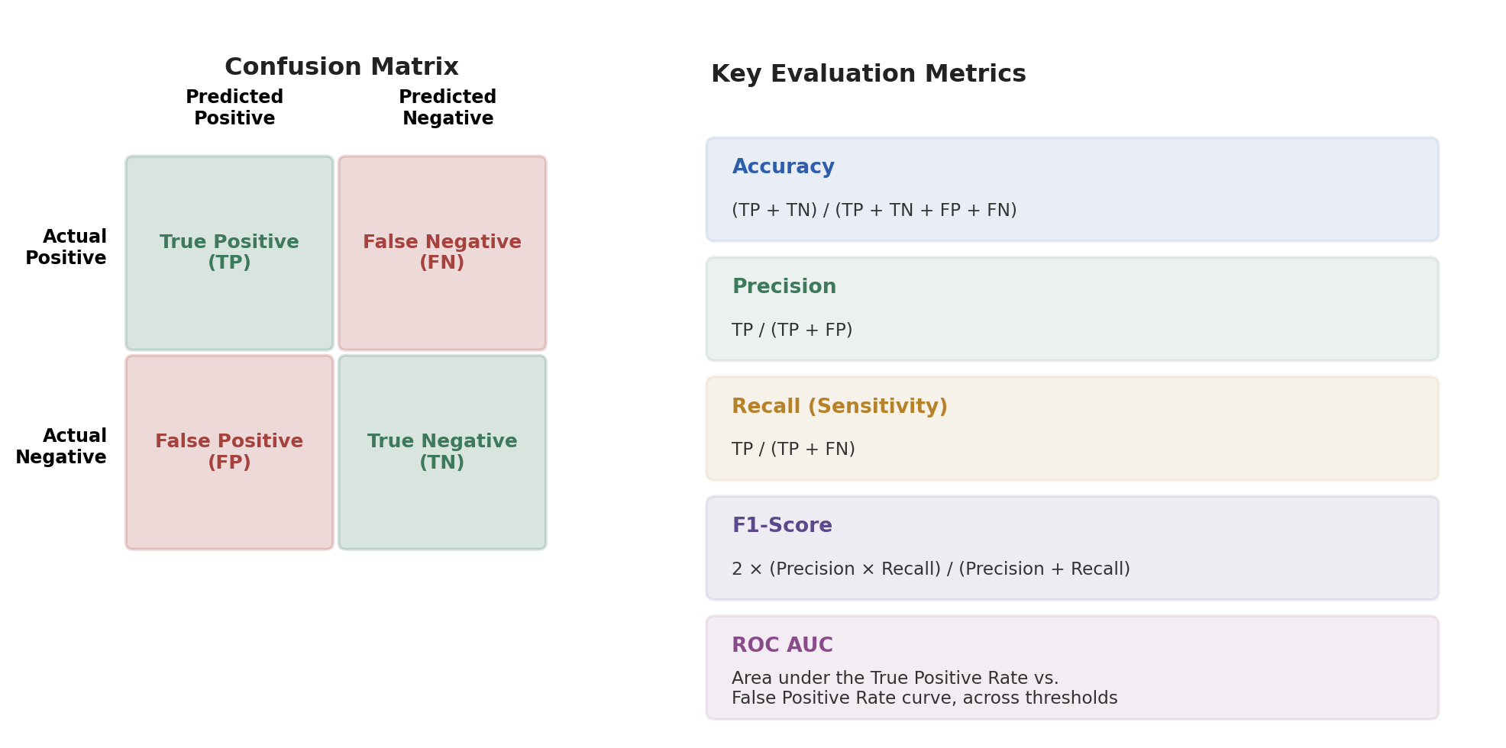
Figure 2. Confusion matrix and derived evaluation metrics.

4.1 Metric Justification
- Accuracy — a useful overall summary, but insufficient alone if risk categories are imbalanced (most facilities may be Low/Medium risk, with High-risk facilities rarer).
- Precision — important for the High-risk class specifically: a false “High-risk” alarm wastes business attention and resources.
- Recall — arguably the most important metric for the High-risk class: missing a genuinely high-risk facility (a false negative) carries the greatest business cost.
- F1-Score — balances precision and recall per class, useful for comparing models when both false positives and false negatives matter.
- ROC AUC (one-vs-rest, per class) — evaluates how well the model ranks facilities by risk across all classification thresholds, not just the default one.

4.2 Validation Strategy
To ensure the reported performance is robust and not an artifact of one lucky data split, this plan uses stratified k-fold cross-validation within the training set, illustrated below.
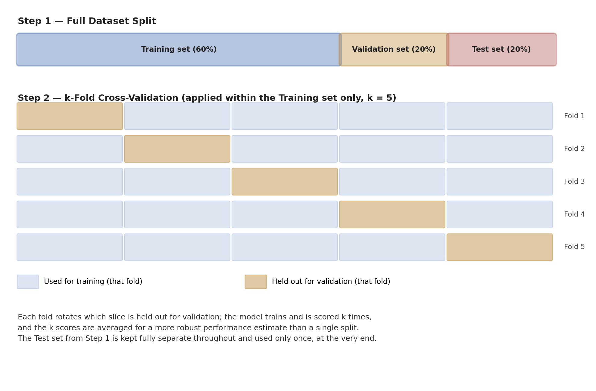
Figure 3. Train/validation/test split and 5-fold cross-validation strategy.
- Stratified 5-fold cross-validation preserves the proportion of each risk category in every fold, which matters given the likely class imbalance.
- The held-out test set (20%) is touched only once, after model selection and tuning are finalised, to give an unbiased estimate of real-world performance.
- Cross-validated metric scores are reported as mean ± standard deviation across folds, not a single number, to communicate the model's stability alongside its accuracy.

5. Model Deployment & Maintenance (Optional)
While full production deployment is outside the scope of this plan, it is worth conceptualising how the model would be maintained once in use, since a model's performance degrades over time as underlying conditions change (concept drift).
- Package the trained model and its preprocessing pipeline together (e.g. with joblib) so predictions on new data always use the exact same transformations as training.
- Serve predictions through a lightweight API (e.g. FastAPI) that the Week 1 dashboard could call to refresh facility risk categories on a schedule.
- Log every prediction alongside the input features, to support later auditing and retraining.
- Set a monitoring cadence (e.g. quarterly) to recompute validation metrics on newly available labeled data, and define a retraining trigger — for example, if recall on the High-risk class drops below an agreed threshold.
- Version each trained model (e.g. via MLflow or simple timestamped artifacts) so any performance regression can be traced to a specific retraining event and rolled back if needed.

6. Conclusion
This plan lays out a complete strategy for developing and evaluating a machine learning model to classify facility-level climate risk: a well-justified problem framing, a thorough preprocessing plan addressing realistic data challenges, a comparison of candidate models with a clear, reasoned choice, a validation strategy built on stratified cross-validation and a held-out test set, and a conceptual path to deployment and ongoing monitoring. With this plan in place, the next stage of work can move directly into implementation against a real dataset, using the exact structure defined here.

