WEEK 2: EXPLORATORY DATA ANALYSIS (EDA) & VISUALIZATION FRAMEWORK DESIGN
A Reusable EDA and Visualization Framework for Any Dataset
A dataset-agnostic framework outlining the techniques, visualizations, and Python libraries used to explore and understand data before modeling
Prepared by: Khushi Mahato
Data Science Program — Week 2 Deliverable
August 2026

1. Introduction to EDA
Exploratory Data Analysis (EDA) is the process of investigating a dataset — before any modeling begins — to understand its structure, spot patterns, detect anomalies, and test initial assumptions using summary statistics and visualizations. Where formal statistical modeling asks “what can we predict?”, EDA asks a more foundational question: “what does this data actually look like, and can we trust it?”
EDA matters because every downstream step — feature engineering, model selection, evaluation — inherits whatever assumptions and errors are baked into the raw data. Skipping EDA risks building a model on data with hidden missing values, skewed distributions, or mislabeled outliers, all of which quietly degrade results in ways that are hard to trace back after the fact. A disciplined EDA phase also builds intuition: it is often where the most useful, non-obvious insights are found, well before any machine learning model is trained.
This framework is written to be dataset-agnostic — it can be applied to a sales dataset, a climate dataset, a healthcare dataset, or any other tabular data source. It outlines a consistent, repeatable process (Section 2), a structured approach to choosing visualizations (Section 3), the Python tools that support each step (Section 4), and a plan for turning findings into a clear report (Section 5).

2. Data Exploration Techniques
EDA is best approached as a staged process, moving from understanding individual variables to understanding how they relate to one another. The diagram below outlines the seven-step process this framework follows.
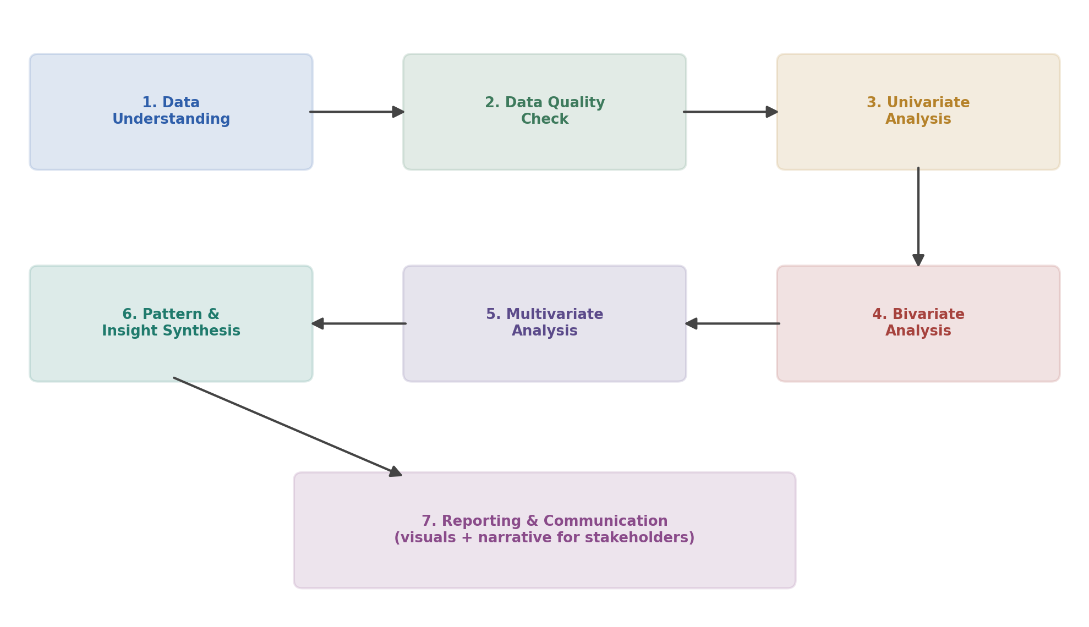
Figure 1. A repeatable seven-step EDA process, applicable to any dataset.

2.1 Data Understanding
- Check the shape of the dataset (rows, columns) and the data type of each column (numeric, categorical, datetime, text).
- Identify which columns are identifiers, features, and (if applicable) target variables.
- Review summary statistics (mean, median, min, max, standard deviation) for a first impression of scale and range.

2.2 Handling Missing Data
- Quantify missingness per column (count and percentage) rather than assuming it is negligible.
- Distinguish between data missing at random versus systematically (e.g. a sensor that consistently fails under one condition).
- Choose a treatment per case: drop rows/columns with excessive missingness, impute with mean/median/mode, or use model-based imputation — and document the choice, since it affects every later stage.

2.3 Handling Outliers
- Detect outliers visually (box plots, scatter plots) and statistically (Z-score, IQR method).
- Investigate before removing — an outlier may be a data entry error, or it may be the most important data point in the set (e.g. a genuine extreme weather event).
- Decide per case whether to cap, transform (e.g. log scale), remove, or explicitly flag and retain outliers.

2.4 Univariate Analysis
Examines one variable at a time to understand its distribution, central tendency, and spread. For numeric variables this typically means histograms, box plots, and summary statistics; for categorical variables, frequency counts and bar charts.

2.5 Bivariate Analysis
Examines the relationship between two variables — numeric-vs-numeric (scatter plots, correlation coefficients), numeric-vs-categorical (box plots grouped by category), or categorical-vs-categorical (cross-tabulations, grouped bar charts).

2.6 Multivariate Analysis
Examines interactions among three or more variables simultaneously, using techniques such as correlation heatmaps, pair plots, and dimensionality reduction (e.g. PCA) to reveal structure that is invisible when looking at variables two at a time.

3. Visualization Strategies
Choosing the right chart depends on how many variables are being examined at once and what type they are. The diagram below organises the main plot types used in this framework by that criterion.
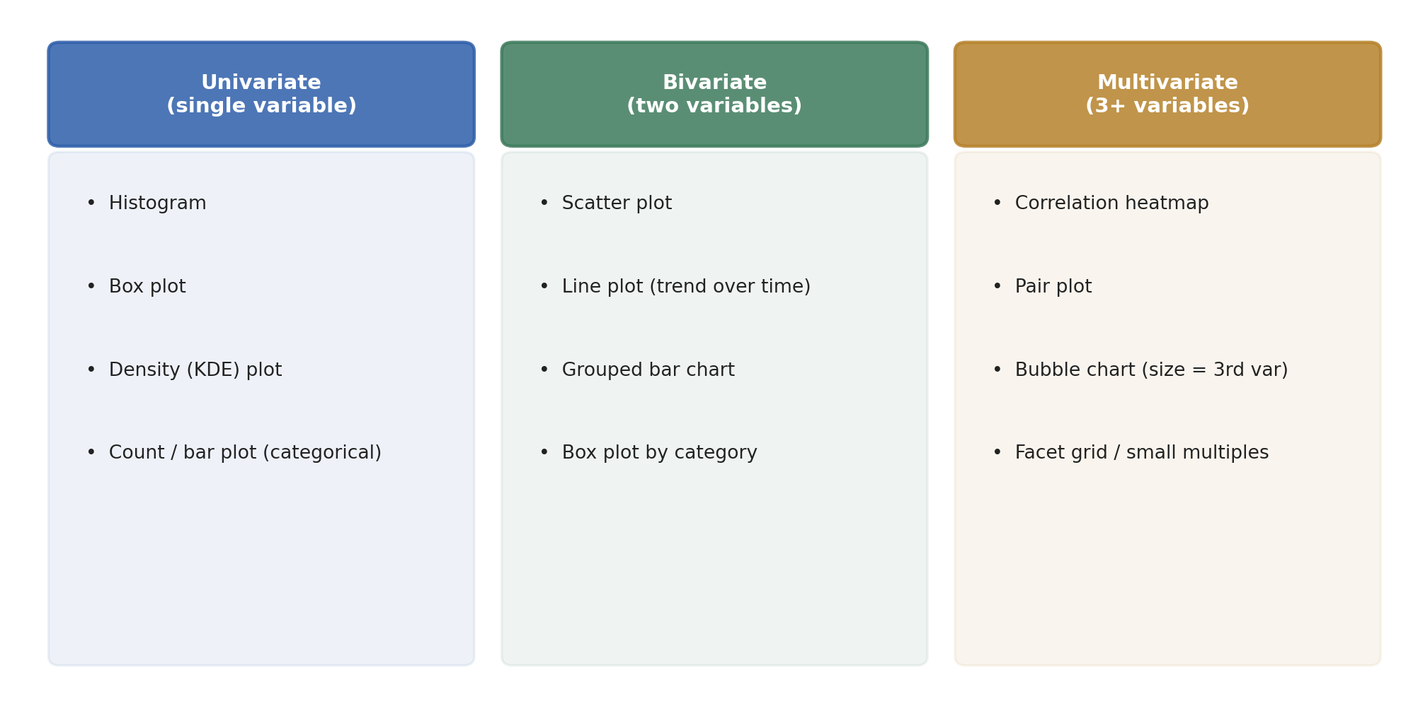
Figure 2. Visualization selection guide, grouped by number of variables analysed.
The table below expands on when each plot type is appropriate and what it is intended to reveal.
Plot Type | Best For | What It Reveals
Histogram | One numeric variable | Shape of the distribution — skew, modality, spread
Box plot | One numeric variable (by category) | Median, quartiles, and outliers at a glance
Bar / count plot | One categorical variable | Frequency of each category
Scatter plot | Two numeric variables | Relationship, direction, and strength of association; clusters or outliers
Line plot | A variable over time | Trends, seasonality, and turning points
Heatmap | Many numeric variables at once | Correlation strength/direction across the whole feature set
Pair plot | 3–6 numeric variables | All pairwise scatter relationships and individual distributions in one grid
Bubble chart | Three numeric variables | A third dimension (bubble size) layered onto a scatter plot

As a concrete example of a multivariate technique, the figure below shows a correlation heatmap built on illustrative sample data — this is the kind of view that would be generated once a real dataset's numeric features are available, to quickly spot which variables move together.
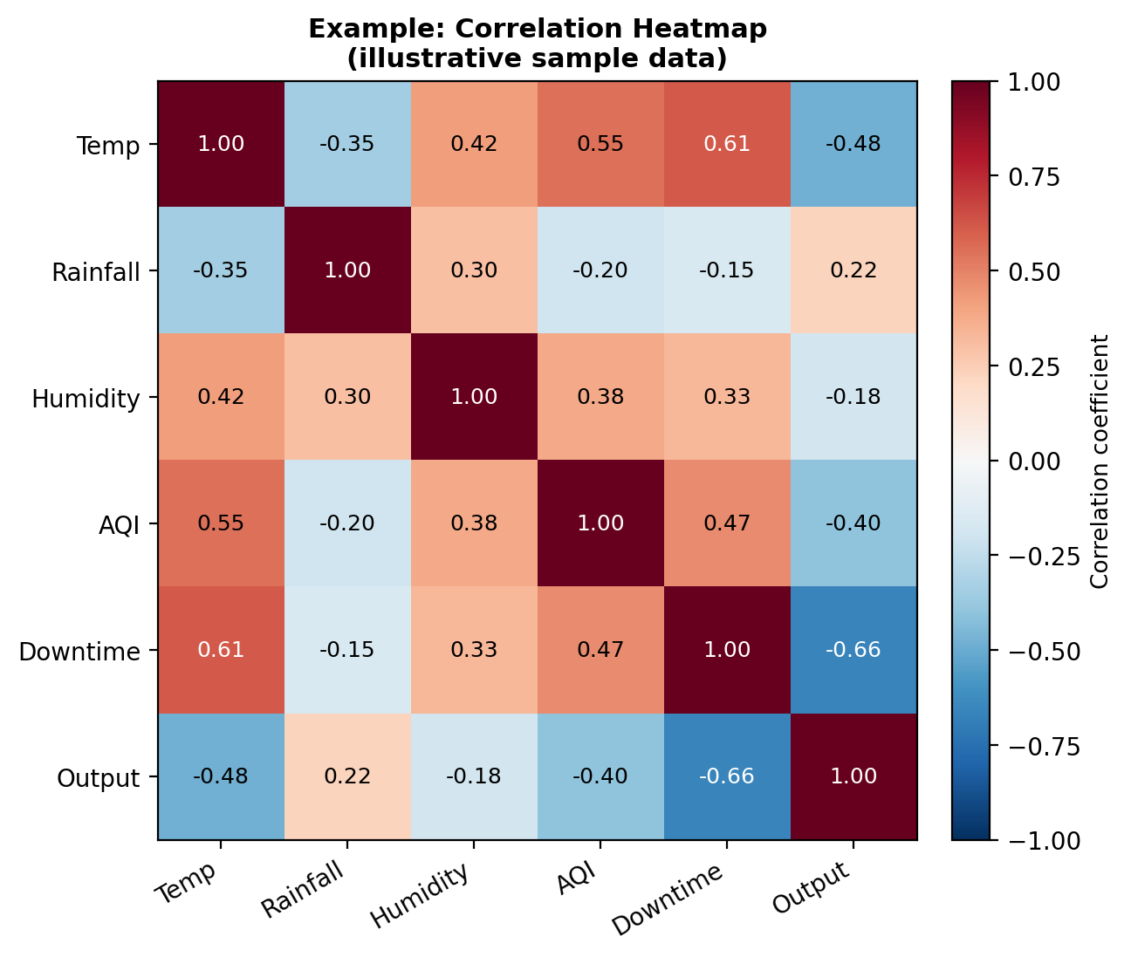
Figure 3. Example correlation heatmap on illustrative sample data, showing the intended output of a multivariate visualization step.

4. Tools and Libraries
The framework relies on a standard Python data-analysis stack. Each tool plays a distinct role, summarised below.
Library / Tool | Category | Role in the EDA Process
pandas | Data handling | Load, inspect, filter, group, and summarise data (.info(), .describe(), .isnull(), .groupby()); the backbone of every EDA notebook
NumPy | Numerical computing | Array operations, statistical calculations (mean, std, percentiles), and support for pandas/other libraries
matplotlib | Visualization (base) | Fine-grained control over plots — histograms, scatter plots, line charts; the foundation seaborn is built on
seaborn | Visualization (statistical) | Higher-level, styled statistical plots — heatmaps, pair plots, box plots — with less code than raw matplotlib
plotly | Visualization (interactive) | Interactive, zoomable charts useful for dashboards or exploratory notebooks where hover-detail matters
missingno | Missing data visualization | Quickly visualise the pattern and extent of missing values across a dataset
scipy.stats | Statistical testing | Hypothesis tests (e.g. correlation significance, normality tests) to support EDA findings
Jupyter Notebook | Environment | Interactive, cell-by-cell exploration with inline plots — ideal for iterative EDA work

5. Reporting and Documentation
EDA is only useful if its findings reach the people who need them. This framework plans for a short, structured report or notebook with the following sections:
- Dataset Overview — source, size, time period, and a one-paragraph description of what the data represents.
- Data Quality Summary — missing value rates, outlier handling decisions, and any data cleaning performed, so results are reproducible and their limitations are transparent.
- Key Distributions — the most important univariate findings, illustrated with histograms/box plots and one or two sentences of interpretation each.
- Relationships & Patterns — the most important bivariate/multivariate findings (e.g. strong correlations, clusters, trends), illustrated with scatter plots and heatmaps.
- Anomalies & Caveats — anything unusual found in the data that a downstream modeler or stakeholder needs to know about.
- Summary of Insights — a short, plain-language recap of the 3–5 most important takeaways, written for a non-technical audience.
Each section pairs a visualization with one or two sentences of written interpretation — a chart alone rarely speaks for itself to a non-technical stakeholder. Where the audience is technical, the underlying Jupyter Notebook itself (with markdown commentary between code cells) can serve as the report; where the audience is a business stakeholder, findings are instead condensed into a short slide deck or one-page summary that leads with the insight, not the method.

6. Conclusion
This framework lays out a complete, dataset-agnostic approach to Exploratory Data Analysis: a repeatable seven-step process, a clear method for choosing the right visualization for the question at hand, the Python tools needed to execute each step, and a reporting structure that turns raw exploration into a communicable set of findings. Applied to any future dataset — including the Climate Risk & Business Impact Analyzer project from Week 1 — this framework provides a consistent starting point before any modeling work begins.

