**A**

**Project Report**

**On**

**SCHOLARSHIP MANAGEMENT SYSTEM**

**Submitted in partial fulfillment of the requirements**

**For the award of the degree of**

**Bachelor of Technology**

**in**

**Computer Science and Engineering**

**By**

**Khushi Mahto**

**(Roll No. – 2200970100089)**

**Under the Supervision of**

**Mr. Rajwantbir Singh Kohli**



**Galgotias College of Engineering & Technology**

**Greater Noida, Uttar Pradesh**

**India-201306**

**Affiliated to**



**Dr. A.P.J. Abdul Kalam Technical University**

**Lucknow, Uttar Pradesh,**

**India-226031**

**January,2024**

**GALGOTIAS COLLEGE OF ENGINEERING & TECHNOLOGY**

**GREATER NOIDA, UTTAR PRADESH, INDIA-201306**



**CERTIFICATE**

This is to certify that the project entitled Scholarship Management System submitted by Mrs. Khushi Mahto, 2200970100089 to the Galgotias college of Engineering & Technology, Greater Noida, Uttar Pradesh, affiliated to Dr. A.P.J. Abdul Kalam Technical University

Lucknow, Uttar Pradesh inpartial fulfillment for the award of Degree of Bachelor of Technology in Computer Science & Engineering is a bonafide record of the mini project carried out by them under my supervision during the year 2023-24.

**SIGNATURE SIGNATURE**

Mr. Rajwantbir Singh Kohli Dr. Vishnu Sharma

Designation Professor and Head

Dept of CSE Dept of CSE & Allied Branches

# Abstract:

# Introduction

The project Scholarship Management System is a software package developed for managing student’s scholarship details, branch details and college details. The software is very helpful to find the eligible candidates from different colleges. The project finds the eligible candidates from students list on the basis of marks and annual income.

This Project is developed using Python Tkinter and MySQL as database. Tkinter is the inbuilt python module that is used to create GUI applications. It is one of the most commonly used modules for creating GUI applications in Python as it is simple and easy to work with.

* **Proposed Solution**

Proposed System is capable of overcoming the limitations of the existing manual system. Speed and accuracy are the main advantages of the proposed system. There is no redundancy of the data. Since all the details are stored in computer searching time can be reduced. The information can be more secure because the computer systems are more secure. The proposed system eliminates the drawbacks of the existing system to a great extent and it provides security of data.

* **Advantages**

# Efficient Workflow:

# Automating the scholarship application, selection, and award processes reduces manual work, streamlining the workflow for administrators.

# Time Savings:

# Automation of repetitive tasks allows administrators to focus on more strategic aspects of scholarship management, saving time and increasing overall efficiency.

# Improved Accuracy:

# Automation reduces the likelihood of human errors in tasks like data entry,

# calculation, and communication, ensuring accurate and reliable scholarship administration.

1. **Data Security:**

Implementing secure database systems ensures the confidentiality and integrity of sensitive student and scholarship information.

1. **Cost Efficiency:**

Streamlining processes and reducing manual labor can result in cost savings for institutions and organizations managing scholarship programs.

1. **Promotion of Fairness and Equity:**

Transparent criteria and automated processes contribute to a fair and equitable distribution of scholarships, promoting diversity and inclusivity.

1. **Transparency:**

A well-designed system promotes transparency in the scholarship award process, providing stakeholders with visibility into criteria, decisions, and outcomes.

1. **Centralized Data Management:**

A centralized system helps store and manage all scholarship-related data in one place, facilitating easy retrieval and analysis.

# Table of contents:

|  |  |  |
| --- | --- | --- |
| S. No. | Title | Page No. |
| 1. | List of Tables | 6 |
| 2. | List of Figures | 7 |
| 3. | List of Abbreviations | 7 |
| 4. | List of Nomenclature | 7 |
| 5. | Chapters | 8 |
| 6. | Introduction | 9 |
| 7. | Problem Statement | 9-11 |
| 8. | Use Case Diagram | 12 |
| 9. | GUI Diagram (User Interface Diagram) | 13 |
| 10. | Data Flow Diagram | 14 |
| 11. | Testing (Test cases and Result) | 15 |
| 12. | Limitations | 16-17 |
| 13. | Future Work | 18-19 |
| 14. | Conclusion | 20 |
| 15. | References | 21 |

**List of tables:**

**Student Table**

1. Department
2. Course
3. Year
4. Semester
5. Student ID
6. Student Name
7. Class Division
8. Roll Number
9. Gender
10. Date of Birth
11. Email
12. Phone
13. Marks
14. Annual Income

# List of figures:

# Use Case Diagram

# User Interface

# Data-Flow Diagram

# List of abbreviations:

* SQL: Structure Query Language
* IDLE : Integrated Development Area
* SMS : Scholarship Management System
* GUI : Graphical User Interface

# List of nomenclature:

* Tk: Abbreviation for Tkinter, a Python library for creating graphical user

Interfaces.

* ttk : Abbreviation for themed Tkinter, an extension module that provides themed widget set for Tkinter.
* INR: Abbreviation for Indian Rupee

**Chapters:**

* 1. **Introduction**
  2. **Problem Statement**
  3. **Proposed Work**
  4. **Requirements**

Use Case Diagrams

* 1. **GUI Design**

Detailed User Interface Design

* 1. **System Design**

High-level architecture diagram

Data Flow Diagram (DFD)

* 1. **Testing**

Test Cases & Result

* 1. **Conclusion, Limitations and Future Work**

# Introduction

# A Scholarship Management System (SMS) is a sophisticated software solution designed to efficiently and transparently manage students applications for scholarship. This system serves as a central hub for handling various aspects of scholarship administration, from the application and eligibility check process. In an era where education plays a pivotal role, a well-implemented Scholarship Management System is crucial for organizations, educational institutions, and foundations seeking to streamline the scholarship lifecycle and ensure equitable distribution of financial support. The Scholarship Management System acts as a comprehensive platform that automates manual tasks, reduces administrative overhead, and enhances the overall effectiveness of data management.

# Problem Statement

# In the current educational landscape, the management of scholarship applications poses significant challenges for institutions, organizations, and foundations. The existing manual and fragmented processes contribute to inefficiencies, lack of transparency, and increased administrative burden. These challenges hinder the seamless and equitable distribution of scholarships, impacting both the administrators responsible for managing the programs and the students aspiring to receive financial support for their education.

**Key Problems**

* **Manual Workflow:**

The majority of scholarship management processes rely heavily on manual tasks, including paper-based applications, document verification, and communication. This not only consumes valuable administrative time but also increases the likelihood of errors and delays in the decision-making process.

* **Lack of Transparency:**

The absence of a centralized system results in a lack of transparency in the scholarship administration. Stakeholders, including applicants and donors, often face difficulties in understanding the criteria, application status, and selection processes, leading to frustration and confusion.

* **Data Security Concerns:**

With the increasing volume of sensitive personal information collected during the application and selection processes, there is a growing concern regarding data security. Manual handling of this data increases the risk of privacy breaches and compromises the confidentiality of applicants.

* **Diversity and Inclusivity Barriers:**

The current systems may inadvertently create barriers to diversity and inclusivity. Without a streamlined and accessible application process, certain demographic groups may face challenges in accessing and successfully applying for scholarships.

**Objective**

The objectives of a Scholarship Management System (SMS) are to enhance the efficiency, transparency, and fairness of scholarship application process. The system is designed to take applications of students for scholarship and to find the eligible students for scholarship. By enhancing the efficiency and accessibility of scholarship programs, the SMS contributes to promoting educational access and supporting students in pursuing their academic aspirations.

**Scope**

The scope of a Scholarship Management System (SMS) is broad and encompasses various aspects of scholarship application process. The system facilitates the submission of scholarship applications, allowing applicants to provide necessary information and details electronically. Automated tools within the system help verify applicant eligibility based on predefined criteria, ensuring that only qualified candidates proceed to the selection phase.

**Significance**

The Scholarship Management System (SMS) holds significant importance in the realm of education, as it addresses various challenges associated with scholarship application process and enhances the overall scholarship experience for both administrators and applicants.

**Use Case Diagram**

**View Scholarship Details of Students**

**Add Student**

**Update Information of Students**



**Delete Student**

**ADMIN**

**Search By Roll No. , Student ID , eligibility etc.**

**Check for Eligible Students.**

**GUI Diagram:**

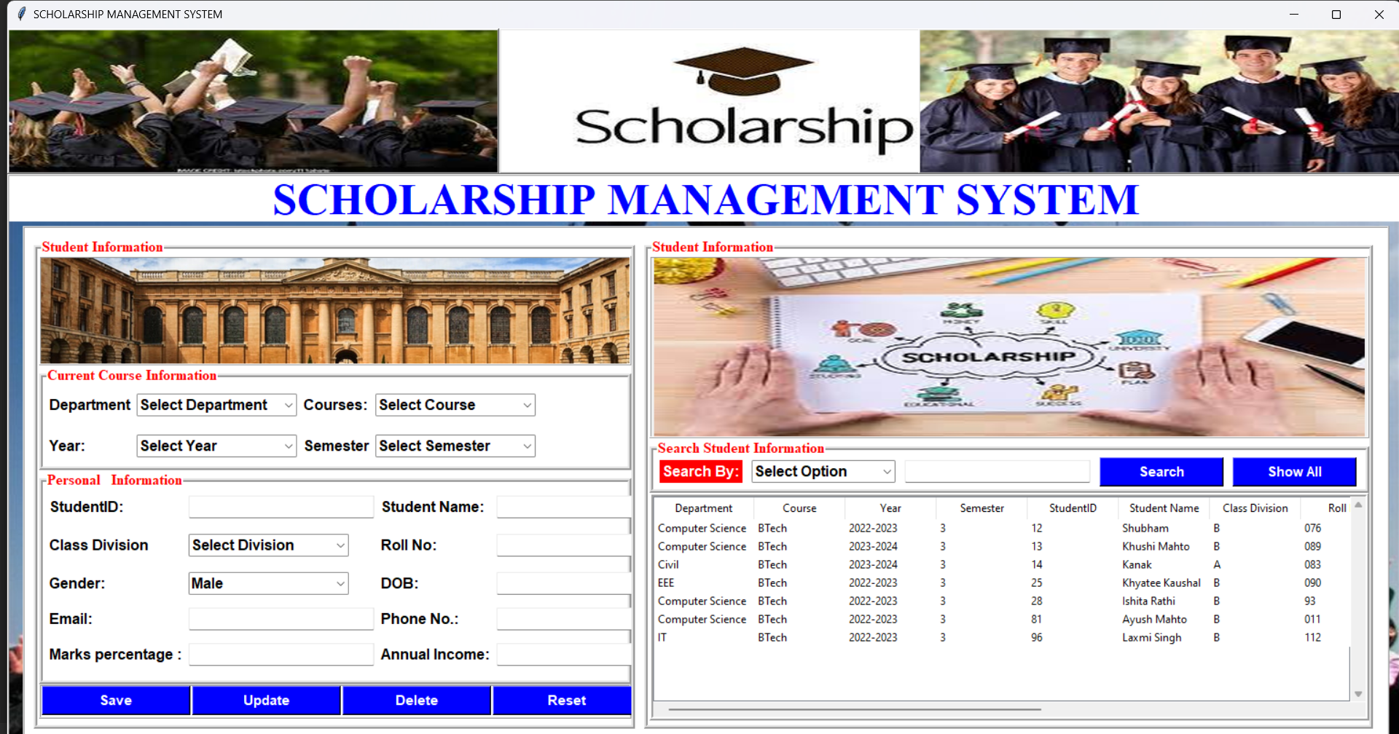

**Data Flow Diagram:**

MySQL WorkBench

Eligible Students based upon criteria

Student Applicant Details

Annual Income

Marks Percentage

# Testing:

# The criteria for Eligibility is :

# Marks percentage > 80%

# Annual Income <INR 500000

|  |  |  |  |  |  |  |  |
| --- | --- | --- | --- | --- | --- | --- | --- |
| Test Case No. | Step No. | Description | Input | Expected Result | Actual Result | Status (Passed/Failed) | Requirement No. |
| *1.* | *1* | *Marks Percentage* | *98* | *Eligible for scholarship* | *Eligible* | *Passed* | *1* |
|  | *2* | *Annual Income* | *360000* |  |  |  |  |
| *2.* | *1* | *Marks Percentage* | *66* | *Not Eligible for scholarship* | *Not Eligible* | *Passed* | *2* |
|  | *2* | *Annual Income* | *450000* |  |  |  |  |
| *3.* | *1* | *Marks Percentage* | *91* | *Not Eligible for scholarship* | *Not Eligible* | *Passed* | *3* |
|  | *2* | *Annual Income* | *1200000* |  |  |  |  |
| *4.* | *1* | *Marks Percentage* | *82* | *Eligible for scholarship* | *Eligible* | *Passed* | *4* |
|  | *2* | *Annual Income* | *250000* |  |  |  |  |
| *5.* | *1* | *Marks Percentage* | *87* | *Eligible for scholarship* | *Eligible* | *Passed* | *5* |
|  | *2* | *Annual Income* | *160000* |  |  |  |  |
| *6.* | *1* | *Marks Percentage* | *75* | *Not Eligible for scholarship* | *Not Eligible* | *Passed* | *6* |
|  | *2* | *Annual Income* | *1500000* |  |  |  |  |

**Limitations:**

While Scholarship Management Systems (SMS) offer numerous advantages, they may also have limitations and challenges that organizations need to consider. Some of the limitations include:

1. **Initial Implementation Costs:**

Implementing a robust SMS can involve significant upfront costs for development, customization, and integration with existing systems. Smaller institutions or organizations with budget constraints may find these costs challenging.

1. **Ongoing Maintenance and Upkeep:**

Maintaining and updating the system requires continuous effort and resources. Regular maintenance may include software updates, security enhancements, and adaptations to changing scholarship application requirements.

1. **Technical Requirements:**

Institutions or organizations lacking the necessary technical infrastructure and expertise may find it challenging to implement and manage a sophisticated SMS. This can result in a reliance on external vendors or hiring additional technical personnel.

1. **Resistance to Change:**

There may be resistance to adopting new technologies, especially among stakeholders who are accustomed to traditional, manual processes. Overcoming resistance and ensuring successful user adoption can be a hurdle.

1. **Limited Flexibility:**

Some SMS may lack flexibility in adapting to evolving scholarship program requirements. Changes in criteria or processes may require significant modifications to the system.

**Future work:**

The future development of a Scholarship Management System (SMS) involves addressing emerging trends, technological advancements, and evolving needs within the realm of scholarship administration. Here are potential areas for future work:

1. **Blockchain Technology Integration:**

Explore the integration of blockchain technology to enhance the security, transparency, and traceability of scholarship transactions, ensuring the authenticity and integrity of scholarship records.

1. **Smart Contracts for Disbursement:**

Utilize smart contracts on blockchain platforms for automated and transparent disbursement of scholarship funds, reducing administrative overhead and ensuring efficient fund distribution.

1. **Enhanced User Experience with AI Chatbots:**

Implement AI-driven chatbots with natural language processing capabilities to provide instant support, answer queries, and guide users through the scholarship application process, improving overall user experience.

1. **Integration with External APIs:**

Enhance integration capabilities by allowing seamless connections with external APIs, fostering interoperability with other educational systems, financial institutions, and external databases.

1. **Cybersecurity Measures:**

Strengthen cybersecurity measures to protect against evolving cyber threats, ensuring that the SMS remains resilient to potential attacks and unauthorized access.

1. **Environmental Sustainability Initiatives:**

Consider incorporating features that support environmentally sustainable practices, such as reducing paper usage, implementing eco-friendly communication channels, and promoting digital documentation.

1. **Dynamic Eligibility Criteria Framework:**

Introduce a dynamic eligibility criteria framework that allows institutions to adapt criteria based on changing program requirements, academic standards, and evolving priorities.

**Conclusion:**

In conclusion, the Scholarship Management System (SMS) stands as a transformative solution that holds immense potential in revolutionizing the landscape of scholarship administration. Through its innovative features, user-centric design, and technological prowess, the SMS addresses critical challenges and brings about positive change for administrators, applicants, and other stakeholders involved in the scholarship ecosystem.

The implementation of the SMS marks a significant shift towards efficiency and transparency in scholarship processes. By automating manual tasks, streamlining workflows, and centralizing information, the system eliminates bottlenecks, reduces administrative burdens, and enhances the overall effectiveness of scholarship programs. This not only saves time and resources but also contributes to a more equitable and accessible educational environment.

As we look towards the future of Scholarship Management Systems, the potential for further advancements is vast. Continued exploration of emerging technologies, adherence to ethical principles, and a commitment to inclusivity will be crucial in shaping the next generation of SMS. Moreover, ongoing collaboration with educational institutions, organizations, and stakeholders will be essential to align the system with evolving needs and ensure its continued relevance in the dynamic landscape of scholarship administration.

In essence, the Scholarship Management System emerges as a catalyst for positive change, facilitating a seamless and fair distribution of educational opportunities. By leveraging the power of technology and embracing continuous improvement, the SMS paves the way for a future where scholarships are administered with efficiency, transparency, and a heightened focus on empowering students to pursue their academic aspirations.

**References**

# - Tkinter: Python’s standard GUI toolkit (https://docs.python.org/3/library/tkinter.html)

# - MySQL WorkBench Manual (https://dev.mysql.com/doc/workbench/en/)