Level 6 Web Designing MODULE: 1 (HTML)

**Q1.** Are the HTML tags and elements the same thing?

**ANS.** No, HTML tags and elements are not the same thing.

HTML tags are used to hold the HTML elements.

HTML elements is used to hold the content.

HTML tags usually exist in pairs consisting of a starting and ending tag.

**Q2.** What are tags and attributes in HTML?

**Ans.** HTML attributes are used to describe the characteristic of an HTML element in detail and are found only in starting of the tag.

HTML tags are used to hold the HTML element and starts with < AND ends with >.

**Q3.** What are void elements in HTML?

**Ans.** Elements with no ending tags are known as void elements.

The following is a complete list of the void elements in HTML :

1. **<br>** 2)**<embed>**

**Q4.** What are HTML Entities?

**Ans.** An HTML entity is a piece of text ("string") that begins with an ampersand ( & ) and ends with a semicolon ( ; ). [One word statement]

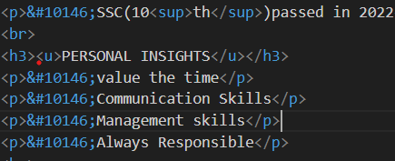

**Q5.** What are different types of lists in HTML?

**Ans.** There are 3 types of lists:

1)Ordered List:-

An ordered list starts with <ol>.

There are 5 Types od ordered list- 1)A 2)a 3)I 4)i 5)numbers[by default]

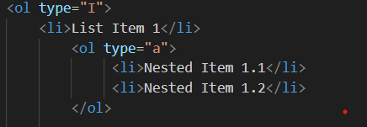

2)Unordered List:-

An Un ordered list starts with <ul>.

There are 3 types of un ordered list- 1)Circle 2) square 3)Disc[by default]

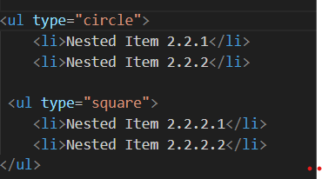

3)Define List.

**Q6.** What is the ‘class’ attribute in HTML?

**Ans.**

**Q7.** What is the difference between the ‘id’ attribute and the ‘class’ attribute of HTML elements?

**Ans.**

**Q8.** What are the various formatting tags in HTML?

**Ans.** Following are the various formatting tags in HTML:

* <b> - Bold text
* <strong> - Important text
* <i> - Italic text
* <sub> - Subscript text
* <sup> - Superscript text

**Q9.** How is Cell Padding different from Cell Spacing?

**Ans.** Cell spacing refers to the distance between the box where content is present, and cell padding refers to the space around each box.

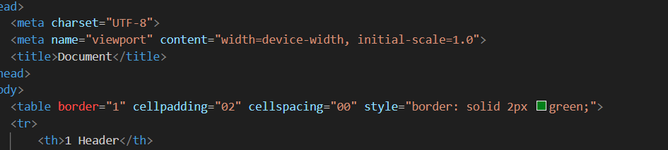

**Q10.** How can we club two or more rows or columns into a single row or column in an HTML table?

**Ans.** We can club two or more rows or columns into a single row or column in an HTML table using colspan and rowspan.

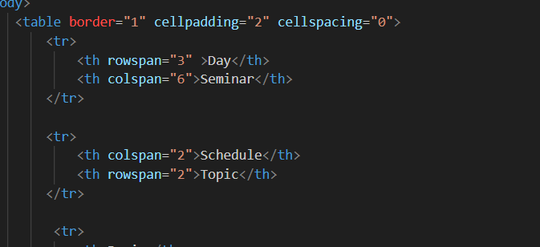

**Q11.** What is the difference between a block-level element and an inline element?

**Ans.** A block level element always has a break in between in the content [start from new line].

An inline element doesn’t break the content [starts in same line].

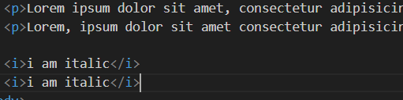

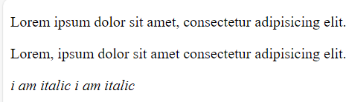

**Q12.** How to create a Hyperlink in HTML?

**Ans.** The HTML <a> tag defines a hyperlink. The most important attribute of the <a> element is the href attribute, which indicates the location of link.

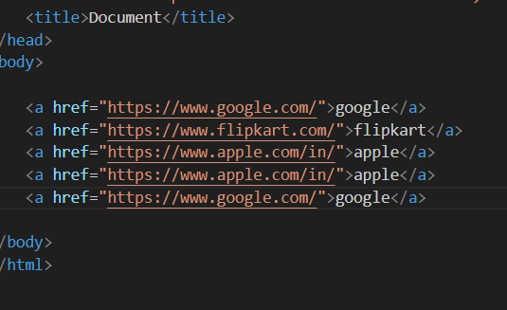

**Q13.** What is the use of an iframe tag?

**Ans.** <iframe> tag also an inline frame. <iframe> tag is used for embedding others document in HTML document.

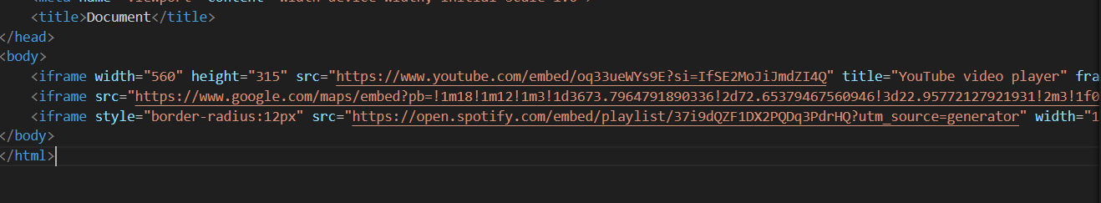

**Q14.** What is the use of a span tag? Explain with example?

Ans.

**Q15.** How to insert a picture into a background image of a web page?

**Ans.** To add a background image on an HTML element, use the HTML style attribute.

**Q16.** How are active links different from normal links?

**Ans**. An Active link is a hyperlink that is currently being interacted with the user. Whenever the user holds the mouse button on the link and not released yet or if right clicked on it, it will change its color into red, this is when the link will be in active state.

In HTML, an normal link is a hyperlink that is not yet clicked by the user. By default, the unvisited links will be in blue in color with an underline. However, we can customize the style using the CSS properties

**Q17.** What are the different tags to separate sections of text?

**Ans.** There are three tags used to separate the texts. Usually <br> tag is used to separate line of texts. Other tags are<p> tag and <blockquote> tag.

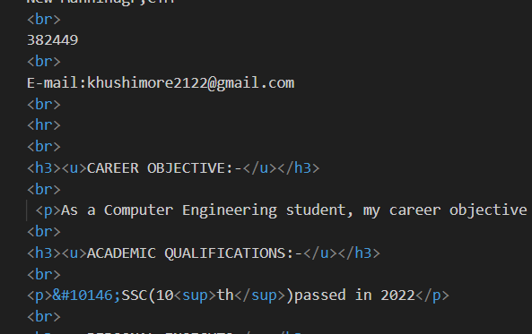

**Q18.** What is SVG?

**Ans.** SVG stands for Scalable Vector Graphics. SVG is used to define graphics for the Web. SVG has several methods for drawing paths, boxes, circles, text, and graphic images.

**Q19.** What is difference between HTML and XHTML?

**Ans.** XHTML stands for EXtensible HyperText Markup Language

XHTML is a stricter, more XML-based version of HTML

XHTML is HTML defined as an XML application

XHTML is supported by all major browsers.

HTML is the Hypertext Markup Language which is the most widely used language over the internet. HTML is used to create web pages and link them from one to another. Please note HTML is not a programming language, it is a markup language. We can use different other technologies as like CSS and javascript to give a new look to the pages developed by HTML**.**

**Q20.** What are logical and physical tags in HTML?

Ans. Logical Tags are used in HTML to display the text according to the logical styles. Following are the Logical tags commonly used in HTML.

**<abbr> <address> <pre> <strong>**

Physical Tags are used in HTML to provide actual physical formatting to the text. Following are the Physical tags commonly used in HTML.

<b> <i> <u>