Superset Id: 6390178

Week: 07

React Hands-On Lab Exercises

# Hands-On 9: ES6 Features

React App Name: cricketapp

Components:

1. ListofPlayers Component

const ListofPlayers = () => {

const players = [

{ name: "Virat", score: 85 },

{ name: "Rohit", score: 65 },

{ name: "Dhoni", score: 75 },

{ name: "Hardik", score: 45 },

{ name: "Gill", score: 90 },

{ name: "Surya", score: 55 },

{ name: "Pant", score: 78 },

{ name: "Shami", score: 60 },

{ name: "Bumrah", score: 70 },

{ name: "Jadeja", score: 88 },

{ name: "Kuldeep", score: 50 }

];

const lowScorers = players.filter(player => player.score < 70);

return (

<div>

<h2>All Players</h2>

{players.map(p => <p key={p.name}>{p.name} - {p.score}</p>)}

<h3>Players scoring below 70:</h3>

{lowScorers.map(p => <p key={p.name}>{p.name}</p>)}

</div>

);

};

2. IndianPlayers Component

const IndianPlayers = () => {

const oddPlayers = ["Virat", "Dhoni", "Gill"];

const evenPlayers = ["Rohit", "Hardik", "Pant"];

const [p1, p2, p3] = oddPlayers;

const [e1, e2, e3] = evenPlayers;

const T20 = ["Virat", "Rohit", "Bumrah"];

const Ranji = ["Gill", "Pant", "Jadeja"];

const merged = [...T20, ...Ranji];

return (

<div>

<h3>Odd Players: {p1}, {p2}, {p3}</h3>

<h3>Even Players: {e1}, {e2}, {e3}</h3>

<h3>Merged Players: {merged.join(", ")}</h3>

</div>

);

};

App.js (with Flag)

import ListofPlayers from './ListofPlayers';

import IndianPlayers from './IndianPlayers';

function App() {

const flag = true;

return (

<div>

<h1>Cricket App</h1>

{flag ? <ListofPlayers /> : <IndianPlayers />}

</div>

); }

**OUTPUT:**

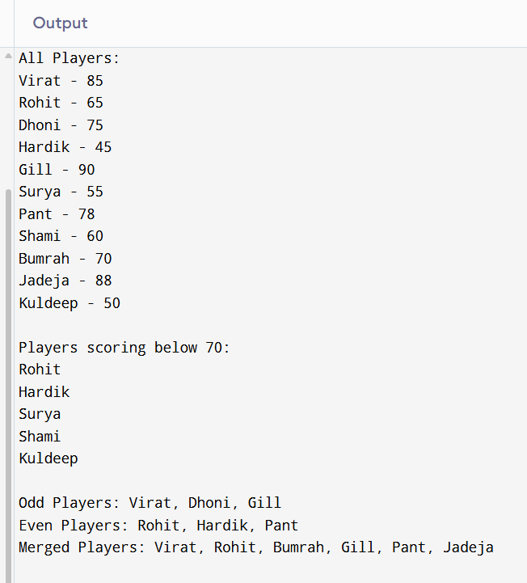

**Hands-On 10: JSX and Rendering**

React App Name: officespacerentalapp

function App() {

const officeList = [

{ name: "Office 1", rent: 55000, address: "Bangalore" },

{ name: "Office 2", rent: 70000, address: "Hyderabad" },

{ name: "Office 3", rent: 62000, address: "Mumbai" }

];

const rentColor = (rent) => rent < 60000 ? "red" : "green";

return (

<div>

<h1>Office Space Rental</h1>

<img src="office.jpg" alt="Office" width="300" />

{officeList.map((office, index) => (

<div key={index}>

<h3>{office.name}</h3>

<p style={{ color: rentColor(office.rent) }}>

Rent: {office.rent}

</p>

<p>Address: {office.address}</p>

</div>

))}

</div>

);

}

**OUTPUT:**

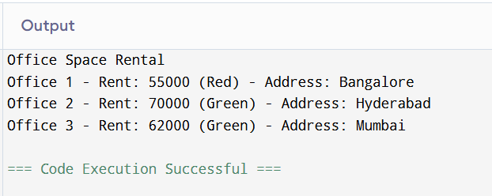

# Hands-On 11: React Events

React App Name: eventexamplesapp

import { useState } from 'react';

function App() {

const [count, setCount] = useState(0);

const increment = () => setCount(count + 1);

const sayHello = () => alert("Hello! Keep going!");

const welcome = (msg) => alert(msg);

const onPress = (e) => alert("I was clicked");

const convertToEuro = (e) => {

e.preventDefault();

const rupees = document.getElementById("rupees").value;

alert("Euro: " + rupees * 0.011);

};

return (

<div>

<h2>Counter: {count}</h2>

<button onClick={() => { increment(); sayHello(); }}>Increment</button>

<button onClick={() => setCount(count - 1)}>Decrement</button>

<button onClick={() => welcome("Welcome!")}>Say Welcome</button>

<button onClick={onPress}>Synthetic Event</button>

<h3>Currency Convertor</h3>

<input type="number" id="rupees" placeholder="Enter INR" />

<button onClick={convertToEuro}>Convert</button>

</div>

);

}

**OUTPUT:**

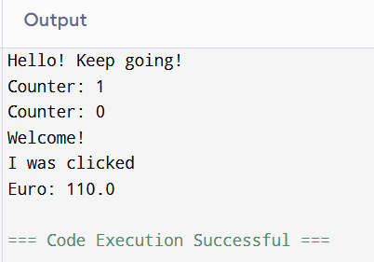

# Hands-On 12: Conditional Rendering (ticketbookingapp)

import { useState } from 'react';

function App() {

const [isLoggedIn, setIsLoggedIn] = useState(false);

const LoginPage = () => (

<div>

<h2>Welcome Guest!</h2>

<p>View flight details...</p>

</div>

);

const UserPage = () => (

<div>

<h2>Welcome User!</h2>

<p>Book your tickets here.</p>

</div>

);

return (

<div>

<button onClick={() => setIsLoggedIn(!isLoggedIn)}>

{isLoggedIn ? "Logout" : "Login"}

</button>

{isLoggedIn ? <UserPage /> : <LoginPage />}

</div>

);

}

**OUTPUT:**

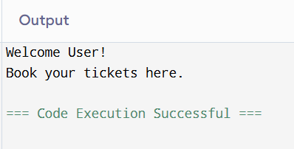

# Hands-On 13: Conditional Rendering (bloggerapp)

React App Name: bloggerapp

Components:

1. BookDetails

2. BlogDetails

3. CourseDetails

import { useState } from 'react';

const BookDetails = () => <h2>Book Details Component</h2>;

const BlogDetails = () => <h2>Blog Details Component</h2>;

const CourseDetails = () => <h2>Course Details Component</h2>;

function App() {

const [page, setPage] = useState("book");

const renderComponent = () => {

switch (page) {

case "book": return <BookDetails />;

case "blog": return <BlogDetails />;

case "course": return <CourseDetails />;

default: return <h2>Select a component</h2>;

}

};

return (

<div>

<h1>Blogger App</h1>

<button onClick={() => setPage("book")}>Book</button>

<button onClick={() => setPage("blog")}>Blog</button>

<button onClick={() => setPage("course")}>Course</button>

{renderComponent()}

</div>

);

}

**OUTPUT:**

