# XCP-ng Installation & Setup on Bare-Metal Server

## 1. Introduction

This document provides step-by-step details on installing and configuring **XCP-ng (Xen Cloud Platform – Next Generation)** on a bare-metal server. The installation was carried out on an Acer system provided by the institute, which initially had Ubuntu OS installed. XCP-ng transforms the bare-metal system into a virtualization hypervisor, enabling VM creation and centralized management through **Xen Orchestra / XCP-ng Center**.

## 2. Prerequisites

* **Bare-metal system (Acer CPU with monitor, keyboard, mouse)**
* **XCP-ng ISO** (downloaded from official [xcp-ng.org](https://xcp-ng.org))
* **USB Drive (min 8 GB)** to make a bootable installer
* **Rufus (Windows tool)** for creating bootable USB
* **Basic BIOS/UEFI access** on server to change boot order
* **Stable network connection** for post-install management

## 3. Bootable USB Preparation

1. On a Windows system (lab machine):
   * Insert USB drive.
   * Use **DiskPart** to clean and assign a letter (if not detected).
   * Open **Rufus**, select:
     + Device: USB stick (≥8GB)
     + Boot selection: XCP-ng ISO
     + Partition scheme: **GPT**
     + File system: **FAT32**
   * Click **Start** → Write ISO.
   * USB is now bootable with XCP-ng.

## 4. BIOS/UEFI Configuration

1. Insert the prepared USB into the bare-metal server.
2. Power on and press **F2 (Acer BIOS)**.
3. Set boot priority to:
   * **USB Flash Drive (UEFI mode)** → First.
4. Save & Exit (**F10**).

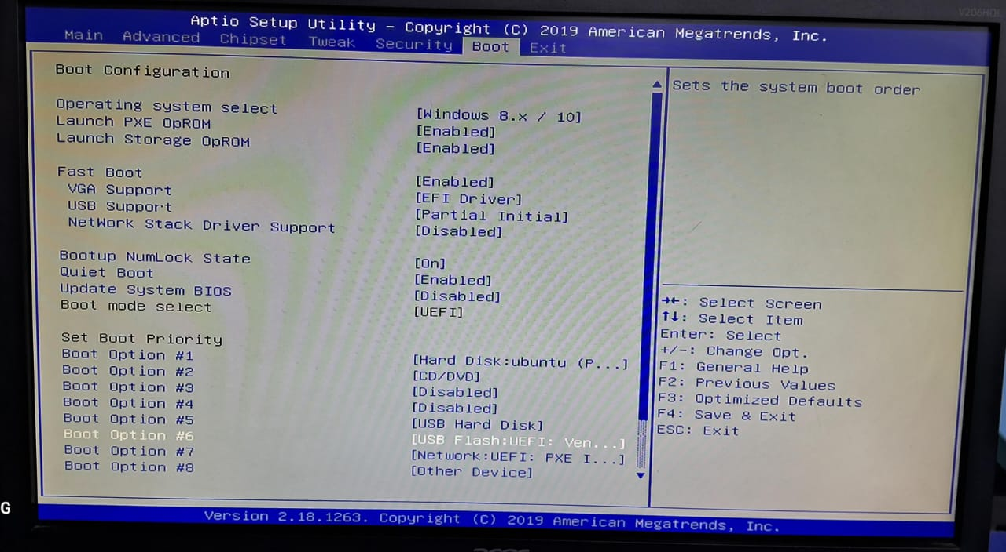

## 5. XCP-ng Installation

1. On boot, XCP-ng installer screen appears.
2. Choose **Install XCP-ng**.
3. Accept license agreements.
4. Select the target hard disk for installation.
5. Configure:
   * Hostname
   * Networking (IP via DHCP or Static)
   * Root password
6. Installation completes → Remove USB → Reboot.

## 6. Post-Installation & Dashboard Access

1. After reboot, XCP-ng console screen (on monitor) displays:
   * Hostname
   * Assigned IP address
   * Login instructions
2. From a client system (same network):
   * Open a browser and go to:
   * https://<XCP-ng-IP>
   * Access the **Xen Orchestra dashboard** (management interface).
3. Verified successful access to dashboard and basic functionality.

## 7. Outcome

* The bare-metal Acer system is now running as a **dedicated hypervisor with XCP-ng**.
* Dashboard accessible via browser confirms installation success.
* Ready for creating & managing Virtual Machines.

## 8. Notes

* BIOS key for Acer: **F2** (Boot Menu: **F12**)
* If USB boot fails, try plugging into **USB 2.0 port**.
* For remote management, install **Xen Orchestra (XO Lite)** from the XCP-ng dashboard.
* Keep root password safe; required for system maintenance.